**Exercise 1,**

Created a new maven project using IntelliJ IDEA.

Added JUnit4 to pom.xml

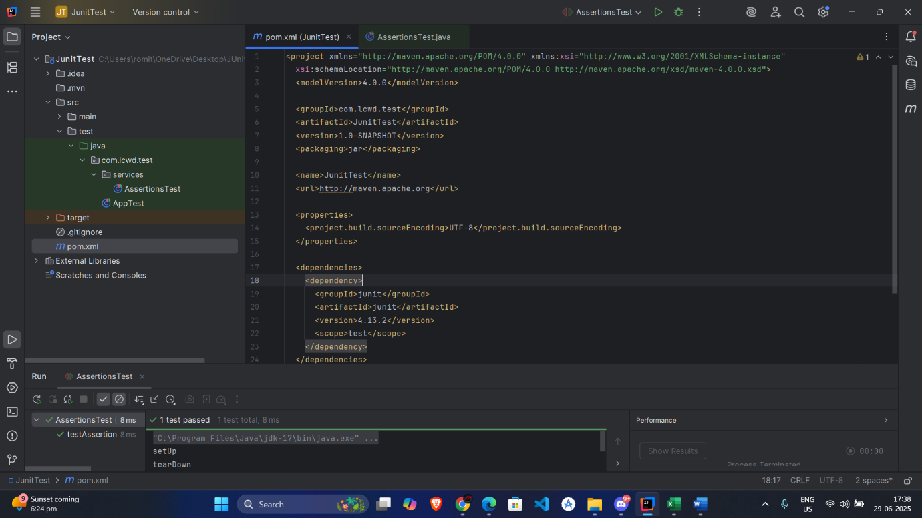

**Exercise 3,**

Output,

**Exercise 4: Arrange-Act-Assert (AAA) Pattern, Test Fixtures, Setup and teardown Methods in JUnit**

Output,

