**1. Created a new React app using *create-react-app* tool with the as “trainers-app”**

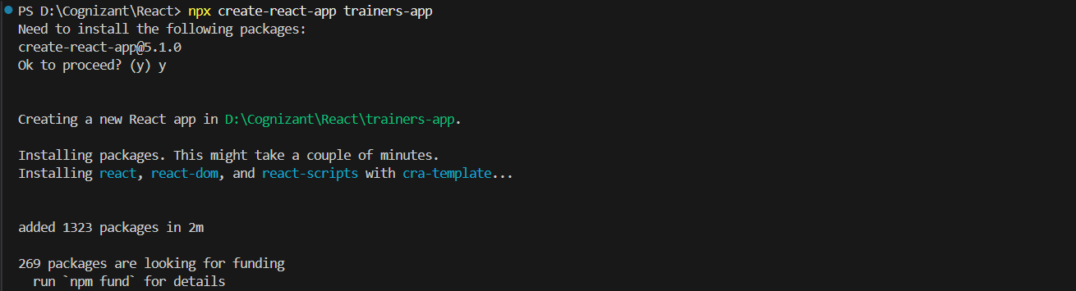

**2. Created** [**Trainer.js**](http://trainer.js)

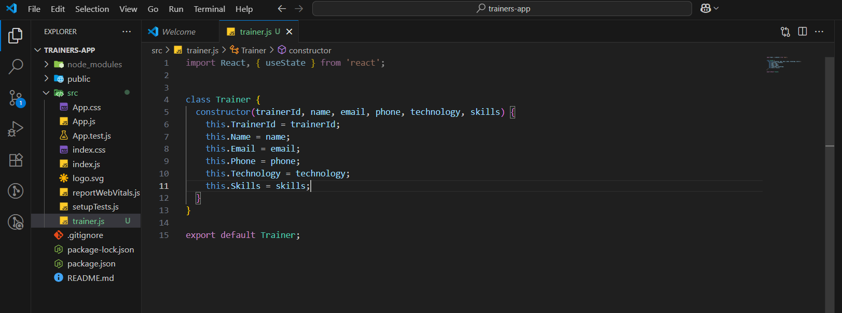

**3. Created** [**TrainersMock.js**](http://trainer.js)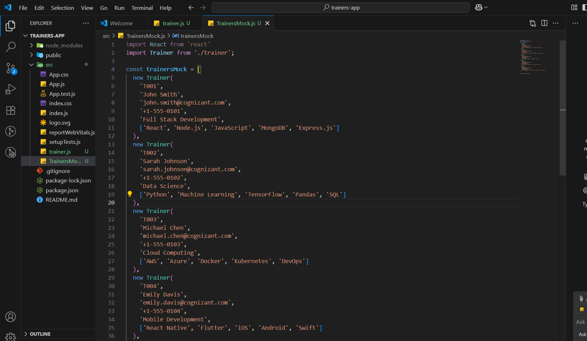

**4. Installed react-router-dom**

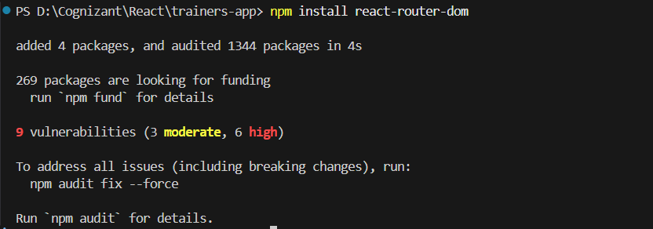

**5. Created** [**TrainersList.js**](http://trainer.js)

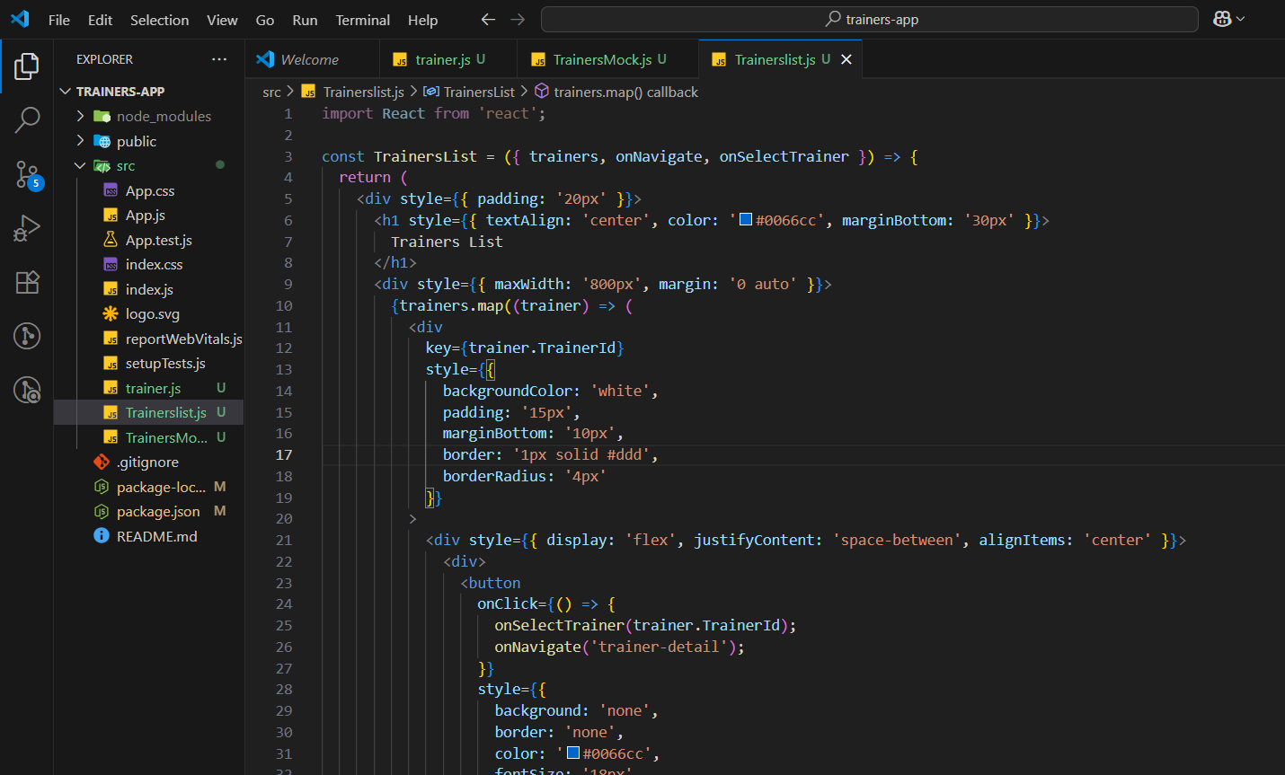

**5. Created** [**Home.js**](http://home.js)

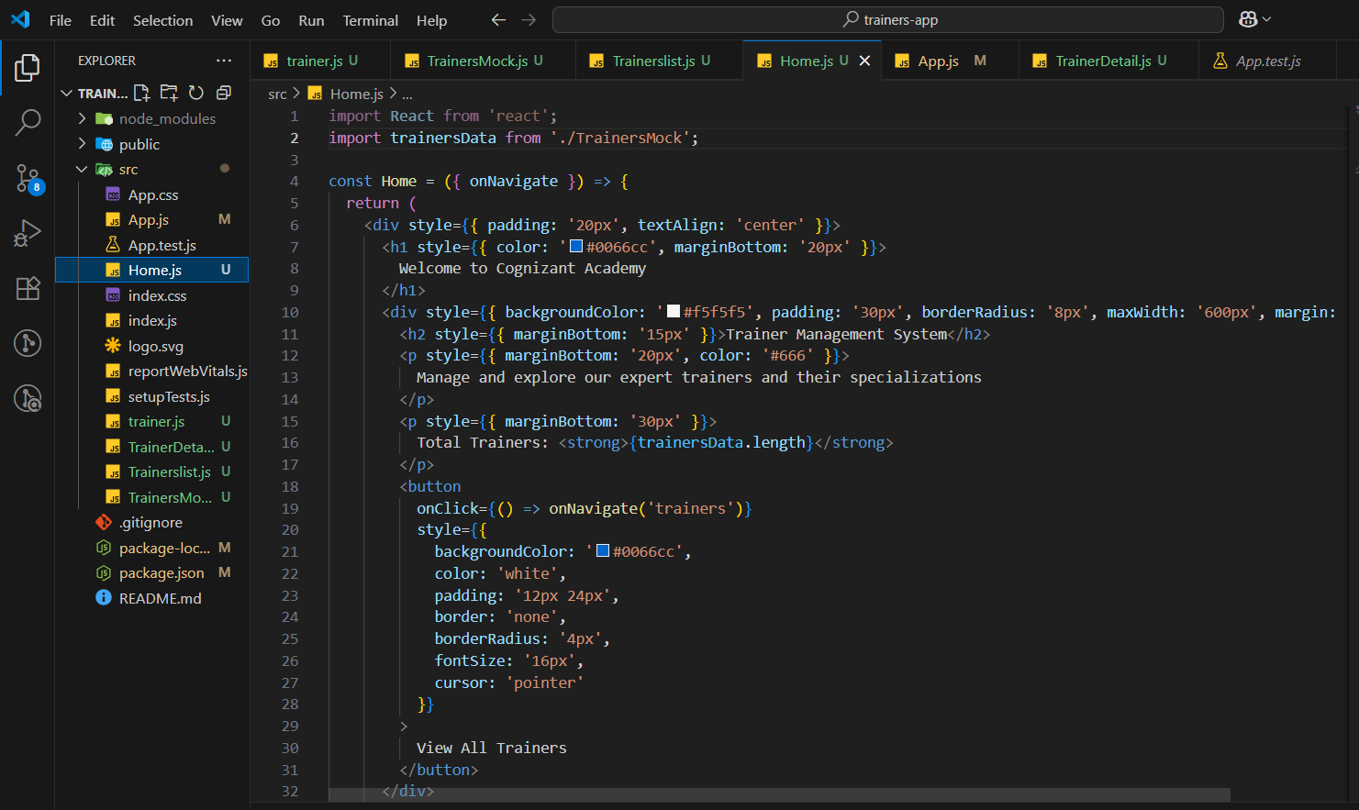

**6. Modified the App component**

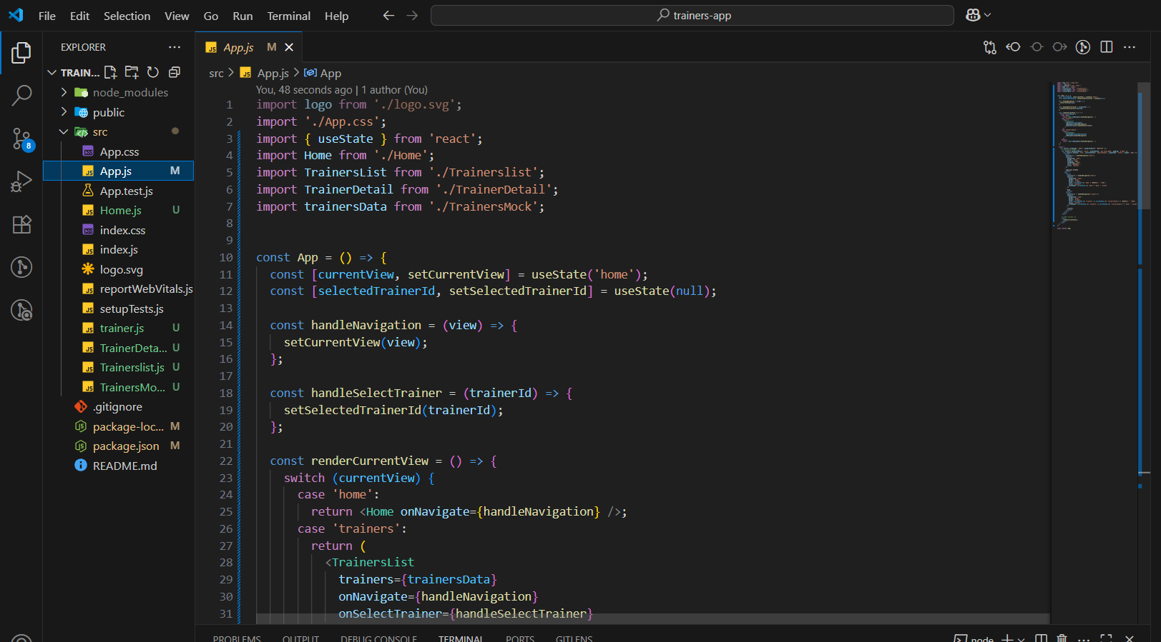

**7. Created** [**TrainerDetail.js**](http://trainerdetail.js) **component**

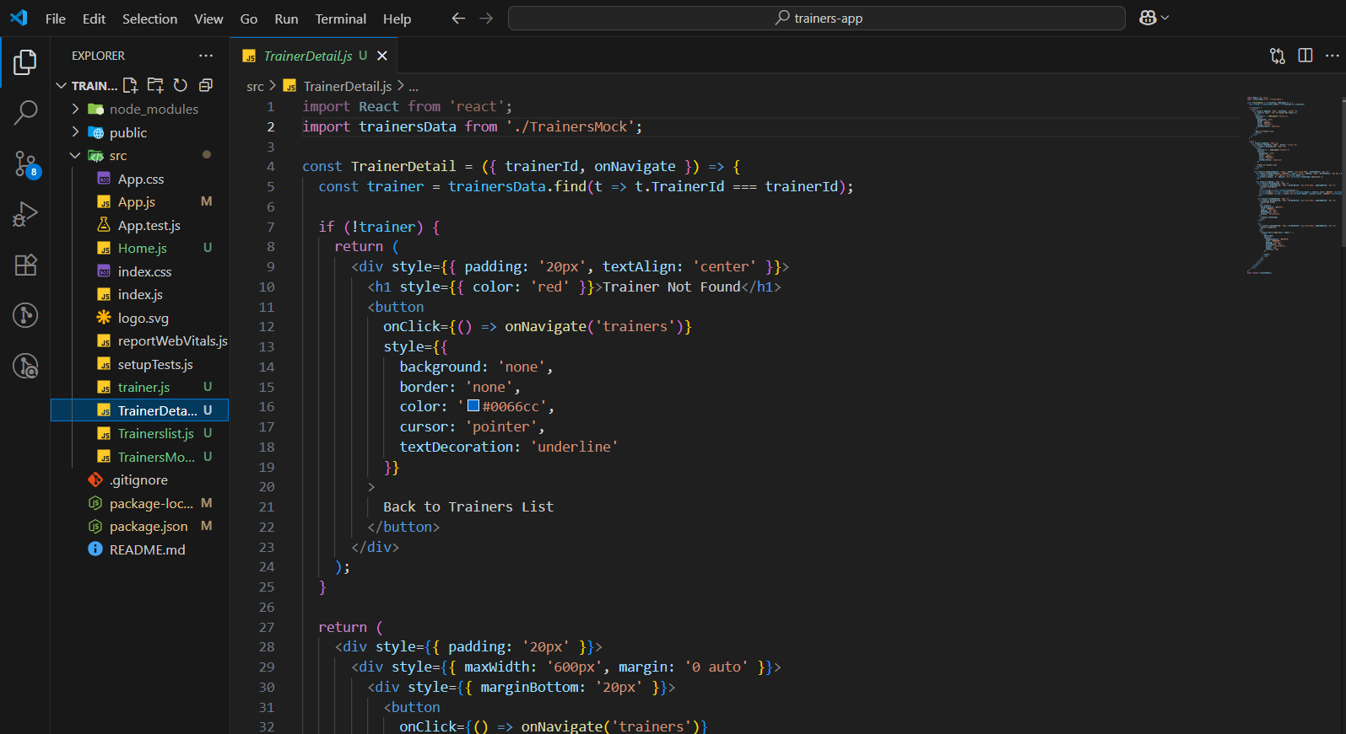

**8. Ran the application**

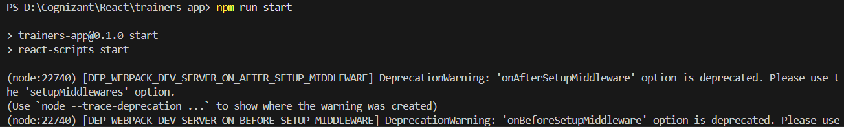

**9. Home Page**

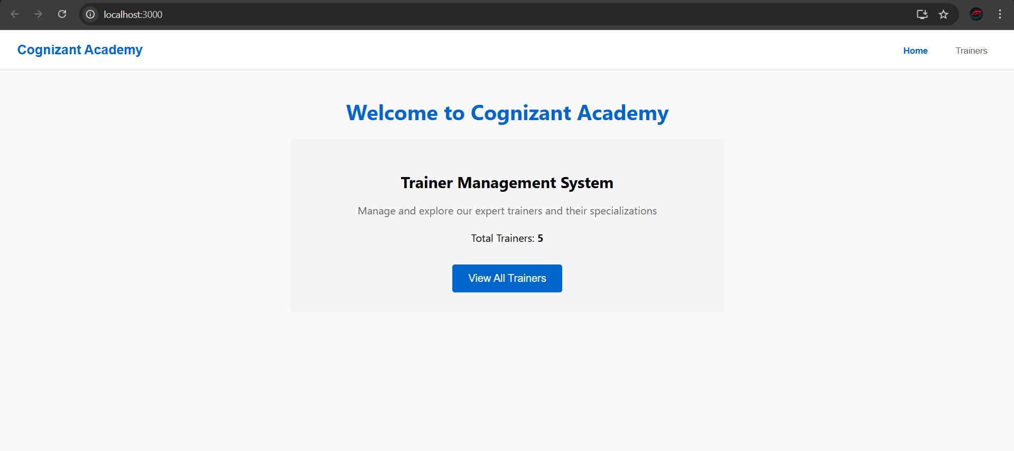

**10. Traineslist Page**

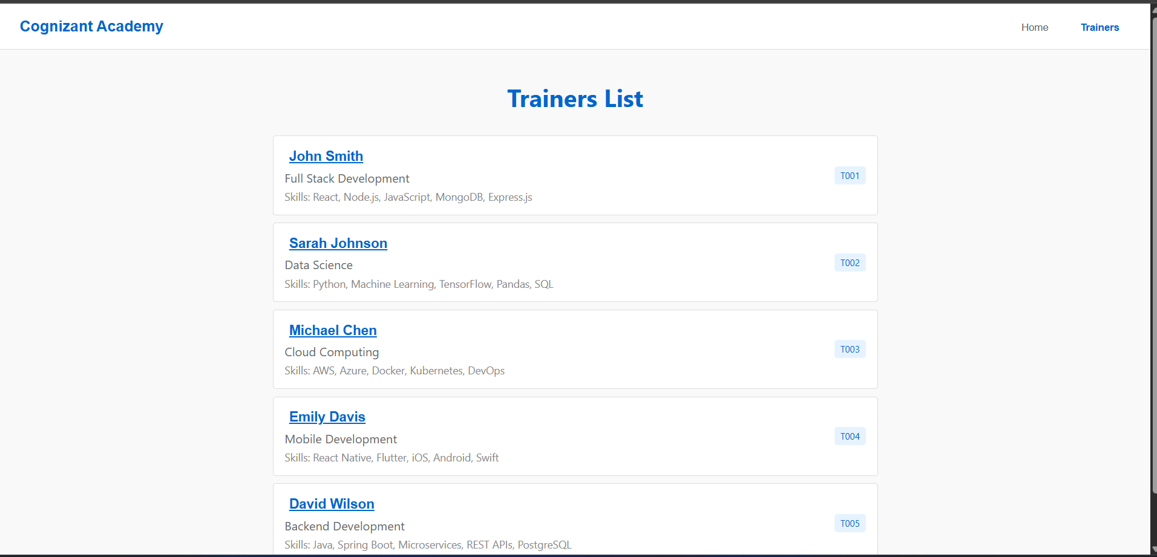

**11. TrainerDetailsPage**

