1. **Created React Application shoppingapp**

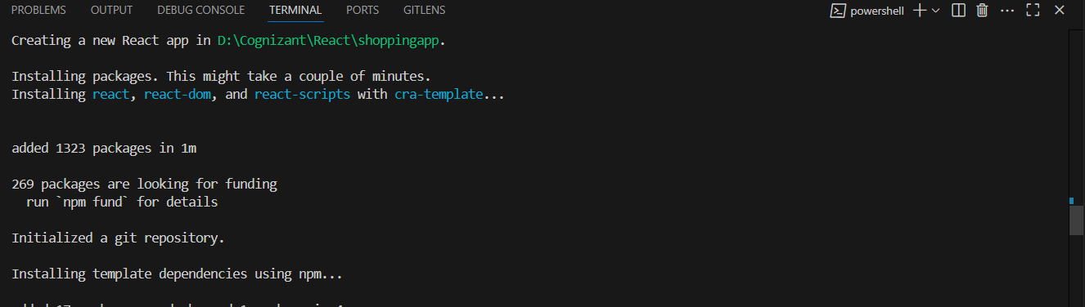

1. **Created** [**Cart.js**](http://cart.js)

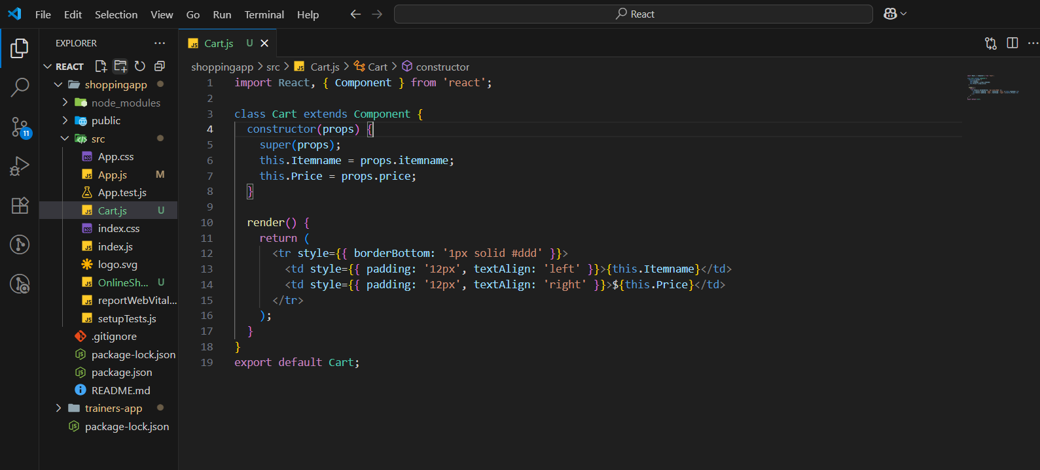

1. **Created** [**OnlineShopping.js**](http://onlineshopping.js)

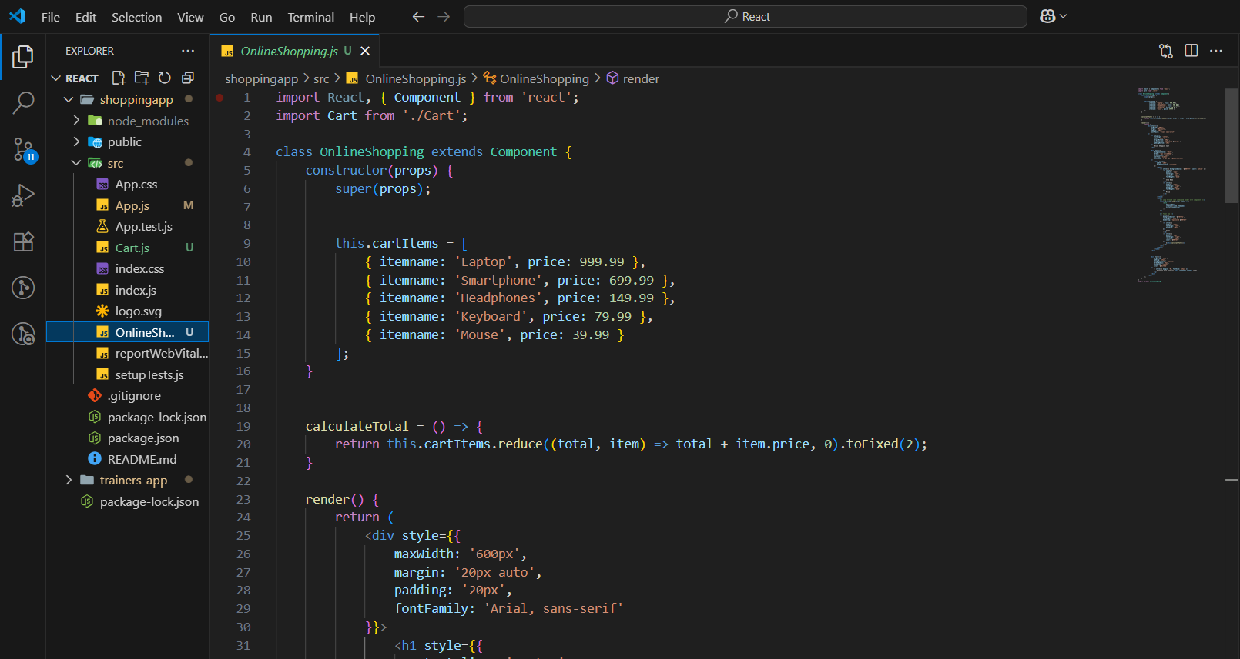

1. **Modified** [**App.js**](http://app.js)

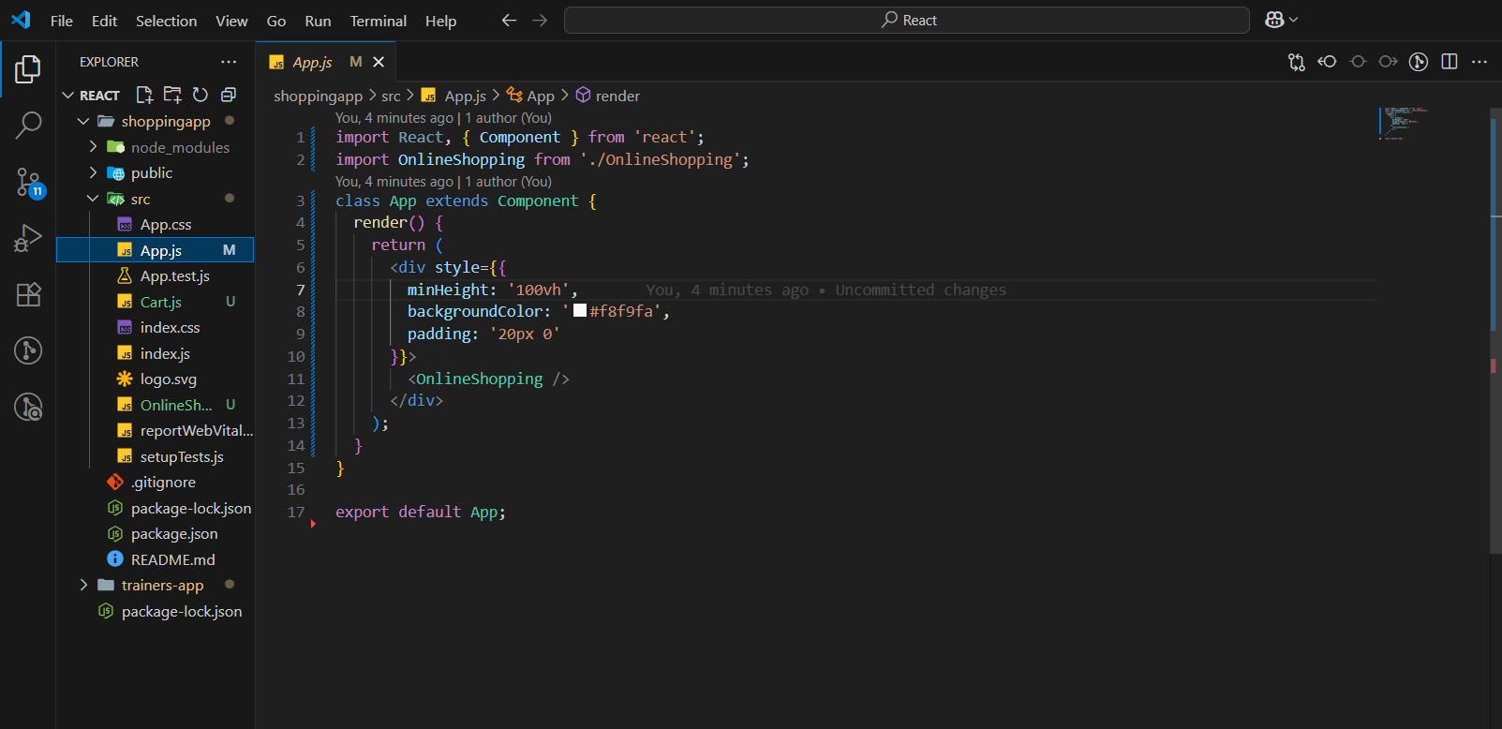

1. **Ran the application**

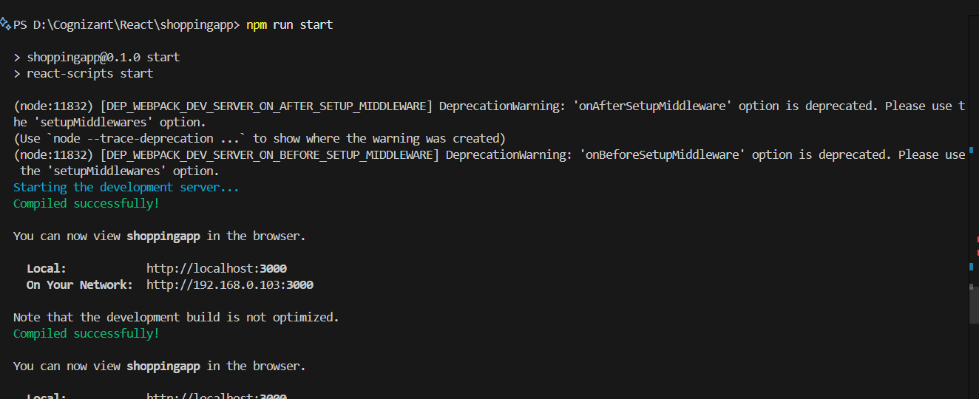

1. **The application looks like**

