1. **Created counterapp using react**

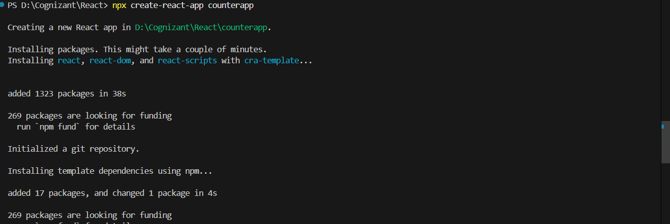

1. **Created CountPeople component**

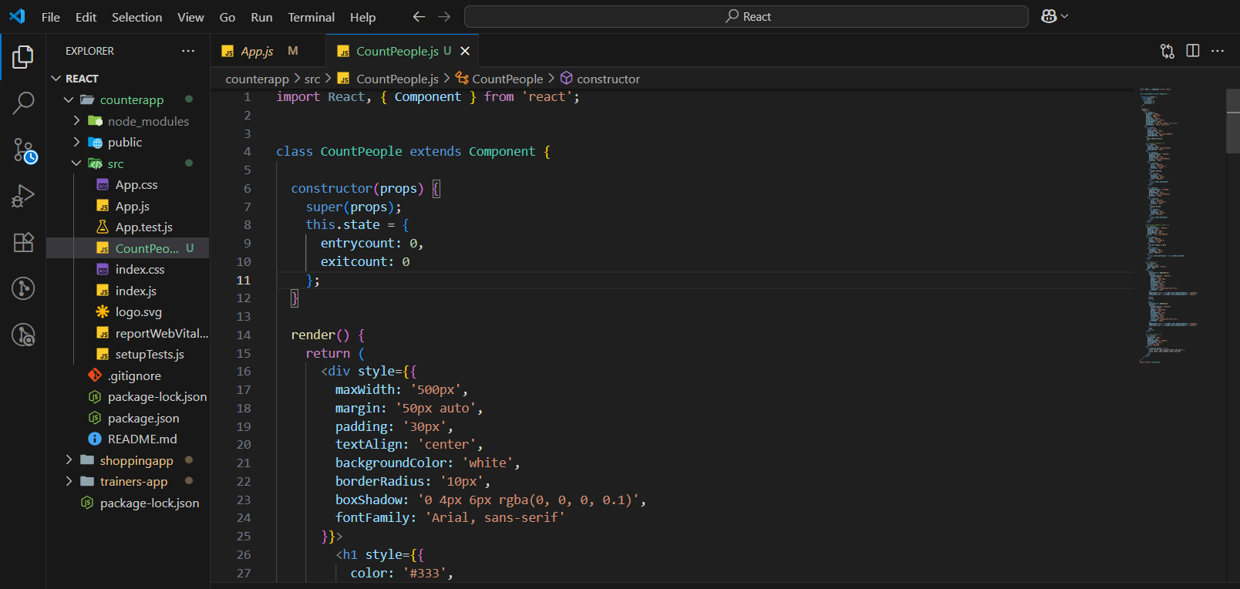

1. **Created UpdateEntry()**

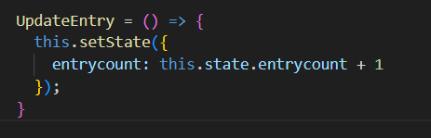

1. **Created UpdateExit()**

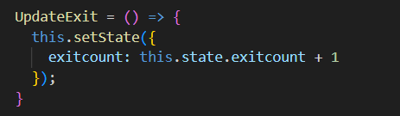

1. **Output**

