Git Hands-On

**1.Opened Git Bash** Typed:

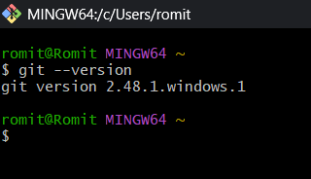

2.Configured my name and email

3.Checked the configuration

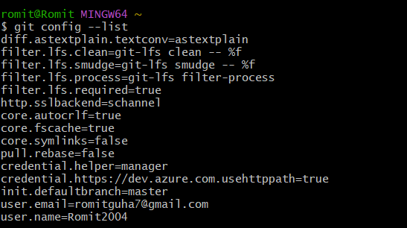

4. Tested if Notepad++ opens from Git Bash

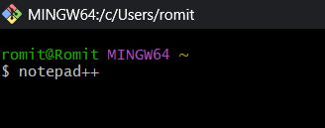

5.Set Notepad++ as default editor for Git



6.Verified editor setting

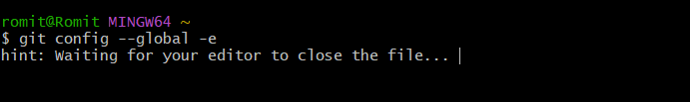

7.Made a new folder and entered it

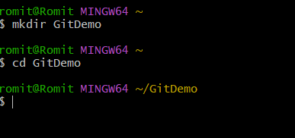

8.Initialized Git

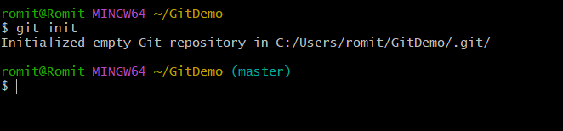

9.Checked hidden files

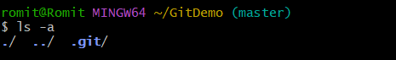

10. Created a text file



11.Checked file exists



12. Viewed file content

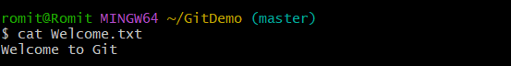

13.Checked status

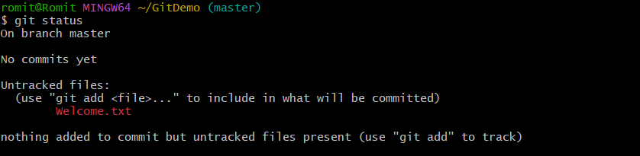

14.Added file to staging



15. Committed the file

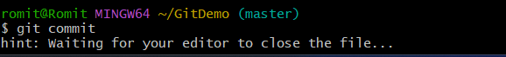

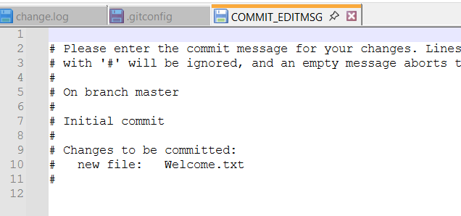

16.Checked status again

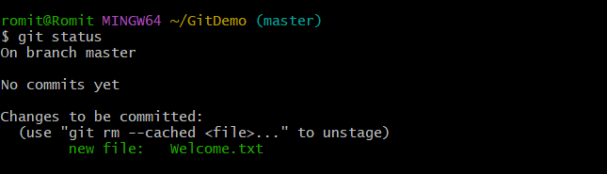

17.Linked local repo to remote



18.Pushed my local repo to remote

