DC-Resilience: A Monte Carlo Failure-Injection Framework for Quantitative Evaluation of Data Centre Redundancy Architectures
Romit Deokar (RA2411003010615) | Shourya Saran (RA2411003010628)
Department of Computing Technologies, School of Computing
SRM Institute of Science and Technology, Kattankulathur

Abstract— DC-Resilience is a continuous-time Monte Carlo failure-injection framework for comparing data centre redundancy architectures under explicitly stated assumptions. The web application models power (UPS, continuous-duty generator, PDU and ATS), cooling, and representative IT service trains: server hardware, co-located OS/hypervisor crashes, network, storage and application replicas. Its mixed dataset contains three IEEE-493-citing secondary-source records and seven illustrative, unverified records. A controlled comparison holds load, component ratings, duration, seed and scenario assumptions constant while varying N, N+1 and 2N redundancy. The framework reports availability, annualized downtime, unserved energy, trial-level SLA breach probabilities, approximate confidence intervals and editable INR planning budgets. Optional common-cause and maintenance experiments, paired rate-sensitivity reruns and trial replay support interpretation. These are model-dependent demonstrations, not field-validated availability forecasts or Tier certification; this report describes the implementation and does not present a completed publication-grade numerical study.
Keywords— data centre reliability, redundancy architecture, Monte Carlo simulation, failure injection, availability, Tier classification, IEEE Std 493
1. INTRODUCTION
Uptime Institute Tier classifications concern infrastructure topology, concurrent maintainability and fault tolerance; they are not certifications of a fixed annual uptime percentage. DC-Resilience uses historically associated availability percentages only as illustrative SLA benchmarks (Tier I: 99.671%, II: 99.741%, III: 99.982%, IV: 99.995%). N, N+1 and 2N counts alone do not establish a Tier classification. This study therefore distinguishes capacity-based simulation results from actual Tier assessment.
DC-Resilience investigates how modelled redundancy changes interruption risk under configurable component and service failures. It uses a mixture of cited secondary-source records and clearly labelled assumptions, not an entirely verified IEEE dataset. Simulation is useful for a controlled comparison, but cannot establish real-world reliability without suitable input evidence and model validation.
The specific contribution of this paper is a controlled comparative study: holding IT load and facility scale constant, we vary only the redundancy architecture (N, N+1, 2N) and measure the resulting difference in availability, downtime under failure, and infrastructure cost overhead — isolating redundancy level as the single independent variable.
2. LITERATURE SURVEY
Ford et al. [1] conducted a year-long empirical study of Google's production storage infrastructure and found that failures across machines and racks are strongly correlated rather than independent, and that theoretical models assuming independence mislead reliability estimates. This finding directly motivates a simulation-based approach over a purely theoretical Tier-lookup approach, and establishes that measured, data-driven availability modelling captures behaviour that static classification schemes miss.
IEEE Std 493 [2], the IEEE Gold Book, provides reliability statistics for industrial and commercial power equipment. This implementation transcribes UPS, generator and ATS records from the IEEE-493-citing Table 2 in Wiboonrat [7], rather than claiming direct verification of the original standard. Applying these equipment-class statistics at larger capacities is an additional extrapolation. PDU, CRAC and all five IT hazard records remain illustrative; they must not be represented as IEEE measurements.
A Monte Carlo next-event simulation tool for data centre power distribution system reliability [3] demonstrated a closely related methodology, including a dependent-event generator for events such as battery discharge and breaker trips, and a multi-threaded implementation for large-system analysis. This work established that Monte Carlo simulation is a validated, established technique for comparing data centre power architectures, and its structure informs the simulation-core design used in this paper.
A parallel Monte Carlo method was applied to network reliability and availability estimation [4], modelling node and link failures across a real backbone network (CERNET) under both immediate- and delayed-repair policies. This confirms that the same failure-injection methodology generalizes beyond power systems to network infrastructure, and motivates a future extension of DC-Resilience to network-layer failures (e.g., Spine-Leaf switch failure).
An empirical study of Tier IV data centre failure diagnosis [5] examined zone-protection redundancy topologies (N, N+1, 2N, 2(N+1)) across eight Tier III and two Tier IV facilities, deriving system reliability from probability density functions, MTBF, MTTR, and IEEE 493 failure-rate data, referencing standards including TIA-942, BICSI 002, and EN 50600. This is the closest prior work to the present study in scope, directly connecting Tier classification, redundancy topology, and IEEE 493-sourced reliability data — the same three elements combined in DC-Resilience.
Work on M-out-of-N architectures with dependent components [6] motivates the optional shared-hazard experiment. DC-Resilience adds Poisson surge opportunities thinned by an assumed damage probability; an accepted event damages all UPS/generator units in bank A or across the site. Default values (1 opportunity/year, probability 0.10 and 4-hour repair) are user-editable assumptions, not values validated by [6]. This adds a common hazard and changes marginal failure rates; it is not a fixed-marginal correlation coefficient or a general cascade model.
3. IMPLEMENTED SYSTEM ARCHITECTURE
DC-Resilience is organized into five functional layers. The original conceptual diagram in Fig. 1 summarizes the workflow; the implementation scope and limitations are specified in the text below.
A. User Input & Facility Configuration
The user specifies an illustrative SLA benchmark, total supported IT load, equipment ratings, N/N+1/2N redundancy independently for power, cooling and IT, and a representative server-node count. IT trains include equal-workload server nodes, OS/hypervisor failure causes on those same hosts, and network, storage and application replicas. IT workload-equivalent kW is not server electrical draw or a procurement inventory. No Spine-Leaf/Three-Tier packet-routing model is implemented. Simulation inputs include trial count, seed, horizon, stress, operating scenario, maintenance and common-cause options.
B. Failure-Rate Engine
The versioned data/failure_rates.json contains three secondary-source records (UPS, generator and ATS) and seven illustrative records (PDU, CRAC, server hardware, OS/hypervisor, network, storage and application). PDU 0.02 failures/year with 3-hour MTTR and CRAC 0.055/year with 5.5-hour MTTR are README demo assumptions, not verified IEEE values. Wiboonrat Table 2 does not provide PDU/CRAC-specific verification. The generator record prints 0.58/year but also reports 115 failures over 266 unit-years (115/266 = 0.432330827/year); the printed MTBF of 15,033.8 hours implies approximately 0.582687/year. The tool exposes both rate interpretations and a paired diagnostic rerun. Neither interpretation resolves the source inconsistency or verifies suitability for a specific facility.
C. Monte Carlo Simulation Core
The engine samples independent exponential operating lifetimes in hours, using scale 8760/lambda_year and constant recorded MTTR. Repair restores the relevant cause. Hardware and OS causes share a host; overlapping causes are reference-counted so one repair cannot restore a still-failed host. Trials are generated in fixed batches of 256 and evaluated by an exact chronological failure/repair sweep. Shared random streams are indexed by component, trial and renewal ordinal for paired comparisons and sensitivity reruns. Single-failure mode intentionally suppresses overlapping starts and is a controlled baseline, not independent operation. Overlapping mode supports natural simultaneous failures, optional common-cause surges and timed maintenance. Generator failure-to-start and general cascading propagation are not implemented.
D. Availability & Impact Calculator
For each trial the engine integrates intervals where usable capacity falls below required IT load, without double-counting overlapping downtime. Usable capacity is the minimum of power, cooling and IT service capacity, selecting complete trains within each 2N subsystem rather than pooling disconnected paths. Availability is 100(1 - downtime/horizon); expected annual downtime is mean trial downtime in hours multiplied by 60 and divided by years per trial. Unserved energy integrates lost capacity over time. SLA breach probability refers to the full trial-horizon average, not separate annual checks or Tier certification.
E. Comparative Analysis & Reporting
The comparison runs N, N+1 and 2N with identical load, ratings, horizon, scenario assumptions and seed. Results include trial records, paired downtime differences, exact Clopper-Pearson trial-risk intervals and approximate mean intervals. Zero-outage samples use a conservative trial-risk-derived bound, never [100%,100%] certainty. Fewer than 30 outage trials is an exploratory caution, not a formal sample-adequacy test. Optional one-factor +/-50% rate sensitivity and dependency diagnostics use up to 1,000 paired trials on the selected architecture. Costs are editable INR planning assumptions, not researched prices or quotations. JSON, summary CSV, trial CSV and browser print/Save PDF exports retain run identity and configuration; JSON retains complete trial data.
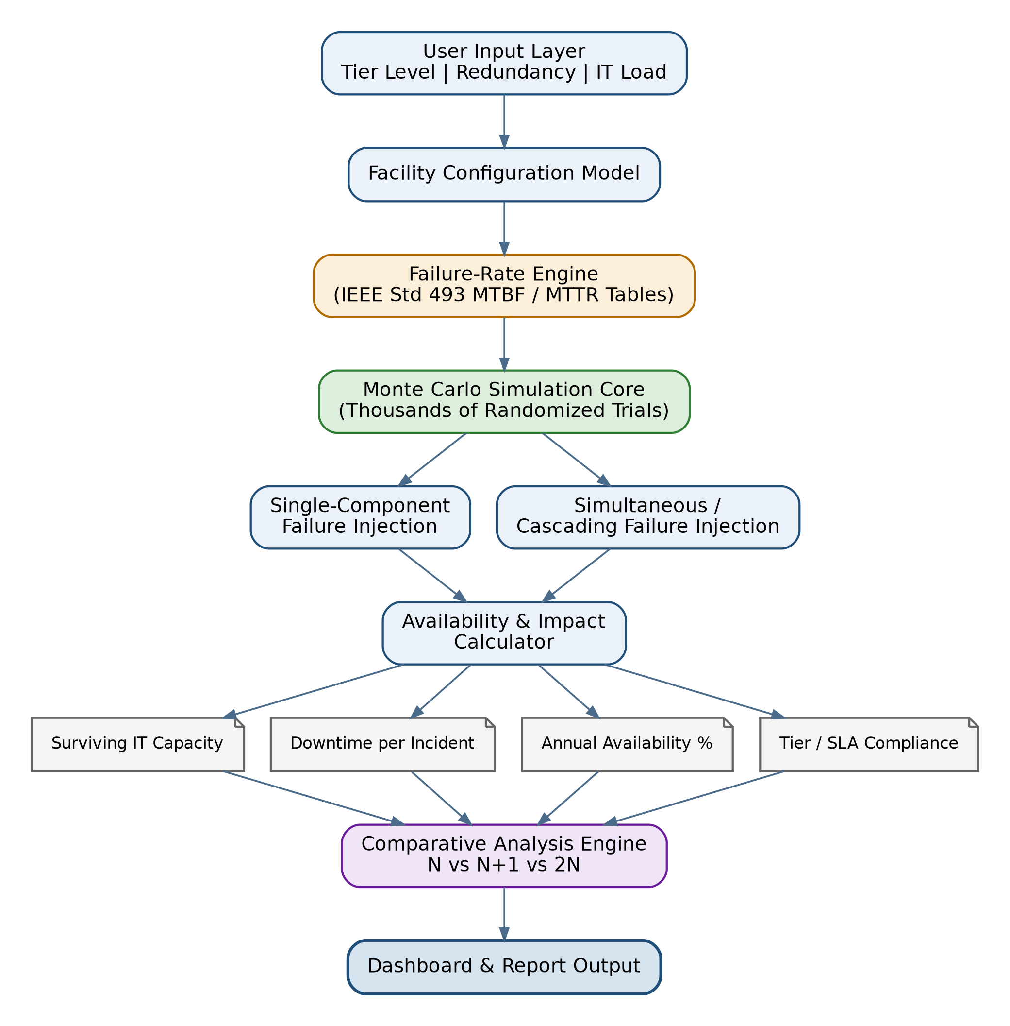
Fig. 1. Original conceptual workflow diagram. Any network-topology or generic IEEE-data wording in this retained figure is superseded by the implemented scope and mixed-source limitations in Sections 3 and 6.
4. EXPECTED OUTCOMES
The completed system and study are expected to produce the following outcomes:
1) A working N/N+1/2N capacity-availability simulator covering power, cooling and representative IT services, using a versioned mixture of cited secondary-source and illustrative failure statistics.
2) Quantified availability results (expected annual downtime, in minutes/hours per year) for each redundancy configuration, enabling direct numerical comparison rather than qualitative Tier-table lookup.
3) An assumption-based cost-versus-reliability comparison using editable INR planning inputs and a legacy equal-weight component-count index. Installation, tax, land, staffing, fuel, OPEX and software licensing are excluded; these figures are not market quotations.
4) A live interactive dashboard demonstrating real-time failure injection and resulting facility state, suitable for demonstration to industry evaluators.
5) A reproducible foundation for a future IEEE-format submission after equipment-specific data verification, multi-seed experiments and complete bibliographic review. Submission or publication is not claimed here.
5. PROGRESS REPORT
Completed
The application implements facility sizing, server/OS/network/storage/application availability abstractions, seeded Monte Carlo simulation, comparison, common-cause scenarios, scheduled maintenance, rate sensitivity, interactive failure injection, trial replay, browser history and export workflows. Engine 2.1 regression tests cover capacity, failure/repair overlap, source labels, paired random streams, guardrails and job limits. This implementation review does not claim field validation.
In Progress
Equipment-specific data verification remains open for PDU, CRAC and IT hazards, as does independent resolution of the generator count/exposure discrepancy. The illustrative assumptions are prominently caveated in the data, UI, exports and this report. A final numerical study must report exact engine and dataset versions, seed, trial count, horizon, settings and confidence limits.
Planned
Future work includes utility-outage and per-demand generator failure-to-start/retry models, battery autonomy, fuel exhaustion, thermal delay, empirical dependency calibration, workload placement and service quorum. Before publication, run a multi-seed baseline/sensitivity study using defensible input evidence and complete references [3]-[6] with verified authors, venues and identifiers.
6. METHODOLOGY LIMITATIONS AND DEMO INTERPRETATION
Data provenance: seven of ten hazard records are unverified educational assumptions. PDU/CRAC values are not IEEE-validated; IT values are not measured server/service incident rates. Secondary-source equipment classes and the disputed generator rate limit quantitative external validity. Do not use these outputs as headline field availability claims. Sampling intervals exclude input-data and model uncertainty.
Operating scenarios: islanded mode continuously requires the generators. Utility mode assumes an ideal grid and ignores generator operating failures. Operating hazards per year and start-failure probabilities per demand are different quantities. Failure-to-start, grid interruptions, battery discharge and fuel exhaustion are explicitly future work, not hidden within the 0.58/year parameter.
Maintenance: one selected A-bank unit is offline for a scheduled window per full trial. Maintenance-only tolerance is evaluated separately from an optional random same-group companion fault. The latter is conditional stress, not an empirical annual forecast. If no peer exists in an architecture, the companion fault is skipped and applied/skipped trial counts are reported. A maintenance-only test cannot establish tolerance of an additional fault, and neither test certifies Tier III/IV.
Service abstraction: server hardware, OS/hypervisor, network, storage and application availability are represented, but disk durability, routing, quorum, VM placement, request latency, cybersecurity, human error and physical power-to-rack mapping are not. Repairs and failover are idealized. Capacity is computed from integer healthy-unit counts to avoid floating-point drift in fractional server workload shares.
Reproducibility and limits: engine 2.1 couples rate-perturbation draws by trial and renewal ordinal; changing engine version can therefore change seed-specific results. Record engine/dataset versions as well as seed. Trial prefixes remain stable when increasing sample count. Compute preflight limits designs to 160 comparison components and 45 million weighted unit-trials; the client offers a safe trial count. Two concurrent CPU jobs are allowed; HTTP 429 means the third job did not start and should be retried after another finishes. No fabricated progress percentage is displayed.
Demo evidence: browser regression checks exercise the real 1,000-trial comparison, dependency, maintenance and diagnostic presets, IT hardware/OS/service injection, guardrail feedback, JSON/CSV downloads, print/PDF output and saved-run restoration. These checks establish application behaviour, not scientific validity of the assumed hazard rates. A short demo should distinguish 1x baseline, 20x stress and conditional maintenance scenarios.
7. REFERENCES
[1] D. Ford, F. Labelle, F. I. Popovici, M. Stokely, V.-A. Truong, L. Barroso, C. Grimes, and S. Quinlan, "Availability in globally distributed storage systems," in Proc. 9th USENIX Symp. Operating Systems Design and Implementation (OSDI), 2010.
[2] IEEE Std 493-2007, IEEE Recommended Practice for the Design of Reliable Industrial and Commercial Power Systems (IEEE Gold Book), IEEE, 2007.
[3] "Data center power distribution system reliability analysis tool based on Monte Carlo next event simulation method," in Proc. IEEE Conf., IEEE Xplore, Doc. 8096406.
[4] "The method of network reliability and availability simulation based on Monte Carlo," in Proc. IEEE Conf., IEEE Xplore, Doc. 6246229.
[5] "An empirical study on data center system failure diagnosis," ResearchGate, 2022.
[6] "Reliability of redundant M-out-of-N architectures with dependent components: A comprehensible approach with Monte Carlo simulation," arXiv:2402.18187, 2024.
[7] M. Wiboonrat, "Condition-Based Maintenance for Data Center Operations Management," IntechOpen, 2020, Table 2. DOI: 10.5772/intechopen.93945. https://www.intechopen.com/chapters/73642. Cited as a secondary source, not direct verification of IEEE Std 493.

