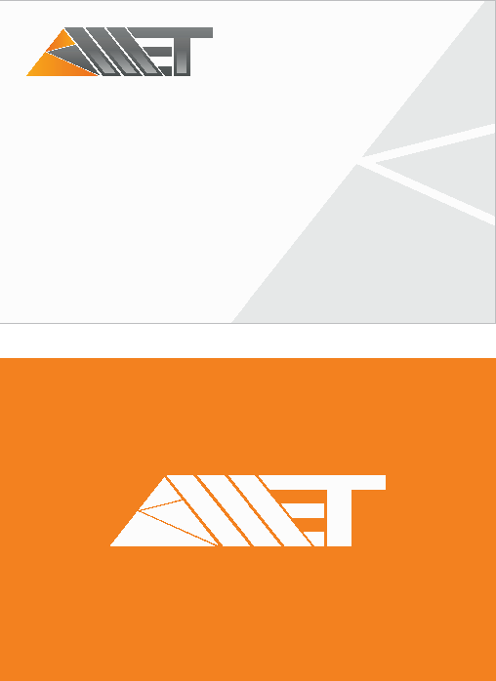
MANPOWER EQUIPMENT TRANSPORTATION
Elvin Babayev
Operations Manager
3001, Tbilisi avenue, Baku, AZ1102, Azerbaijan Republic Oskar Business
Center AZ 1102
Phone: 994 12 530 99 15 Mobile: 994 70 293 33 02
e-mail: elvinbabayev@ametsolution.com
MANPOWER EQUIPMENT TRANSPORTATION
www.ametsolution.com

