www.ametsolution.com

Azerbaijan, Baku, AZ1102 Salyan Highway 12 km

T: +99412 565 51 46

www.ametsolution.com

Equipment Rental &Technical Service:

One of the main services AMET offers in Azerbaijan market is the rent of construction equipment

Diesel Engine Safety Solutions:

Operating diesel engines in hazardous environments is a serious safety risk. A release of flammable gas or hydrocarbon vapor can occur at any time and be drawn into the engine's air intake. Turning off the ignition will not shut off the engine because it is running on the external fuel source.

Vehicle/Truck Technical Service and Rent:

We provide vehicle technical services and rental since 2012. Our fleet compliance safety standards according Oil and Gas Safety standards and staff is trained accordingly

AMET SERVICES

Information Technology Solutions

The mission of our company is to deploy the best people, equipment, and solutions to enable our customers to safely build a better and stronger future.

Our main value is striving for the safety of our employees, customers, and community. We build a diverse workplace that challenges our employees to grow professionally and embrace teamwork in everything they do.

Thanks to our customer-oriented approach we enthusiastically support the best interests of our customers and develop better ways to get their job done.

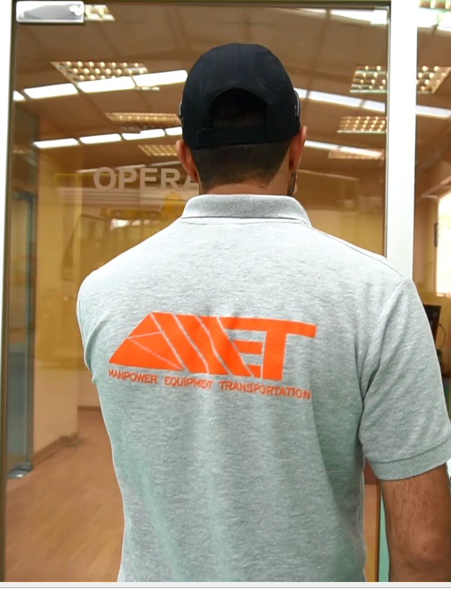

AMET Solution LLC is at the disposal of its clients in Azerbaijan since 2012 as an exclusive source for construction equipment service, generator repair, Diesel Engine Safety system, vehicle rent and many more. We are proud to be the authorized distributor of AMOT, Chalwyn and Roda Deaco.

Azerbaijan, Baku, AZ1102 Salyan Highway 12 km

T: +99412 565 51 46

www.ametsolution.com

AMET aims to maintain an outstanding corporate citizen position at all times and maximizes its efforts towards becoming more environment-friendly.

Our intention is to convert our commitments into responsible business behaviors and sustainable practices. To do that we optimize and adjust our business processes accordingly.

Our Mission and Values

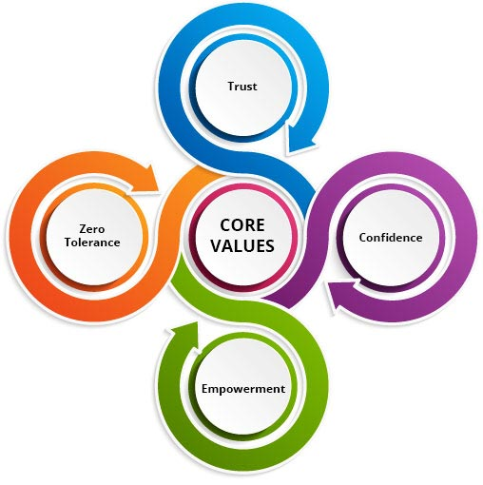

Trust:

AMET trusts its employees and employees trust each other for safe behaviour

Confidence:

Our employees always demonstrate their professional skills to maintain safety

Empowerment:

Every employee, direct or indirect is empowered to intervene unsafe act or situation

Zero Tolerance:

No employee will tolerate any deviation or dispensation for Safety

* **Trust:**AMET trusts its employees and employees trust each other for safe behaviour.
* **Confidence:**Development of confidence within employees that they will be supported for safe behaviour.
* **Empowerment:**Every employee, direct or indirect is empowered to intervene unsafe act or situation.
* **Zero Tolerance:**No employee will tolerate any deviation or dispensation for Safety.

Azerbaijan, Baku, AZ1102 Salyan Highway 12 km

T: +99412 565 51 46

www.ametsolution.com

Being AMET Solution LLC we are fully equipped to meet all your service and maintenance needs.

You can solely rely on us for construction equipment service, heavy equipment service or any other type of support for diesel engine safety components and allied equipment in Azerbaijan.

Our extensive service capabilities are complemented by one of the largest inventories of replacement parts in the region.

We have an inventory of more than 30,000 items and can fulfill almost any order within 24 hours or less.

Anything we don’t have in stock can be quickly sourced from our network of dealer partners.

One of the main services AMET offers in Azerbaijan market is the rent of construction equipment. Our business focuses on the rental needs of a wide range of industries including construction, oil & gas, events, industrial and facilities management. We stock a variety of equipment to meet your rental needs, however if we don’t have it we will make every effort to either acquire it or source it for you to rent.

We were proud supporters of the very significant, at the same time international sporting events that were held in Azerbaijan like Formula 1 Grand Prix, European Games, Islamic Solidarity Games and etc. Through our long association with industry, AMET Solution has become a key supplier of equipment and services to this vast sector. This is down to our ability to meet any industry’s diverse equipment needs as well as providing the essential service and support.

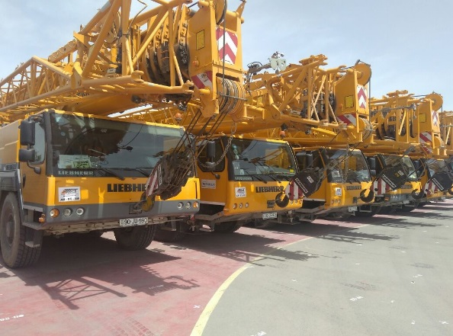

**4th Islamic Solidarity Games 2017**

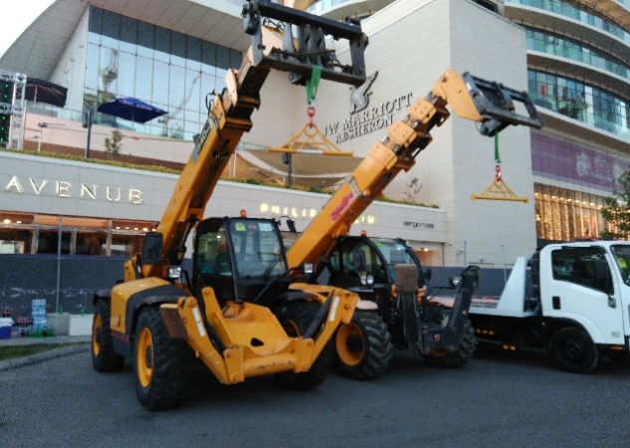

**Baku Grand Prix 2016-2018**

Our Services:Rent

Safety:

Safety is number one priority at everything we do.

Quality:

Providing the quality service for our customers 24/7.

Reporting:

We ensure that the customer gets regular reports during the process.

Azerbaijan, Baku, AZ1102 Salyan Highway 12 km

T: +99412 565 51 46

www.ametsolution.com

Our Services - Tech.Service

In addition to being a leading provider of construction and farm equipment service in Azerbaijan and beyond, AMET can also provide repairs for gen sets and related power equipment by various brands.

Whether you rely on your generator for prime or standby power, you need to know it will deliver reliable, cost-effective performance in any scenario.

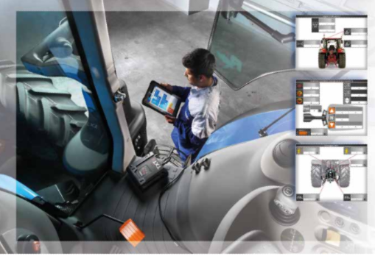

Our team is available to quickly respond to your concerns with preventive maintenance and field service in Diagnostic tools such as the TEXA diagnose program provide our technicians with in-depth insights into the condition of your important equipment.

We can help you make smarter repair decisions that maximize your budget while minimizing risks.

Construction Equipment Technical Service is an important part of our commitment to help clients run more profitable, sustainable operations. When there’s a problem with one of your key assets, we’ll be there to diagnose the issue promptly and accurately, so you can keep downtime to a minimum.

AMET offers field repairs in Azerbaijan and Georgia. One call to our 24-hour service hotline is all it takes to have a mobile repair van, equipped with a full set of tools and access to your fleet’s service history, dispatched to your location. If we can’t fix the problem right away, we’ll suggest temporary repairs that get you up and running again until a permanent solution can be arranged.

When it comes to large equipment repairs, identifying a problem before it leads to unanticipated downtime is always preferable. Regular preventive maintenance is one of the best investments you can make for your fleet. AMET Service representative can assess your specific equipment maintenance needs and put together a schedule that meets your warranty requirements. We can diagnose and fix problems before they become an issue.

Different organizations have different internal capabilities – AMET will work with you to determine how to best manage your fleet with your existing resources.

Whether it’s by giving you access to diagnostic data through the platform or by taking a more active role in your overall equipment management, we specialize in developing solutions that work for you.

We have a team of factory-trained mechanics both in our shop and in the field available to help you restore your machine to working order. We can arrange for transport to get your equipment to our facility for maintenance and repair, or we can dispatch a field mechanic to your work site. Contact a service representative for more information about your construction equipment preventive maintenance options.

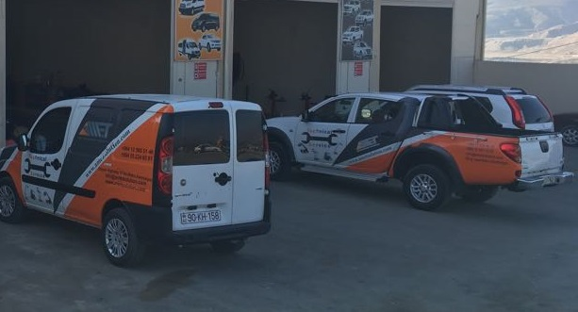

Call Service:

Did you know that we have been offering this service since 2012? It’s totally free and allows you or your employees to get answers to problems that may have been causing delays and even downtime.

Mobile Service:

Team is always happy to mobilise to your work yard or site for provision of technical services.

Whether your fleet consists of one machine or dozens, contact AMET for all large equipment services and repairs, in Azerbaijan and near regions.



Vehicle Rent & Tech.Service

**Vehicle/Equipment compliance**

People working at Oil and Gas, Mining, and other hazardous areas must be prepared and well-trained to regulate the transportation safely. It is a requirement to conduct a risk assessment to continuously reduce risks.

AMET Service provides vehicle/equipment compliance services for companies in order to meet HSE Standards and comply with government regulations.

The vehicles should fit the purpose and be maintained functional in safe working order with 3-points seatbelts installed. This applies to all vehicles (light, heavy and multi-passenger transport vehicles).

All vehicles should have specified attributes and features, and manufacturer should be responsible for proper installation. Hence, the final product must comply with the respective international standards.

Moreover, we provide trained personnel – drivers for safe and sound vehicle use experience.

Our drivers have valid driving licenses for the types of vehicles respectively and are properly trained, assessed and medically fit to operate the vehicle. AMET presents all required trainings for drivers working for Oil and Gas, Mining and other specific areas.

Did you know that we have been offering this service since 2012? It’s totally free and allows you or your employees to get answers to problems that may have been causing delays and even downtime.

Our call-line technicians get between 10-15 calls a day. Callers come from companies of all sizes; the most common calls are regarding control systems; specification questions, and electrical problems. When they call the Technical Call Line, callers are asked to leave a message with a summary of their problem, and the model and serial number of the machine or engine. Given a chance to listen to the caller’s message, our experts have time to do some homework, and when they call back, usually within 60 minutes, they are prepared.

With a few exceptions, AMET free technical call line staff can handle all questions. If your call is regarding material processing, your call will be routed to an expert approximately 60% of the issues can be rectified with the phone call back to the customer. Other options may include training an operator, dispatching a field service technician or a Product Service Consultant

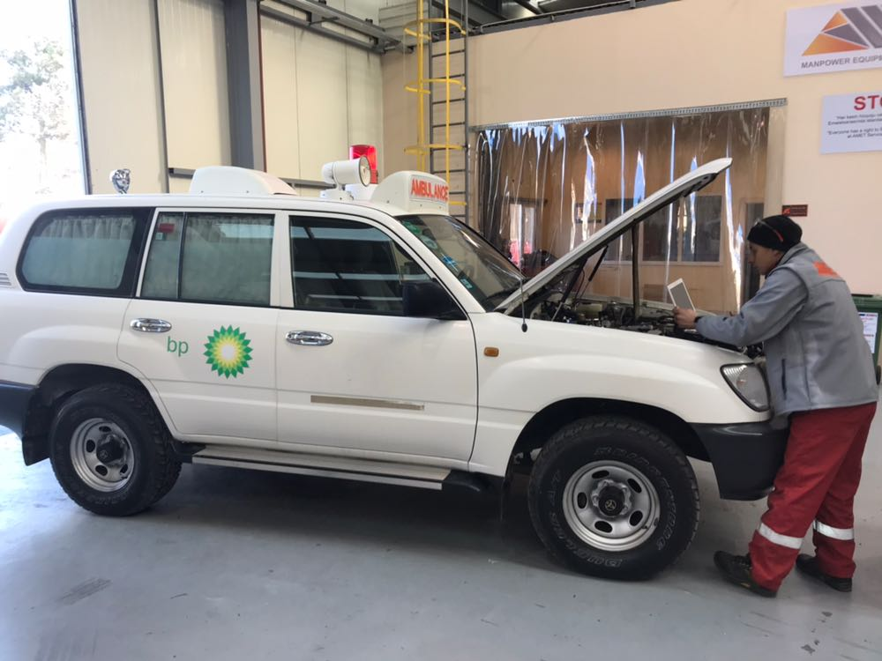

Compliance of Vehicle

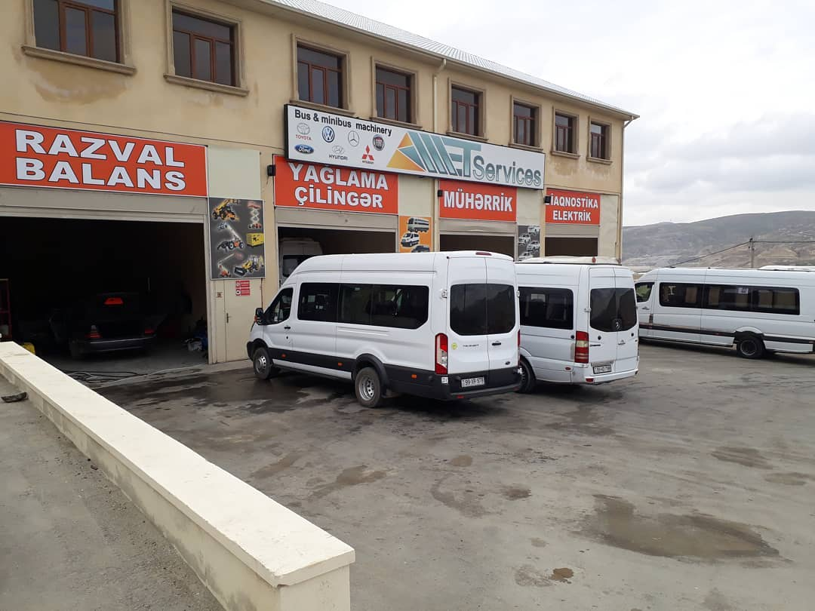

Shuttle Service

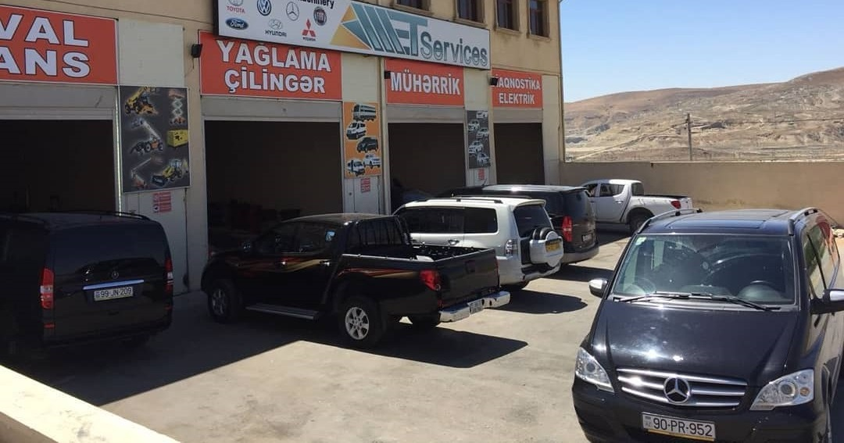

Company Fleet



Technical Fleet

When you run into a problem you can’t fix or a question that needs an answer, call the technical call line at:

+994 50 224 60 81

Vehicles:

Drivers:

Permits:

Experience:

Azerbaijan, Baku, AZ1102

Salyan Highway 12 km

T: +994 12 565 51 46

www.ametsolution.com

Azerbaijan, Baku, AZ1102

Salyan Highway 12 km

T: +994 12 565 51 46

www.ametsolution.com

AMET Solution is an authorized distributor of AMOT, Chalwyn, Roda Deaco and the only supplier of Air Shut off valve Spark arrestor in Azerbaijan.

AMOT works with original equipment manufacturers and Oil &Gas companies to design and develop safety products and solutions for engines, compressors, turbines and other rotating equipment.

Our product families include valves, electric and pneumatic instrumentation, control and condition monitoring systems and hazardous area safety products: listed on left

Operating a diesel engine in an area where a hydrocarbon release may occur is highly dangerous.

Once the external flammable gas or vapor is being drawn into the diesel engine intake, it may not be possible to stop the engine by turning off the ignition.

The engine will continue to rev out of control and over speed, leading to mechanical failure or explosion.

The diesel engine will continue to accelerate rapidly and runaway. This situation will lead to dangerous mechanical failure or flashback explosion of the leaking hydrocarbons.

Several major accidents have been linked to diesel engine runaway being the source of ignition, usually with fatal and catastrophic consequences.

The most effective way of shutting down a runaway diesel engine is with an automatic Air Intake Shutoff Valve which is available for the customers of AMET Solution.

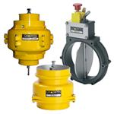

Air intake shutdown valves (often referred as AISV, ASOV or Emergency Shutdown valves) and systems provide emergency over speed shutdown protection for diesel engines and are the most effective way of preventing a runaway situation. The valves completely block the engine air intake system, cutting off an uncontrolled external fuel source and the air required to keep the engine running.

Diesel Engine Solutions

Valves:

thermostatic control, temperature control, fuel metering, diesel engine air intake shut off, fuel shut off and air start valves

Electric Pneumatic Instrumentation:

Temperature, pressure, vibration, speed and pneumatic panel components

Condition Monitoring Systems:

Bearing condition monitoring, water in oil sensors, shaft-line earthling, metal particle detectors

Hazardous Area Products:

Temperature, pressure, vibration, speed, spark arrestors and alternators

[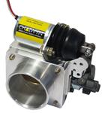](http://www.chalwyn.com/products/air-intake-shut-down-valves/electric/product/454/svr-3xx-compact-butterfly-valves)

SVR-3XX Compact Butt

[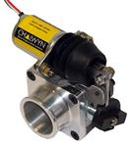](http://www.chalwyn.com/products/air-intake-shut-down-valves/electric/product/453/svr-2xx-compact-butterfly-valves)

SVR-2XX Compact Butterfly Valves

[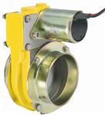](http://www.chalwyn.com/products/air-intake-shut-down-valves/electric/product/321/svx-safe-area-energized-to-open-ce240)

SVX Safe Area Energized to Open CE240

[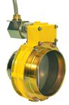](http://www.chalwyn.com/products/air-intake-shut-down-valves/electric/product/302/svx-hazardous-area-energized-to-open-ce239)

SVX Hazardous Area Energized to Open CE239

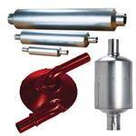

Spark Arrestors