

USER MANUAL
Document Management System (DMS)

TABLE OF CONTENTS
1. Introduction ................................................................................................................ 1
1.1 What is DMS ........................................................................................................... 1
1.2 Importance of DMS ................................................................................................. 1
2. System Requirements ............................................................................................... 2
2.1 Hardware Requirements ......................................................................................... 2
2.2 Software Requirements .......................................................................................... 2
2.3 Network Requirements ........................................................................................... 2
3. Accessing the DMS ................................................................................................... 3
3.1 Logging In .............................................................................................................. 3
3.2 Forgot Password Procedure ................................................................................... 3
4. Admin User Guide ..................................................................................................... 4
4.1 Admin Dashboard Overview ................................................................................... 4
4.2 Adding New Users .................................................................................................. 4
4.3 Managing Users ...................................................................................................... 5
4.4 Document Management ......................................................................................... 5
5. Standard User Guide ................................................................................................. 6
5.1 User Dashboard Overview ...................................................................................... 6
5.2 Uploading Files ....................................................................................................... 6
5.3 Editing Profile Information ....................................................................................... 7
6. Best Practices ............................................................................................................ 8
7. Troubleshooting Guide ............................................................................................. 9
8. Appendices .............................................................................................................. 10
8.1 Glossary of Terms .............................................................................................. 10
8.2 Frequently Asked Questions (FAQs) ................................................................ 11

1. Introduction

1.1 What is DMS
A Document Management System (DMS) is a software platform that collects, organizes, stores, secures, and retrieves documents within an organization. It ensures documents are centralized, easily accessible, and properly managed.

1.2 Importance of DMS
- Provides accurate, timely, and consistent data, enabling informed decisions.
- Streamlines document handling, reducing errors and saving time.
- Prevents data silos and ensures compliance with organizational policies.
- Enhances collaboration by making information readily available across divisions.
- Secures sensitive data against unauthorized access while maintaining version control.

2. System Requirements

2.1 Hardware Requirements
PC/laptop with at least Intel i3 (or equivalent), 4GB RAM, 500MB free storage.

2.2 Software Requirements
Any modern browser (Chrome, Edge, Firefox, Safari).

2.3 Network Requirements
Stable connection with access to 192.168.0.158/login.php.

3. Accessing the DMS

3.1 Logging In
1. Open a browser (any modern browser supported).
2. Type 192.168.0.158/login.php and press Enter.
3. Enter your assigned Username and Password.
4. Click Login to access your dashboard.

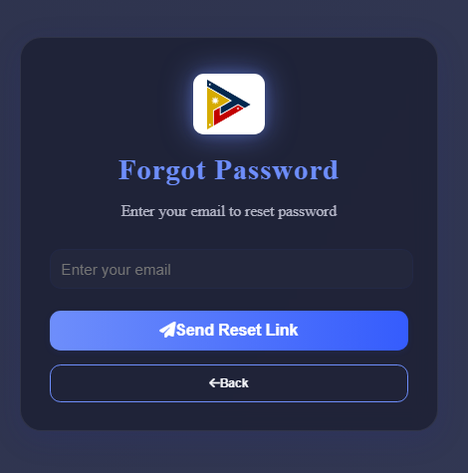

3.2 Forgot Password Procedure
1. On the login page, click 'Forgot Password'.
2. Enter your registered email address.
3. You will receive a reset link from the System Administrator.
4. Follow the link to set a new password.

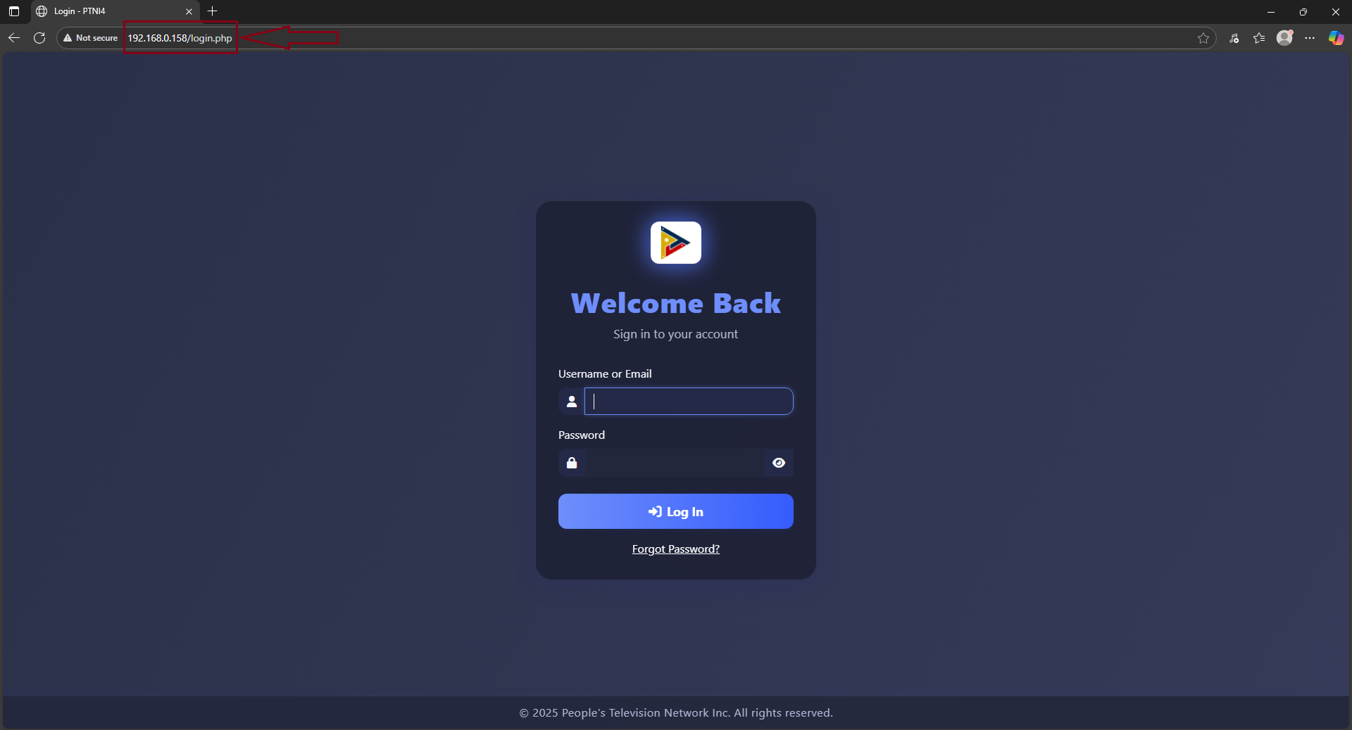

4. Admin User Guide

4.1 Admin Dashboard Overview
The Admin Dashboard is where division documents are managed and new users can be added within the division.

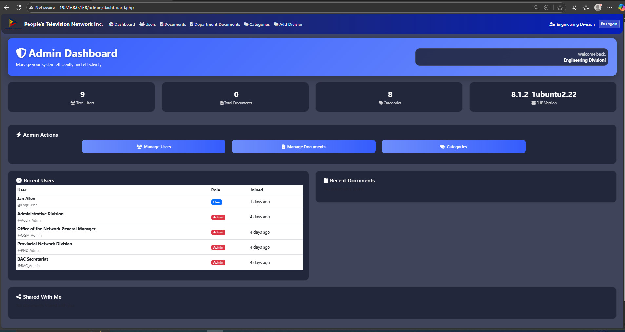

4.2 Adding New Users
Steps to add a new user:
1. Navigate to Manage User > Add New User.
2. Fill in the Add User Form:
- Enter desired Username and Email
- Full Name
- Password
- Set Status to Active
- Select Division
3. Click Add User.
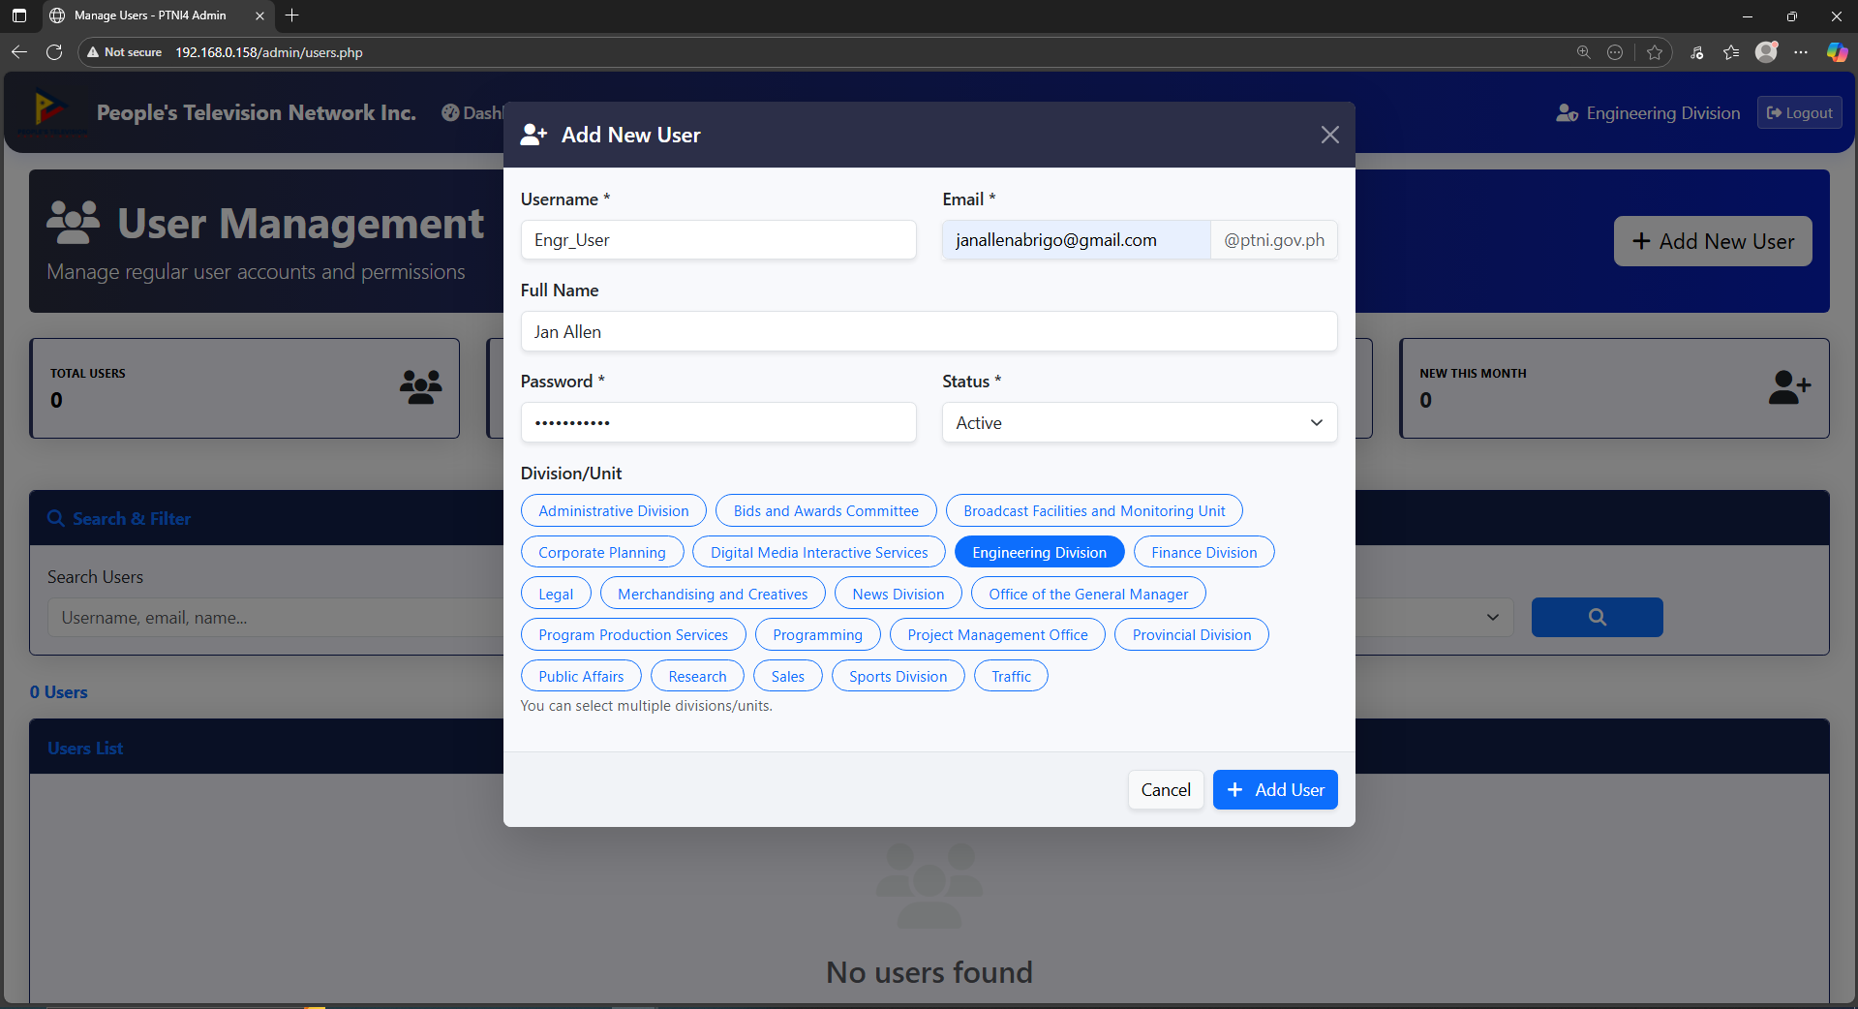

4.3 Managing Users
From the User Management menu, you can:
- View the Users List
- Edit user details (username, password, division, name)
- Activate or deactivate users

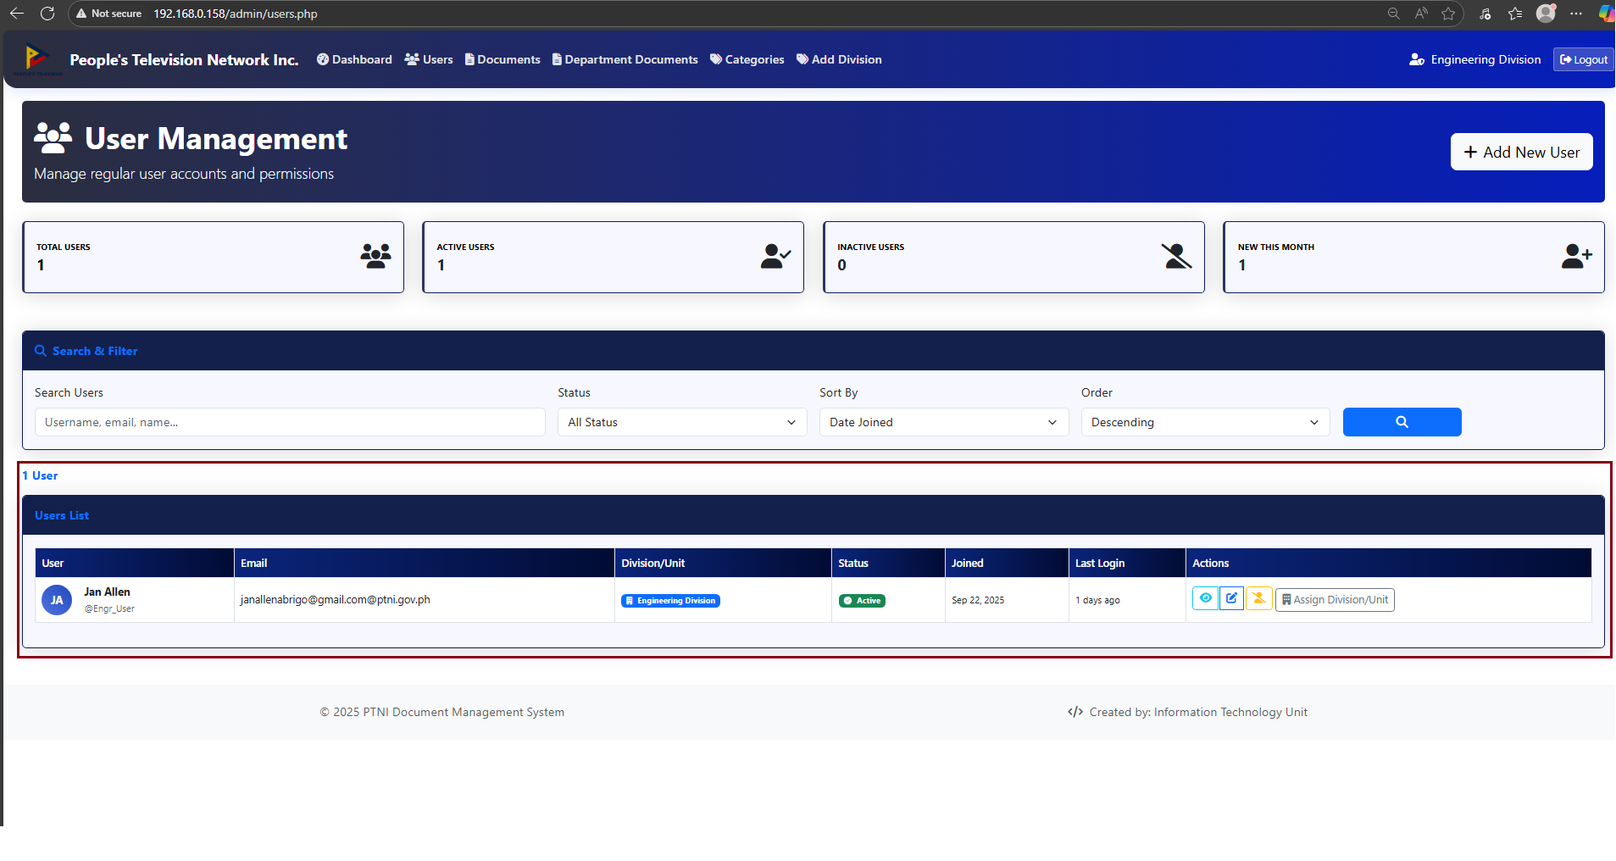

4.4 Document Management
Admins can upload and organize documents:
- Select a folder where you want to upload your file
- From Manage Documents, click Upload Documents
- Fill in the upload form and confirm
- To create a new folder, go to Document Management and click 'New Folder', then enter the folder name and click Create.
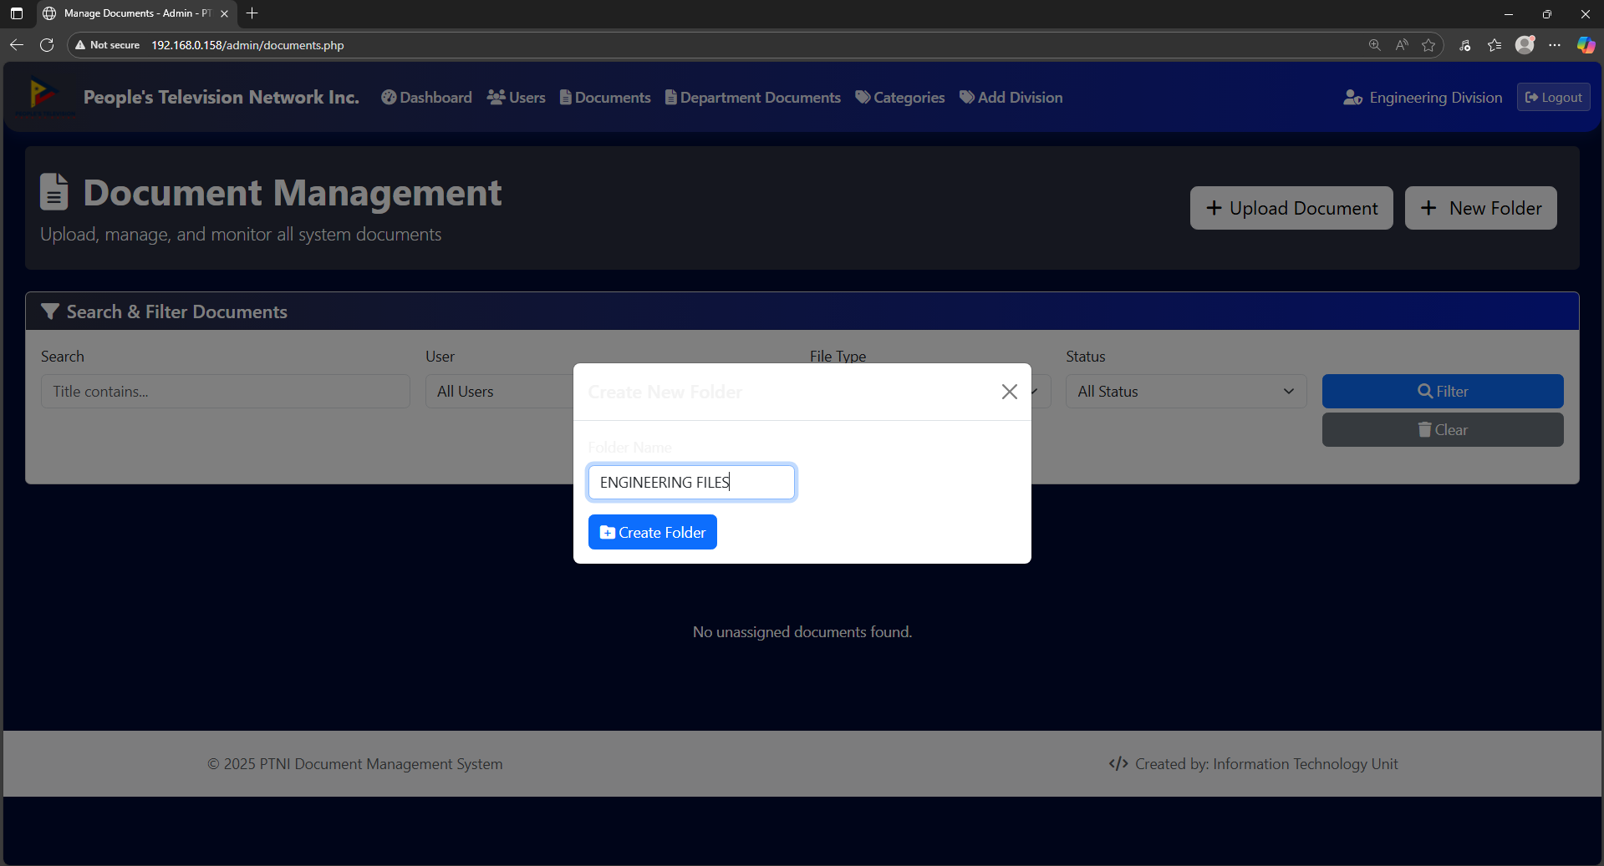
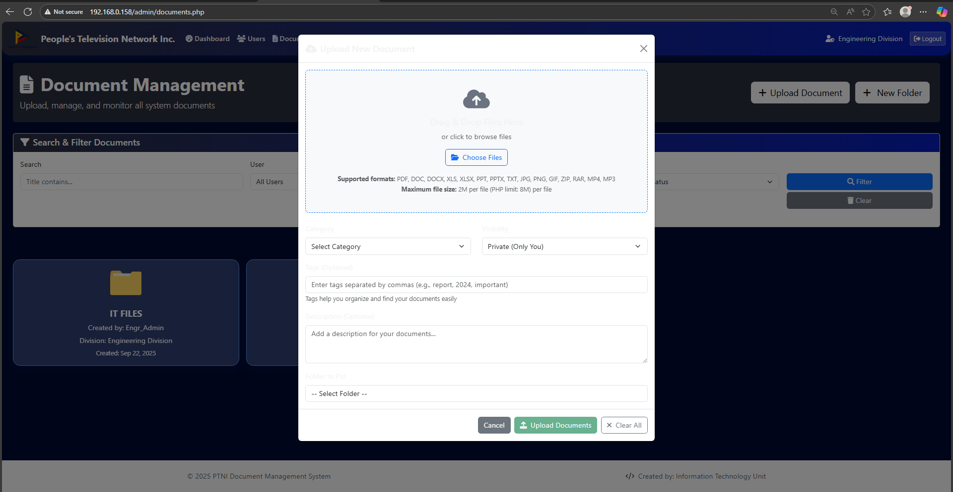

5. Standard User Guide

5.1 User Dashboard Overview
The User Dashboard allows users to upload, manage, and access documents assigned to their division.

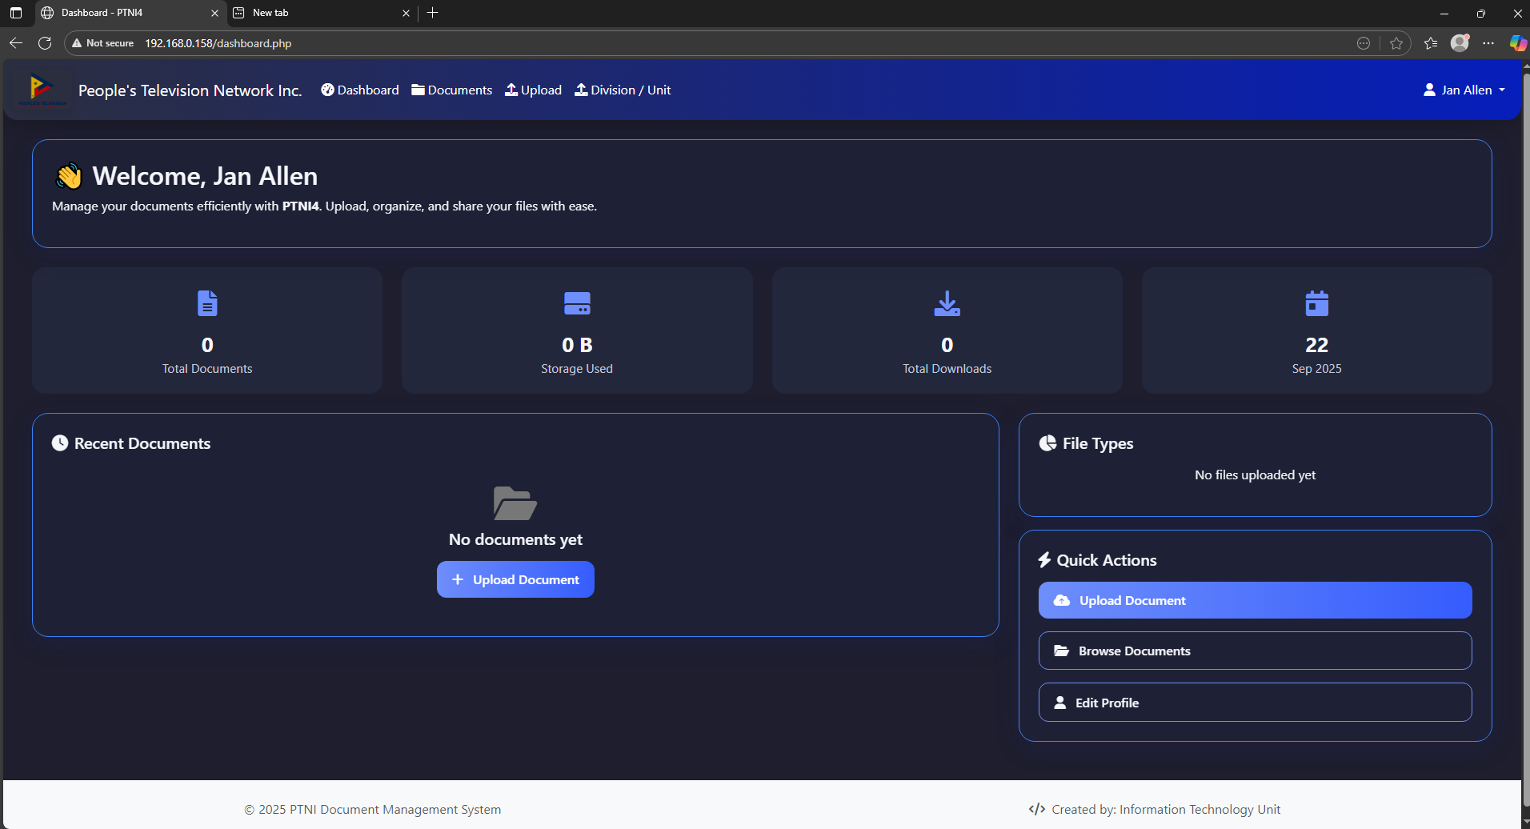

5.2 Uploading Files
Steps for uploading files:
1. From your dashboard, go to Documents.
2. Select the folder where the file will be stored.
3. Fill in the upload form or drag and drop your file.
4. Select Categories and Visibility.
5. Add Tags and a Description.
6. Click Upload to complete the process.
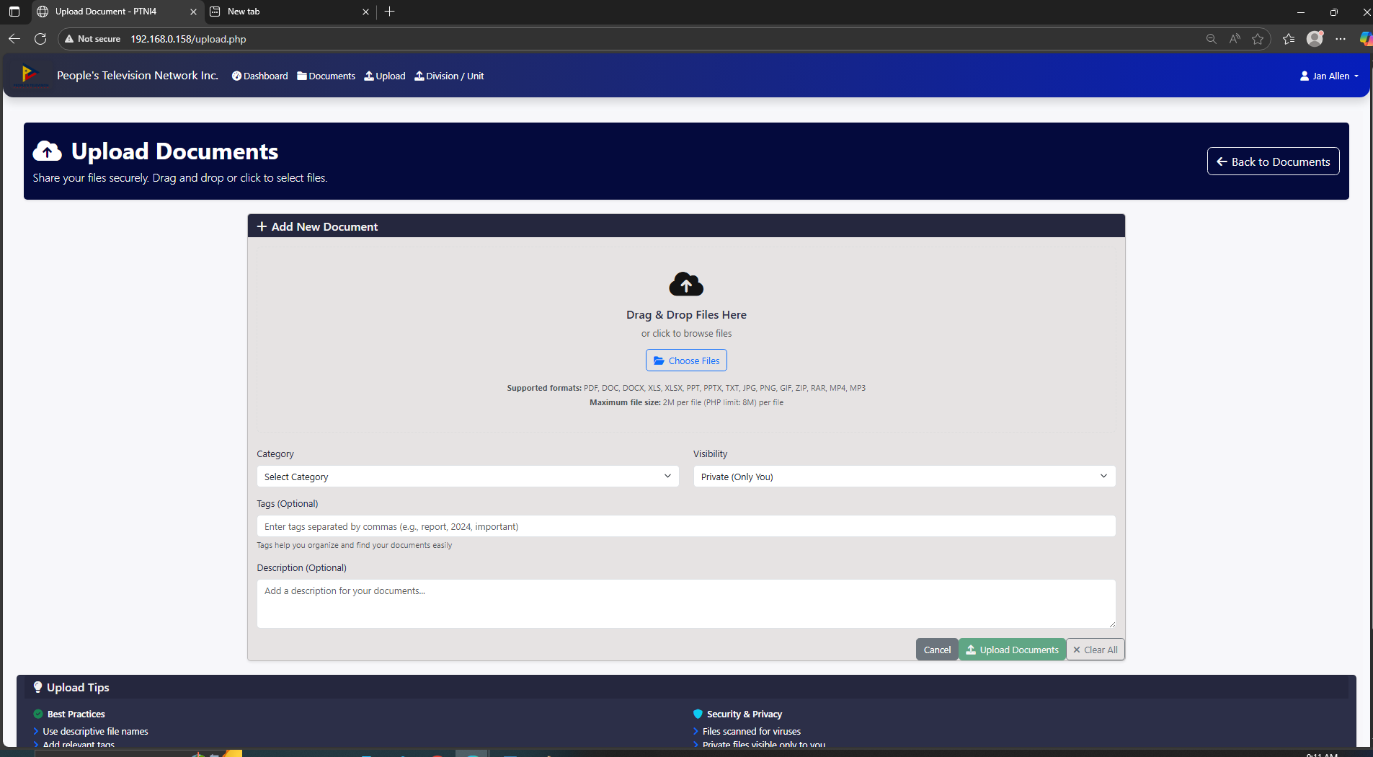

5.3 Editing Profile Information
Users can edit their profile information by navigating to Edit Profile from their dashboard.

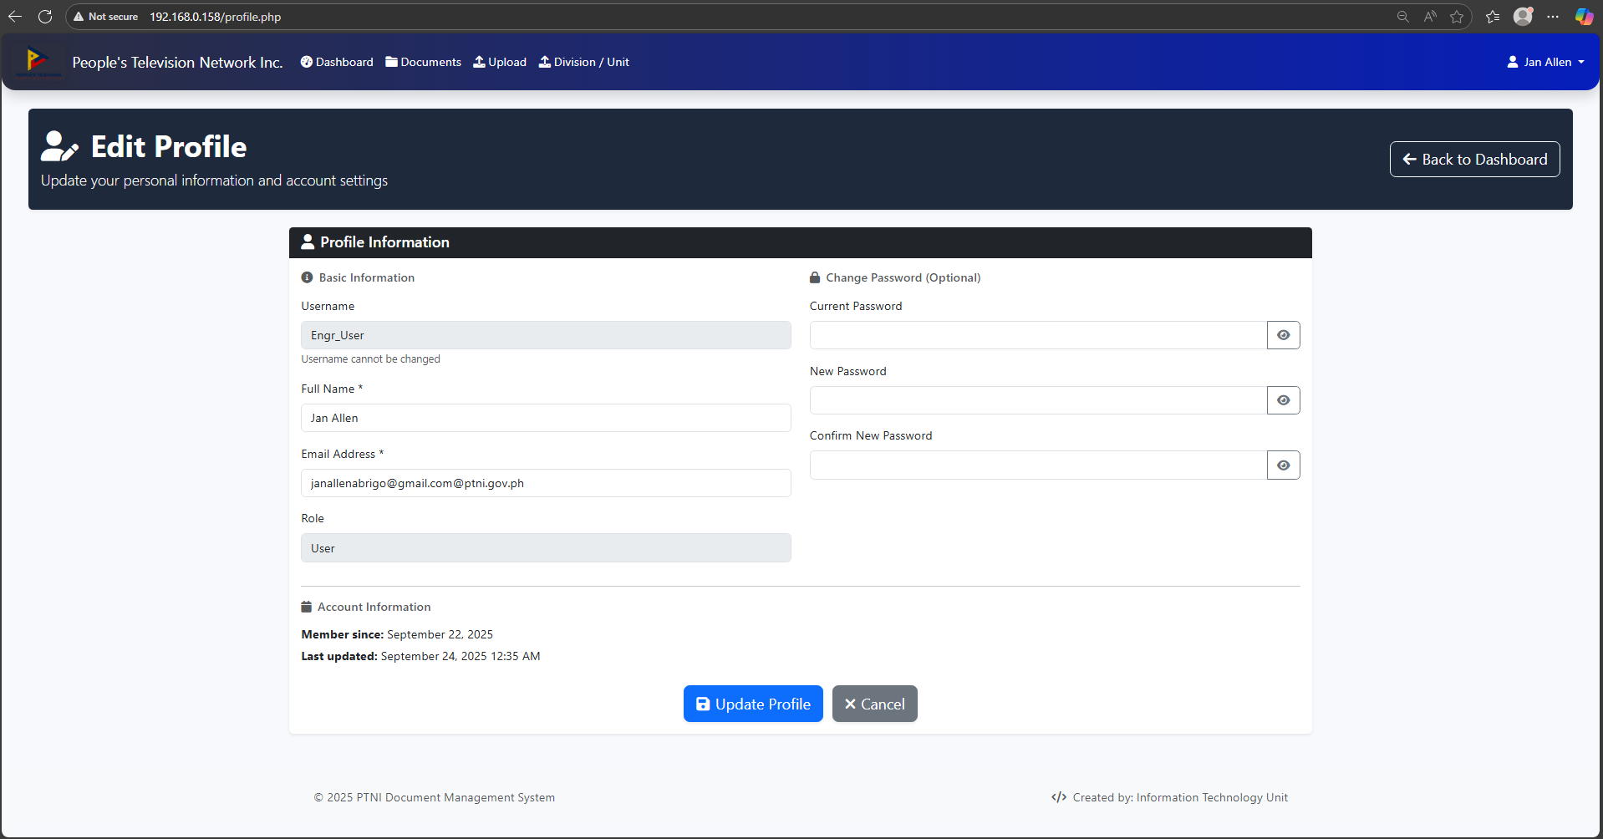

6. Best Practices
- File Naming: Use standardized formats (e.g., Division_Project_Date).
- Folder Structures: Organize documents by year, department, or project.
- Access Control: Review user access regularly.
- Version Control: Upload updated versions rather than overwriting important files.

7. Troubleshooting Guide
- Login Issues: Verify internet connection, ensure correct URL, or reset password.
- Upload Errors: Check file size and format, clear browser cache, and retry.
- Forgot Password: Follow the reset procedure.
- Persistent Issues: Contact the System Administrator.

8. Appendices

8.1 Glossary of Terms
DMS - Document Management System
Dashboard - Main page showing controls and options
Super admin – System administrator manage by IT personnel

8.2 Frequently Asked Questions (FAQs)
Q: Can I access DMS outside the office?
A: Only if the system has been configured for remote access.
Q: Can I delete documents?
A: Only Admin users can delete documents permanently.
Q: Can I restore the deleted documents?
A: No, once deleted it can’t be restored in database

