JAVA SERVLET

* Java objects that are intended to play the role of server component in client-server communications,
* Handles client request by generating responses to such request.
* Servlets provide a component-based, platform-independent method for building Web based applications, without the performance limitations of Common Gateway Interface (CGI) programs.
* Servlets have access to the entire family of Java APIs, including the JDBC API to access enterprise databases. This tutorial will teach you how to use Java Servlets to develop your web based applications in simple and easy steps.

**Tutorials Point. (2018, February 13). Servlets Tutorial. Retrieved from https://www.tutorialspoint.com/servlets/index.htm**

**SERVLET LIFECYCLE**

A servlet life cycle can be defined as the entire process from its creation till the destruction. The following are the paths followed by a servlet.

* The servlet is initialized by calling the **init()** method.
* The servlet calls **service()** method to process a client's request.
* The servlet is terminated by calling the **destroy()** method.
* Finally, servlet is garbage collected by the garbage collector of the JVM.

Tutorials Point. (2018, February 13). Servlets Tutorial. Retrieved from <https://www.tutorialspoint.com/servlets/index.htm>

* **INSTALLATION => constructor call**
  + Created an instance of the servlet to service client request.
  + Invoked implicitly by the servlet container when the servlet is called upon to service a client request and no instance currently exist.
* **INITIALIZATION => service() method**
  + Invoked for each client request
  + Servlet performs whatever logic necessary in order to serve the request and generate a response.
  + The service() method checks the HTTP request type (GET, POST, PUT, DELETE, etc.) and calls doGet, doPost, doPut, doDelete, etc. methods as appropriate.
  + Multiple client request are typically handled by a single, multi-threaded servlet instance.

public void service(ServletRequest request, ServletResponse response)

throws ServletException, IOException {

}

* **Destruction => destroy() method**
  + Invoked before the servlet instance is ‘unloaded’.
  + The destroy() method is called only once at the end of the life cycle of a servlet.

**Architectural Diagram**

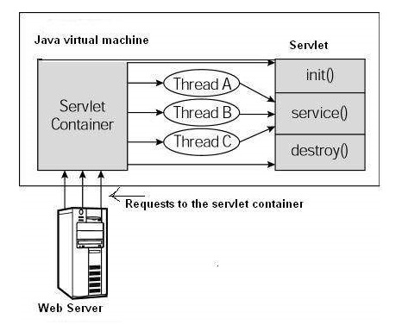

https://www.tutorialspoint.com/servlets/servlets-life-cycle.htm