**ESCUELA SUPERIOR POLITÉCNINCA DEL LITORAL**



**SOFTWARE ENGINEERING II**

**PAO 1 2024**

**Rommel Zamora**

**INDEX**

**1a.- REPORT** 3

**INTRODUCTION** 3

**SECTION A** 3

**SECTION B** 3

**CONCLUSION** 3

**RECOMMENDATIONS** 3

**1b.- REASON FOR TOOL OF CHOICE** 3

**2.- CODING STANDARD REPORTS** 3

**3.- REPOSITORY** 3

# **1a.- REPORT**

## **INTRODUCTION**

## **SECTION A**

Errors shown before making changes:

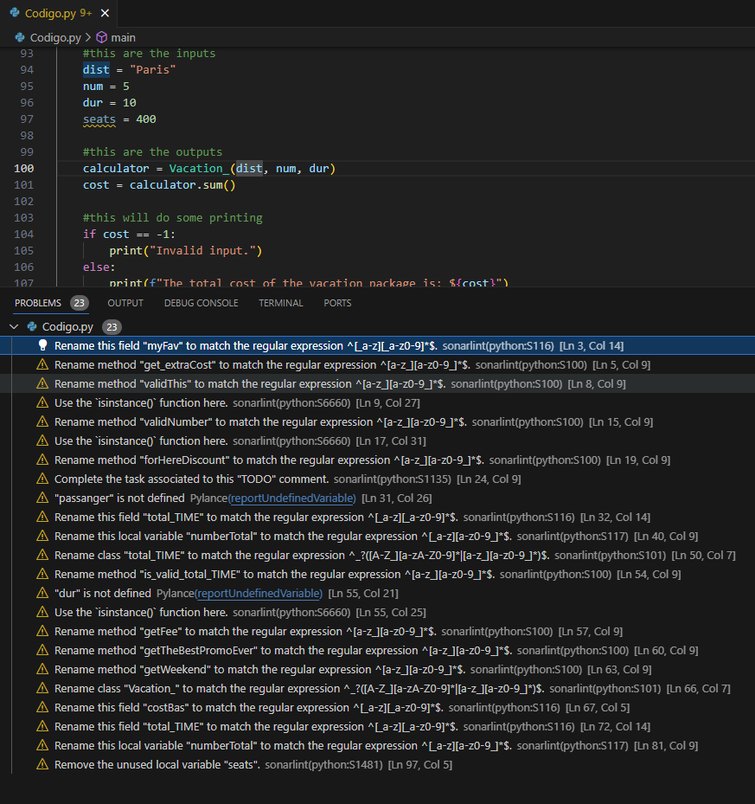

## **CONCLUSION**

## **RECOMMENDATIONS**

# **1b.- REASON FOR TOOL OF CHOICE**

# **2.- CODING STANDARD REPORTS**

# **3.- REPOSITORY**

<https://github.com/RommelZamora/TallerCodingStandards.git>