Hindcast summary and default forecast scenario (0TAC)
WGNAS 2021 - Life Cycle Model Output
14 avril, 2021
Section | Stock.Unit | Page
1 | Labrador | 2
2 | Newfoundland | 3
3 | Quebec | 4
4 | Gulf | 5
5 | Scotia-Fundy | 6
6 | US | 7
7 | France | 8
8 | EnglandWales | 9
9 | Ireland | 10
10 | Ireland.N_FO | 11
11 | Ireland.N_FB | 12
12 | Scotland_West | 13
13 | Scotland_East | 14
14 | Iceland.SW | 15
15 | Iceland.NE | 16
16 | Sweden | 17
17 | Norway_SE | 18
18 | Norway_SW | 19
19 | Norway_MI | 20
20 | Norway_NO | 21
21 | Finland | 22
22 | Russia_KB | 23
23 | Russia_KW | 24
24 | Russia_AK | 25
25 | Russia_RP | 26

Labrador
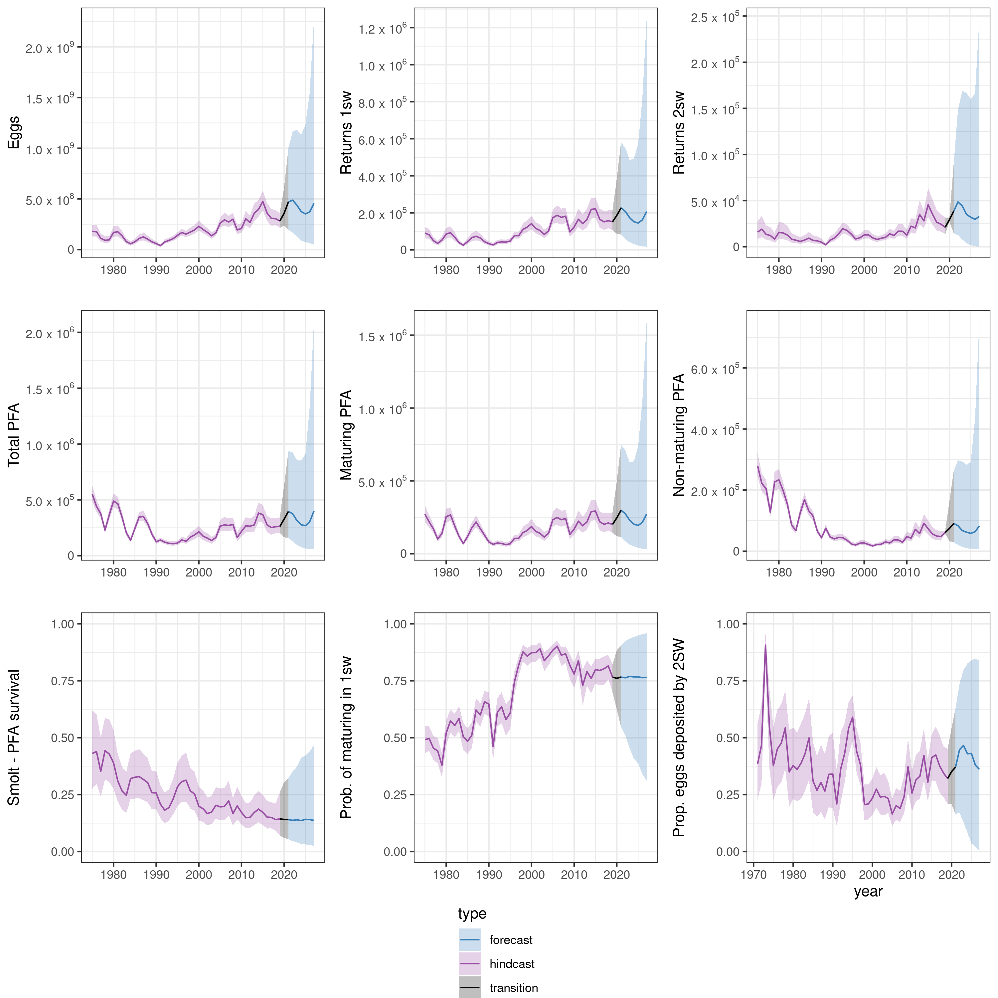

Newfoundland
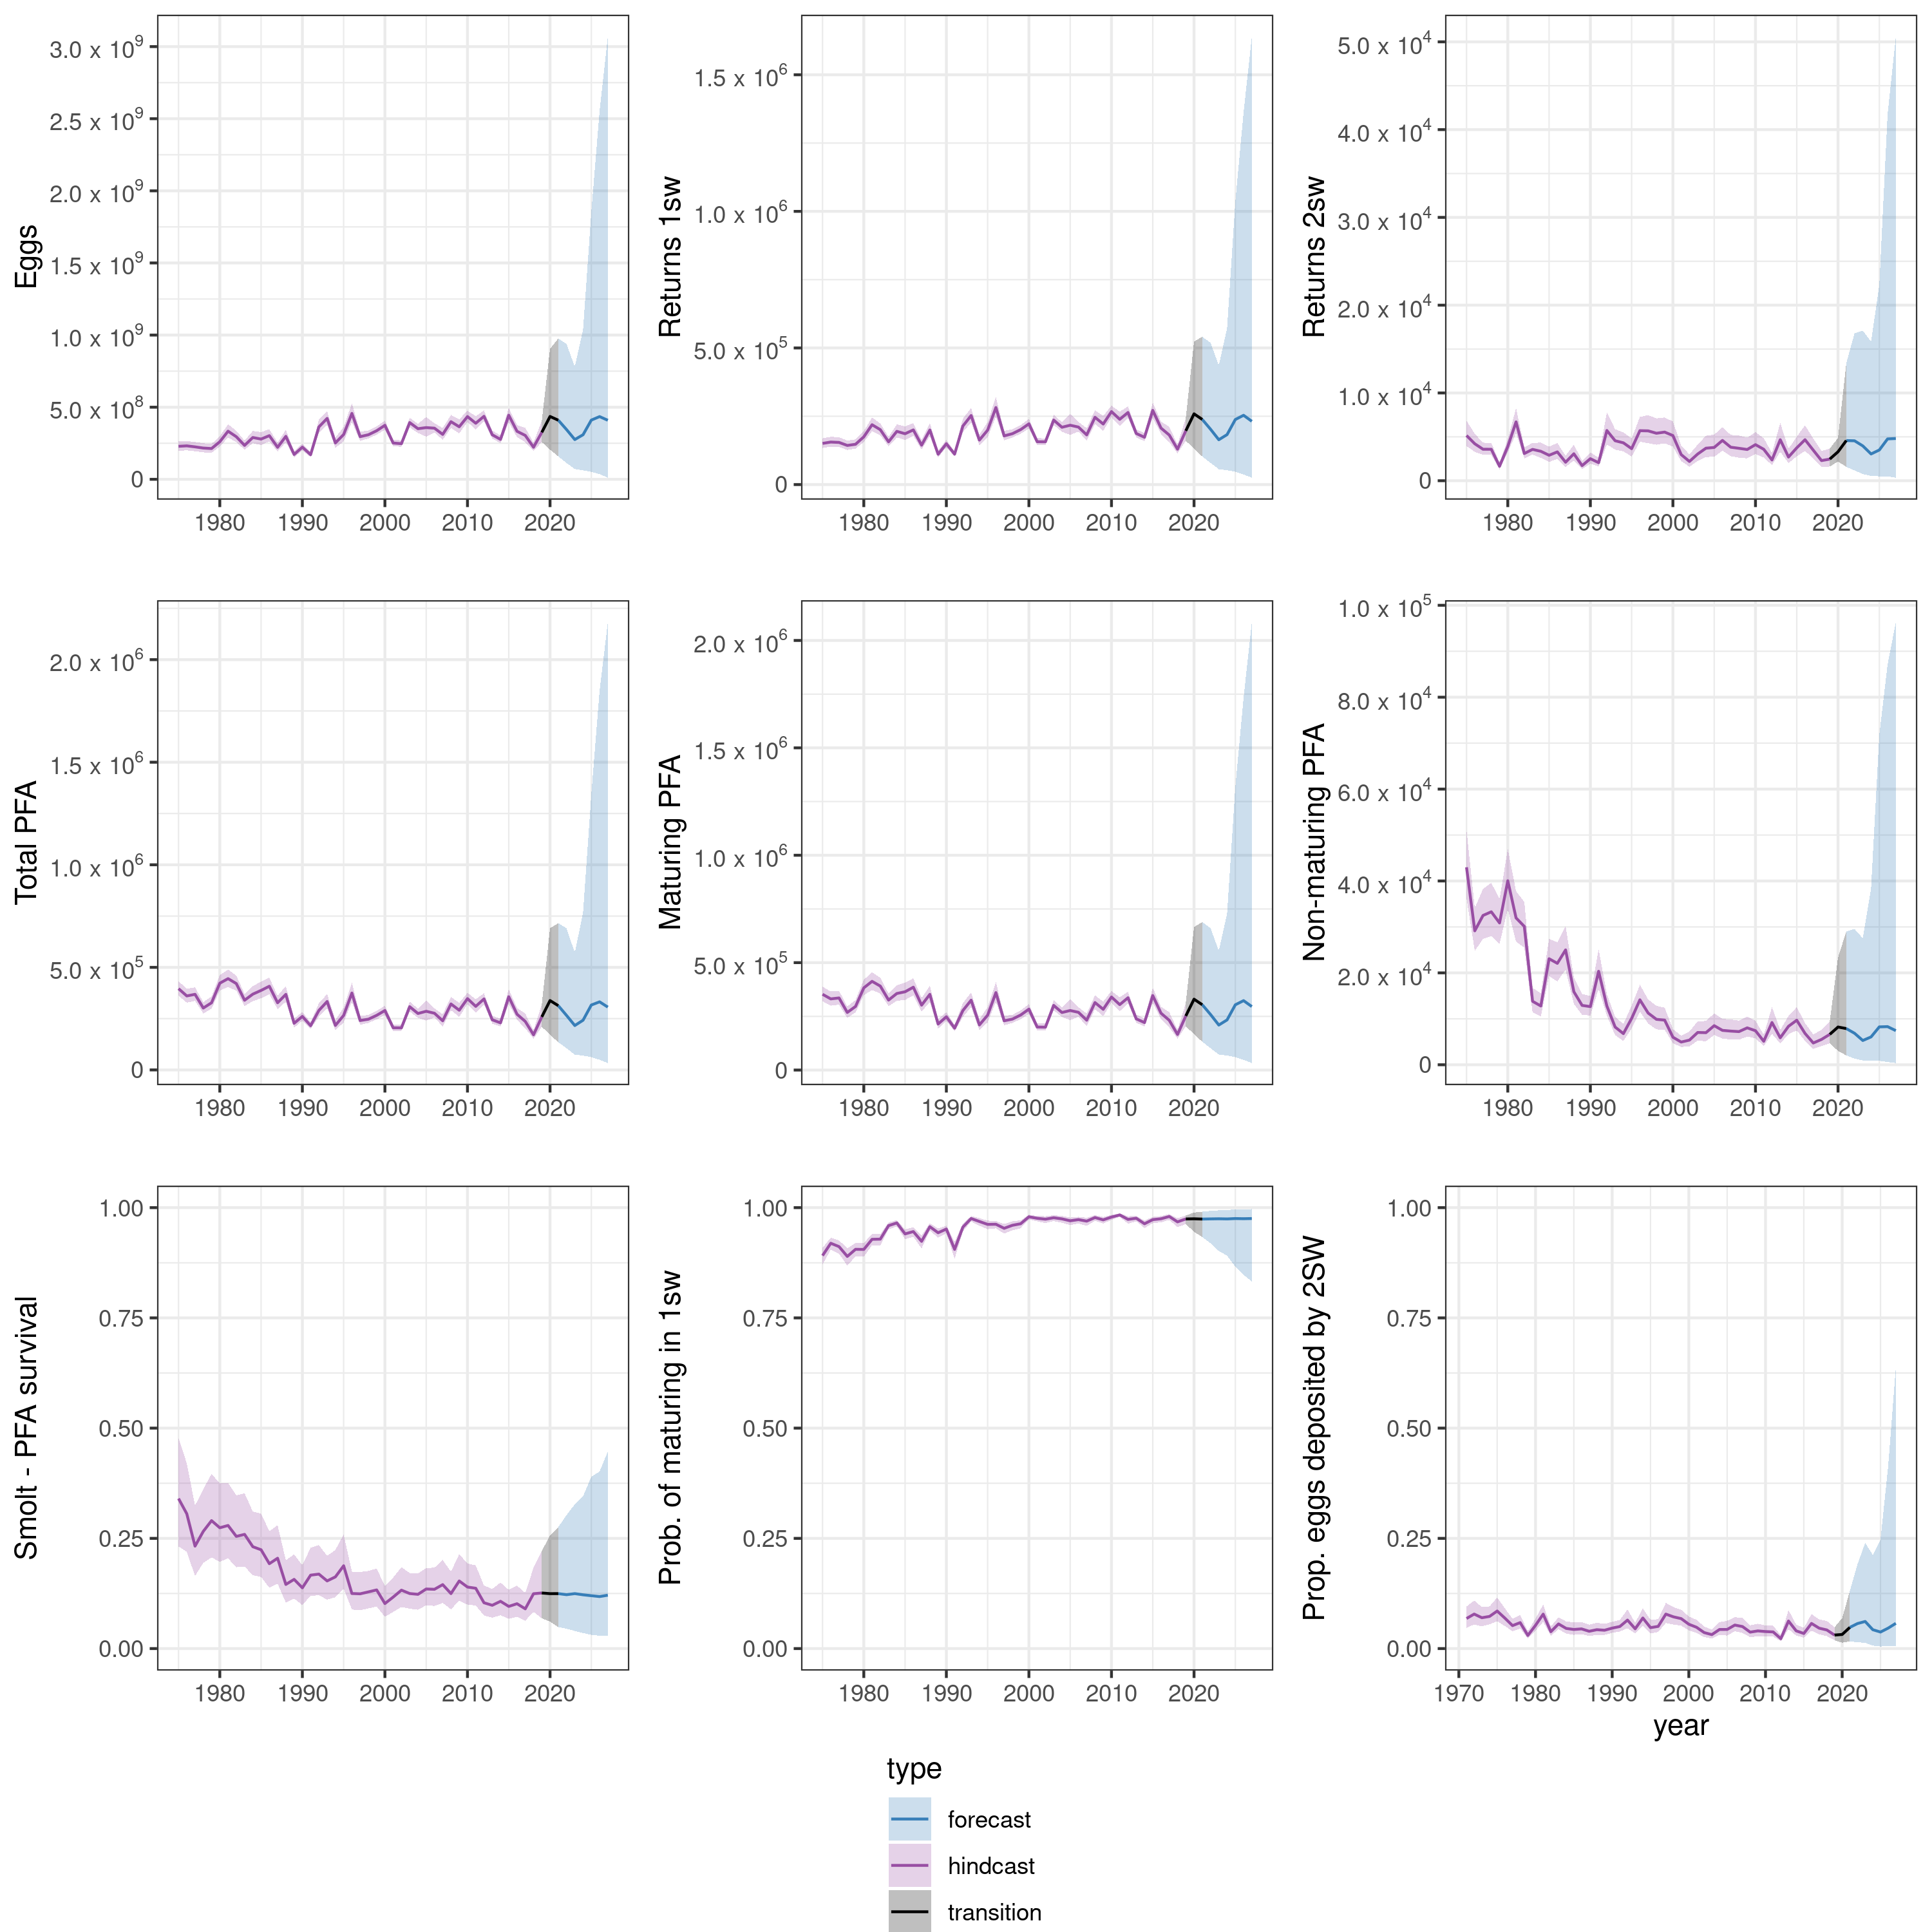

Quebec
