CREATE TABLE TREASURE_CHEST(

PRIMARY_KEY INTEGER NOT NULL,

TREASURE_NAME CHARACTER(20),

DESCRIPTION CHARACTER(100),

DROP_CHANCE DECIMAL(2, 1),

LUCK_STATUS CHARACTER(6)

);

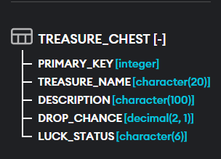

INSERT INTO TREASURE_CHEST (PRIMARY_KEY, TREASURE_NAME, DESCRIPTION, DROP_CHANCE, LUCK_STATUS)

VALUES

(1, 'PURE GOLD', 'IM', 20.5, 'LUCK'),

(2, 'SILVER BRACELET', 'TOO', 24.5, 'LUCK'),

(3, 'WORN SHOE', 'LAZY', 40, 'UNLUCK'),

(4, 'RUSSKAYA VOLUTA', 'FOR', NULL, 'LUCK'),

(5, 'VAMPIRE SWORD', 'THESE', 5, 'LUCK'),

(3, 'WORN PANTS', 'STUFF', 10, 'UNLUCK');

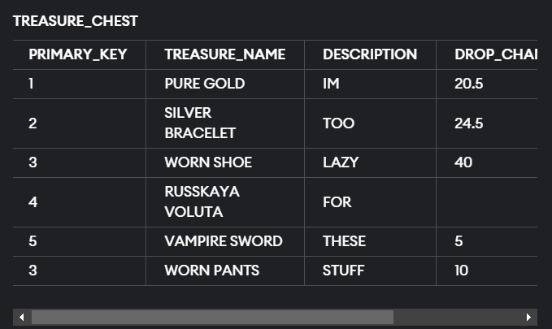

SELECT* FROM TREASURE_CHEST

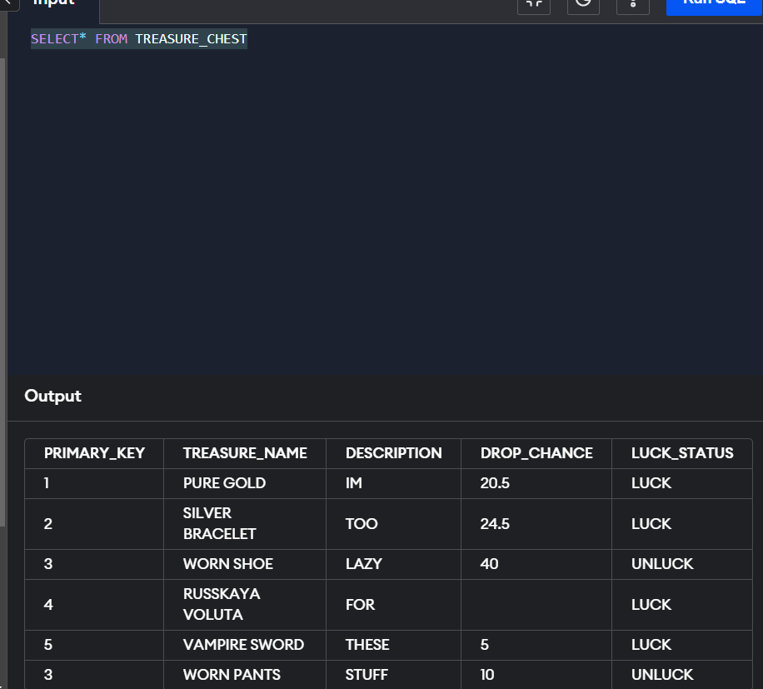

SELECT* FROM TREASURE_CHEST

WHERE DROP_CHANCE >= 20

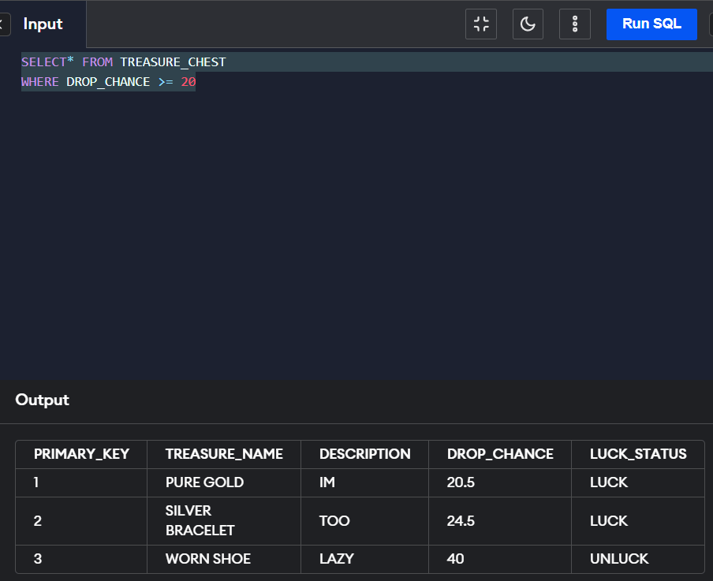

SELECT LUCK_STATUS FROM TREASURE_CHEST

WHERE DROP_CHANCE >= 20

AND TREASURE_NAME = 'PURE GOLD'

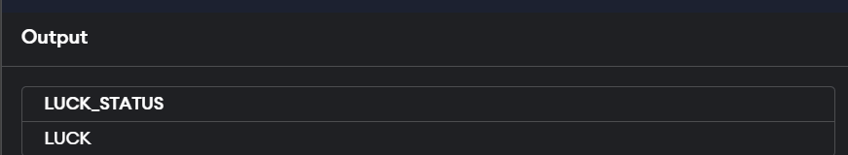

* СЛУЧАЙНО ЗАМЕТИЛ, ЧТО PRIMARY KEY ПОВТОРЯЕТСЯ

UPDATE TREASURE_CHEST

SET PRIMARY_KEY = 6

WHERE TREASURE_NAME = 'WORN PANTS'

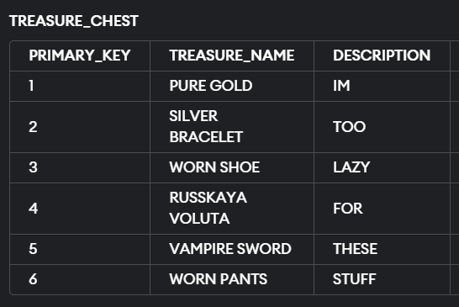

SELECT DESCRIPTION FROM TREASURE_CHEST

WHERE TREASURE_NAME IS NOT NULL

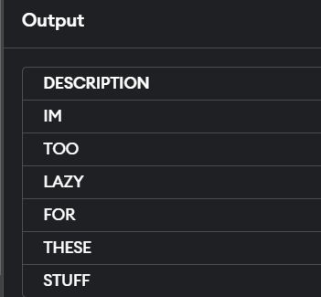

SELECT TREASURE_NAME FROM TREASURE_CHEST

WHERE DROP_CHANCE IS NULL

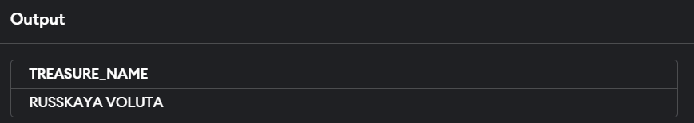

SELECT TREASURE_NAME, COUNT(PRIMARY_KEY) AS 'КОЛ-ВО' FROM TREASURE_CHEST AS T_C

WHERE DROP_CHANCE IS NULL

OR LUCK_STATUS = 'UNLUCK'

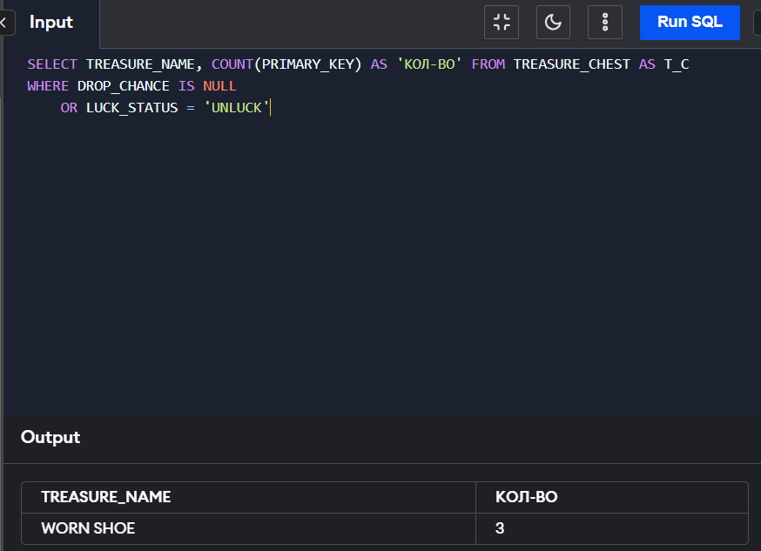

SELECT TREASURE_NAME, COALESCE(DROP_CHANCE, 'ETO BAZA') FROM TREASURE_CHEST

