|  |  |
| --- | --- |
| **IT303 SYSTEMS ANALYSIS AND DESIGN**    **STATIONERY PRODUCTS INVENTORY MANAGEMENT SYSTEM**    **Submitted by:**  Mark David S. Castillo  Ron Russel C. De Guzman  Rosemarie Z. Legaspi  John Martin M. Mendoza  Mark Russel S. Ramores  Jeremiah R. Reyes    **Submitted to:** Ms. Reliza R. Gatchalian  Instructor | **Bulacan State University**    **College of Information and**  **Communication**  **Technology**    **Bachelor of Science in**  **Information Technology** |

**Description of the Proposed System**

The objective of this study is to develop and implement a computerized inventory management system. This project eliminates the paperwork, human faults, manual delay and speed up process. It will have the ability to track the availability of the items, tell when it's time to restock and how much to purchase. Thus, this project will provide solutions for retailers that are still using traditional ways of keeping their inventory data like the Stationery Store in Melody Plains, Brgy. Muzon. This new system that will be developed will contain a database that enables data storage and retrieval of data about inventory of each item in the store, manage the products availability and stock control. This would generate a faster improvisation of work with less time and effort.

**Project Name: Stationery Products Inventory Management System**

**Date of Project Approval: December 17, 2022**

**Executive Summary**

The Stationery store’s vision is to maximize profit from customer satisfaction and loyalty towards the store by providing more personalized service for the customer. However, retail business is easy to lose its possible customer if it doesn’t have sufficient stocks in the store. Thus, in this paper, the developer had identified the problem related to inventory that exists in one of longest running stationery products retail store in Melody Plains, Brgy. Muzon.

The major problem of the store is they do not have a proper inventory control system for guiding and managing the sales and inventory level of the store. By proposing an Inventory Management System to the store as a replacement of old manual ways, the project aims in providing system with enhanced and more flexible functions to the store.

Besides, the development of the system will be based on Local Area Network. The expected result of the system is that the user interface will be user-friendly so that it can be handled easily by people with no IT background. The system is also expected to serve its functions and helps the Stationery Store in reducing time and paperwork in managing their inventory.

Inventory is one of the important departments that must be well managed in order to ensure daily business activity runs smoothly. However, the Stationery Store still does not realize the importance of inventory management as they are not equipped with a computerized system in running their business.

In fact, the Stationery Store is the oldest stationery products retail store in the area with thirteen years of operation. However, until now they have not used any computerized system to help them with sales and inventory control. That explains the need to have a systematic inventory control system. Increased proper management of inventory and efficiency are the main targets of the system, which will overcome the weakness of the current manual ways of doing business.

The security level of all data, documents and anything related to daily transactions and inventory is very low. A lot of documents have been kept for each product, which consumes a lot of time and is not effective for future references. In addition, due to poor inventory management, the Stationery Store also faces problems in identifying the quantity sold for each item per day and the available inventory level of the items.

As the available existing system provides limited functions to the user, this project will contain enhanced and more flexible functions for the store. The objectives are to provide a function to manage goods in the store more efficiently. Basic functions such as ‘view’, ‘add’, ‘delete’, and ‘update’ for data management will be made available. It will automatically generate daily reports on inventory activities, provide notifications on the goods’ low stock for restocking activity, provide inventory report for each day, and reduce time and cost to control and manage inventory.

As this would be the first computerized system that will be used by the store, the functions only focused on solving a major problem which is inventory management problem. The interfaces design is also categorized as user friendly which means the system can be handled by anyone without IT background.

Finally, the Stationery Store must shift its ways of operating business in order to stay competitive in the industry and against supermarket which is growing in Muzon area such as Melody Plains and Melody Heights.

**Reasons**

The main problem in their store is that they do not have any means of detecting which products are moving out of the store. Thus, they must check the inventory manually. This can cause losses for them as the possible customers cannot get the products they want and have a sale at the store. And due to the wide range of products being offered to the customers, they are having difficulties in handling their inventory. So, we have proposed developing an Inventory Management System that will provide a solution to their problem. Increased proper management of inventory and efficiency are the main targets of the system, which will overcome the weakness of the current manual ways of doing business.

**Expected benefits**

As the advantages of switching to a modern inventory control system clearly proven by many businesses, it is the time for Stationery Store to start implementing it in their store to see the differences will be brought to the store. Within the boundary of this project, the system aims in having the following aspects:   
  
**Employer**

• Inventory management increases profitability, when Inventory management is done right, costumer can place stock levels are kept at optimum levels, waste is minimized, and sales increase

• Inventory management improves cash flows, holding too much inventory stocks ties up cash that could be invested in other areas of the business

• It offers better inventory accuracy by using real-time inventory tracking that helps improve inventory management and ensures that you have optimal stocks available to fulfill orders

• Saves time and reduce costs

• Improves business planning

• Increased information transparency

**Staff**

• More productivity, a better inventory save time that could be spent on other activities

• It helps maintain the right amount of stocks

• Generates daily report to know the number of products in the inventory

• It Improves costumer service

• It improves efficiency and productivity

• It helps to maintain the right amount of stocks

**Expected downside**

The limitations of the proposed Inventory Management System include the following:

* High implementation costs
* Lack information regarding stolen, damaged or scrapped units
* Even with an efficient inventory management method, you can control but not eliminate business risk

**Timescale**

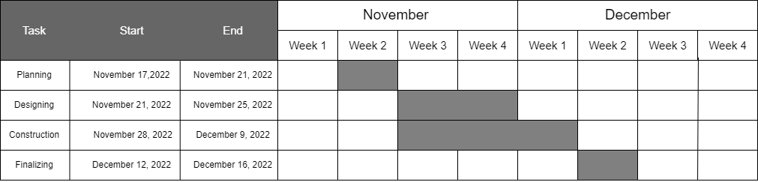

**Table 1. Timescale**

On November 17, 2022, the programmers started to plan the system. The programmers started to design and finished it on November 25, 2022. Then, on November 28, 2022, the programmers began building the system. The programmers focus on the user interface (UI) before moving on to the system's features. On December 9, 2022, the system completed with the functionalities and the database. On December 12 to December 15 2022, the programmers finalized the system.

**Cost and Benefits Analysis**

|  |  |  |  |  |  |
| --- | --- | --- | --- | --- | --- |
| **Category** | **Item** | **Duration**  **(month)** | **Qty** | **Cost**  **(₱)** | **Total**  **(₱)** |
| Hardware and Services | Desktop |  | 1 | 20,000 | 20,000 |
| Microsoft Windows  (OS) |  | 1 | 3,899 | 3,899 |
| Visual Studio |  | 1 | 2,514 | 2,514 |
| Microsoft Office |  | 1 | 9,299 | 9,299 |
| Networked Printer |  | 1 | 4,300 | 4,300 |
| Photoshop CS6 |  | 1 | 1,898 | 1,898 |
| Electricity | 1 |  | 1,000 | 1,000 |
| Maintenance | 6 |  | 5,000 | 5,000 |
|  |  |  |  |  |  |
| Development Cost | Junior Programmer | 1 | 3 | 15,000 | 45,000 |
| Utilities and Tools | 1 | 1 | 5,000 | 5,000 |
| Travel and Miscellaneous | 1 |  | 5,000 | 5,000 |
|  |  |  |  |  |  |
| Total: **₱102,910** | | | | | |

**Table 2. Gantt Chart**

This table summarizes all of the cost associated with developing an inventory management system which requires the following components: Desktop, Microsoft Windows, Visual Studio, Microsoft Office, Networked Printer, Photoshop CS6, electricity, maintenance, Junior Programmers, utilities and tools, and travel and miscellaneous.

**Major Risks**

* Product Loss

Inventory loss occurs in the form of the physical loss of a product or when errors occur during the receipt of goods. Goods can get lost through poor inventory control or mishandling by employees therefore online inventory control systems and automated inventory control can help to identify the cause of each loss to prevent future losses and reduce costs to the company.

* Malicious Hacks

Hackers look for any way to get company or consumer information. An inventory system connected to point-of-sale devices and accounting is a valuable resource to hack into in search of potential financial information or personal details of owners, vendors or clients. Updating firewalls and anti-virus software can mitigate this potential issue.

**Recommendations**

The following recommendations for future research were developed as a result of this project.

• Improving Data Visibility, Reporting tools give employers valuable insight into how daily process function and how to plan for the future

• Continually improving data availability and quality

• Improving the process of Inventory tracking

• Improving the Inventory Database security

**Presentation of the Proposed System**

**User Interface**

**Sample Reports**

**Database Design**

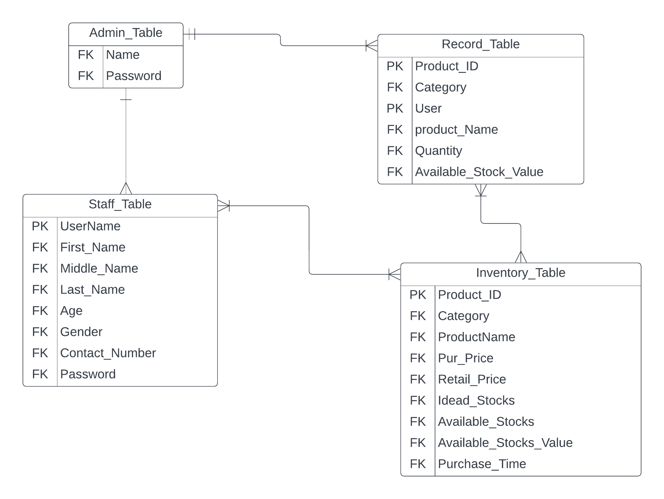

**Figure 1. Entity Relationship Diagram**

**The admin can access everything, while the staff has a limited access to the table. Admin can access the Inventory table and the record table. While the staff can access the inventory.**

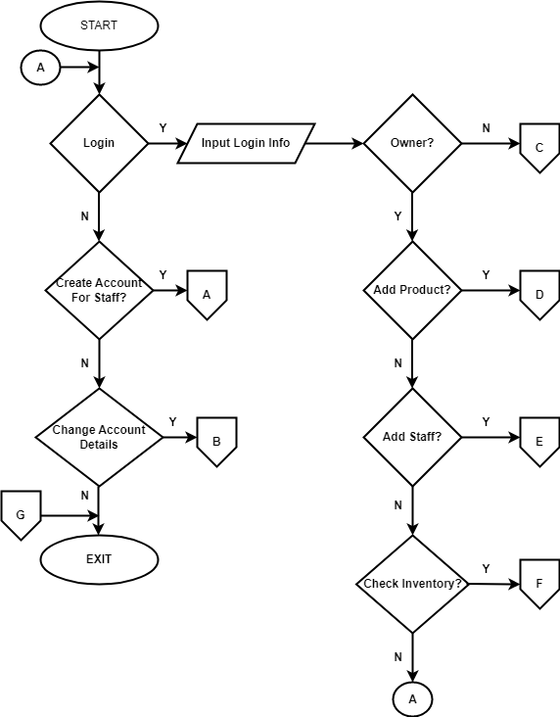**Figure**