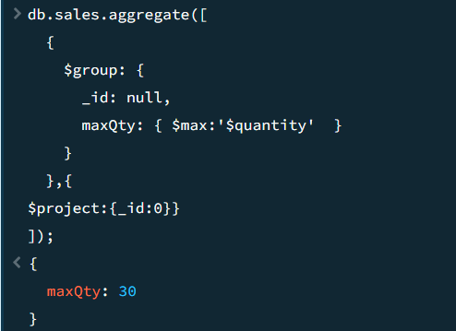

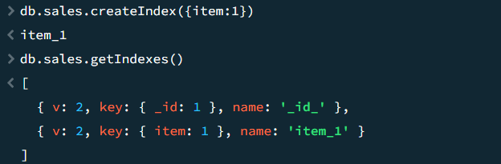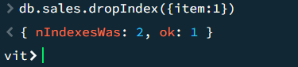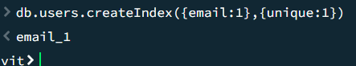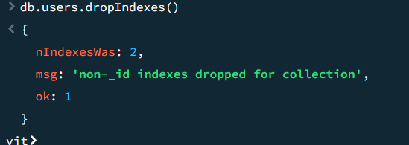

**package** connection;

**import** com.mongodb.MongoClient;

**import** com.mongodb.MongoCredential;

**import** com.mongodb.client.MongoDatabase;

**public** **class** MongoDB {

**public** **static** **void** main(String[] args) {

**try** {

MongoClient db= **new** MongoClient("localhost", 27017);

MongoCredential credential;

credential = MongoCredential.*createCredential*("GFGUser", "mongoDb","password".toCharArray());

System.***out***.println( "Successfully Connected"+ " to the database");

MongoDatabase database= db.getDatabase("mongoDb");

System.***out***.println("Credentials are: "+ credential);

}

**catch**(Exception e){

System.***out***.println("Connection establishment failed");

System.***out***.println(e);

}

}

}