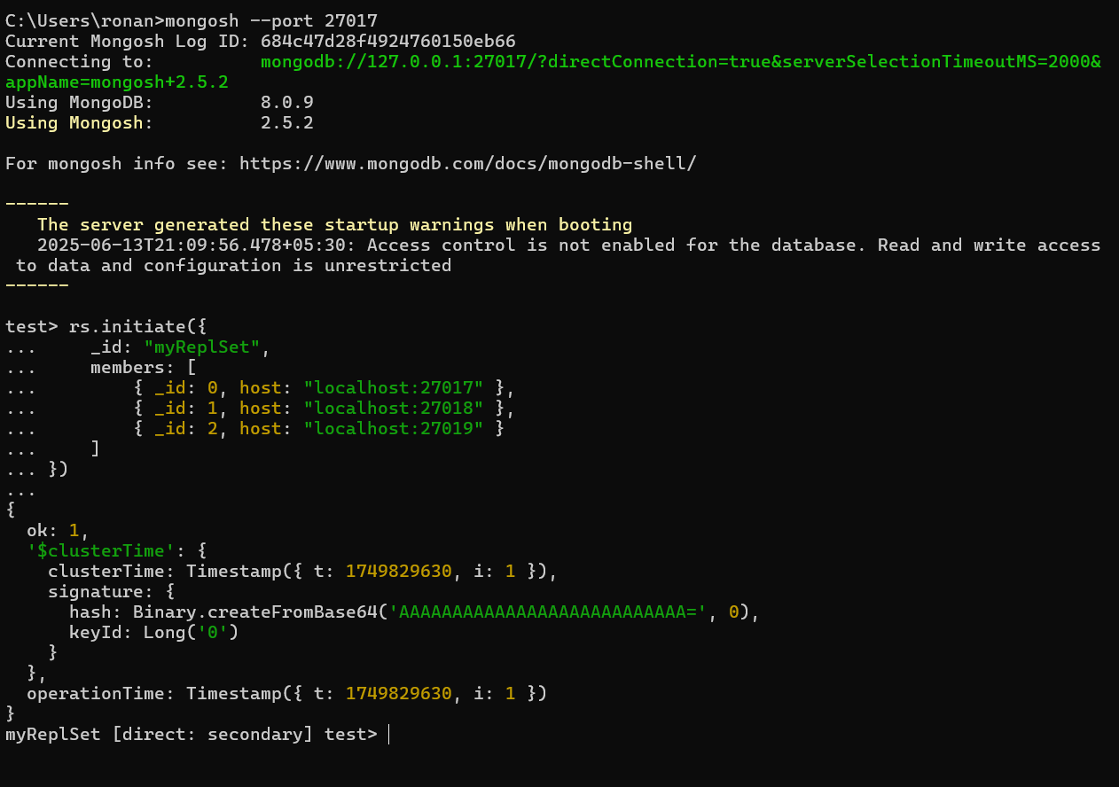

Primary Node

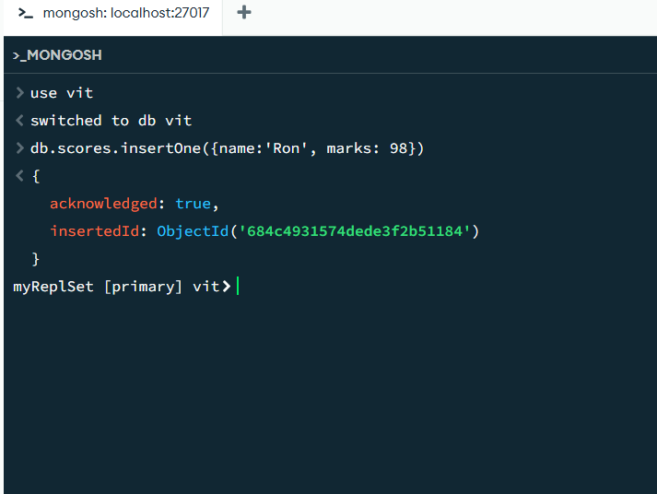

Secondary Node 1

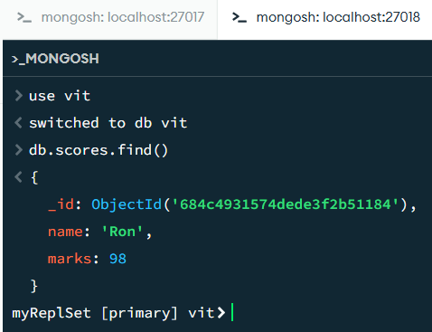

Secondary Node 2

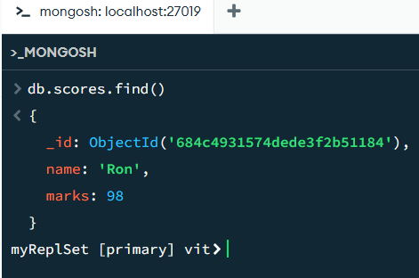

**Code:**

Mkdir data

Mkdir db0

Mkdir db1

Mkdir db2

mongod --replSet myReplSet --dbpath data\db0 --port 27017

mongod --replSet myReplSet --dbpath data\db1 --port 27018

mongod --replSet myReplSet --dbpath data\db2 --port 27019

rs.initiate({

_id: "myReplSet",

members: [

{ _id: 0, host: "localhost:27017" },

{ _id: 1, host: "localhost:27018" },

{ _id: 2, host: "localhost:27019" }

]

})