

Capstone Project — Phase B
The Climate Capacitor
Modelling Extreme-Weather Disasters as Electrical Breakdown
Team code: | 26-1-R-14
Track: | Research
Students: | Ron Salama (207475146)
 | Lior Dagash (313855404)
Supervisor: | Dr. Zakharia Frenkel

Project repository (code, Phase A & B books, poster, video):
https://github.com/Ron-Salama/Climate-Modeling-Research-Project

Table of Contents
Table of Contents 2
1. Problem Review and Background 4
1.1 The Problem 4
1.2 The Proposed Idea — the Capacitor Analogy 4
1.3 Literature Background 4
1.4 Research Question and Objectives 5
2. Description of the Project — What We Built and Achieved 5
2.1 General Description 5
2.2 The Solution — Method and Algorithms 6
2.2.1 Temperature anomaly 6
2.2.2 Thermal charge accumulation 6
2.2.3 Terrain permittivity (ε) 6
2.2.4 Breakdown field 6
2.2.5 Flagging, clustering and characterisation 6
2.2.6 Validation 7
2.3 The Solution — System Architecture 7
2.4 The Solution — Operation (Activity Flow) 7
2.5 The Research and Development Process 8
2.6 Tools, Technologies and Supervisor Interaction 9
2.7 Challenges and Solutions 9
2.7.1 Engineering / technical challenges 9
2.7.2 Analytical challenges 10
2.8 Results and Conclusions 10
2.9 Did We Meet the Project Metrics? 12
2.10 Lessons Learned 13
2.11 AI Tools and Assistance 13
Appendix A — User Guide 14
A.1 What the program does 14
A.2 Running the program 14
A.3 Reading the results 14
A.4 Changing settings and running experiments 15
A.5 Built-in help 15
Appendix B — Maintenance Guide 16
B.1 Operating environment 16
B.2 Installation 16
B.3 Project structure (where to make changes) 16
B.4 Extending the system 17
B.5 Running and verifying after changes 17

1. Problem Review and Background

1.1 The Problem
Extreme-weather disasters — heatwaves, floods and storms — cause the most damage, and they are hard to see coming. They usually build up gradually: heat or cold collects in a region over days and weeks until conditions tip over into a disaster. The hard part is knowing where and when that tipping point will be reached.
There are two main ways to forecast this today, and each has a drawback. Detailed physics simulations — the models behind the daily weather forecast — are accurate but very heavy to run, so they are impractical for scanning the whole planet over long periods. Machine-learning models are lighter, but they work as “black boxes” that give an answer without explaining why. What is missing is a simpler, in-between method: one that can scan the globe over months, point to the regions where instability is building up, and do it in a way a person can actually follow. This project asks whether a physics analogy — treating the Earth like a capacitor — can be that method.

1.2 The Proposed Idea — the Capacitor Analogy
This project investigates an unconventional, exploratory idea: modelling the Earth's surface as a giant electrical capacitor. The surface is divided into a grid of cells, and each electrical quantity is mapped to a climate quantity, as summarised below.
Electrical quantity | Climate quantity | Computation in the model
Charge Q | Accumulated thermal anomaly | Sliding-window sum of (temperature − climatology), with decay
Permittivity ε | Terrain's resistance to discharge | f(elevation, slope); smooth/flat → high ε, rugged → low ε
Breakdown field E | Atmospheric “stress” | E = ‖∇Q‖ / ε, per cell per day
Breakdown event | Predicted extreme-weather disaster | Cells where E exceeds a critical threshold, then clustered
Table 1 — The core analogy: mapping electrostatics onto thermal–topographic data.
We are not claiming the Earth is literally an electrical circuit — the idea is that the mathematics might be similar enough to be useful. The important detail is what makes the model “fire”. It does not use raw temperature; it uses the temperature anomaly — how far a day is from normal for that place and time of year — and it keeps track of whether the day is hotter (+) or colder (−) than normal. Because the formula is built on the gradient (the ∇ symbol, meaning the change from one place to the next), the model reacts most strongly not to heat on its own, but to a sharp clash: a very hot area sitting right next to a very cold one. That clash — like the gap between the two plates of a capacitor — is where a “breakdown” is predicted.

1.3 Literature Background
The framework unifies three well-established findings from the literature:
- Thermal clustering — temperature anomalies cluster spatially and persist through positive feedbacks, so energy concentrates rather than dissipating uniformly (Perkins-Kirkpatrick & Lewis, 2020; IPCC, 2021).
- Topographic control — terrain strongly modulates extreme events through atmospheric blocking, orographic convection and thermal trapping (Woollings et al., 2018; Lin et al., 2001), motivating terrain as a variable “permittivity”.
- Instability thresholds — atmospheric catastrophes involve threshold-crossing behaviour — small increases in surface heating can trigger large jumps in instability (Brooks, 2013) — echoing dielectric breakdown.
Borrowing physics from one field to describe another is not new in Earth science: the Global Atmospheric Electric Circuit describes the Earth–atmosphere system with circuit theory (Rycroft et al., 2000), and “sandpile” models describe how earthquakes release energy (Bak et al., 1987). Our capacitor analogy is the same kind of idea — reusing the maths of electricity to describe heat.

1.4 Research Question and Objectives
The core research question is: does the capacitor analogy reveal a real link between where sharp hot–cold clashes build up over the terrain and where real disasters actually happen?
It is worth stressing that this is about the clash between hot and cold sitting side by side, not about heat on its own. The work is exploratory: the analogy had never been tested, so we did not know in advance whether it would work, and the project brief treats a clear negative result — one that maps out the limits of the idea — as just as valuable as a positive one. Our objectives were: (1) build a working implementation of the capacitor idea; (2) produce “breakdown” maps that flag the high-risk regions; (3) test those maps statistically against an independent disaster database; and (4) work out which parts of the climate (if any) the analogy captures, and why.

2. Description of the Project — What We Built and Achieved

2.1 General Description
We built a complete, working and tested system that carries the capacitor idea from raw data all the way to a scored result, using ten years of real data. It is written in Python as a chain of small stages: it takes in global temperature and terrain, works out the thermal “charge”, the terrain “permittivity” and the “breakdown field”, groups the high-stress cells into separate predicted events, and then scores those predictions against a database of real disasters — producing maps, a list of predicted events, and the summary numbers.
What kind of system it is. It is an offline analysis tool, not a live forecasting service. Its job is to test the idea and measure how closely it matches reality, so what it produces is evidence — numbers, maps and diagnostics — rather than live alerts.
Who it is for. Right now the system is a research tool, and its immediate users are us and our supervisor, checking whether the approach is worth pursuing. But the point of building it is practical: if the capacitor idea worked well, a tool like this could be run continuously to flag at-risk regions ahead of time — the kind of early signal that weather analysts, forecasters and disaster-response teams rely on. Those forecasters and analysts are the intended end users if the method proves itself.

2.2 The Solution — Method and Algorithms
The method is a straight chain of steps, each one a small, testable piece that works on the whole global grid at once for speed:

2.2.1 Temperature anomaly
For every cell and every day we subtract that cell's day-of-year climatology (the average of that calendar day across the ten years, smoothed ±15 days). This removes the fixed seasonal and geographic pattern, leaving only the unusual departure — the quantity that should behave like charge. The anomaly is kept signed so hot and cold both contribute.

2.2.2 Thermal charge accumulation
The charge Q is a decayed 30-day running total of the anomaly: recent days count more, and the influence of older days fades away. This is the “capacitor charging” step. It is done in a single fast pass over the whole map at once, rather than a slow cell-by-cell loop.

2.2.3 Terrain permittivity (ε)
Terrain is turned into a per-cell “permittivity” value ε using one of a small set of interchangeable formulas (straight-line, logarithmic, slope-based, or a combination). Smooth, flat areas get a high ε (energy escapes easily); rugged, mountainous areas get a low ε (energy is trapped). The formula in use can be switched easily, so we were able to test each one.
We did not simply pick a value for ε. We ran the whole analysis many times, each with a different terrain setting — different formulas, and different minimum-ε values from 0.2 up to 0.7 — and scored every version against the real disasters. Mid-range settings (around 0.4–0.6) worked best, so we used a straight-line mapping with a floor of 0.5. One result stood out: a control run with the terrain effect switched off completely scored almost the same, which told us the terrain was adding very little — a useful finding in its own right.

2.2.4 Breakdown field
The breakdown field is E = ‖∇Q‖ / ε — the spatial gradient of accumulated charge, divided by the terrain permittivity. The gradient is computed in kilometres (with a cos-latitude correction for the converging meridians) rather than in degrees, which is essential for a physically meaningful result. E is largest where a strong hot region abuts a strong cold region over rugged terrain.

2.2.5 Flagging, clustering and characterisation
Each day we flag the most-stressed cells — specifically the top 2.5% (the 97.5th percentile of that day's breakdown field). We use a percentage rather than a fixed cut-off so the same small slice of the map is flagged every day, whatever the season or units. We chose 2.5% as a balance: strict enough to pick out genuine hot-spots from the background, but loose enough to leave enough predictions to score. (We also tried stricter and looser cut-offs; they shifted the numbers but not the overall conclusion.) The poles, which have no disasters and produced numerical noise, are left out.
The flagged cells are then grouped into blobs each day and linked day-to-day into multi-day “events”. Each event is described by where and when it started, whether it was driven by heat or by terrain, and how its charge built up beforehand.

2.2.6 Validation
Each predicted event is matched to real disasters within a spatial radius and a temporal window. We report recall (fraction of disasters caught), precision (fraction of predictions that hit), and a binomial p-value against a uniform space-time null. Predictions and disasters are confined to the same latitude band for a fair comparison.

2.3 The Solution — System Architecture
The software is built as a stack of layers, shown in Figure 1. Outside data sources feed a data layer; a thin control layer runs the stages in order; the science happens in the physics and analysis layers; and a visualisation layer draws the maps. Each stage is a small, self-contained piece with a single job, and none of the settings are baked into the code — they all live in one central settings file. This keeps the system easy to follow, easy to change, and easy to trace: any result can be followed back to the exact inputs and settings that produced it.
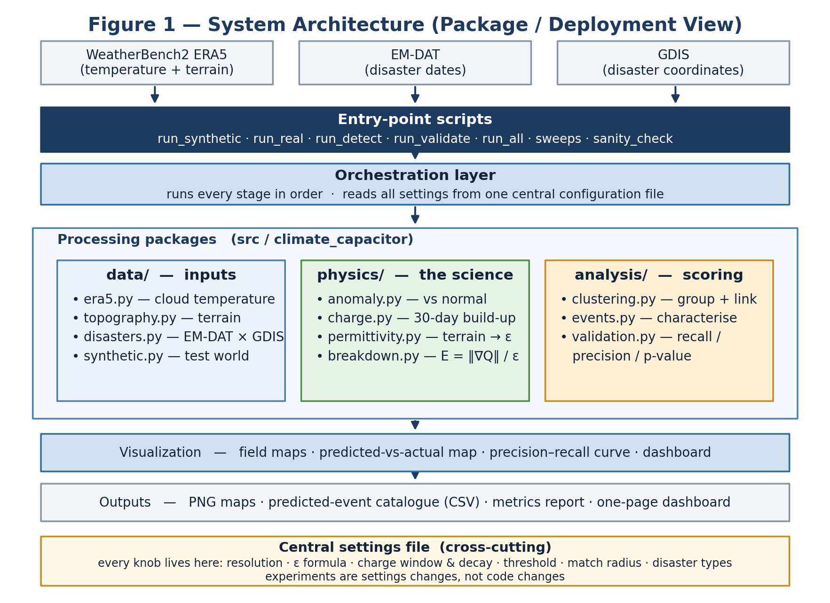
Figure 1 — System architecture (package / deployment view).

2.4 The Solution — Operation (Activity Flow)
A single run carries out the activity below. Each box is one stage, and the data it produces is the input to the next. All of the run options follow this same flow; they differ only in which outputs they report.
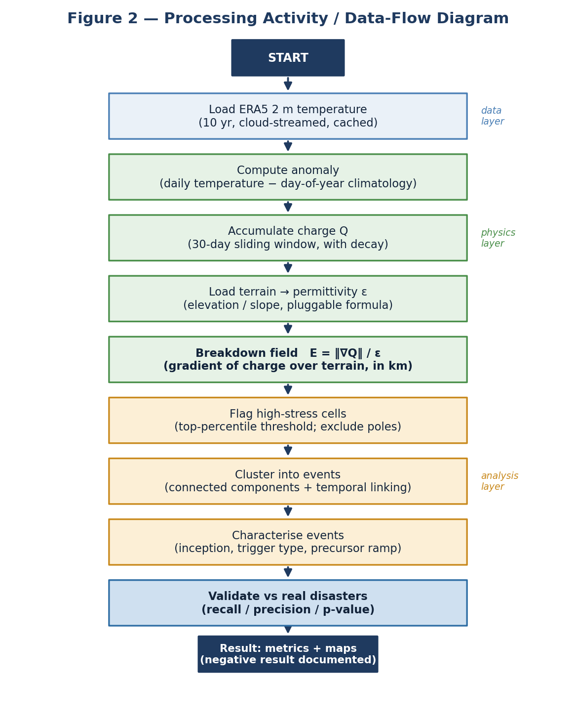
Figure 2 — Processing activity / data-flow diagram of a single run.

2.5 The Research and Development Process
We worked in incremental phases, keeping a working system at every step (an “architect-first, no throwaway” approach): the physics modules were built and unit-tested on a synthetic world with a planted heatwave before any real data was introduced, so the real data could later slot into identical interfaces.
- Phase 0–1 (physics core) — built the scaffold, the configuration system and the pluggable permittivity registry.
- Phase 1 (synthetic proof) — implemented the physics on synthetic data and verified that a known planted heatwave stands out far above the background in the charge and breakdown maps.
- Phase 2 (real data) — connected the real data — cloud-streamed ERA5 temperature, terrain from the same store, and the EM-DAT × GDIS disaster set — and confirmed a sanity check (the 2010 Russian heatwave appears clearly in the real anomaly map).
- Phase 3 (detection) — added connected-component clustering and temporal linking to turn flagged cells into an event catalogue.
- Phase 4–5 (validation & analysis) — built the validation and scoring, ran the parameter sweeps, diagnosed the results and documented the verdict.

2.6 Tools, Technologies and Supervisor Interaction
The system is written in Python 3 using the scientific stack. The main components are:
Tool / technology | Role in the project
Python 3 + NumPy / SciPy | Core engine; vectorised physics and the recursive charge filter
xarray + zarr + gcsfs + dask | Lazy, parallel, cloud-streamed access to the ERA5 data cube
WeatherBench2 ERA5 (public Zarr) | 10 years of global 2 m temperature and terrain fields
EM-DAT + GDIS | Disaster “truth” set — dates (EM-DAT) joined to precise coordinates (GDIS)
scipy.ndimage / pandas | Connected-component clustering; tabular disaster handling and metrics
Matplotlib | Field maps, the predicted-vs-actual map and the precision–recall curve
Git / GitHub | Version control and the submission repository
Table 2 — Tools and technologies used in the as-built system.
Supervisor interaction. Our client for this research was our supervisor, Dr. Zakharia Frenkel. We consulted him on the scientific framing — in particular the decision to build charge from anomalies rather than raw temperature, the choice to treat a clear negative result as a valid outcome, and the interpretation of the final metrics. His guidance shaped the emphasis on honest, well-diagnosed results over a forced positive.

2.7 Challenges and Solutions
The project presented both engineering and analytical challenges. The most significant are below, each with the solution we adopted.

2.7.1 Engineering / technical challenges
- Data volume and acquisition. — our original plan was to download native ~30 km ERA5 through the Copernicus service — terabytes of data that overflow a laptop's memory and are slow and fragile to fetch. We switched to WeatherBench2, a public analysis-ready ERA5 store on Google Cloud, and stream only the slice we need with xarray + dask, caching it locally. First run pulls ~1 GB; later runs are offline.
- Runtime and memory. — Even the streamed cube is large. Loading many small cloud chunks was slow until we enabled a multi-threaded dask scheduler, which cut a fetch from minutes to seconds. Finer grids still peaked memory, so we cast the whole physics chain to float32 and used in-place operations, roughly halving peak RAM and fixing repeated MemoryErrors at the 1.0° and 0.703° grids.
- Harmonising heterogeneous data. — The disaster records (EM-DAT, GDIS) use different formats, coordinate conventions and identifiers from the gridded climate data. We built a join that links GDIS precise coordinates to EM-DAT dates by disaster number, with a country-centroid fallback flagged as “estimated” so that events without precise coordinates remain usable.

2.7.2 Analytical challenges
- A polar artefact masking the signal. — early results showed almost no skill. Diagnosis revealed the spatial gradient was being computed in degrees, which distorts badly near the poles where meridians converge, producing spurious high-stress bands. Recomputing the gradient in kilometres and excluding the poles roughly tripled the apparent skill and was a prerequisite for trusting any number.
- A match tolerance finer than the grid. — the original 100 km / ±48 h match was smaller than a single grid cell at our resolution, making a “hit” almost impossible by construction. We evaluated at grid-appropriate radii (250 km and 500 km) and reported the scale-dependence explicitly.
- The core mismatch: gradient vs. uniform extremes. — the gradient formulation flags contrasts (edges), but many real disasters — heatwaves especially — sit at the centre of a large, near-uniform hot region where the gradient is low. We confirmed this on the 2010 Russian heatwave (very high charge, but the breakdown field stayed below threshold) and added an alternative charge-level field as a documented option. This tension is our central scientific finding.

2.8 Results and Conclusions
As a reality check, the real-data anomaly map reproduces known events — for example the 2010 Russian heatwave appears as a large positive anomaly over western Russia (Figure 3) — confirming the pipeline is physically sound before we judge its predictive skill.
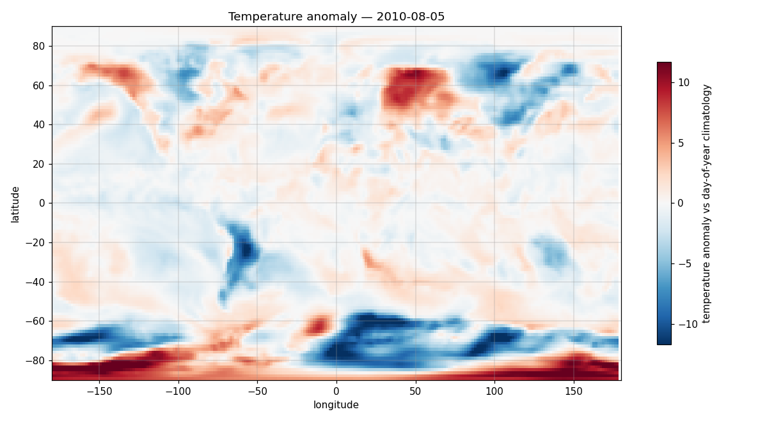
Figure 3 — Real-data temperature anomaly map; large red region over western Russia is the 2010 heatwave (a sanity check that the pipeline is correct).
The decisive result is the comparison between predicted breakdown zones and real disasters over 2010–2019 (Figure 4). The predicted zones (red) concentrate along high-latitude and terrain edges, whereas real disasters (blue) concentrate in populated lowlands and the tropics: at the scale that matters, the two largely do not coincide.
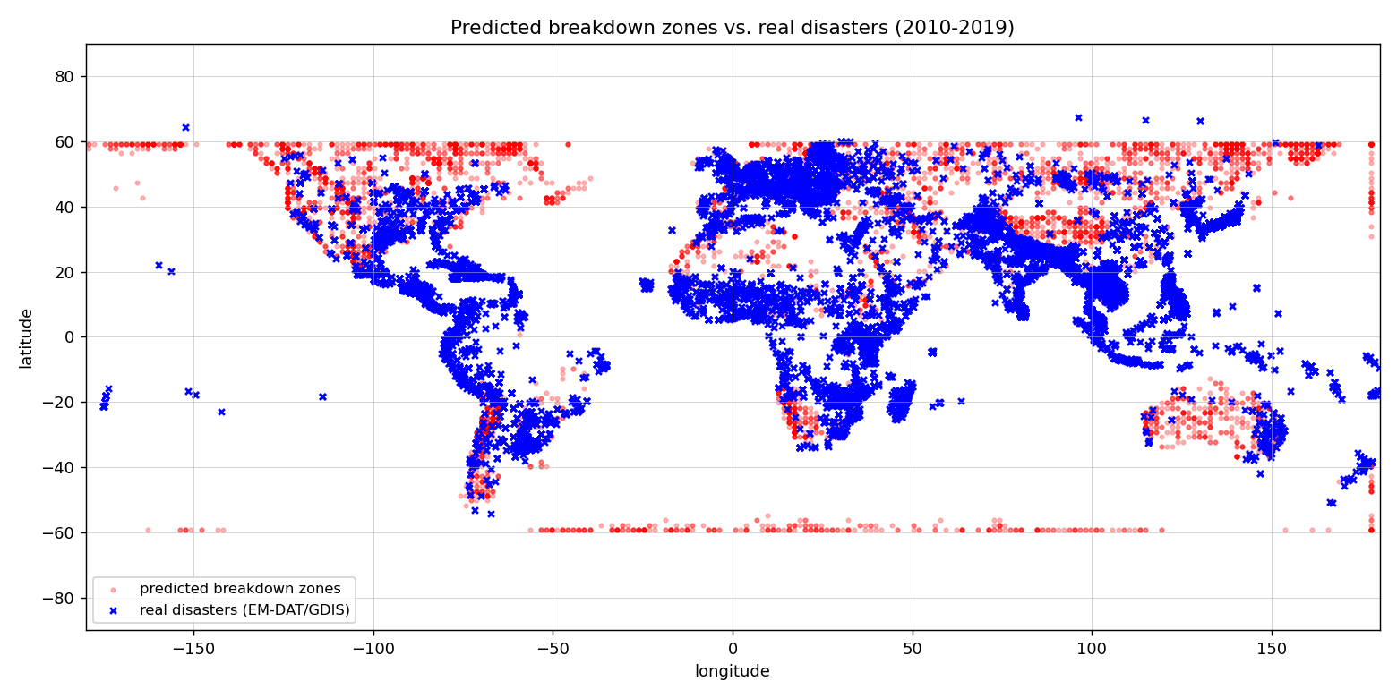
Figure 4 — Predicted breakdown zones (red) vs. real disasters (blue), poles excluded. The limited overlap is the negative result in a single picture.
Quantitatively, the strongest configuration (finest grid, temperature-type disasters, poles excluded) reaches about 20% recall at a regional 500 km scale, and the signal strengthens with resolution — a real, physically-consistent thermal signal. But precision remains around 1–2%, and recall at a pinpoint 250 km scale is only a few percent. The final numbers are summarised in Table 3.
Disaster type | Recall @ 250 km | Recall @ 500 km | Precision @ 250 km
Temperature | 4.5% | 20.3% | 0.15%
Thermal | 4.8% | 18.5% | 0.29%
Full (all types) | 4.8% | 15.4% | 1.6%
Table 3 — Final results at the finest grid tested (0.703°), poles excluded. Targets: recall > 30%, precision > 10%, p < 0.05.
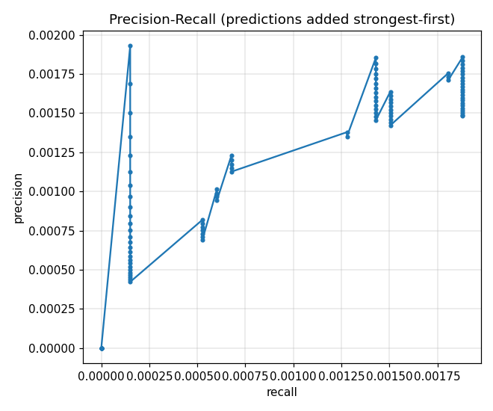
Figure 5 — Precision–recall trade-off as more predictions are included.
Conclusion. The Climate Capacitor analogy captures a real but weak thermal signal — strongest for temperature-driven disasters and improving with resolution — but it is too imprecise to serve as a predictor of individual events. It identifies broad regions of thermal stress, not the specific location or timing of a disaster. This is a clear, valid negative result, and it is diagnosed rather than merely reported: we can explain why (a gradient-based field targets contrasts, while extremes are broad and near-uniform), which is exactly the kind of insight the project brief counts as a genuine scientific contribution.

2.9 Did We Meet the Project Metrics?
At the start of the project we set three quantitative success targets. We report against them honestly below.
Metric (target we set) | Target | Best achieved | Met?
Recall — regional (500 km) | > 30% | ~20% (temperature) | No (approached)
Precision | > 10% | ~1.6% (full) | No
Statistical significance | p < 0.05 | Yes | Yes — but sample-size driven
Pinpoint early-warning (100 km / ±48 h) | clear skill | ≈ 0 | No
Table 4 — Performance against the success targets we set at the start of the project.
We did not meet the headline recall and precision targets. We judge this an honest and informative outcome rather than a failure of the project: the metrics were deliberately demanding, the framework was explicitly exploratory, and the shortfall is fully explained by the diagnosed gradient-vs-extreme mismatch. The statistically-significant p-values are real but are driven by the large number of grid cells and events, so we treat recall and precision — not p — as the metrics that reflect practical usefulness.

2.10 Lessons Learned
- What worked. — Building the physics on a synthetic world with a known answer before touching real data was the single best decision — it let us trust the pipeline and isolate scientific questions from bugs.
- What worked. — Making everything configuration-driven turned each experiment (resolution, ε formula, match radius, disaster type) into a one-line change, which made the sweeps fast and reproducible.
- What we would change. — We would evaluate at grid-appropriate scales and exclude the poles from the very first run — the early “no skill” result was partly an artefact that cost time to unwind.
- What we would change. — We would treat the gradient-vs-uniform-extreme issue as a first-class hypothesis earlier, and test a charge-level field alongside the gradient field from the start rather than as a late addition.
Overall we believe we worked in the right way: incrementally, with tests, honest diagnostics, and a clear separation between the scientific question and the engineering. Directions for future work follow directly from the diagnosis — a charge-level or blended breakdown field to capture uniform heatwaves, combining the permanent climatic gradients with the anomalous ones, and adding physical variables such as moisture and atmospheric flow.

2.11 AI Tools and Assistance
As we disclosed at the earlier stage of the project, generative-AI tools were used during the work as assistants — for example to check the work against the submission guidelines, to help with documentation wording and formatting, and to sanity-check explanations. All scientific decisions, the implementation, the experiments and the interpretation of results are our own.

Appendix A — User Guide
This guide describes the normal, successful operation of the system for a user who wants to run the analysis and read the results. Installation and environment setup are covered in Appendix B.

A.1 What the program does
The program tests whether natural disasters can be predicted by treating the Earth like a capacitor. It builds “risk maps” from ten years of real climate data and checks them against a database of real disasters, reporting how many it caught (recall) and how many of its alarms were correct (precision).

A.2 Running the program
Open a terminal (or the Spyder IDE) in the project folder and run one of the entry-point scripts:
Command | What you get
python scripts/run_synthetic.py | A quick demo on made-up data (no download) — five maps in outputs/phase1/
python scripts/run_all.py | The full run on real data — a one-page dashboard in outputs/report/
python scripts/run_detect.py | The catalogue of predicted events (a CSV spreadsheet)
python tests/test_physics.py | A quick check that the physics calculations are correct
Table A.1 — The main scripts a user runs.
The first real run downloads about 1 GB of climate data (a few minutes) and caches it; later runs are offline and fast. In Spyder, open the script and press F5 — the maps appear in the Plots panel.

A.3 Reading the results
Two numbers summarise each run. Recall is the fraction of real disasters the model caught; precision is the fraction of the model's alarms that were correct — higher is better for both. The maps use red for hotter-than-normal and blue for colder-than-normal; the final breakdown map highlights the regions the model flags as at risk. The one-page dashboard (Figure A.1) collects the key maps, the predicted-vs-actual comparison and the metrics on a single image.
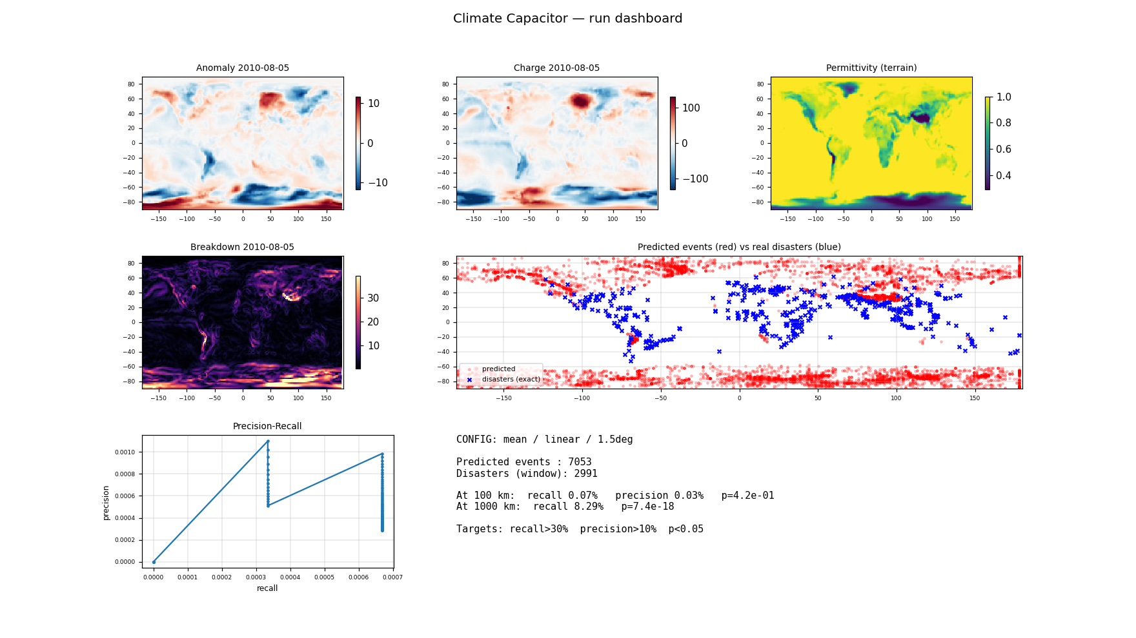
Figure A.1 — The one-page dashboard produced by run_all.py.

A.4 Changing settings and running experiments
Every scientific setting lives in one file, config/default.yaml, and the tunable ones are marked with a “PLAY” comment. To try a different scenario, change one value, save, and re-run a script. Useful knobs include:
- data.era5.daily_statistic — mean, max or min (hottest / coldest moment vs. the daily average).
- permittivity.method and eps_min / eps_max — how strongly terrain is weighted.
- charge.window_days / decay_per_day — a faster or slower heat build-up.
- breakdown.threshold_value — flag more or fewer risk zones.
- validation.spatial_radius_km — a looser or stricter match distance.
Ready-made sweep scripts try several values automatically and print a comparison table: run_experiment.py (terrain weighting ε), run_stat_sweep.py (daily statistic) and run_final.py (match radius × early-warning window). Keep resolution_deg at 1.5 on a normal laptop; finer grids need much more memory (see Appendix B).

A.5 Built-in help
Each script prints a short description of what it does and what it produced when it runs, and the configuration file documents every knob inline, so a user always has on-screen guidance without consulting external material.

Appendix B — Maintenance Guide
This guide enables a future developer to install, run and extend the system after the project ends.

B.1 Operating environment
- Runtime — Python 3.11 or newer (developed on 3.13). Windows, macOS or Linux.
- Hardware — A standard laptop is sufficient for the default 1.5° grid (~1 GB cached data, ~2 GB peak RAM). Finer grids are heavier: 1.0° ≈ 3 GB peak; 0.703° ≈ 5–7 GB peak (≥ 32 GB RAM recommended).
- Network — Internet is needed only for the first run (to stream and cache the climate data); afterwards the system runs offline.

B.2 Installation
Only the project's own Python dependencies need installing; all are standard packages listed in requirements.txt (no specialised infrastructure such as a database is required).
1. Clone the repository:
git clone https://github.com/Ron-Salama/Climate-Modeling-Research-Project.git
2. Create and activate a virtual environment, then install dependencies:
python -m venv .venv → activate it → pip install -r requirements.txt
3. Disaster data (a one-time manual download; free logins): export EM-DAT (natural disasters, 2009–2021, World) as .xlsx and download the GDIS coordinates CSV, place both in data/raw/, and set their filenames in config/default.yaml under data.disasters. Climate and terrain data download automatically on first run.
(For Spyder: point its interpreter at the project's .venv and install spyder-kernels.)

B.3 Project structure (where to make changes)
The code is a modular pipeline; each stage is a small module under src/climate_capacitor/, and nothing is hard-coded — every parameter is in config/default.yaml. The most common maintenance tasks map to specific files:
To change… | Edit
Any scientific parameter (no code change) | config/default.yaml
How temperature/terrain is loaded or cached | data/era5.py, data/topography.py
How disasters are read and joined | data/disasters.py
The physics (anomaly, charge, ε, breakdown) | physics/*.py
A new terrain→ε formula | physics/permittivity.py (add a @register function)
Clustering / event building / scoring | analysis/clustering.py, events.py, validation.py
The maps and dashboard | viz/maps.py
The order stages run in | pipeline.py
Table B.1 — Maintenance map: task → file.

B.4 Extending the system
The architecture was designed for extension. To add a new permittivity parameterisation, register a new function in physics/permittivity.py and select it by name in the config — no other code changes are needed. To add a new breakdown formulation (for example the charge-level field discussed in the results), add it to physics/breakdown.py behind the existing breakdown.field switch. Because the physics functions are pure operations on arrays with unit tests in tests/test_physics.py, changes can be verified quickly on the synthetic world before running on real data.

B.5 Running and verifying after changes
After any change, run python tests/test_physics.py for a fast correctness check, then python scripts/run_synthetic.py to confirm the planted heatwave is still detected, and finally python scripts/run_all.py for the full real-data report. All source and run files are kept in the project's Git repository; the code is documented inline and is not intended to be printed.

