Table of Contents

Purpose .................................................................
1.1. Intended Audience ............................................................... 3
1.2. Intended Use ................................................................... 3
1.3. Scope ............................................................................. 3
1.4. Definitions and Acronyms ................................................. 3

Overall System Description ................................................... 4
2.1. Use Case Diagrams ......................................................... 4
2.2. System Architecture ....................................................... 5
2.3. Functional Requirements ............................................. 6
2.3.0 Display Main Menu ................................................. 6
2.3.1 Function Login .......................................................... 6
2.3.2 Function Scan Barcode ........................................... 7
2.3.3 Function Cancel Unwanted Items ........................ 8
2.3.4 Payment ................................................................ 9
2.3.5 Clearl Order .......................................................... 10
2.3.6 Online Purchases ....................................................... 11

Non-Functional Requirements ............................................ 12
3.1. Non-Functional Requirements .................................... 12
3.1.1 Non-Functional Requirement ....................... 12

Software Architecture .......................................................... 13
4.1. Static Software Architecture ...................................... 13 3
2. Overall System Description 4

Document Version
No | Update | Name | Date | Version
1. | Initial version | Benedict, Yining,Rondell | 6/6/2025 | 1.0

Purpose

Intended Audience
This SRS document describes the System Requirements and Software Design for the SPmart self-checkout system and the target audience are System and Software Engineers working on the development of this project.

Intended Use
The SRS defines the overall System Architecture and Requirements as well as the Software Architecture and Design. This document also contains the definition of the System Requirements which shall be used as the input for System Test cases and Software Unit Test cases.

Scope
Project goals:
- bring value to the SPmart by reducing the manpower needs in the supermarket.
- We hope that our project is intuitive and user-friendly.
- We hope that our project will be scalable
- Protect customer information from hackers (common exploits, SQL injection)

Project deliverables:
- We will allow users to signup/login to their accounts and earn points when spending. They can use these points to offset their future purchases
- The customers can easily purchase items, be it online or in person with minimum staff intervention

Outline Task and Activities:
- Build a function database with different tables to store respective information
- Link database to code
- Build friendly user-interface for customers
- build a bar code scanner that will be mapped to a 10 digit id number for different products
- generate barcodes using python code
- decide what to print on the limited lcd screen
- build a password hasher to has passwords before storing them
- build a point system ($10 = 1 point or $1 = 10 points, then how many points to offset one dollar)
- Build a functioning website that is user-friendly and intuitive that allows users to purchase items online

Scope in:
1.User Account Management
- Sign-up and login system
- Password hashing for secure storage
- Points system (30 points for every $10 spent)
- Points redemption mechanism

2.Secure Transaction System
- RFID card simulation for payments (basic "card-present" confirmation)
- Protection against SQL injection and common exploits
3.User Interface
- LCD screen interface (limited to 2 lines x 16 characters)
- Keypad input (with special mappings like # for Enter, * for Cancel)
4.Product Identification
- Barcode generation and scanning
- Mapping barcodes to product IDs
5.Database Integration
- Structured database with tables for users, products, points, etc.
- Code linked to database for full-stack functionality
6.Online shopping
- Users can shop online on a user-friendly intuitive website
- They can make purchases with the points they have collected or with atm card linked to their accounts
7.Hybrid Shopping Experience
- Support for both online and in-person purchasing
- Minimal need for staff intervention in both cases
Scope out:
1.Real PayWave or NFC-based Payment Integration
- The system only simulates RFID behavior, not actual payment validation with banks.
2.Inventory Management System
- This project does not include a full backend to manage stock or automatic restocking alerts.
3.Dynamic Pricing or Promotions
- No real-time discount systems, dynamic pricing, or promotional logic included.
4.Integration with External APIs (e.g., Google Pay, GrabPay)
- Our system does not handle actual digital wallet APIs.

5.Hardware Expansion
- Using an external webcam as the Picamera is not very clear
Constrains:
- The lcd screen can only display up to 16 characters per line with only 2 lines, what we can display is very limited.
- There is only 0 to 9 and “#” and “*” on the keypad as user inputs therefore we have to use input buttons that might not make sense like “#” for enter and “*” for cancellation etc.
- The RFID card returns true when the card is there. We are using that for a stimulation of payWave. Usually, when there is insufficient amount of money in the account that the payWave Is linked to, the transaction will not go through. However, in this case, as long as the card Is there, the reader will return true.

Document scope statement: We will make a smart system that is intuitive to create a pleasant experience for customers when shopping in SPmart, be it online or in the stall, while minimizing human intervention.

Definitions and Acronyms

Acronym | Description
IR | Infra-Red
LED | Light Emitting Diode
NFC | Near Field Communication
SW | Software
HW | Hardware

Overall System Description

Use Case Diagrams
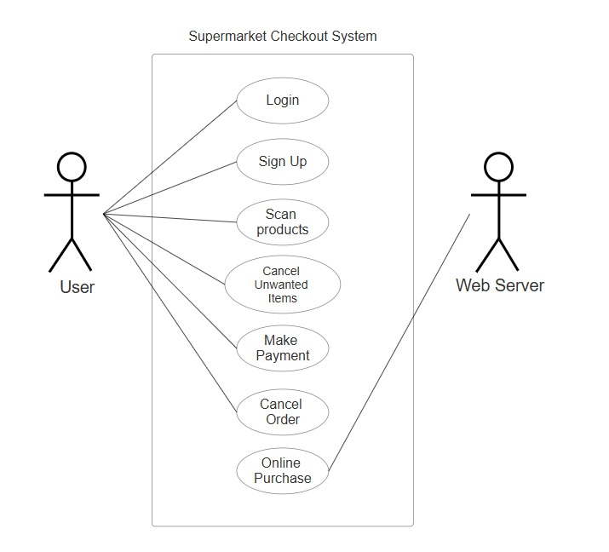

System Architecture

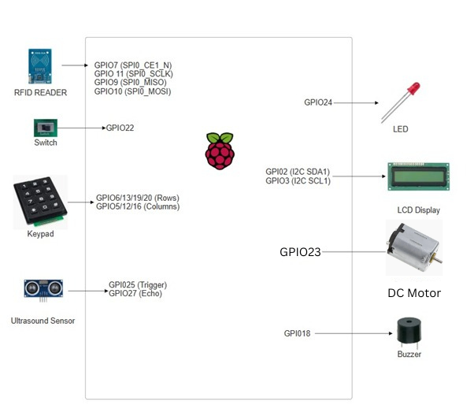

Functional Requirements
2.3.0- Display Main Menu
Function Description: Display a main menu which prompts user to login/signup or continue as guest account.
REQ_ID | Requirement
REQ_01 | If ultrasound detects motion, REQ_02 runs as supposed. Otherwise, lcd is blank.
REQ_02 | Prompts user to select if they are a staff or customer  Line 1: “Admin”  Line2: “Customer”
REQ_03 | Prompts user to login / signup or use a guest account.  Display on LCD screen  Line1: “1. Login 2. Signup”  Line2: “3. Guest Login”
REQ_04 | Corresponding function runs when corresponding number is selected. Otherwise, display on line1 “Invalid option” and Line2 “Select 1,2 or 3” for 3s. After that, Run REQ_01 again
REQ_05 | If 3 is selected  Guest Login Process:  - When the customer selects the "3. Guest login" option from the main menu, the system shall allow the customer to proceed without entering any credentials.  - The system shall prompt the customer with the following message on the LCD:  - Line 1: “1.Scan Products”  - Line 2: "2.View Cart "  - The customer shall be able to scan products, view the cart, and proceed with payment without needing to create an account or log in.

Function login

Login Function: Allows user to type login credentials (id and password).
REQ_ID | Requirement
REQ-06 | The system shall query the relational database to validate the entered user ID and PIN.  If the credentials are correct, the system shall display:  - Line 1: "Login success!"  - Line 2: “ Welcome to SPmart”  Then wait for 1s before displaying the following:  - Line 1: “1.Scan Products”  - Line 2: "2.View Cart "  If the credentials are incorrect, the system shall display:  - Line 1: " 1.TryAgain 2.SignUp "  - Line 2: "Guest login"
REQ-07 | Corresponding function runs. If 1, 2 or 3 are not selected and something else is selected, display on line1 “Invalid option” and Line2 “Select 1,2 or 3” for 3s. Run REQ-05 again

2.3.1.5- Function Signup
REQ-08 | Generate a valid id and display the id for the customer to note their id.  Line 1: “ID: <generated id>”
REQ-09 | Ask user to key in a strong password where the password is of 8 digits long and contains 4 or more different numbers
REQ-10 | Users are prompt to link a card to their account for payment
REQ-11 | If the user decides to link their card, store the credentials of the user in the database.  Else, jump to Login Function but take note that they can only pay with “Paywave” or get a discount with “Points” if they didn’t link their card
REQ-12 | Prompt them to login in with their new credentials

Function Scan Barcode

Allows user to scan barcode of product and display name and price. If invalid barcode is scanned, prompt customer to approach staff for help.

REQ_ID | Requirement
REQ-13  (Valid Barcode) | Function: Handle valid barcode scanning and add the product to the cart.  - Barcode Scanning:  - The customer scans a product barcode using the camera.  - The system reads the 10-digit unique identifier from the barcode.  - The system queries the relational database to retrieve the product details (e.g., product name, price, etc.).
REQ-14 | Action After Valid Barcode:  If the barcode is valid, the system shall:  - Add the product to the temporary cart.  - Update the LCD to display:  - Line 1: Product name and price(e.g., "Product Name $.X.XX")  - Line 2: Total price and Quantity (e.g., "Price : X.XX x1")
REQ-15  (alcoholic product) | If product scanned is an alcoholic product, lcd screen will prompt user to approach staff to verify that they are not underage. Staff must key in their id and password to approve the purchase of item.  Lcd screen shall display:  - Line 1: “Alcoholic Item”  - Line2: “Please Approach staff”  Until “#” is keyed. Then Lcd will display:  - Line 1: “ID: ”  - Line 2 ”Pw: ”  Line 2 will only appear after id is keyed in.  If credentials are correct, item is added to cart and the scanning or products can continue. Otherwise, lcd shall display:  - Line 1: “Wrong Credential”  - Line 2:” Try again”  For 2 seconds before prompting the staff for their id and password  If Credentials are entered wrongly 3 Times, Buzzer and LED will buzz and light up until switch is turned off.

Function Cancel Unwanted Items
- Allows user to delete unwanted items from the cart and scroll through their current items in the cart.
REQ_ID | Requirement
REQ-16 | Before payment, the customer can press the “2” key to view the items in the cart.  If applicable, the system will display the first item in the cart along with its quantity and total price.  Lcd Output( no items)  - Line 1: “No Items scanned"  - Line 2 : "Scan items first”  LCD Output(1 item)  - Line 1: “1. <Item name>  - Line 2: “<-End of Cart-->”  LCD Output(2 or more items):  - Line 1: "1. <Item name>"  - Line 2: "2. <Item name>”
REQ-17  Navigate Through Cart: | - The customer can press the # key to see the next item in the cart or click 1 or 2 to show details of the item.
REQ-18 | For each item displayed, the customer can press “#” to remove the item.  After pressing the item number, the system will confirm the removal by displaying:  - Line 1: "Delete <Item>?"  The customer presses # to confirm removal, or * to cancel.  - If "Yes" (#) is selected:  - The item is removed from the cart.  - The system updates the cart and recalculates the total.  - The LCD will briefly show:  - Line 1: "<Quantity of items> <name of item> Removed"(Eg. 6 drinks removed)  - If "No" (*) is selected:  - The cart view remains unchanged, and the system returns to the item display as defined in REQ-14
REQ-19 | The user can exit this viewing of cart by pressing “*” to continue scanning more items

2.3.4(Payment)
REQ_ID | Requirement
REQ-20 | Initiate Payment:  - After the customer has reviewed their cart and is ready to proceed to payment, they will press the “0” option on the system.  - The system will display the following prompt on the LCD screen:  - Line 1: "Total: $X.XX" (total amount to pay)  - Line 2: “Points: <points they earned this purchase>”  The system will then prompt user to select payment method  - Line 1: “1. ATM 2.Paywave”  - Line 2: “3. Points”
REQ-21 | If the customer selects 1 (ATM), the system will prompt them to enter their 8-digit PIN using the keypad.  The system will validate the entered PIN against the relational database.  - PIN Verification:  - If the PIN is correct, the system will process the payment.  - LCD Output:  - Line 1: "Payment Successful"  - Line 2: "Total Paid: $X.XX"  - If the PIN is incorrect, the system will display:  - Line 1: "Invalid ID or PIN"  - Line 2: "Please Try Again"  - Transaction Completion:  - Upon successful payment, the system updates the transaction database and clears the cart while also printing a receipt with the DC Motor with the length of the time being dependent on the length of the order.
REQ-22 | - RFID Payment:  - If the customer selects 2 (PayWave), the system will prompt them to scan their RFID card.  - The RFID reader will detect the card and process the payment.  - Transaction Completion:  - If the payment is successful, the system will display:  - Line 1: "Payment Successful"  - Line 2: "Total Paid: $X.XX"  - If the payment fails, the system will display:  - Line 1: "Payment Failed"  - Line 2: "Try Again"  - System Updates:  - Upon successful payment, the system updates the transaction database and clears the cart while also printing a receipt with the DC Motor with the length of the time being dependent on the length of the order.
REQ-23  Pay using Points | When 3 is selected, users can have the option to pay with the points they have collected from previous purchases. When selected, the lcd will display:  - Line1: “Before: $X.XX”  - Line 2: “After: $X.XX”  However, if it is not enough, prompt users if they would like to use atm card or payWave to pay the remaining amount. Run the corresponding functions (REQ-21 for atm and REQ-22 for payWave)

2.3.5(Clear Cart)
4.Allows user to clear their cart and restart their order
REQ_ID | Requirement
REQ-24 | Pressing the 3 Button in the “View Cart” page:  When the 3 button is pressed, the system shall immediately trigger the order cancellation prompt.  Displaying the Cancel Order Prompt:  When the 3 button is pressed, the system shall display the following message on the LCD to confirm whether the customer wants to clear the entire order:  Line 1: "Are u sure u wan"  Line 2: "to clear ur cart”
REQ-25 | Clearing the Order:  - If the customer presses #(Yes) to confirm the cancellation, the system shall:  - Clear the entire cart (remove all items).  - Let the customers scan products.
REQ-26 | Cancelling the clearing of items:  - If the customer presses *(No), the system shall:  - Cancel the order cancellation interrupt.  - Return to the previous screen or continue with the ongoing process (e.g., cart view, payment screen).  - The cart and any entered data remain unchanged, and no action is taken.

2.3.6(Online purchases)
5.Allows users to order and pay for their products online with the option of self-pickup or delivery.
- For online orders and payments on our website.
REQ-27: Online login/signup | Function: Prompts user to login to their account / sign up  - Requirement:  - Prompts user to login to their existing account or sign up for a new one.  - Must be able to retrieve customer login details from database.  - Optional for user to link atm card
REQ-28: Online purchasing | Function: Allows user to add their products to the cart.  - Requirement:  - Must allow user to add and remove products to and from the cart.  - Allows user to checkout.
REQ-29: Pickup or Delivery Option | Function: Allow the customer to choose between pickup or home delivery after completing the payment.  - Requirement:  - After completing the payment, the website will prompt the customer with the following options:  - Option 1: "Pickup from Supermarket"  - Option 2: "Home Delivery (+$4.00)"  - The customer can choose pickup or delivery based on their preference.  For Pickup Option:  - If the customer selects "Pickup from Supermarket", the system will generate a QR code for the customer’s order.  - The QR code will be displayed on the order confirmation page.  - The customer must show this QR code to the supermarket staff upon arrival to collect their items.  For Delivery Option:  - If the customer selects "Home Delivery", a $4 delivery fee will be added to the total amount.  - The system will finalize the payment and confirm the delivery schedule.  - If user does not have a card linked, prompt user to link card.
REQ-30: Online Payment Options | Function: Allow customers use ATM to pay on the website.  - Requirement:  - After adding items to the cart, the customer proceeds to payment on the website.  - On the payment page, the customer will use the card linked to the account to pay if they select the delivery option.
REQ-31: Update item count or remove item in cart | - Function: Allow customers to update item count or remove an item in their cart.  Requirement:  After adding items to the cart, the user may decide to update the item count or completely remove it from the card if they change their mind.
REQ-32: Lock account if too many failed attempts to log in. | - Function: If a user logs in too many times with wrong credentials, lock the account ID.  - Requirement:  If a user logs in with wrong credentials more than 5 times, the account locks for 1 min and will increase exponentially every failed attempt
REQ-33: QR Code Generation for PickupOrders | Function: Generate a QR code for pickup orders and display the order confirmation.  - Requirement:  - Once the payment is successful and the customer has chosen pickup, the website will generate a unique QR code for the order.  - The QR code will contain the order ID, customer ID, and pickup instructions.  - The QR code will be displayed on the order confirmation page and available for the customer to save or print.  - The customer will show this QR code at the pickup counter to collect their items.
REQ-33: Cancel Order Before Payment | Function: Allow the customer to cancel the order before completing the payment.  - Requirement:  - If the customer wishes to cancel the order before completing payment, they can click the "Cancel" button on the payment page.  - The system will prompt the customer with:  - "Are you sure you want to cancel the order?"  - Options: Yes or No  - If Yes (1) is selected:  - The cart will be cleared, and the customer will return to the main store page.  - If No (2) is selected:  - The customer will remain on the payment page and can continue the transaction

Non-Functional Requirements

Non-Functional Requirement

Requirements that enhance user experience.

REQ_ID | Requirement
REQ-34 | After every purchase or reboot, system will automatically navigate to the login/signup page.
REQ-35 | Passwords must be stored in a safe way and absolutely not in plain text
REQ-36 | To save electricity, the device starts with a dimmed LCD backlight during idle periods.

Software Architecture

Static Software Architecture

The Software Architecture defines the various Software Components that are developed to realize the implementation of the system requirements. 