CSC 555 Assignment 1
Ronaldlee Ejalu
Student Number: 2020637

Suggested reading: Mining of Massive Datasets: Chapter 1, Chapter 2 (sections 2.1, 2.1 only).
Please be sure to submit all python code (if you are using Jupyter notebooks, please export it into the main document or into a .py file before submission).

Part 1
- Compute (you can use any tool or software to compute answers in this part – but if you do not know to perform this computation, please talk to me about your course prerequisites):
2¹¹
(2⁴)⁴
4⁴
8⁵

842 MOD 100 (MOD is the modulo operator, a.k.a. the remainder)

837 MOD 20

22 MOD 111

111 MOD 22

- Given vectors V1 = (1, 1, 3) and V2 = (1, 2, 2) and a 3x3 matrix M = [(2, 1, 3), (1, 2, 1), (1, 0, 1)], compute:
V2 – V1
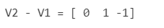
V1 + V1
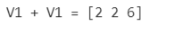
|V1| (Euclidean vector length, not the number of dimensions)
|V2|
M * V2 (matrix times vector, transpose it as necessary)
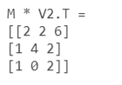
M * M (or M²)
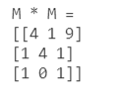
M³
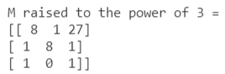

- Suppose we are flipping a coin with Head (H) and Tail (T) sides. The coin is not balanced with 0.4 probability of H coming up (and 0.6 of T). Compute the probabilities of getting:
HTHT
0.4 * 0.6 * 0.4 * 0.6 = 0.0576

THTH
0.6 * 0.4 * 0.6 * 0.4 = 0.0576
Exactly 2 Heads out of a sequence of 3-coin flips.
= 0.4 * 0.4 * 0.6 + 0.4 * 0.6 + 0.4 + 0.6 * 0.4* 0.4 = 0.096 + 0.096 + 0.096 = 0.288
Exactly 1 Tail out of sequence of 3 coin flips.
= 0.6 * 0.4 * 0.4 + 0.4 * 0.4 * 0.6 + 0.4 * 0.6 * 0.4 = 0.096 + 0.096 + 0.096 = 0.288

- Consider a database schema consisting of two tables, Employee (ID, Name, Address), Project (PID, Name, Deadline), Assign(EID, PID, Date). Assign.EID is a foreign key referencing employee’s ID and Assign.PID is a foreign key referencing the project.
Write SQL queries for:
- Find projects that are not assigned to any employees (PID and Deadline of the project).

SELECT PID, NAME FROM Project WHERE PID NOT IN (SELECT PID FROM Assign)

OR
SELECT PID, NAME FROM Project
WHERE PID IN
(SELECT PID FROM Project
MINUS
SELECT PID FROM Assign
)

- For each date, find how many assignments were made that day.

SELECT Date, COUNT(PID) AS numberOfAssignments
FROM Assign
GROUP BY DATE

- Find all projects that have either 0, 1, or 2 employees assigned to them (note that the answer should include 0 employees to be correct).

SELECT
Employee.ID
, Employee.Name
, Employee.Address
--, COUNT(Assign.PID) Projects
FROM Assign RIGHT OUTER JOIN Employee
ON Assign.EID= Employee.ID
GROUP BY Employee.ID
, Employee.Name
, Employee.Address
HAVING COUNT(Assign.PID) < 3

- Mining of Massive Datasets, Exercise 1.3.3
Justify your answer (giving an example only would be worth partial credit)

If the hash function h(x) = x mod 15, that the remainder when x is divided by 15, this means that h(x) can only have 15 buckets numbered from 0, 1, 2, 3, 4, 5, 6, ……….14. The bucket number in the range of 0 to B – 1, which is an integer where B represents the number of buckets; h(x) will send approximately equal numbers of hash-keys to each of the B buckets if hash keys are uniformly distributed into all buckets. So, with h(x) = x mod 15 this means that 1/15th of the integers will be assigned to each of the buckets. It is always preffered to select a prime number as B (the number of buckets) because taking B, which has any common factor with all possible hash-keys results in a nonrandom distribution into buckets. Choosing B as 11, 31, we would find that either 1/11th or 1/31th of the even integers get sent to each of the 11 or 31 buckets, which makes the hash function to operate well. The hash function is non random in its behavior if we chose B as 10 resulting in the h(x) values of 0, 2, 4, 6, 8.

- Hadoop Distributed Filesystem.

  - What are the guarantees offered by a replication factor of 3 (3 copies of each block)?

So that we don’t lose all copies of blocks due to a rack failure and this results in making HDFS fault-tolerant. This implies that blocks are replicated with two more copies at three different compute nodes in the cluster.

  - What action does NameNode have to take when a machine in the Hadoop cluster fails/crashes?

The NameNode detects any failed Map workers since it periodically pings the worker processes. All the Map tasks that were assigned to this worker will have to be redone, even if they had been completed. Not only does the NameNode sets the status of each of these Map tasks to idle and will schedule them on a Worker when one becomes available, but also must inform each reduce task that the location of its input from that Map task has changed.

  - What is the storage cost for a file of size X MBs, when the HDFS replication factor is set to 3?

If I had a file of size X MBs, it would be divided into 4 blocks and this amounts to 4 * X * 3 = 12XMBs.

Part 2
- Write python code that is going to read a text file and compute a total word count using a dictionary (e.g., {‘Hadoop’:3, ‘Cloud’: 2, ‘MapReduce’:4}. For our purposes, a word is anything split by space (.split(‘ ‘)), even if it includes things like punctuation.
Test the code on HadoopBlurb.txt (attached to the homework, from Apache Hadoop Wikipedia entry).

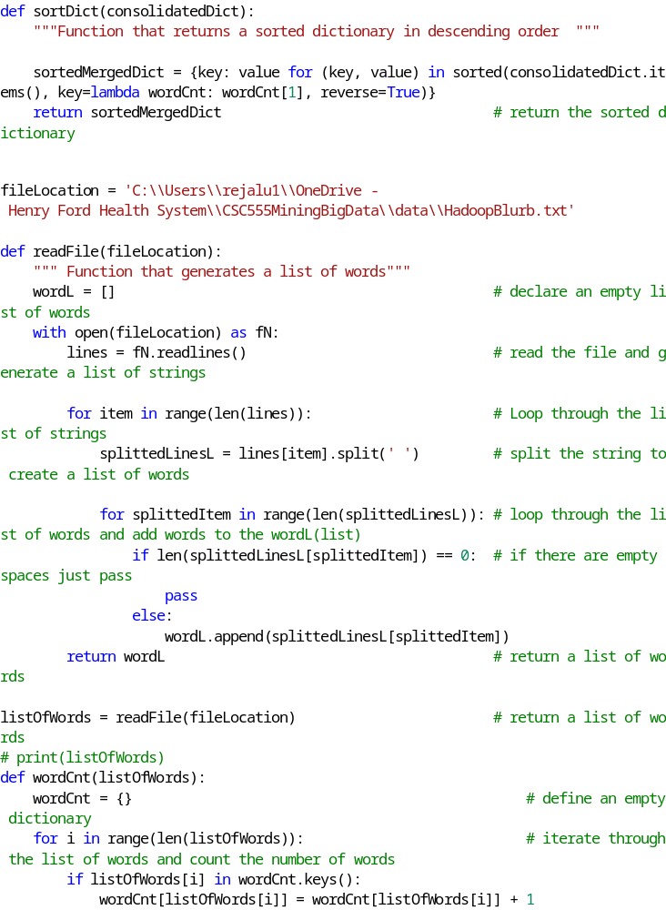
How many keys does your dictionary have?

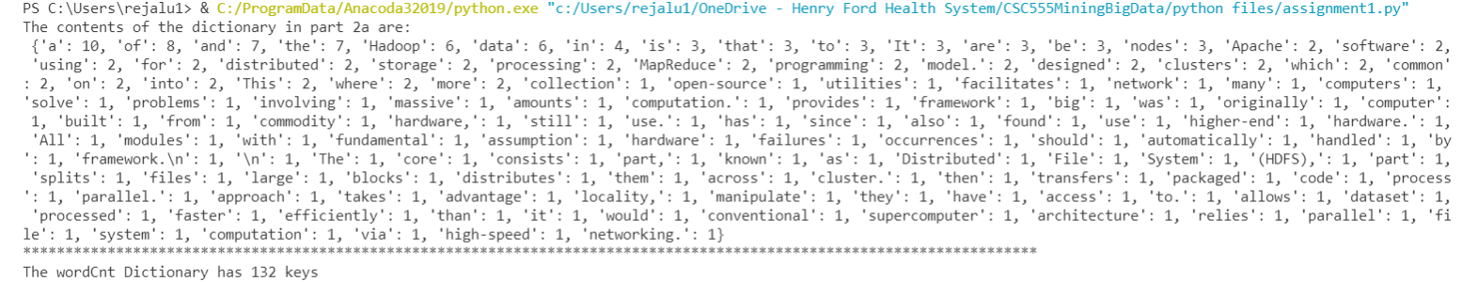

The dictionary has 132 keys as shown in the screen shot output above.

- Write python code that is going to create three different word count dictionaries, splitting the words at random between the three. Each time you process the word, choose at random which count dictionary to add it to (that means some words will appear in multiple dictionaries simultaneously).

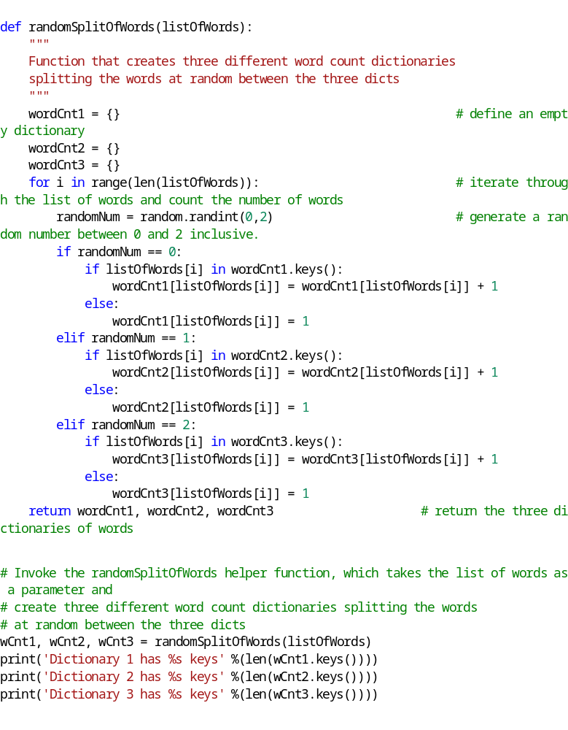

How many keys does each dictionary have?

From the screenshot output above:
- Dictionary 1 had 56 keys.
- Dictionary 2 had 61 keys.
- Dictionary 3 had 50 keys.

- Write python code to merge the three dictionaries into one and verify that it matches the dictionary from Part 2-a.

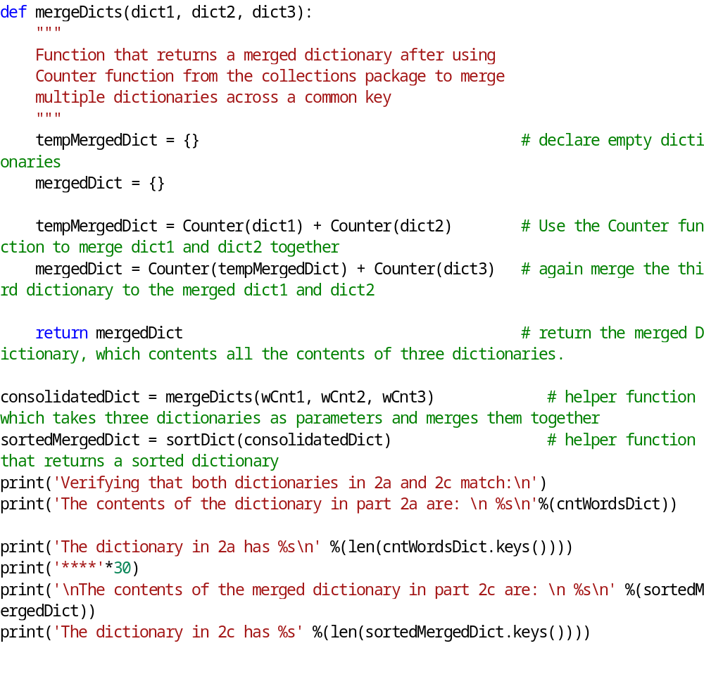

A screenshot below verifies the contents of both dictionaries in 2a and 2c:

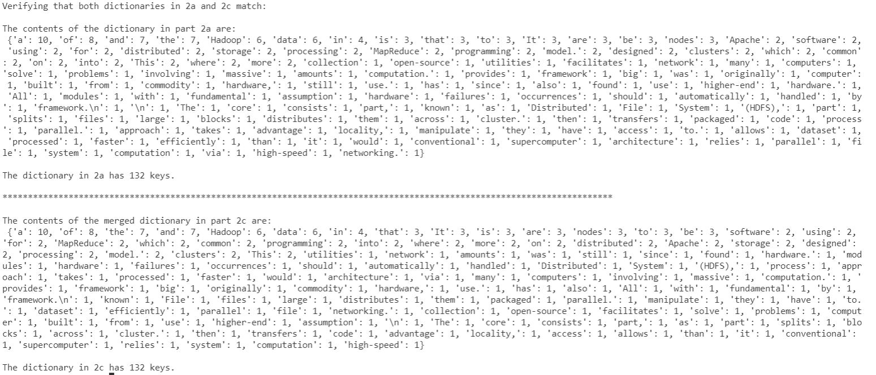

- Write python code that is going to deterministically assign each word to one of the three dictionaries instead. For example, you can make that assignment using the remainder (YourNumber % 3 will always return 0, 1, or 2 depending on the number). You can convert a string into a numeric value using hash (e.g., hash('Hadoop.')). We will talk about hashing in more detail later in the quarter.

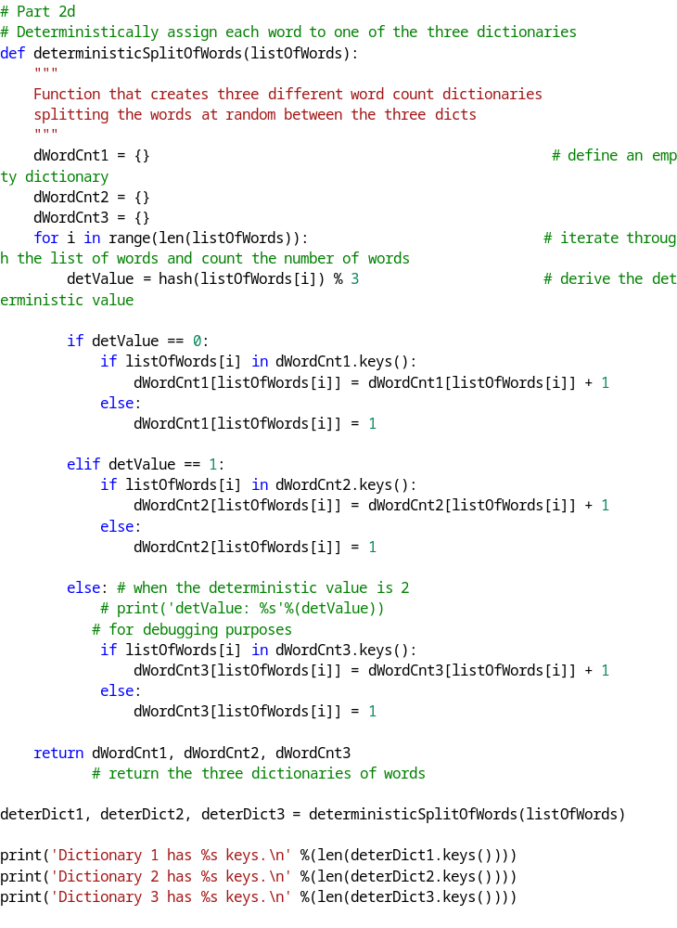

How many keys does each dictionary have?


Dictionary 1 has 52 keys.

Dictionary 2 has 38 keys.

Dictionary 3 has 42 keys.

- Write python code to merge the three dictionaries into one and verify that it matches the dictionary from Part 2-a.

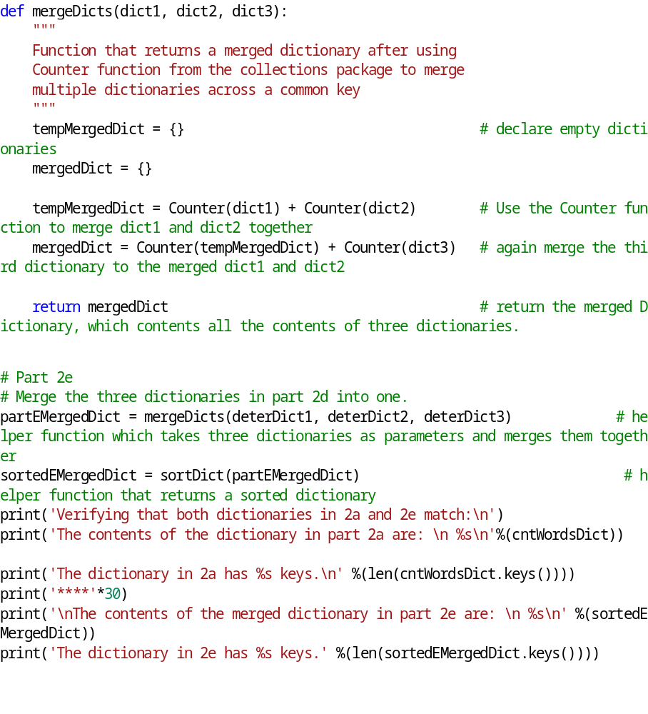

Verifying that the merged dictionary matches with the dictionary in part2a.

The screenshot below verifies that:
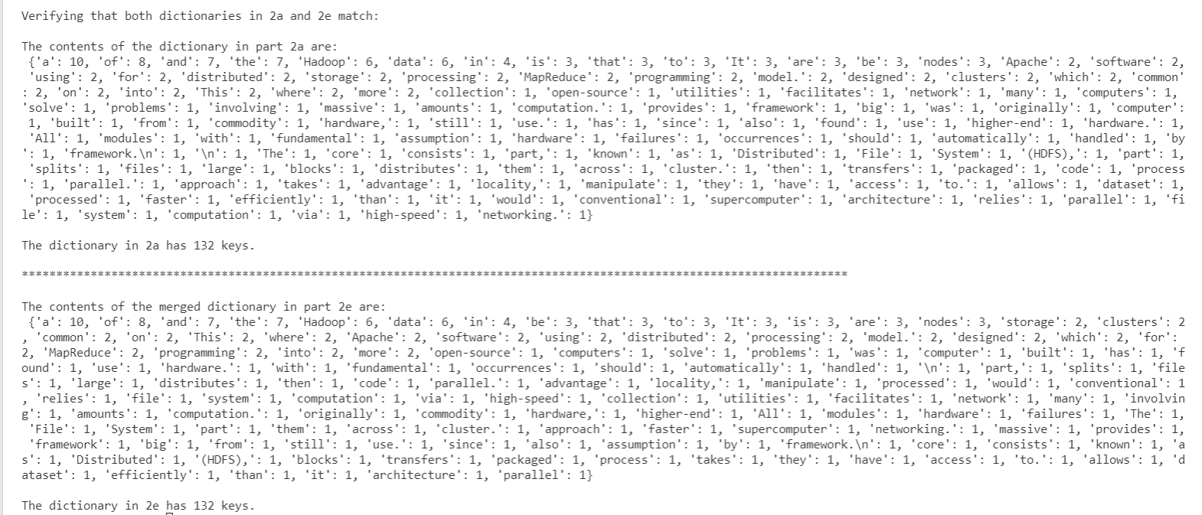
Both dictionaries in 2a and 2e have the same contents and number of keys, which is 132 keys.

Part 3

Write (and test) python code that is going to measure the speed of reading from the web (using urllib or similar), reading from a file and writing to a file on your computer.
That means your code will read or write some amount of data, time the operation, and compute the read or write rate (in MBytes/sec). Each of the measuring operations has to execute for at least 4 seconds.

- Compute the speed of reading from disk

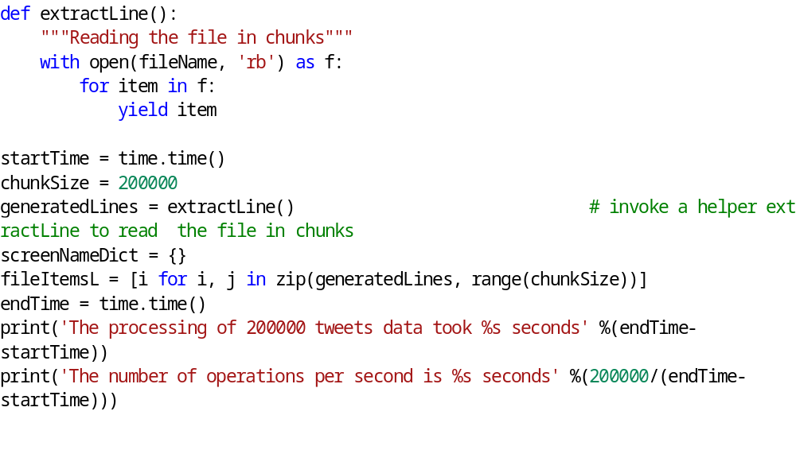From the screenshot below:

The reading of 200,000 tweets from the file took 4 seconds.

- Compute the speed of reading from the web

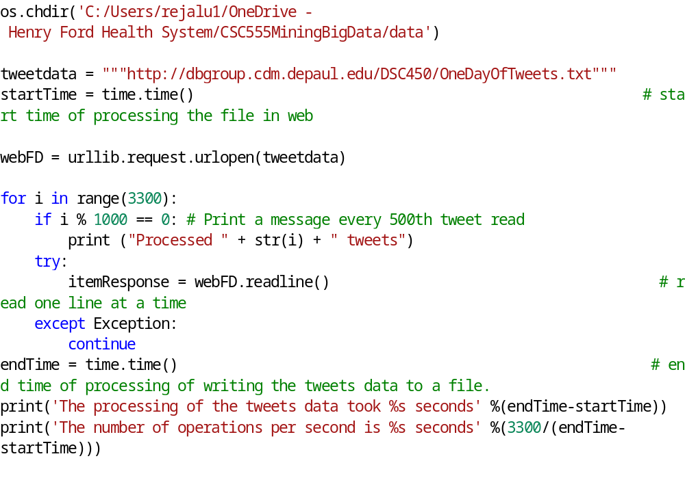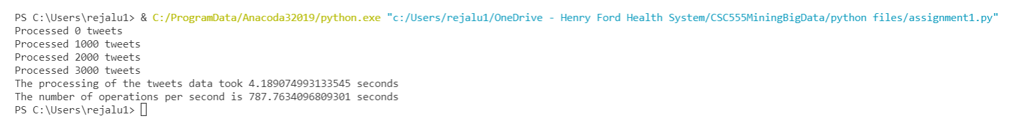

From the above screenshot, the processing of the tweets data took around 4 seconds.

- Compute the speed of writing to disk

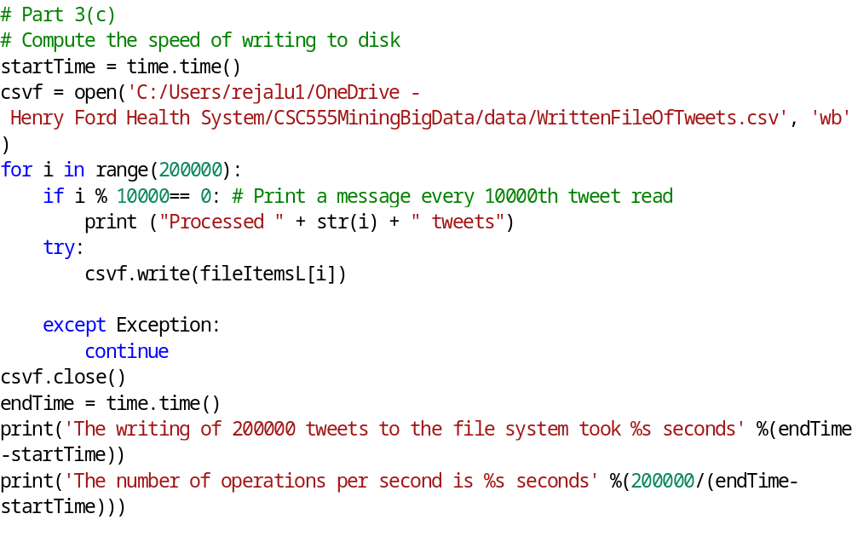
From the screenshot below:

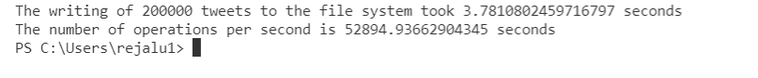
The speed of writing 200, 000 tweets to the local file system took 3.7 seconds

- Finally, add a print statement in part 3-a (i.e., print everything you read from the file) and measure the new throughput in MBytes/sec.

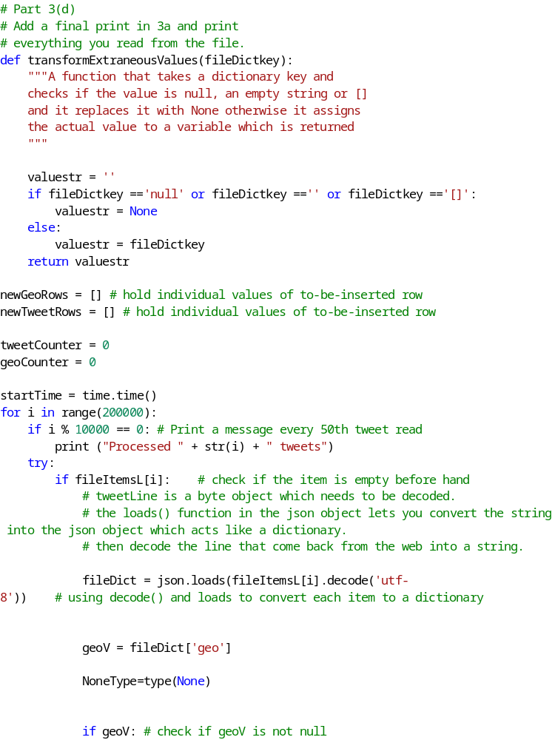
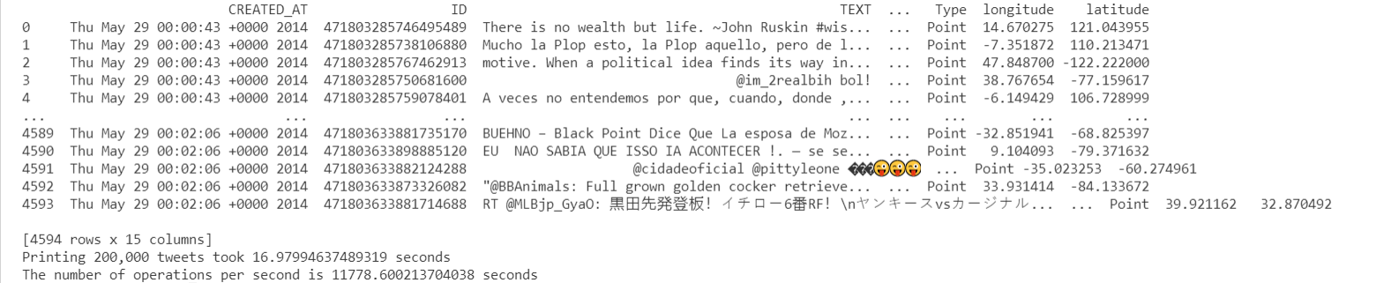

From the above screenshot, printing everything from the file took 16.97 seconds because I had to decode and convert each item to a dictionary, do some data transformation, derive the expected tuples, which I added to the respective list and used the list to derive a pandas data frame and finally print the contents of the data frame. There is no way this process would take 4 seconds to finish.

Submit a single document containing your written answers. Be sure that this document contains your name and “CSC 555 Assignment 1” at the top.

