CSC 555 Mining Big Data
Ronaldlee Ejalu
CSC 555 Assignment 3

1) Describe how to implement the following queries in MapReduce:
  - SELECT a.First, a.Last, e.EID, a.AID, e.Age
FROM Employee as e, Agent as a
WHERE e.Last = a.Last AND e.First = a.First;

 | Key | Value
Mapper1 | First_Last | First, Last, AID
Mapper2 | First_Last | EID, Age
Reducer | First_Last | First + Last + AID + EID + Age

Mapper 1 will read data from the employees table and for every instance, it checks if the first and last column values are equal to the first last and last name column values of the Agent table, and If there are equal, set the concatenation of First and Last columns as keys and set First, Last and AID as a value which produces the of key-values pairs in the form of
{First_Last ‘\t’{First, Last, AID}}

Mapper 2 will read from the Agent table and for every instance, it checks if the first and last column values are equal to the first and last column values of the Employee table and if they are, set the concatenation of First and Last columns as keys, and set EID, age as a value which produces key values pairs in the form of {First_Last ‘\t’ {EID, Age}}

Since Mapper 1 and 2 have the same keys so the reducer’s key will be set to first_last and the values will be the concatenation of the First, Last , AID, EID and Age and remember that first_last as the key will be sorted before they are added to the reducer.

  - SELECT SUM(lo_extendedprice)
FROM lineorder, dwdate
WHERE lo_orderdate = d_datekey
AND d_yearmonth = 'Feb1996'
AND lo_discount = 6;

 | Key | value
Mapper1lo | lo_orderdate | lo_extendedprice
Mapper2d | d_datekey | _d
Reducer | lo_orderdate,d_datekey | SUM(lo_extendedprice)

Mapper1lo will read the data from lineorder with a condition that lo_discount is equal to 6 and this condition or filter will have to be met so that key is set to lo_orderdate and set lo_extendedprice as the value so the output of the key-value pairs will be in the form of {lo_orderdate ‘\t’ {lo_extendedprice_lo} }

Mapper2d will read data from dwdate with a condition that d_yearmonth = ‘Feb1996’ and this condition or filter will have to be met so that the key is set to d_datekey and set _d as the value so the output of the key-value pairs will be in the form of {d_datekey ‘\t’ {_d}}

Then, a partitioner is modified with a custom range function, which is given the mapper’s output key and the number of reducers, and returns the index of the intended reducer, which ensures that all the values of the same key are sent to the same reducer.

For all the keys of lo_orderdate, d_datekey, sum up the values of lo_extendedprice and output an aggregate value which will be written back to HDFS.

  - SELECT d_month, COUNT(d_year)
FROM dwdate
GROUP BY d_month
ORDER BY COUNT(d_year)

 | key | value
Mapper1 | d_month | d_year
Reducer1 | d_month | COUNT(d_year)

Mapper1:
For an input block of data, for every date record identified, set the d_month as the key and set d_year as a value.

Reducer1: For each d_month received, compute and output the count of all years by month

Mapper2 | Count(d_year) | d_month
Reducer2 | Count(d_year) | d_month

Mapper2: For an input block of data, for each record with month and count of year, set the count of year as key and corresponding month as the value.

Then, a partitioner is modified with a custom range function, which is given the mapper’s output key , count(d_year)and the number of reducers, and returns the index of the intended reducer, which ensures that all the values of the same key are sent to the same reducer.

The keys and values for each partition are sorted by Hadoop before being presented to the reducer.

Reducer2: For each count of year received, output the d_month values as a list such as
1 ‘\t’ Jan Feb Dec Nov Jul
2 ‘\t’Jun Jan Feb Oct

- Consider a Hadoop job that processes an input data file of size equal to 72 disk blocks (72 different blocks, not considering HDFS replication factor). The mapper in this job requires 1 minute to read and fully process a single block of data. Reducer requires 1 second (not minute) to produce an answer for one key worth of values and there are a total of 7000 distinct keys (mappers generate a lot of key-value pairs, but keys only occur in the 1-7000 range for a total of 7000 unique entries). Assume that each node has a reducer and that the keys are distributed evenly.

  - How long will it take to complete the job if you only had one Hadoop worker node? For simplicity, assume that that only one mapper and only one reducer are created on every node.
Mapper: 72 blocks
1 min to process one block
- 72 blocks * 1 min = 72 mins
Reducer: 1 key => 1 min
- 7000 keys * 1 sec = 7000 secs
- 7000 secs/60 = 116.67 mins
Therefore: it would take 116.67 + 72 = 188.67 mins

  - 30 Hadoop worker nodes?

Mapper:

 | Node 1 | Node 2 |  | Node 3 |  | Node 4 |  | Node 5 |  | Node 6 |  | Node 7 |  | Node 8 |  | Node 9 |  | Node 10
1 | B1 |  | B2 |  | B3 |  | B4 |  | B5 |  | B6 |  | B7 |  | B8 |  | B9 |  | B10
2 | B31 |  | B32 |  | B33 |  | B34 |  | B35 |  | B36 |  | B37 |  | B38 |  | B39 |  | B40
3 | B61 |  | B62 |  | B63 |  | B64 |  | B65 |  | B66 |  | B67 |  | B68 |  | B69 |  | B70

Node 11 | Node 12 | Node 13 | Node 14 | Node 15 | Node 16 | Node 17 | Node 18 | Node 19 | Node 10
B11 | B12 | B13 | B14 | B15 | B16 | B17 | B18 | B19 | B20
B41 | B42 | B43 | B44 | B45 | B46 | B47 | B48 | N49 | B50
B71 | B72

Node 1 | Node 2 | Node 3 | Node 4 | Node 5 | Node 6 | Node 7 | Node 8 | Node 9 | Node 10
B21 | B22 | B23 | B24 | B25 | B26 | B27 | B28 | B29 | B30
B51 | B52 | B53 | B54 | B55 | B56 | B57 | B58 | B59 | B60

Mapper takes 3 mins

Reducer:
(7000/30) * 1 sec = (7000/30) secs
Therefore 3*60 + (7000/30) = 413.3 seconds which is equivalent to 6.89 mins (413.3/60)

  - 50 Hadoop worker nodes?

Mapper:
72 blocks take 2mins

Reducer: (7000/50) * 1 second = (7000/50) seconds
Therefore: 2 * 60 + (7000/50) = 260 seconds which is equivalent to 4.3 mins.

  - 100 Hadoop worker nodes?

Mapper:
72 blocks take 1 min
Reducer:
(7000/100) * 1 sec = (7000/100) secs
Therefore: 1 * 60 + (7000/100) = 130 secs which is equivalent to 2.2 mins.

  - Would changing the replication factor have any affect your answers for a-d?

You can ignore the network transfer costs as well as the possibility of node failure.

Changing the replication factor will have no effect on the answers for a – d.

  - Suppose you have an 8-node cluster with replication factor of 3. Describe what MapReduce has to do after it determines that a node has crashed while a job is being processed. For simplicity, assume that the failed node is not replaced and your cluster is reduced to 7 nodes. Specifically:

If a datanode fails while data is being written to it, then the following actions will be taken and these are always transparent to client node writing the data:
First, the pipeline is closed and any packets in the ack queue are added to the front of the data queue so that datanodes that are downstream from the failed node will not miss any packets.
The current block on the good nodes is given a new identity, which is communicated to the namenode, so that the partial block on the failed datanode will be deleted if the failed datanode recovers later on.
The failed datanode is removed from the pipeline, and a new pipeline is constructed from the seven good datanodes.
The remainder of the block’s data is written to the good datanodes (7 nodes) in the pipeline. The namenode notices that the block is under-replicated, and it arranges for a further replica to be created on another node. Subsequent blocks are then treated as normal.

    - What does HDFS (the storage layer) have to do in response to node failure in this case?
Fault tolerance is one of the key features of HDFS so data blocks will be replicated to other nodes implying that HDFS will function normally.

    - What does MapReduce engine have to do to respond to the node failure? Assume that there was a job in progress at the time of the crash (because otherwise MapReduce does not need to do anything).
If a node manager fails by crashing or running very slowly, it will stop sending heartbeats to the resource manager (Namenode). The resource manager will notice a node manager that has stopped sending heartbeats if it hasn’t received one for 10 minutes and remove it from its pool of nodes to schedule containers on. Any tasks running on the failed node manager will be channeled to the good datanodes.

  - Where does the Mapper store output key-value pairs before they are sent to Reducers?
The output of the mapper is stored on the local disk of which ever node it is running from.

  - Can Reducers begin processing before Mapper phase is complete? Why or why not?
No, the Reducer will have to wait for a Mapper phase to complete because the Reducer’s input are the keys and values which are produced by the Mapper.

- Using the SSBM schema (http://cdmgcsarprd01.dpu.depaul.edu/CSC555/SSBM1/SSBM_schema_hive.sql) load the Part table into Hive (data available at http://cdmgcsarprd01.dpu.depaul.edu/CSC555/SSBM1/part.tbl)

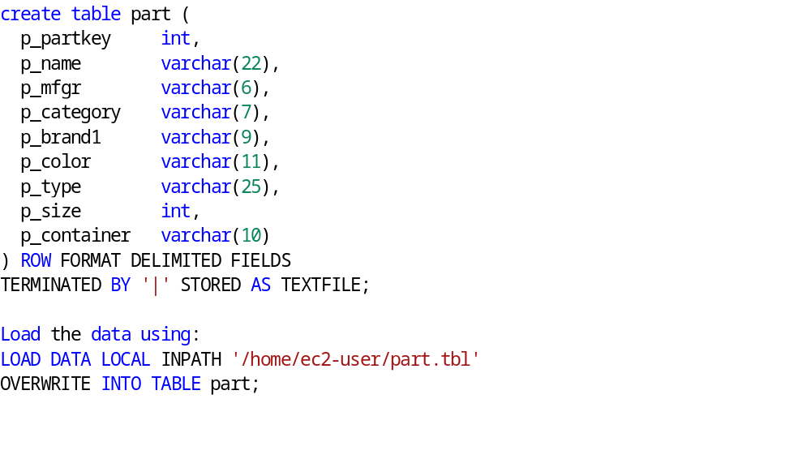

NOTE: The provided schema is made for Hive, but by default Hive assumes ‘\t’ separated tables. You will need to modify your CREATE TABLE statement to account for the ‘|’ delimiter in the data.

Use Hive user defined function to perform the following transformation on Part table (creating a new PartSwapped table with the same number of columns): in the 7th column/p_type swap the first and last word in the column and replace the space by a comma. For example, STANDARD BRUSHED TIN would become TIN, BRUSHED STANDARD. For the rest of the columns, where applicable, replace space (‘ ‘) and # characters by an underscore (_), so that MFGR#4 becomes MFGR_4 and MED BAG becomes MED_BAG.

Keep in mind that your transform python code (split/join) should always use tab (‘\t’) between fields even if the source data is |-separated. You can also take a look at the transform example included with this assignment for your reference (Examples_Assignment3.doc) which deliberately uses a different delimiter (‘?’).
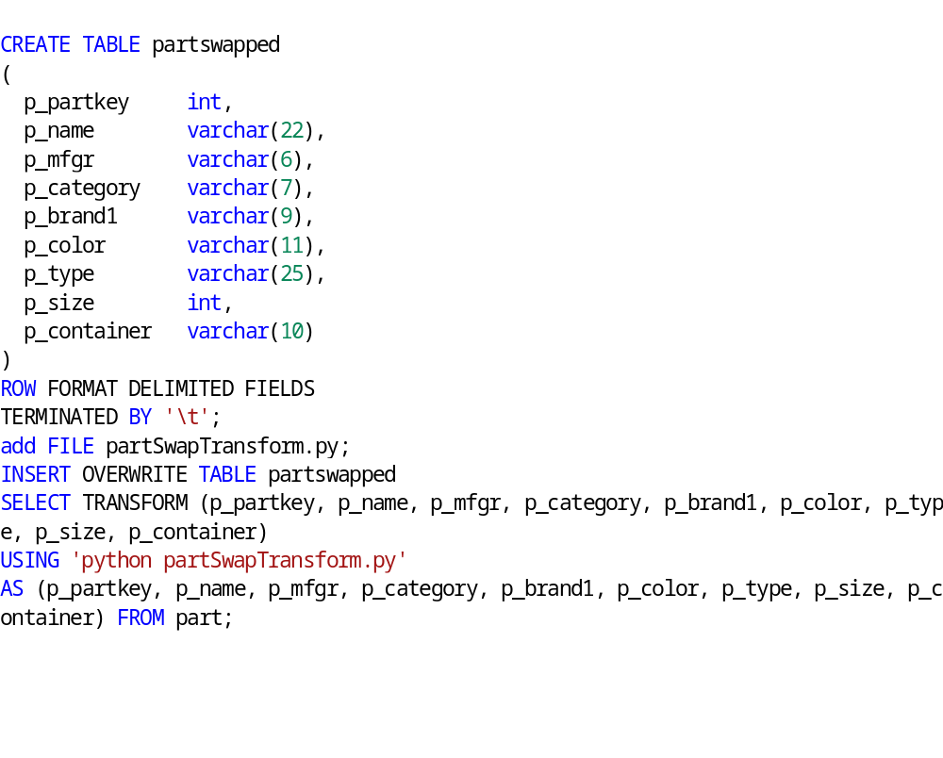

partSwapTransform.py
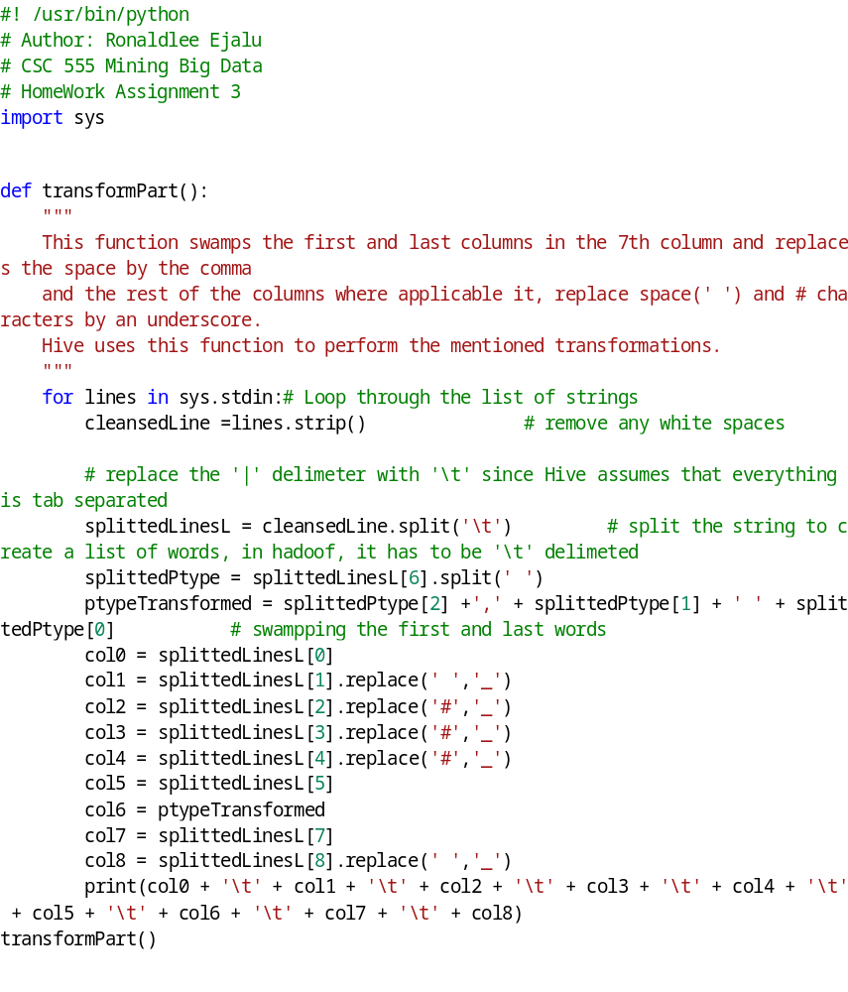

Below is the output screen after loading the transformed data into partswapped:
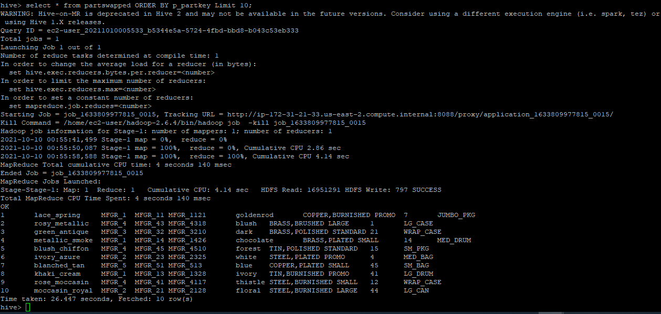

- Download and install Pig:
cd
wget http://cdmgcsarprd01.dpu.depaul.edu/CSC555/pig-0.15.0.tar.gz
gunzip pig-0.15.0.tar.gz
tar xvf pig-0.15.0.tar

set the environment variables (this can also be placed in ~/.bashrc to make it permanent)
export PIG_HOME=/home/ec2-user/pig-0.15.0
export PATH=$PATH:$PIG_HOME/bin

Use the same vehicles file. Copy the vehicles.csv file to the HDFS if it is not already there.

Now run pig (and use the pig home variable we set earlier):
cd $PIG_HOME
bin/pig

Create the same table as what we used in Hive, assuming that vehicles.csv is in the home directory on HDFS:

VehicleData = LOAD '/user/ec2-user/vehicles.csv' USING PigStorage(',')
AS (barrels08:FLOAT, barrelsA08:FLOAT, charge120:FLOAT, charge240:FLOAT, city08:FLOAT);

You can see the table description by
DESCRIBE VehicleData;
Verify that your data has loaded by running:

VehicleG = GROUP VehicleData ALL;
Count = FOREACH VehicleG GENERATE COUNT(VehicleData);
DUMP Count;
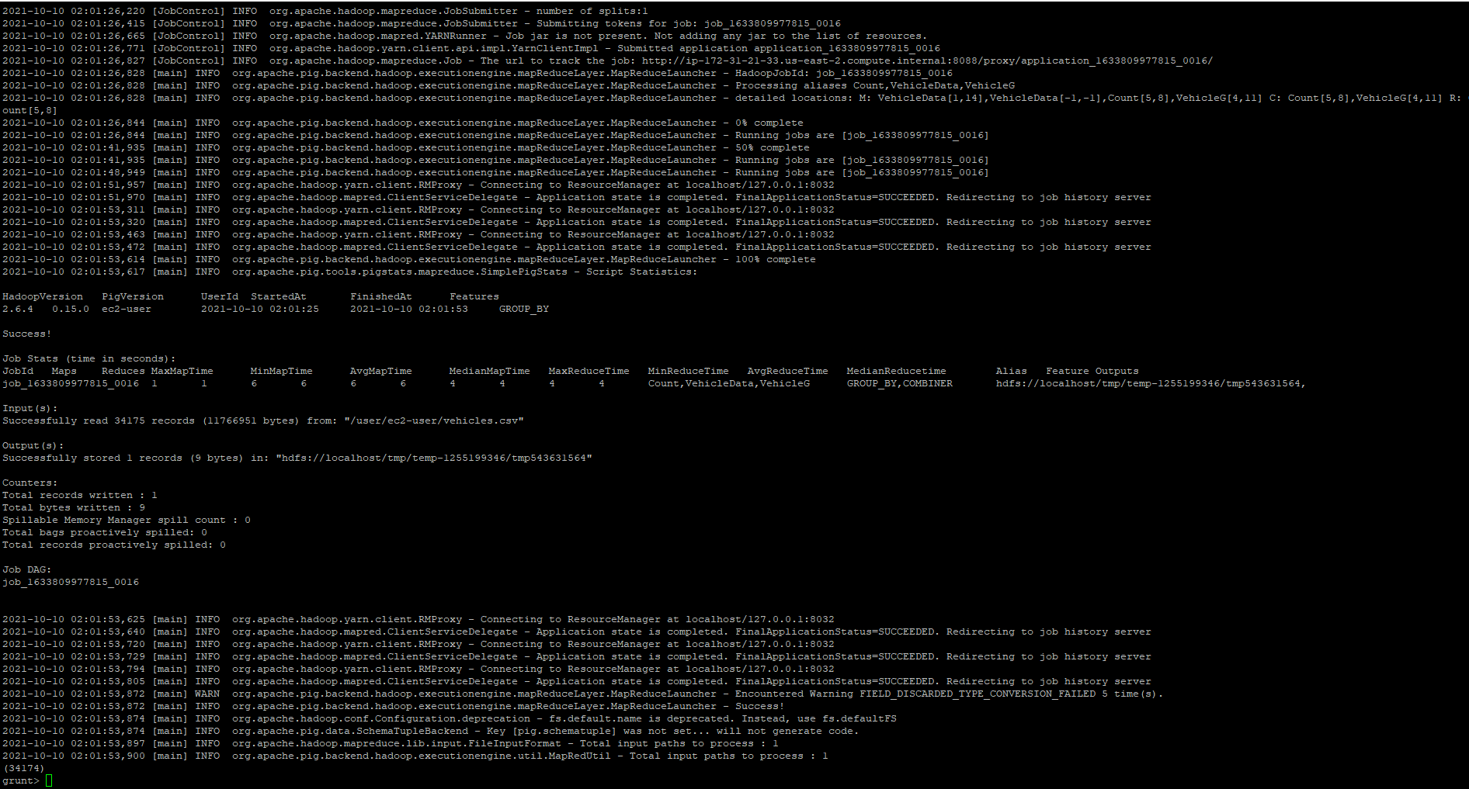

How many rows did you get? (if you get an error here, it is likely because vehicles.csv is not in HDFS)
34,174 records.

Create the same ThreeColExtract file that you have in the previous assignment, by placing barrels08, city08 and charge120 into a new file using PigStorage .You want the STORE command to record output in HDFS. (discussed in p457, Pig Chapter, “Data Processing Operator section)

For example, you can use this to get one column (multiple columns are comma-separated)

OneCol = FOREACH VehicleData GENERATE barrels08;

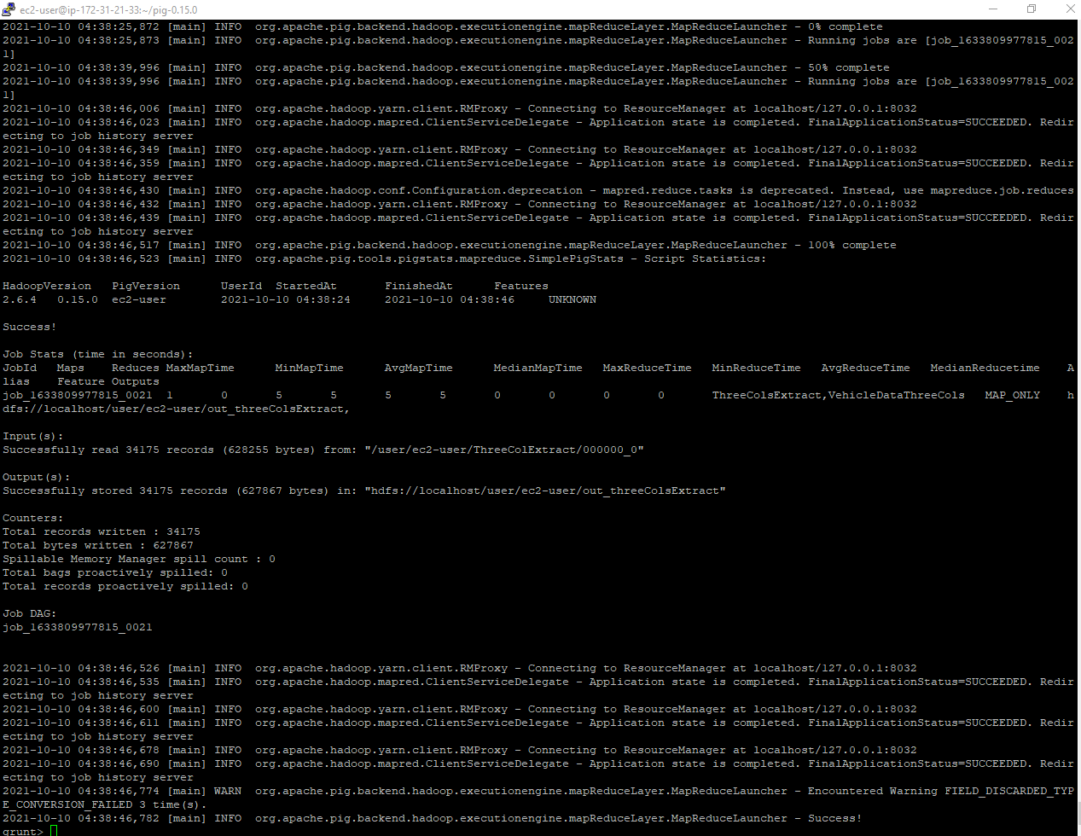

Verify that the new file has been created and report the size of the newly created file.
(you can use quit to exit the grunt shell)
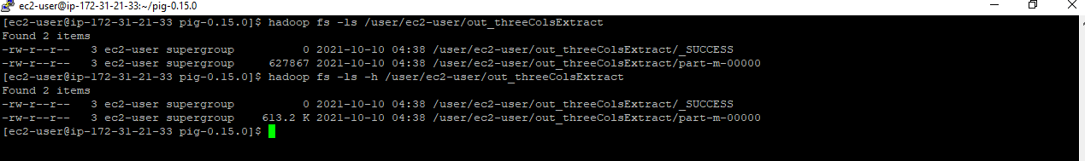

The size of the file is 613.2 K.

Submit a single document containing your written answers. Be sure that this document contains your name and “CSC 555 Assignment 3” at the top.

