Ronaldlee Ejalu
CSC 555 Mining Big Data
Assignment 5
Due Sunday, November 7th
- Identify which type of database/data processing system you would choose (Key-Value store, Column-oriented store, Document-oriented store, Graph database, Relational database, Streaming engine) in each scenario below.

  - Highly structured multi-table data that requires enforcing data constraints.
    - Relational database
  - Stock market data ticker with decisions that must be made in real time.
    - Streaming engine.
  - LinkedIn type data with interconnected nodes where much of the information resides in the links between nodes.
    - Graph database
  - An image storage system that allows lookup images by file name.
    - Key-Value store
  - A collection of JSON objects (e.g., tweets).
    - Document-oriented store.
  - Data that is stored in large sparse tables that are continuously growing (new rows/columns).
    - Column-oriented store.

  - Consider the following graph
A
Z

Z
B
X

Compute the page rank for the nodes in this graph. If you are multiplying matrices manually, you may stop computing after 5 steps. If you use a tool (e.g., Matlab, python) for matrix multiplication, you should get your answer to converge.

0 | 1 | 0 | 1 | A | * | 1/4 | = | 52429/131072
0 | 0 | 1/2 | 0 | B | * | 1/4 | = | 52429/524288
1/2 | 0 | 0 | 0 | X | * | 1/4 | = | 104857/524288
1/2 | 0 | 1/2 | 0 | Z | * | 1/4 | = | 78643/262144
A | B | X | Z |  | * |  | =

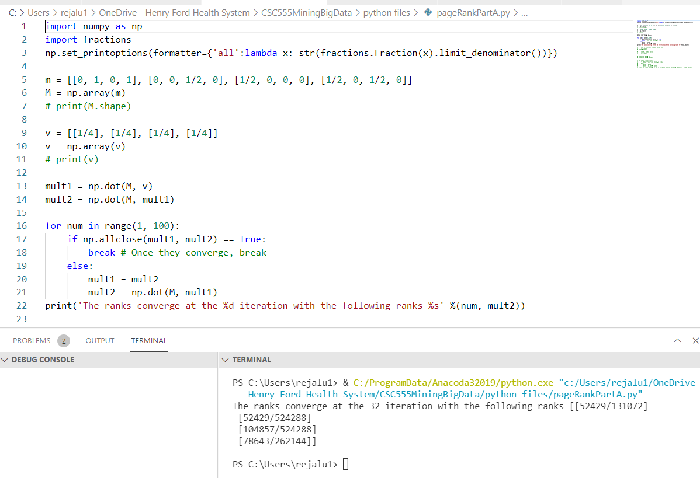
It converges at the 32 step

  - Now consider a graph with dead-end nodes Q and P:
A
Z
X
Q

P

What is the page rank of Q?
Q
What is the page rank of P?
Removing the dead ends P and Q:

0 | 1 | 1/2 | A | * | 1/3 | = | 78643/196608
0 | 0 | 1/2 | X | * | 1/3 | = | 78643/393216
1 | 0 | 0 | Z | * | 1/3 | = | 52429/131072
A | X | Z |  | * |  | =

It converges at the 33 iteration as shown below:

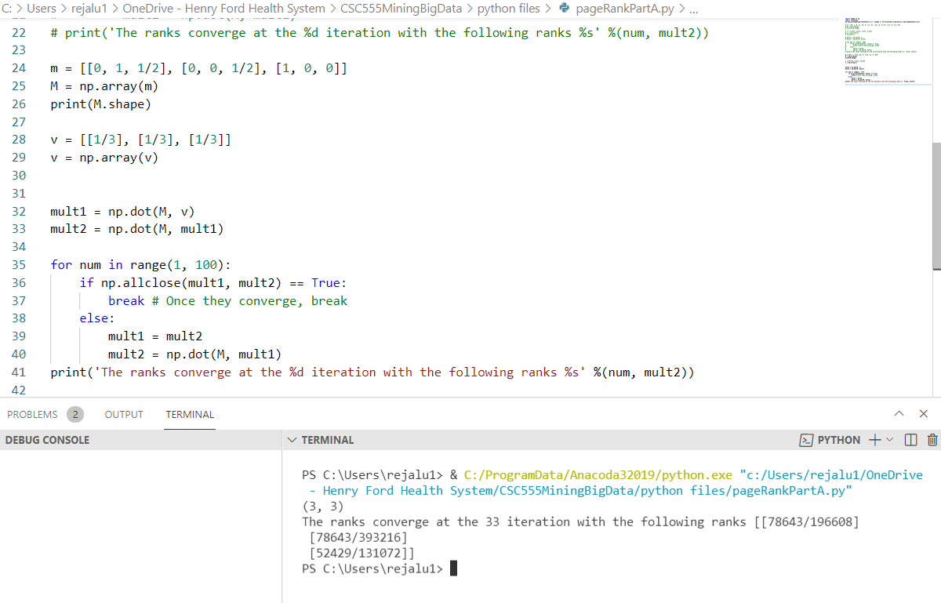

The page rank of :
Q = 0 * (78643/196608) + (½) * (78643/393216) + 1/3 * (52429/131072) = 0.23
P = 1 * Q = 1 * 0.23 = 0.23

  - Exercise 5.1.6 from Mining of Massive Datasets
Q
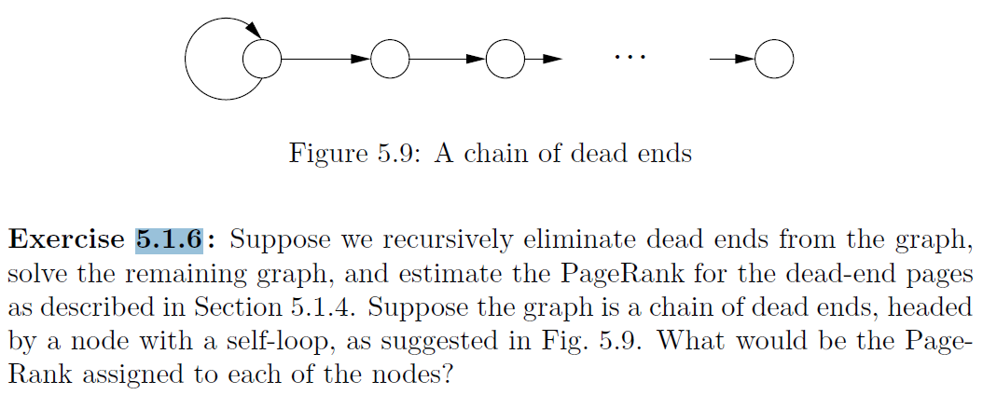

Looking at figure 5.9, all the successive dead end nodes are ranked ½ since they have one successor and predecessor. Removing the dead ends leaves us with only the root node, which has a link to itself, therefore its rank is 1. The first dead end and the root node itself make up the root node’s successor, which means that the first dead end has a page rank of ½.

- Given the following data: QQQQQZZZZAAAANNN and assuming that each letter takes 1 byte (8 bits). These are not trick questions – the goal of this exercise is to quantify compression effects.

  - What is the storage size of the uncompressed string?
Since each letter takes 1 byte:
Number of given letters = 16
Size of uncompressed string = 1byte * 16
- 16 bytes.

  - Suppose you apply Run Length Encoding compression (e.g., replace QQQQQ by Q5). What is the size of the RLE-compressed string? You can assume that 5 also requires 1 byte just as Q.
(Q,5; Z,4; A,4; N, 3)
Q takes 1 byte
5 takes 1 byte
Z takes 1 byte
4 takes 1 byte
A takes 1 byte
4 takes 1 byte
N takes 1 byte
3 takes 1 byte
- The RLE-compressed string takes 8 bytes.

  - Suppose you build a dictionary that represents each letter with a 5-bit code. What is the size of the dictionary-compressed string (where each letter is replaced by a 5 bit code)?

Size of the RLE compressed string = 8 bytes

- 8 * 5 = 40 bits
  - Repeat the computation in 3-b and 3-c using QQBQQZZUZAAANN string (which only has 14 characters and thus takes 14 bytes uncompressed)

The size of the RLE-compressed string:
QQBQQZZUZAAANN
- (Q, 4; B, 1; Z, 3; U,1; A, 3; N, 2)
- 12 * 8 byte = 96 bits

The size of the dictionary-compressed string:
Number of letters = 14
- Size = 12 * 5
- 60 bits

- Given the input data [(1pm, $6), (2pm, $15), (3pm, $16), (4pm, $29), (5pm, $10), (6pm, $20), (7pm, $20), (8pm, $21), (9pm, $23), (10pm, $28), (11pm, $26), (12am, $30)].

  - What will the Hive query “compute average price” return? (yes, this question is as obvious as it seems, asked for comparison with part-b and part-c)
Average price = (6 + 15 + 16 + 29 + 10 + 20 + 20 + 21 + 23 + 28 + 26 + 30)/12
- 244/12
- 20.3

  - What will a Storm streaming query “compute average price per each 3 hour window” return? (tumbling, i.e., non-overlapping window of tuples). For example, the first window would 1pm-4pm. Second window would be 4pm-7pm. If you are wondering about overlap, I recommend defaulting to [1pm-4pm) [4pm-7pm). (e.g., 1pm-3:59pm). Also note that with this type of processing you have to ask such questions.

- [1pm – 4pm) = (6 + 15 + 16) / 3 = 37/3 = 12.3

- [4pm – 7pm) = (29 + 10 + 20) / 3 = 59/3 = 19.7

- [7pm – 10pm) = (20 + 21 + 23)/ 3 = 64/3 = 21.3

- [10pm – 1am) = (28 + 26 + 30) / 3 = 84/3 = 28

  - What will a Storm query “compute average price per each 3 hour window” return? (sliding, i.e. overlapping window of tuples, moving the window forward 2 hours each time). First window is 1pm-4pm, second window is 3pm-6pm and so on.

1st Window 1pm – 4pm:
- (6 + 15 + 16)/3
- 37/3 = 12.3

2nd Window 3pm – 6pm:
- (16 + 29 + 10)/3
- 55/3 = 18.3

3rd Window 5pm – 8pm:
- (10 + 20 + 20)/3
- 50/3 = 16.7

4th Window 7pm -10pm:
- (20 + 21 + 23)/3
- 64/3 = 21.3

5th Window 9pm – 12pm:
- (23 + 28 + 26)/3
- 77/3 = 25.7

NOTE: when Storm does not have a full window, you cannot output anything until the window fills with data.

- Run another custom MapReduce job, implementing a solution for the following query:
For Employee(EID, EFirst, ELast, Extension) and Customer(CID, CFirst, CLast, Address), find everyone with the same name using MapReduce:

SELECT EFirst, ELast, Address, Extension
FROM Employee, Customer
WHERE EFirst = CFirst AND ELast = CLast

You can use this input data:
http://cdmgcsarprd01.dpu.depaul.edu/CSC555/employee.txt
http://cdmgcsarprd01.dpu.depaul.edu/CSC555/customer.txt

Be sure to submit your python code, the command line and the screenshot of successful execution of your code. We discussed a join example and there is a posted sample code in Week6.

# joinMapper.py

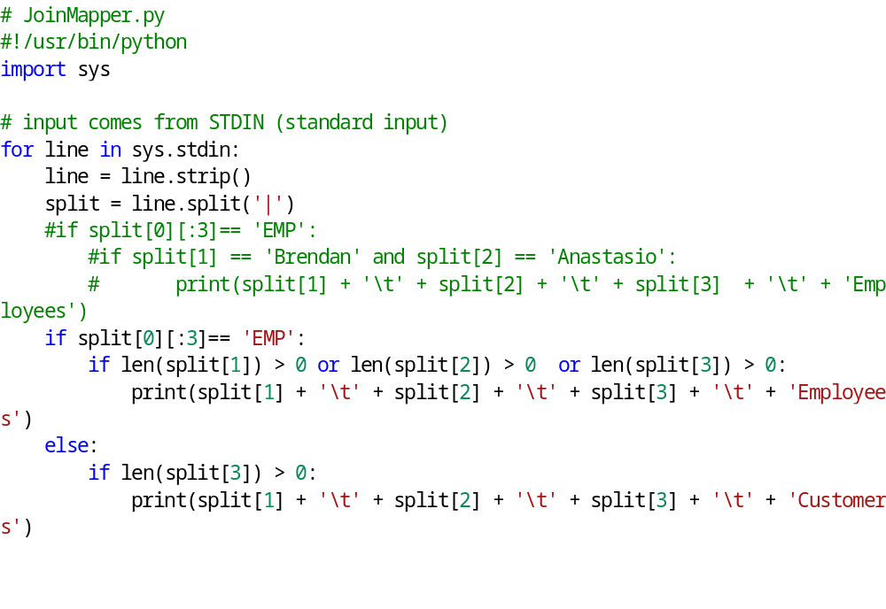
# joinReducer.py
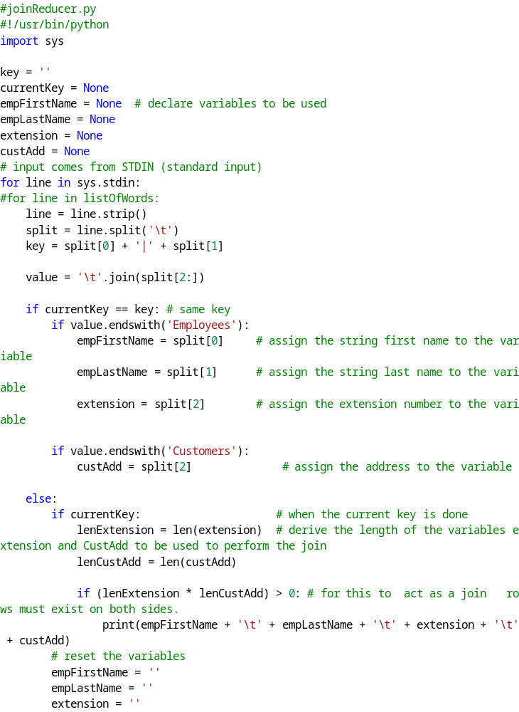
Screenshots:
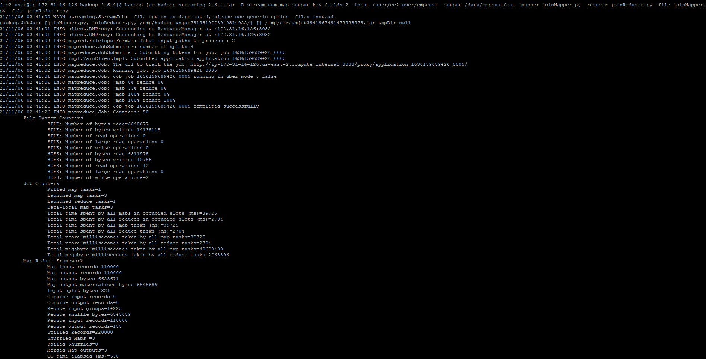

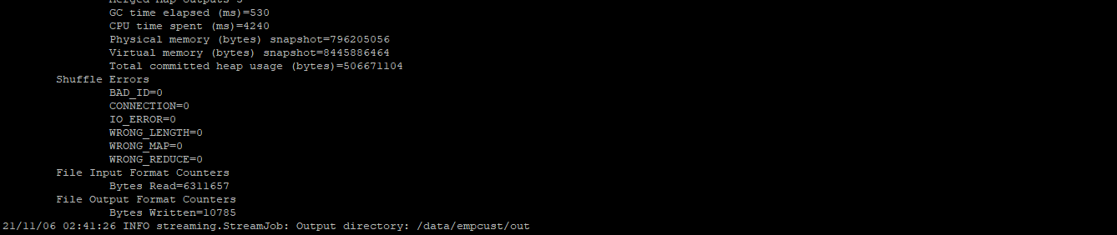
One file was written:

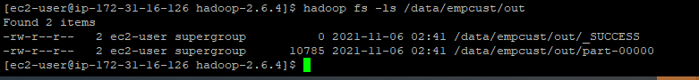

A screenshot of the file contents:

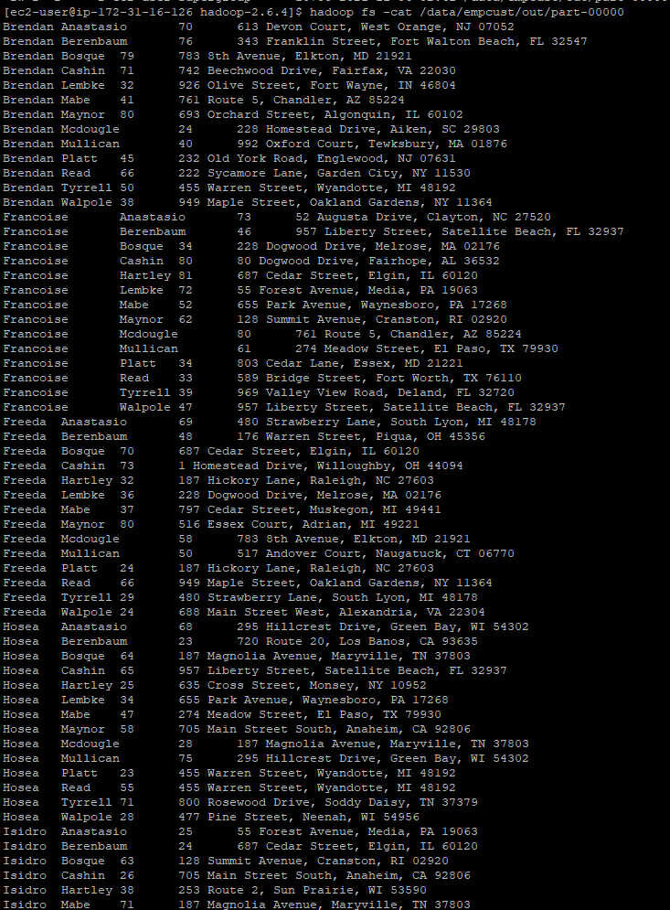

- In this section you will run an implementation of the page rank algorithm. Unfortunately, newer versions of Mahout (machine learning library that runs on Hadoop and Spark, which we will use for a couple of other examples later) removed their MapReduce page rank implementation. So we will run a publically available implementation from GitHub – an opportunity to build a custom Java job (while it is written in Java, you do not need to know Java to run it).

Download the Stanford graph dataset (this is a graph of page links from Stanford.edu, originally from here – https://snap.stanford.edu/data/)
wget http://cdmgcsarprd01.dpu.depaul.edu/CSC555/web-Stanford.txt.gz
gunzip web-Stanford.txt.gz

- Take a look at the file and report how many nodes and edges the web-Stanford.txt contains (it’s on the third line).

- There are 281,903 nodes and 2,312,497 edges.

Download the PageRank implementation from here: https://github.com/danielepantaleone/hadoop-pagerank, as follows:

Install git (Git is a version control system for tracking changes in source code).
sudo yum install git
git clone https://github.com/danielepantaleone/hadoop-pagerank

cd hadoop-pagerank/
Edit the source file (that is the reducer of the preprocessing MapReduce job)
nano src/it/uniroma1/hadoop/pagerank/job1/PageRankJob1Reducer.java
to modify PageRank.NODES.size() to 281903 (number of nodes), like in the screenshot.
// is a comment in Java, equivalent of # in python, so you do not need the blue line.
This code is meant to count the total number of nodes, but it isn’t working correctly (returning 0) and I have not yet figured out why. If you do not make this change, all of the initial values will compute be Infinity.

Set the classpath environment variable (you do not have to put it in .bashrc because we will only be using it to compile Java code in the next command). As always, note that this is a single line, no linebreaks
export CLASSPATH="/home/ec2-user/hadoop-2.6.4/share/hadoop/common/*:/home/ec2-user/hadoop-2.6.4/share/hadoop/mapreduce/lib/*:/home/ec2-user/hadoop-2.6.4/share/hadoop/mapreduce/*"
Compile the code:
javac -sourcepath src/ src/it/uniroma1/hadoop/pagerank/PageRank.java

Build the new jar file with your custom compiled code.
cd src
jar cvf PageRank.jar it

Congratulations, you have build a new custom PageRank.jar from Java code, similar to hadoop-streaming or hadoop-examples jar files that we have previously used.

Now, load the web Stanford data into HDFS:
hadoop fs -mkdir /data/
hadoop fs -mkdir /data/webStanford
hadoop fs -put ~/web-Stanford.txt /data/webStanford

And, finally, run the new jar to execute page rank evaluation.
time hadoop jar PageRank.jar it.uniroma1.hadoop.pagerank.PageRank --input /data/webStanford --output /data/prOutput --damping 90 --count 8

Note that --damping 90 means a 10% chance of teleporting and --count of 8 means 8 iterations are computed.

- Report the runtime (took about 5 minutes to run when I tested it)
It took 5mins to run as shown below:

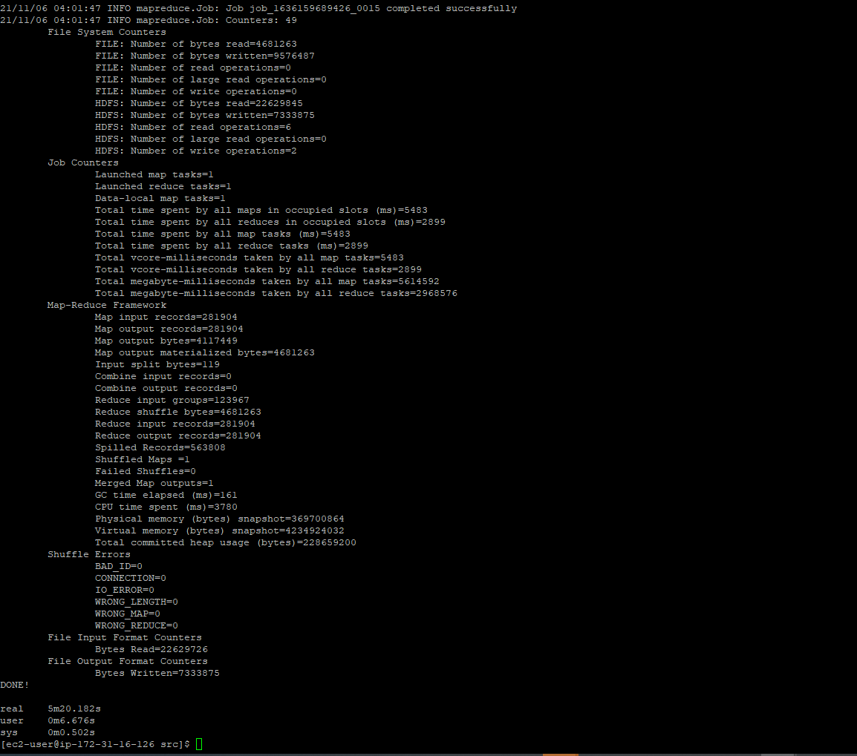

- Submit a screenshot of the first page of nodes, e.g., by running
hadoop fs -cat /data/prOutput/result/part-r-00000 | more

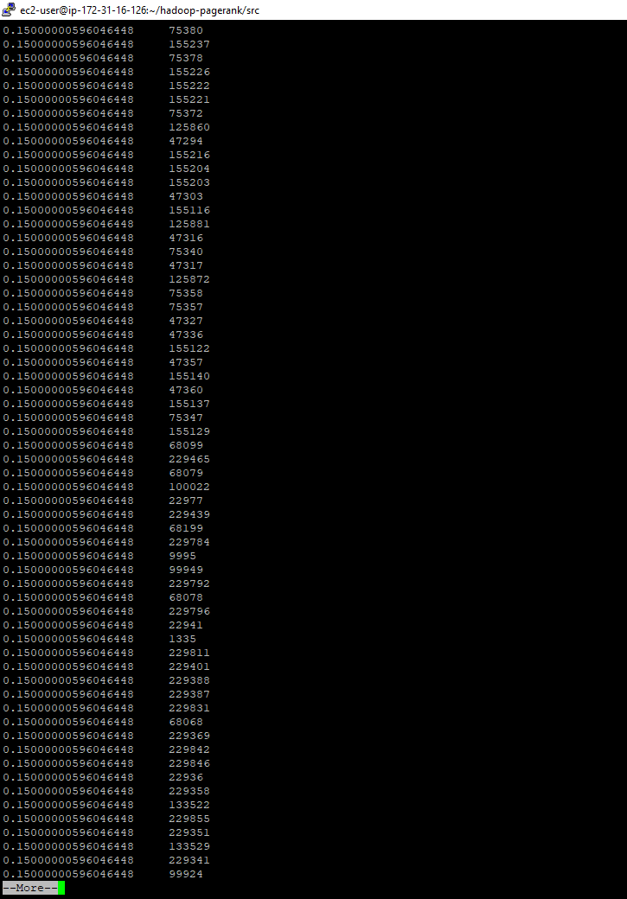

Submit a single document containing your written answers. Be sure that this document contains your name and “CSC 555 Assignment 5” at the top.

