Student Name: Ronaldlee Ejalu

Student Number: 2020637

Module 1: Homework Part2

Part 2

1. Define a relational schema with underlined (primary) keys and arrows connecting foreign keys and primary keys for a database containing the following information.

* **Authors** have LastName, FirstName, ID, and Birthdate (identified by ID)
* **Publishers** have Name, PubNumber, Address (identified by PubNumber)
* **Books** have ISBN, Title, Publisher (each book has a publisher and is identified by its ISBN).
* Authors **Write** Books; since many authors can co-author a book, we need to know the relative contribution of the author to a book, signified by their position in the author list (i.e. 1, 2, 3, etc.).

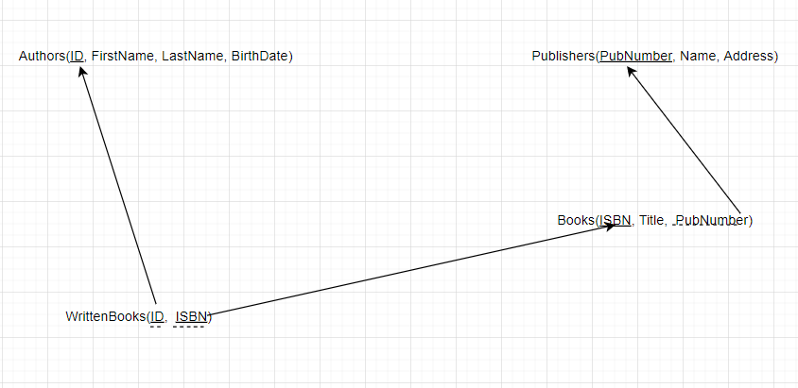

Solid underline defines the primary key ID for the Authors, PubNumber for the Publishers table and the composition of ID and ISBN is the primary key for the WrittenBooks table. The foreign keys are identified by the dotted underline. PubNumber in Books table is a foreign key linking to the Publishers table, ISBN in the WrittenBooks table is a foreign key linking to the Books table primary key and ID in the WrittenBooks table is a foreign key linking to the Authors table primary key.

1. Define a relational schema for students, student advisors, and advisor departments

* **Students** have StudentID, First Name, Last Name, DOB, Telephone and a reference to their advisor
* **Advisors** have ID, Name, Address, Research Area, and a reference link to their Department

**Departments** have Name, Chair, Endowment (identified by Name)

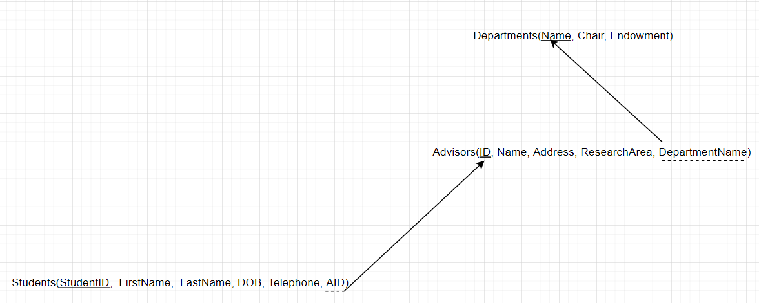

Solid underline defines the primary key ID for the Advisors tables, Name for the Departments table and StudentID for Students table. The foreign keys are identified by the dotted underline; DepartmentName in the Advisors table is a foreign key linking to the Departments table primary key, and AdvisorID (AID) in the Students table is a foreign key linking to the Advisors table primary key.