DSC 450: Database Processing for Large-Scale Analytics

Take-home Final

Student Name: Ronaldlee Ejalu

Part 1

We will use one full day worth of tweets as our input (there are total of 4.4M tweets in this file, but we will intentionally use fewer tweets to run this final):
http://dbgroup.cdm.depaul.edu/DSC450/OneDayOfTweets.txt
Execute the following tasks with 50,000 tweets and 500,000 tweets.

  - Use python to download tweets from the web and save to a local text file (not into a database yet, just to a text file). This is as simple as it sounds, all you need is a for-loop that reads lines and writes them into a file, just don’t forget to add ‘\n’ at the end so they are, in fact, on separate lines.

NOTE: Do not call read() or readlines(). That command will attempt to read the entire file which is too much data. Clicking on the link in the browser would cause the same problem.

# Author: Ronaldlee Ejalu
# Course DSC 450
# 1a
"""
a.Use python to download tweets from the web and save to a local text file (not into a database yet, just to a text file).
This is as simple as it sounds, all you need is a for-loop that reads lines and writes them into a file, just don’t forget to add ‘\n’ at the end so they are, in fact, on separate lines.
NOTE: Do not call read() or readlines().
That command will attempt to read the entire file which is too much data. Clicking on the link in the browser would cause the same prob
"""

import urllib.request
import json
import os
import csv
import time

os.chdir('C:/Users/rejalu1/OneDrive - Henry Ford Health System/DSC450/Assignments/FinalExamTakeHome')

tweetdata = """http://dbgroup.cdm.depaul.edu/DSC450/OneDayOfTweets.txt"""
startTime = time.time() # start time of processing the file in web

webFD = urllib.request.urlopen(tweetdata)
# csvf = open('OneDayOfTweets.csv', 'w', newline = '\n', encoding = 'utf-8')
csvf = open('OneDayOfTweets.csv', 'wb')

for i in range(500000):
if i % 5000 == 0: # Print a message every 500th tweet read
print ("Processed " + str(i) + " tweets")
try:
itemResponse = webFD.readline() # read one line at a time
# strItemResponse = itemResponse.decode('utf-8') # decode the line that comes back from the web into a string.
csvf.write(itemResponse)

except Exception:
continue

csvf.close() # close the file
# csve.close() # close the error file
endTime = time.time() # end time of processing of writing the tweets data to a file.
print('The processing of the tweets data took %s seconds' %(endTime-startTime))
print('The number of operations per second is %s seconds' %(500000/(endTime-startTime)))

The screenshot of the run time when processing 500,000 tweets:

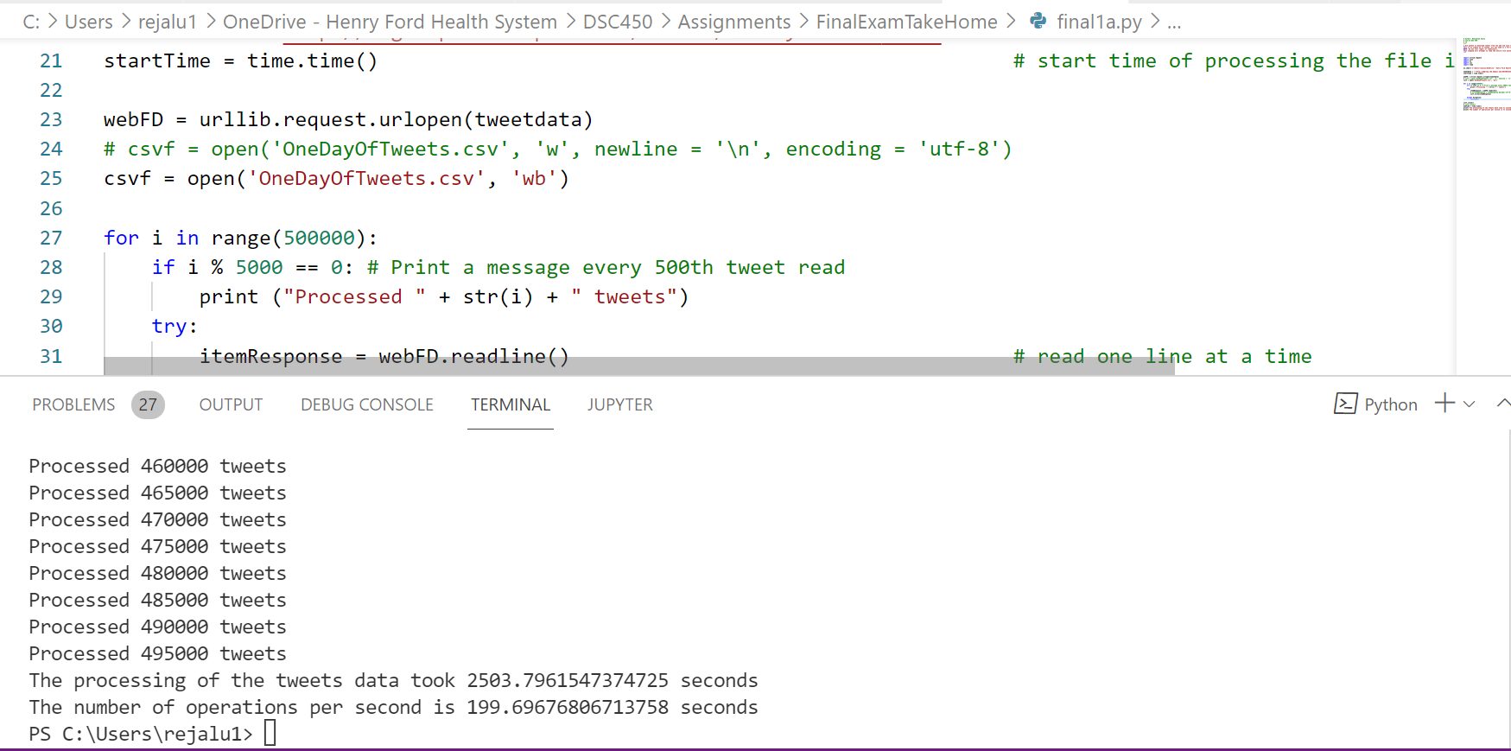

The screenshot of the run time when processing 50,000 tweets:
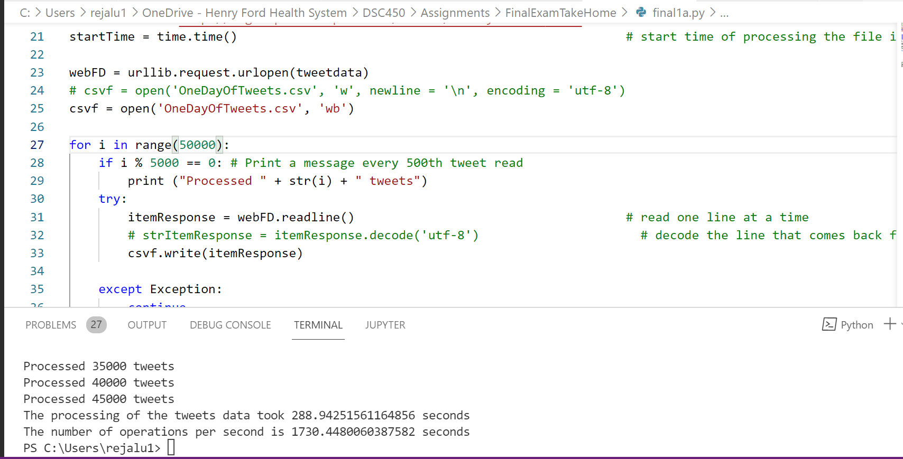

  - For text, in_reply_to_user_id and in_reply_to_screenname in Tweet table and for screen_name in User table, find the length of the longest string in the file in 1-a and compare it to your data type size (you only have to change your table if the data type turns out to be too short). You only need to do 1-b for 500,000 tweets file and you do not need to use SQLite database.
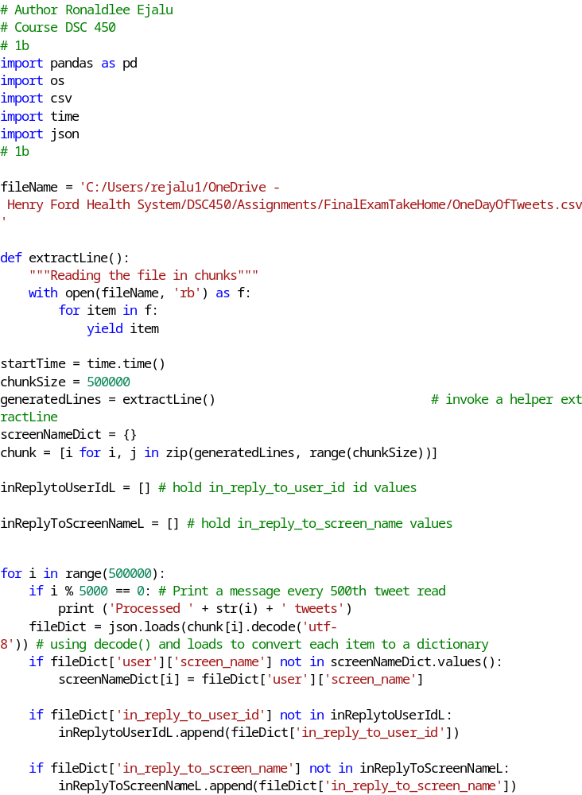The screenshot of the output after running the above script:
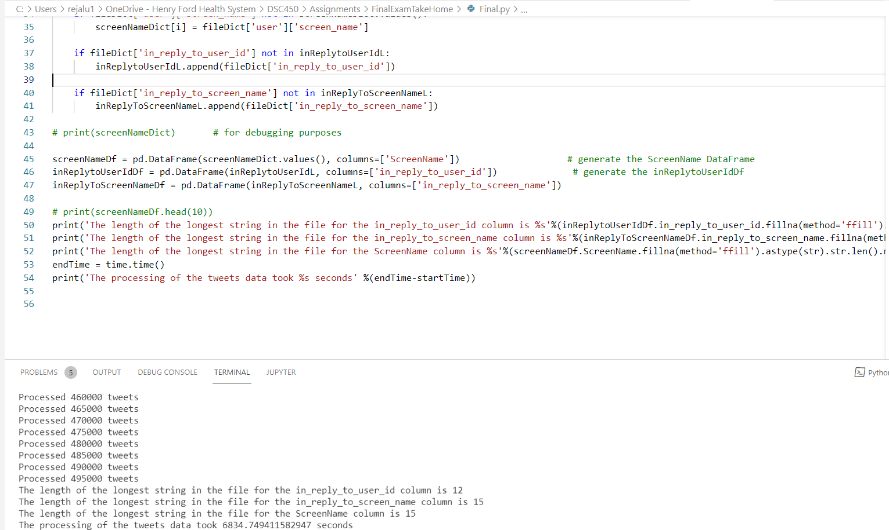

  - Repeat what you did in part 1-a, but instead of saving tweets to the file, populate the 3-table schema that you previously created in SQLite. Be sure to execute commit and verify that the data has been successfully loaded. Report loaded row counts for each of the 3 tables.

NOTE: If your schema contains a foreign key in the Geo table or relies on TweetID as the primary key for the Geo table, you should fix your schema. Geo entries should be identified based on the location they represent. There should not be any “blank” Geo entries such as (ID, None, None, None).

Below is the Python Code:

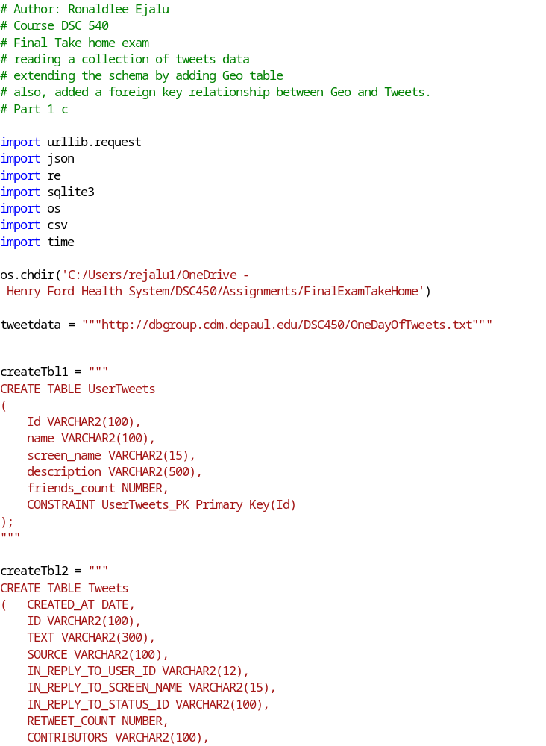
A screen shot showing the run time of 500,000 tweets being processed when reading the tweet data from the given web URL:

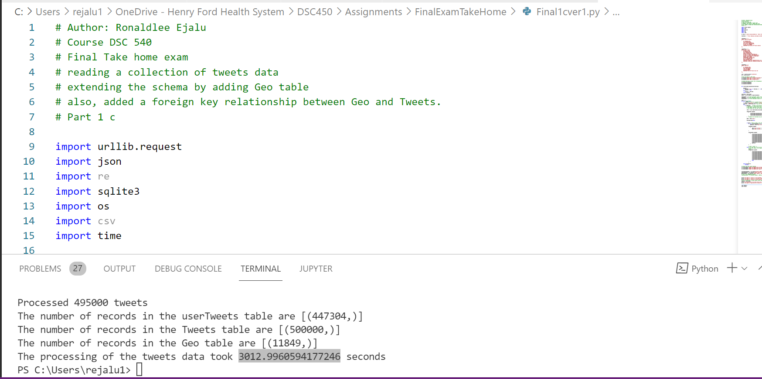

A screenshot showing the runtime of 50,000 tweets being processed when reading the tweet data from the given web URL:

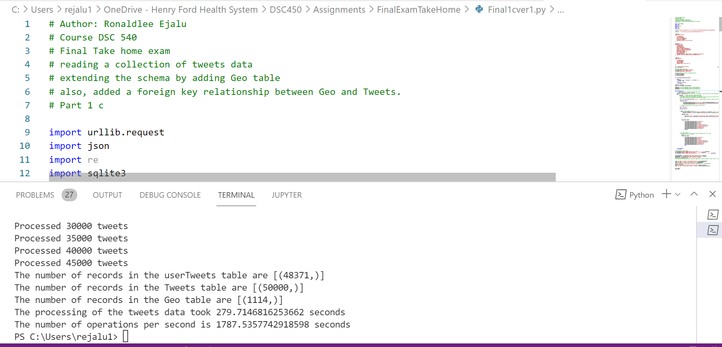

  - Use your locally saved tweet file to repeat the database population step from part-c. That is, load the tweets into the 3-table database using your saved file with tweets. This is the same code as in 1-c, but reading tweets from your file, not from the web.

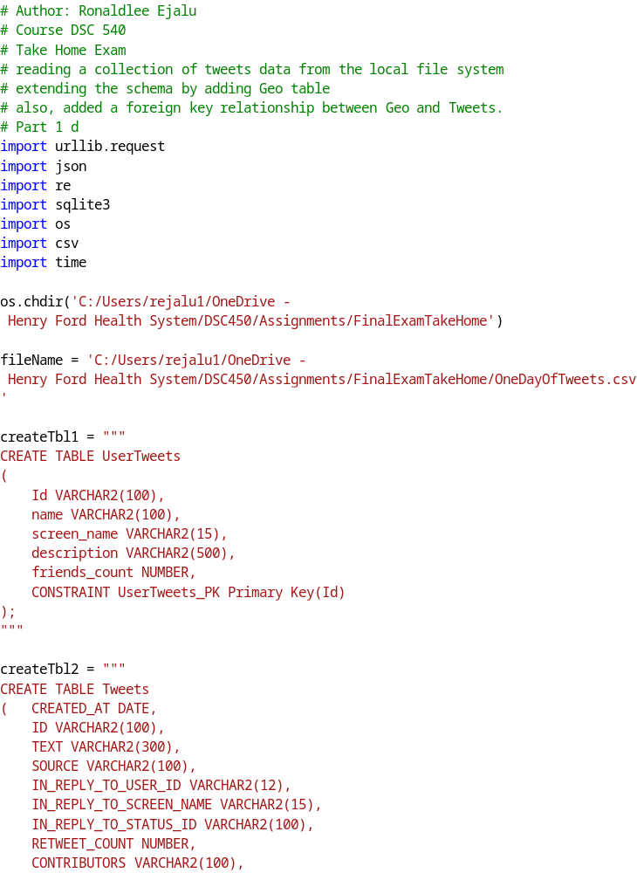
A screen shot showing the run time of 500,000 tweets being processed when reading the tweet data from the local file system:

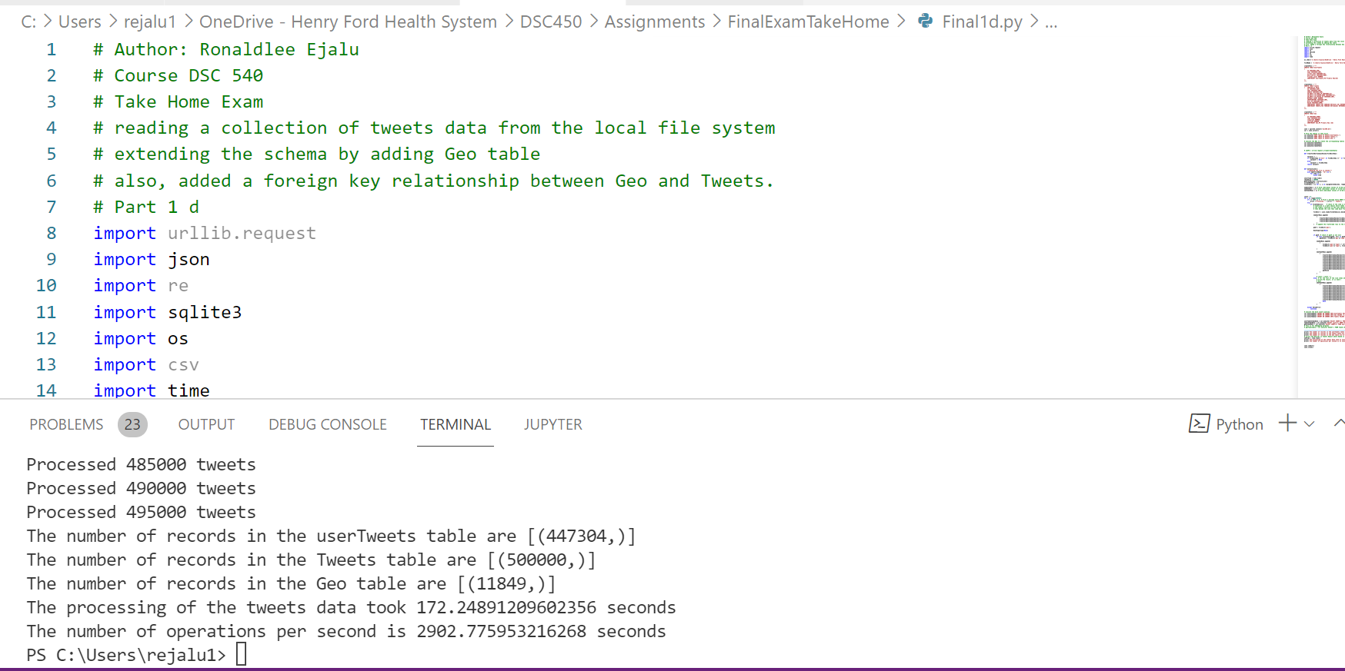

A screen shot showing the run time of 50,000 tweets being processed when reading the tweet data from the local file system:

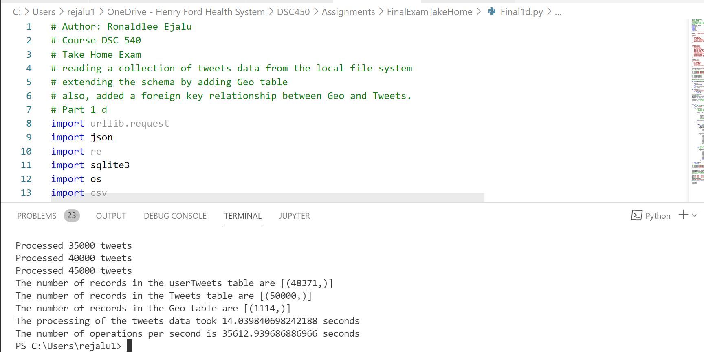

  - Repeat the same step with a batching size of 2000 (i.e. by inserting 2000 rows at a time with executemany instead of doing individual inserts). Since many of the tweets are missing a Geo location, its fine for the batches of Geo inserts to be smaller than 2000.

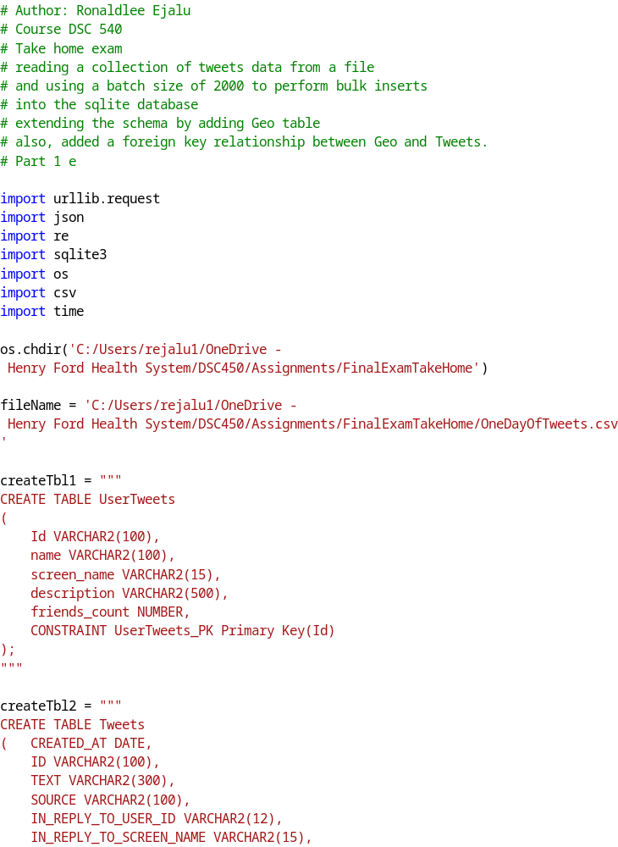
A screen shot showing the run time of 500,000 tweets being processed when a batch size of 2000 records are inserted into sqlite using bulk insert:
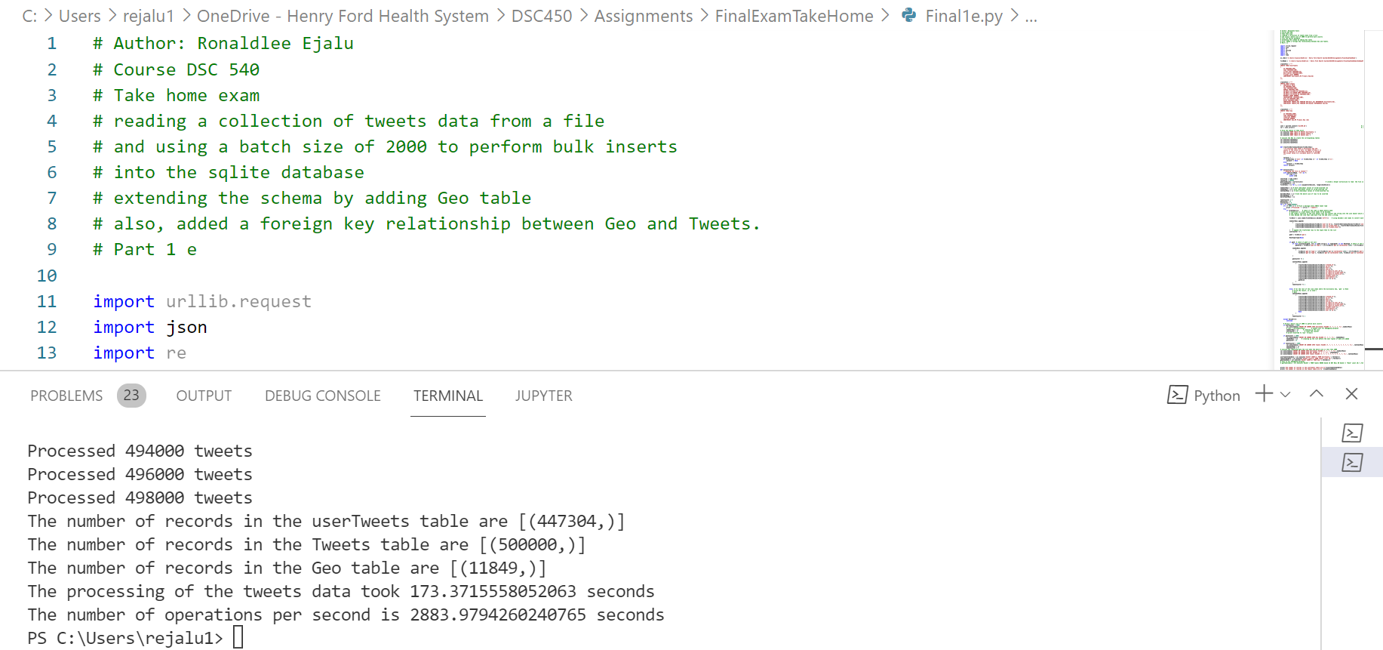

A screen shot showing the run time of 50,000 tweets being processed when a batch size of 2000 records are inserted into sqlite using the bulk insert operation:

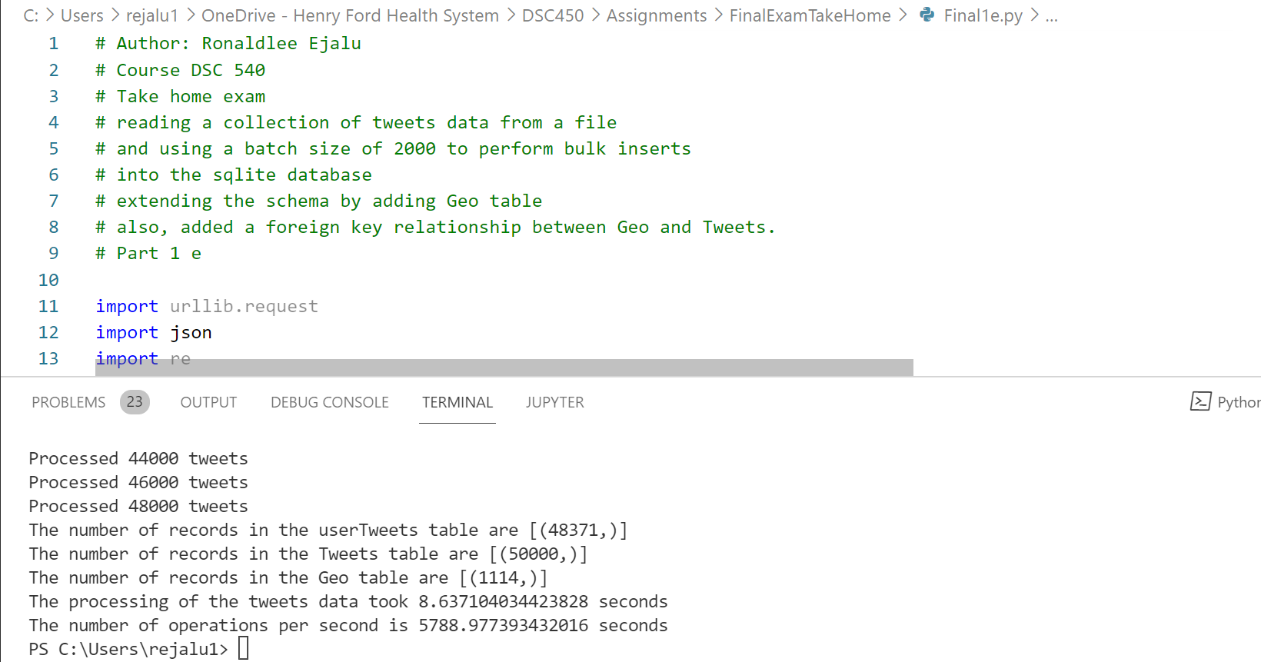

  - Plot the resulting runtimes (# of tweets versus runtimes) using matplotlib for 1-a, 1-c, 1-d, and 1-e. How does the runtime compare?

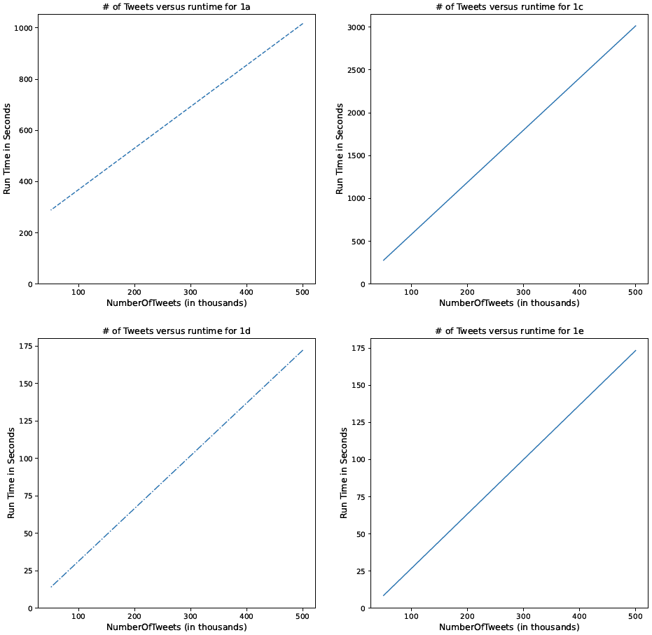

The python code for 1f is below:

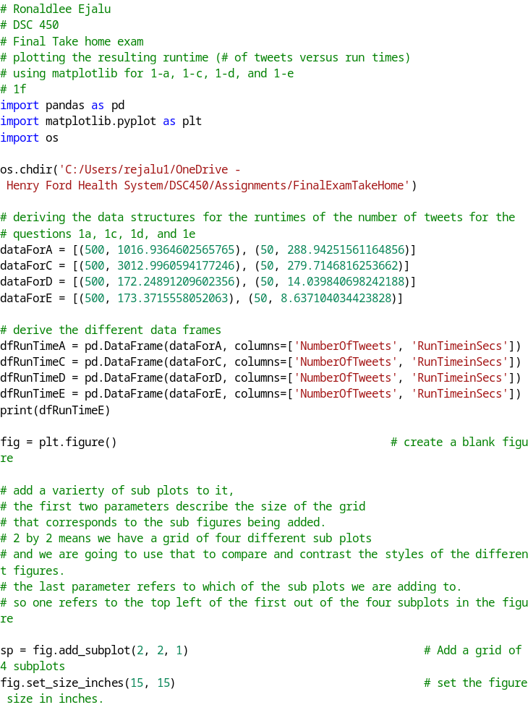

Part 2

- Write and execute a SQL query to find the smallest longitude and latitude value for each user ID. This query does not need the User table because User ID is a foreign key in the Tweet table. E.g., something like SELECT UserID, MIN(longitude), MIN(latitude) FROM Tweet, Geo WHERE Tweet.GeoFK = Geo.GeoID;

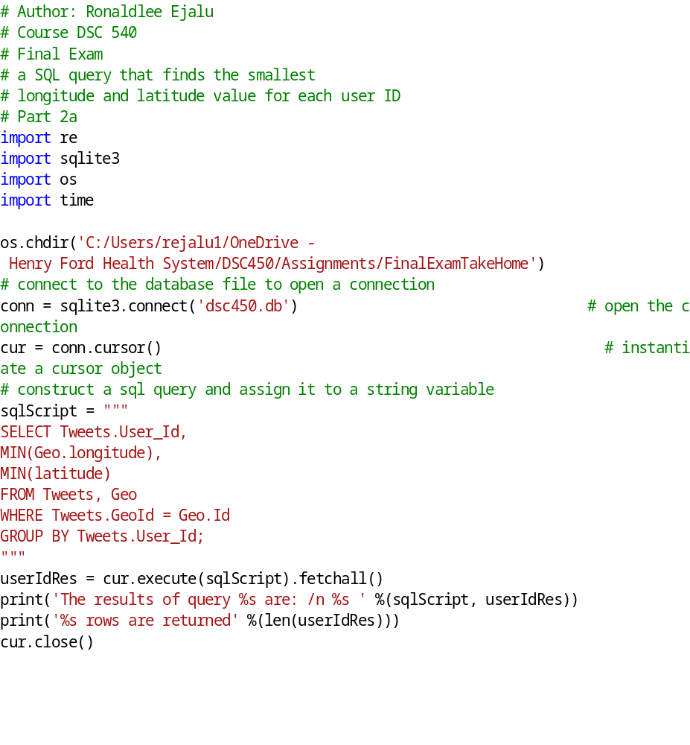

The screenshot of the python execution with the SQL script is below:
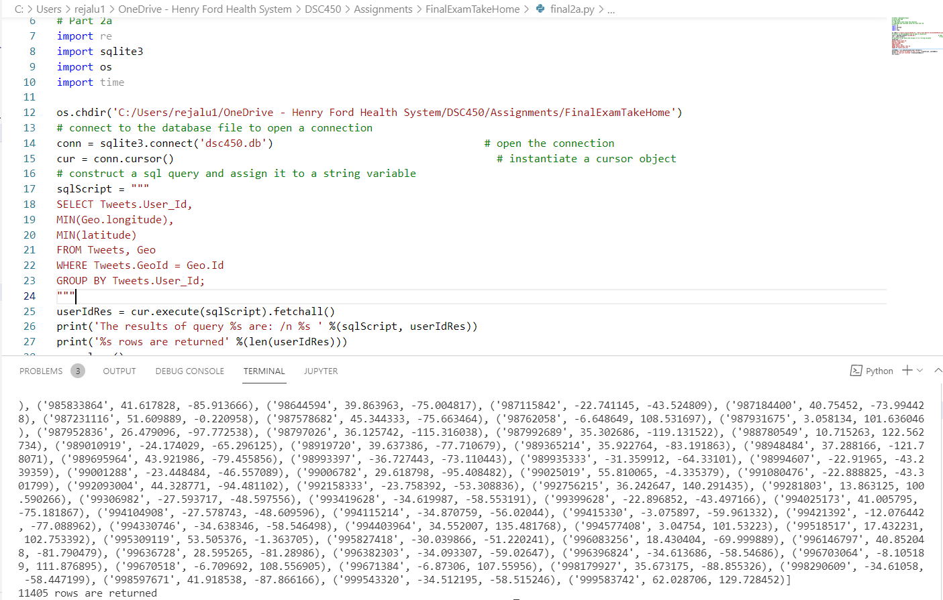

- Re-execute the SQL query in part 2-a 10 times and 100 times and measure the total runtime (just re-run the same exact query multiple times using a for-loop, it is as simple as it looks). Does the runtime scale linearly? (i.e., does it take 10X and 100X as much time?)

The screenshot of the query running 10 times is below:

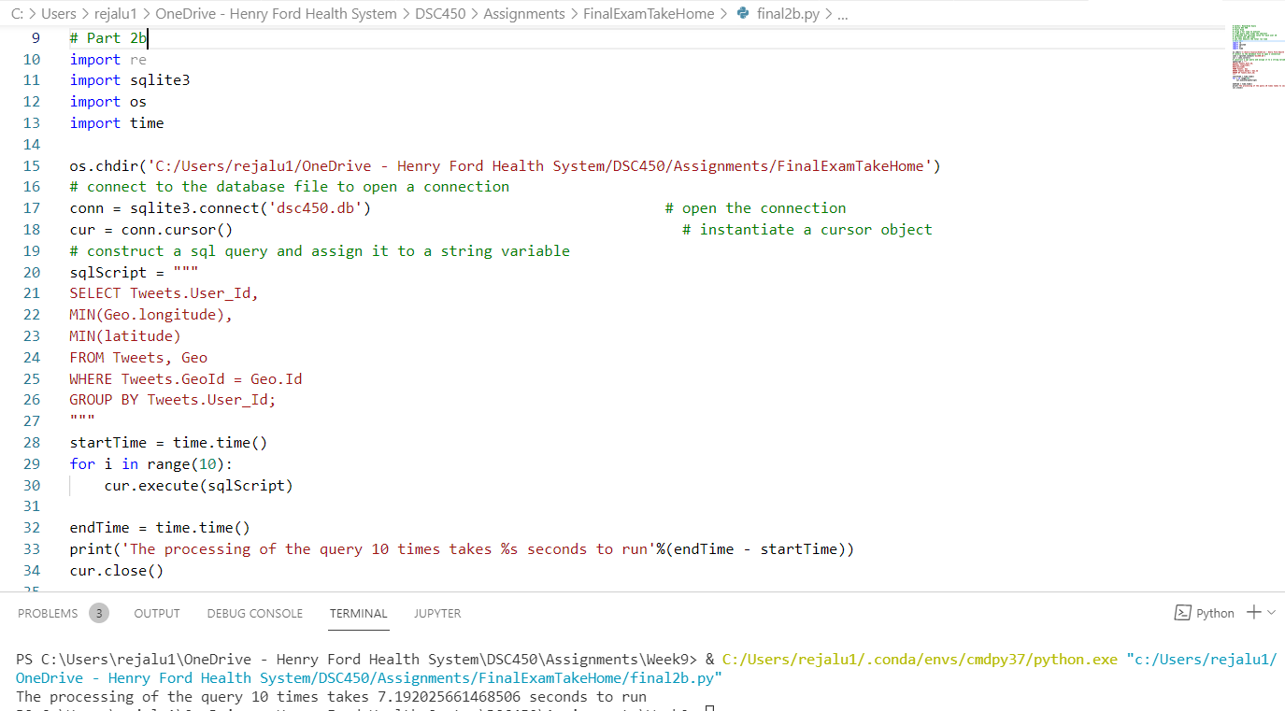

The screenshot of the query running 100 times:

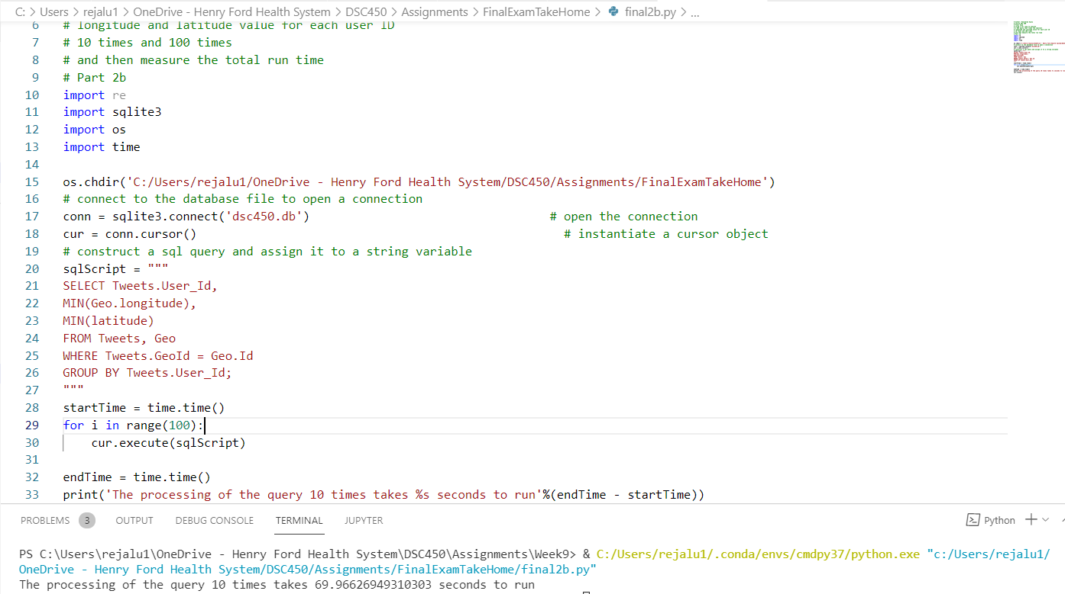

Compared to running it 10 times, which takes 0.1 mins, it takes 1.56 mins more to run it 100 times.

- Write the equivalent of the 2-a query in python (without using SQL) by reading it from the file with 500,000 tweets.

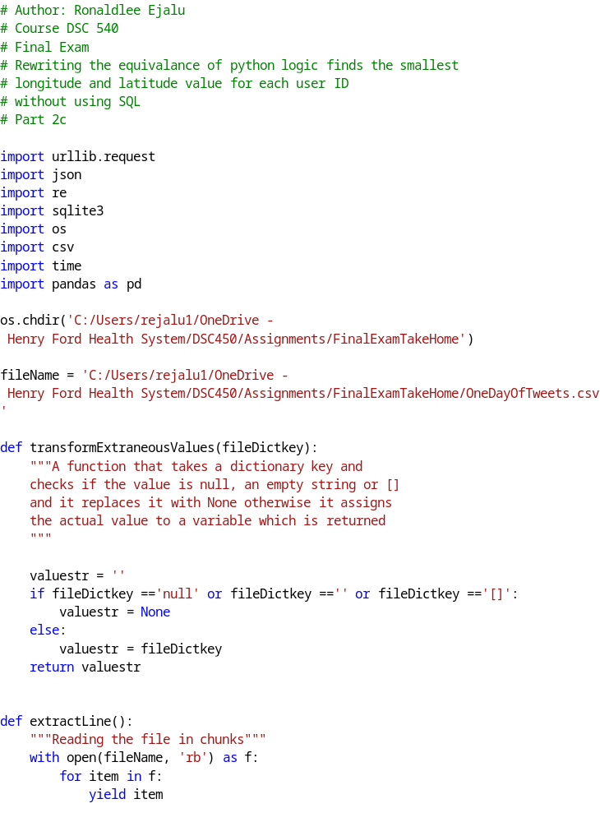
The screenshot of the code run time is below:

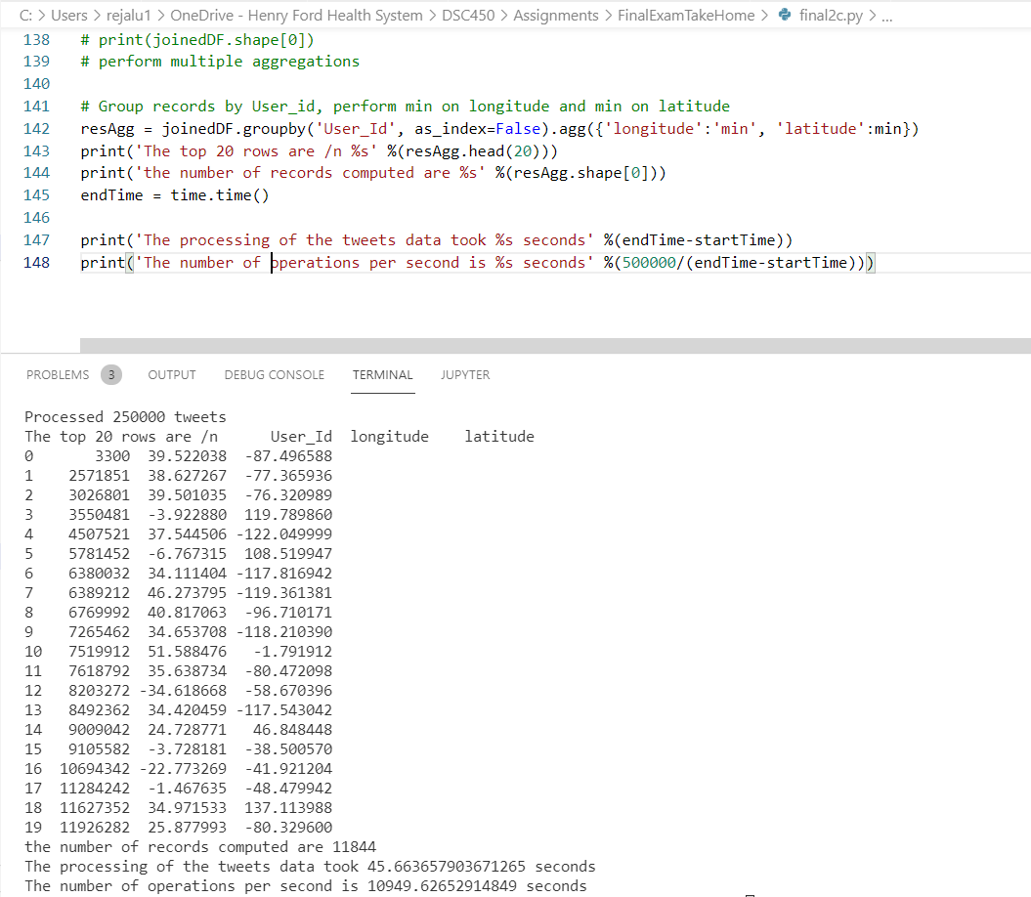

- Re-execute the query in part 2-c 10 times and 100 times and measure the total runtime. Does the runtime scale linearly?

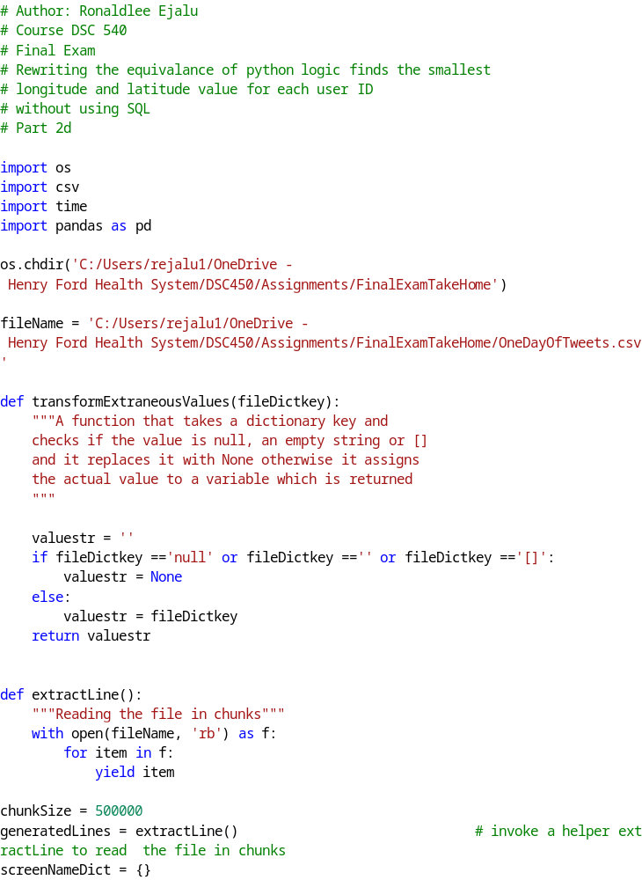

Executing the query in part 2c 10 times:

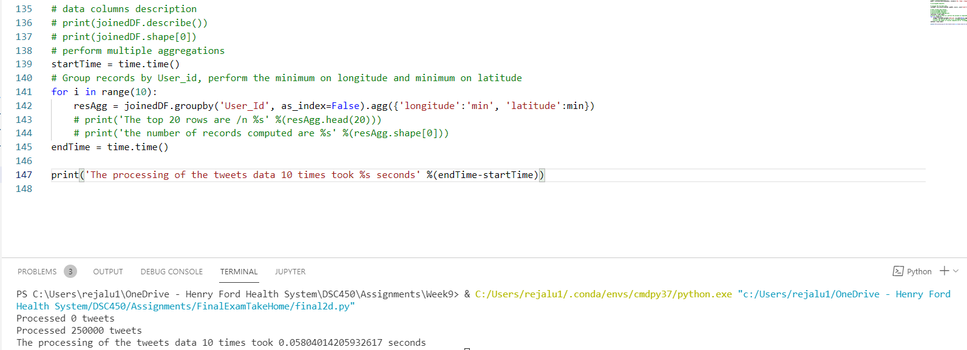

Executing the query in part 2c 100 times:

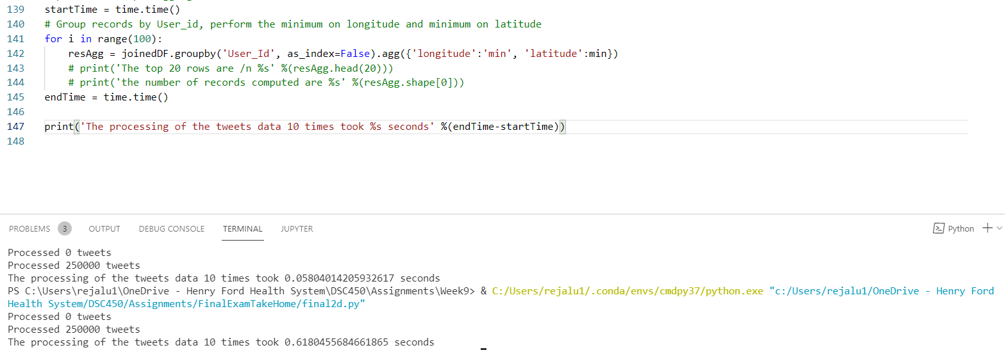

Based on the results of the time, running the query 10 times takes less time to execute when compared to running it 100 times.

- Write the equivalent of the 2-a query in python by using regular expressions instead of json.loads(). Do not use json.loads() here. Note that you only need to find userid and geo location (if any) for each tweet, you don’t need to parse the whole thing.

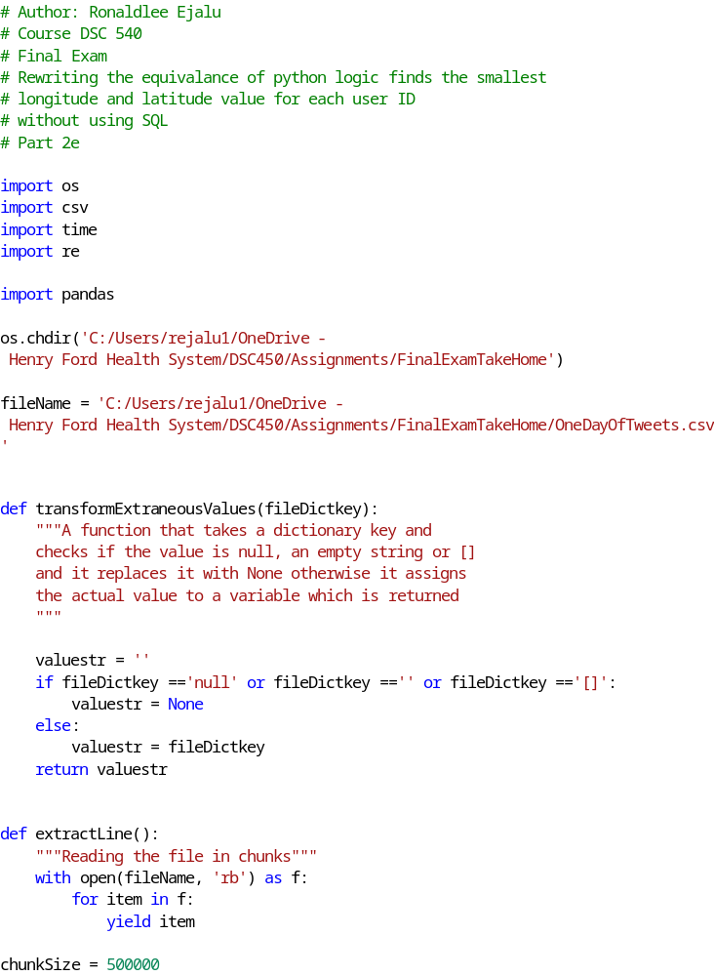

- Re-execute the query in part 2-e 10 times and 100 times and measure the total runtime. Does the runtime scale linearly?

Processing the query in part 2-e 10 times took 32.98 seconds as shown below:

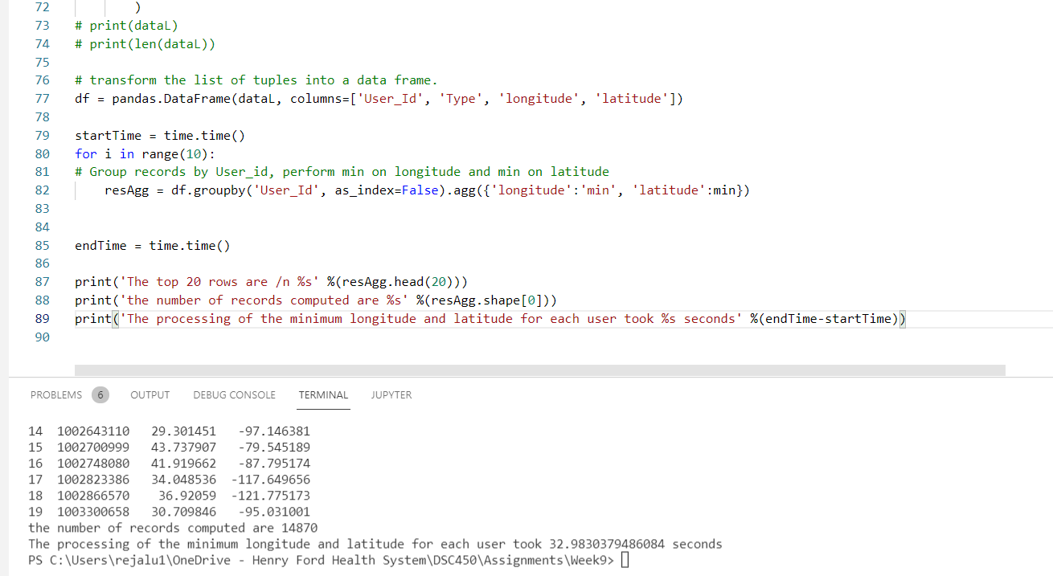

Processing the query in part 2-e 100 times took 352.26 seconds as show below:
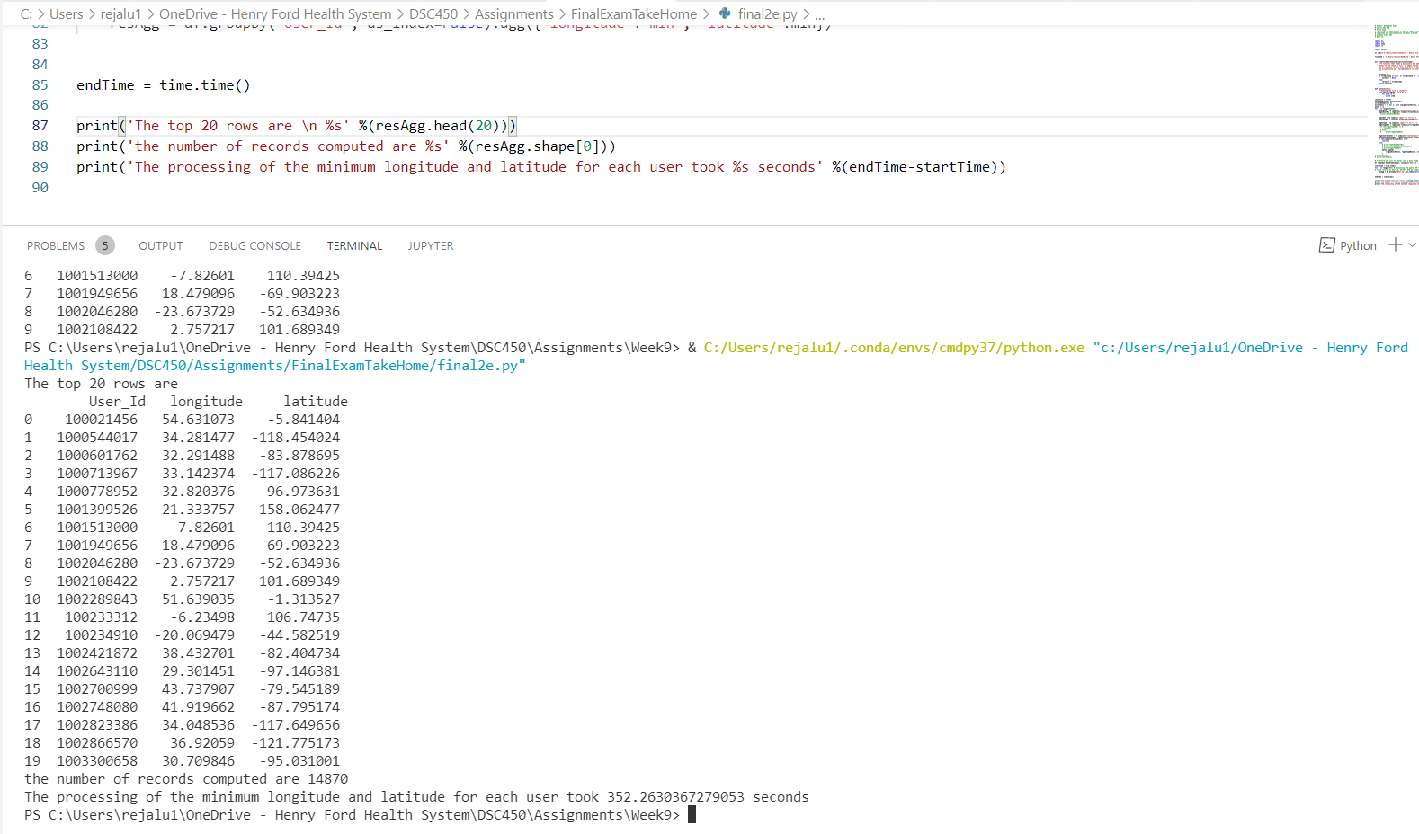

Processing the query 100 times in 2e takes much time to process compared to when the query is processed 10 times.

Part 3

- Using the database with 500,000 tweets, create a new table that corresponds to the join of all 3 tables in your database, including records without a geo location. This is the equivalent of a materialized view but since SQLite does not support MVs, we will use CREATE TABLE AS SELECT (instead of CREATE MATERIALIZED VIEW AS SELECT).

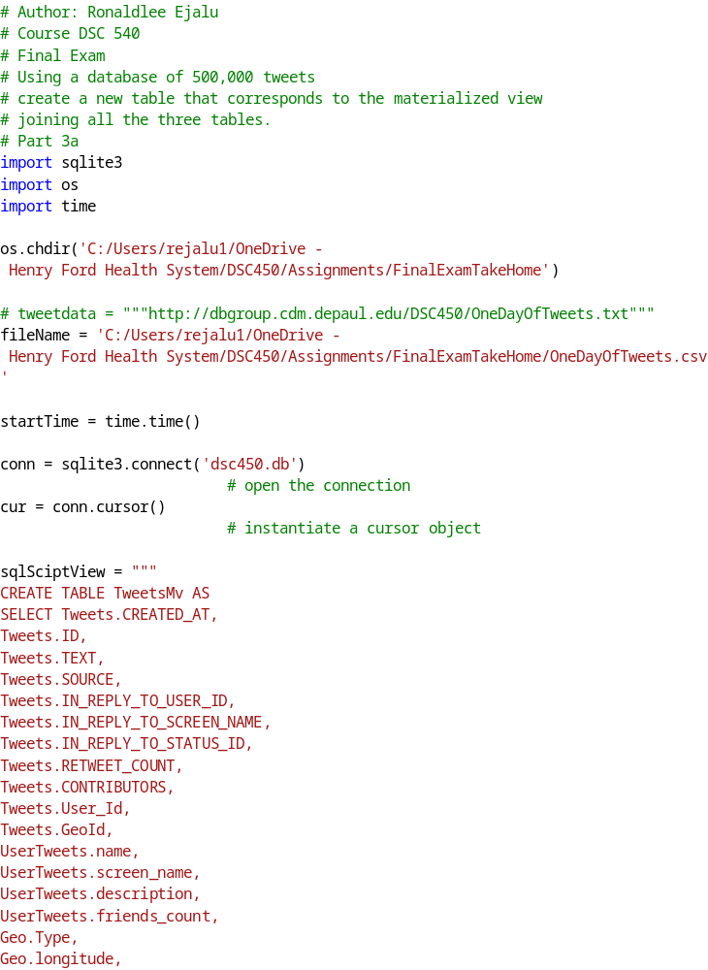
The screenshot of the first 10 records in the view:

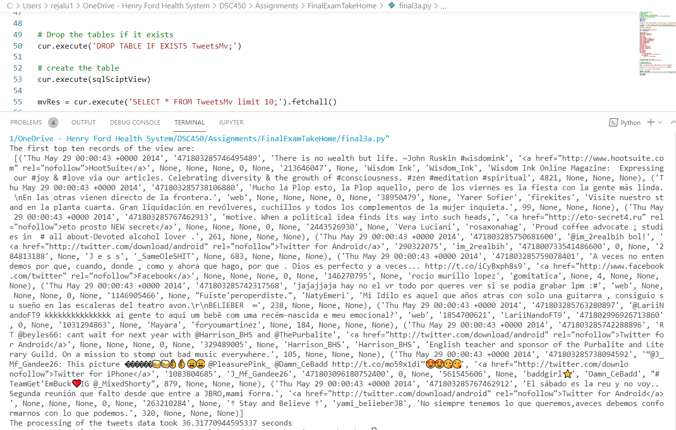

- Export the contents of your table from 3-a into a new JSON file. You do not need to replicate the structure of the input and can come up with any reasonable keys for each field stored in JSON structure (e.g., you can have longitude as “longitude” key when the location is present). How does the file size compare to the original input file?
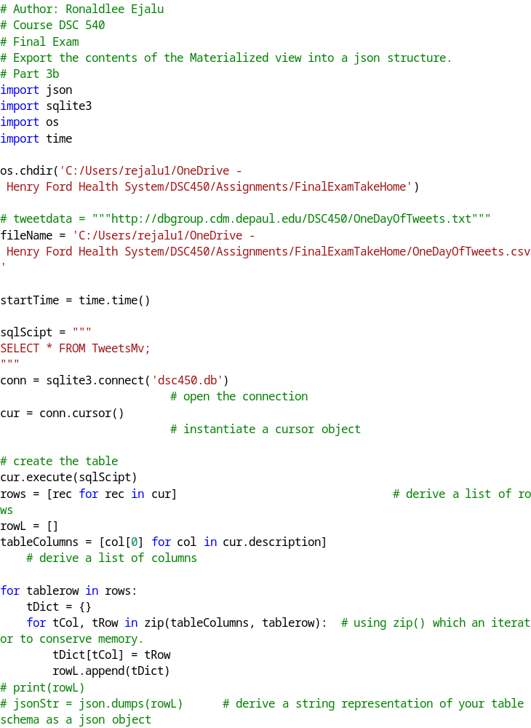
The json file appears much bigger when compared with the original csv file as shown below:

- Export the contents of your table from 3-a into a .csv file. How does the file size compare to the original input file and to the file in 3-b?

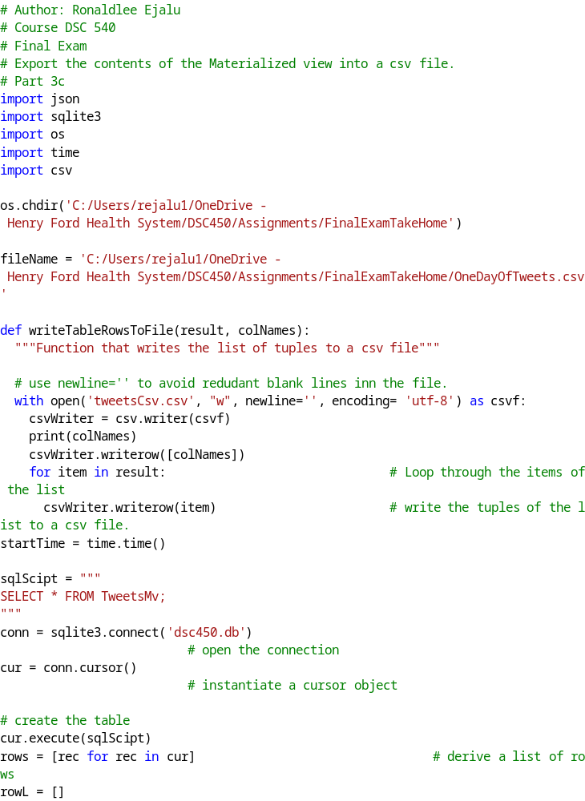
The screen shot of the file size is shown below:

The file size in 3c is smaller than both the original file and generated file in 3b.

