DSC 450: Database Processing for Large-Scale Analytics

Assignment Module 4

Student Name: Ronaldlee Ejalu

Part 1

- Using the extended Zoo database (ZooDatabase_extended.sql), write the following queries in SQL:

- Find all the rare animals and sort the query output by feeding time (from small to large)

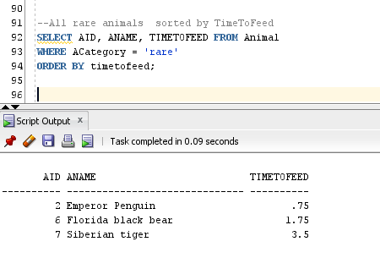
- Find the animal names and categories for animals related to a bear (hint: use the LIKE operator)

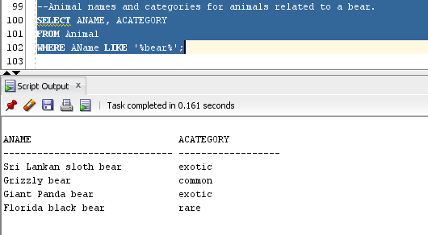

- Find the names of the animals that are related to the tiger and are not common

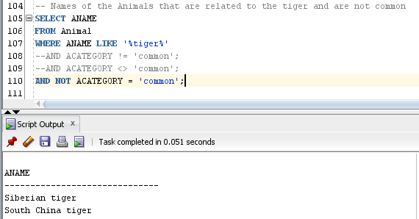

- Find the names of the animals that are not related to the tiger

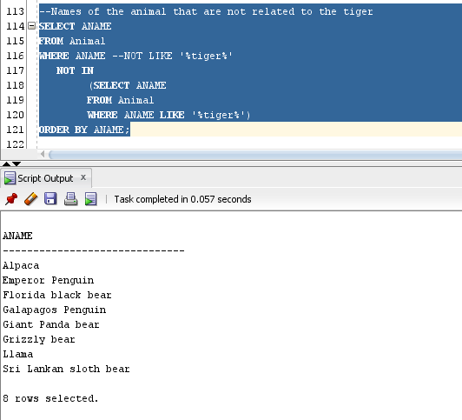

- List the animals (animal names) and the ID of the zoo keeper assigned to them.

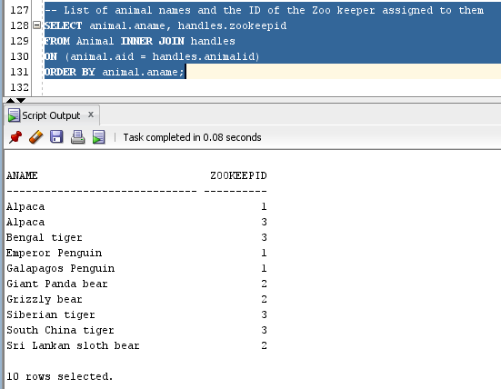

- Now repeat the previous query and make sure that the animals without an assigned handler also appear in the answer.

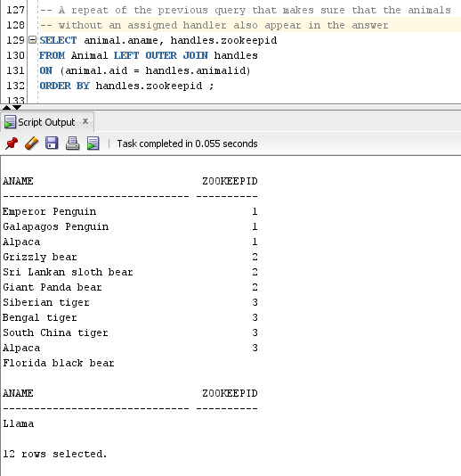

- Report, for every zoo keeper name, the average number of hours they spend feeding all animals in their care.

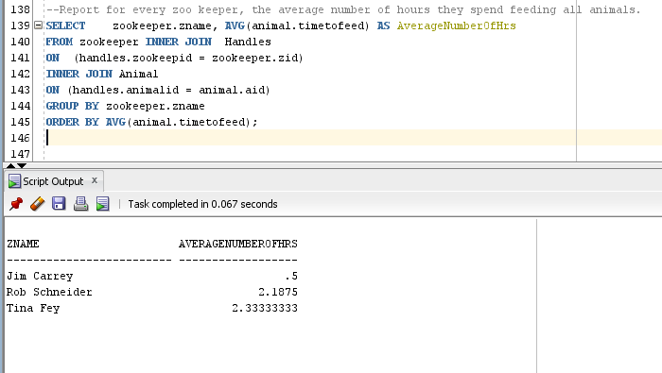

- Report every handling assignment (as a list of assignment date, zoo keeper name and animal name). Sort the result of the query by the assignment date in an ascending order.

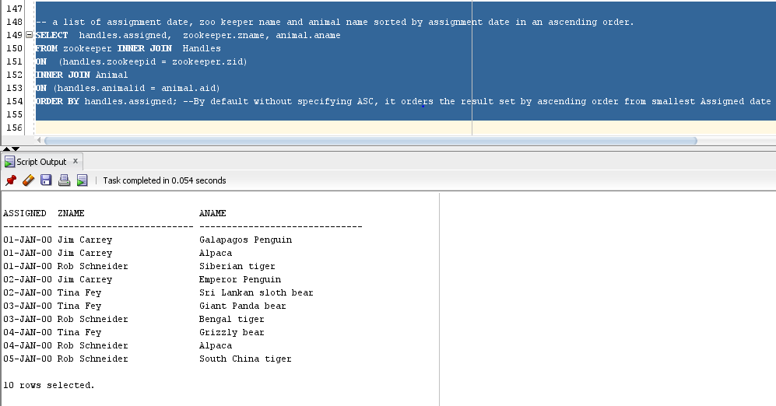

- Repeat the following queries using python (i.e., by reading data from animal.txt, without using a database)

Python Code:
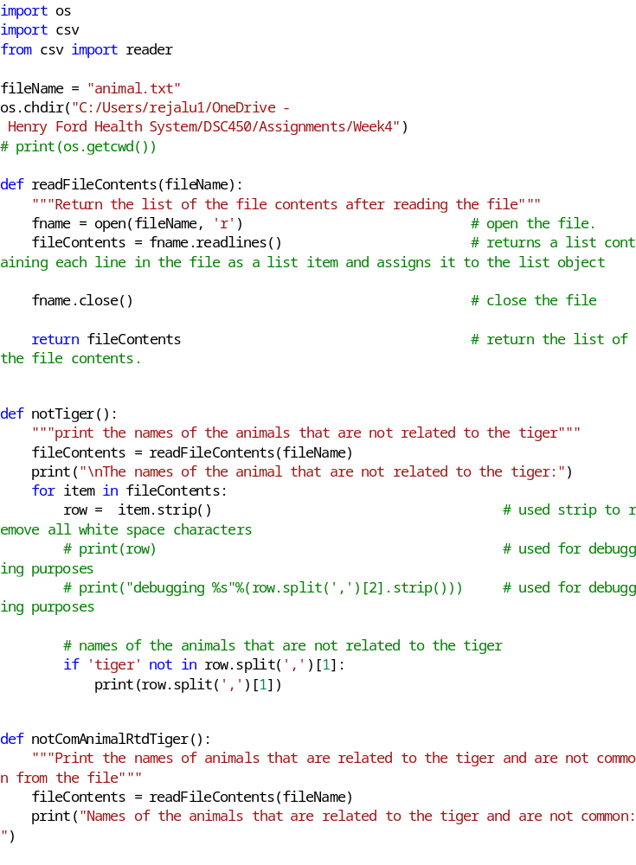

- Find the names of the animals that are related to the tiger and are not common

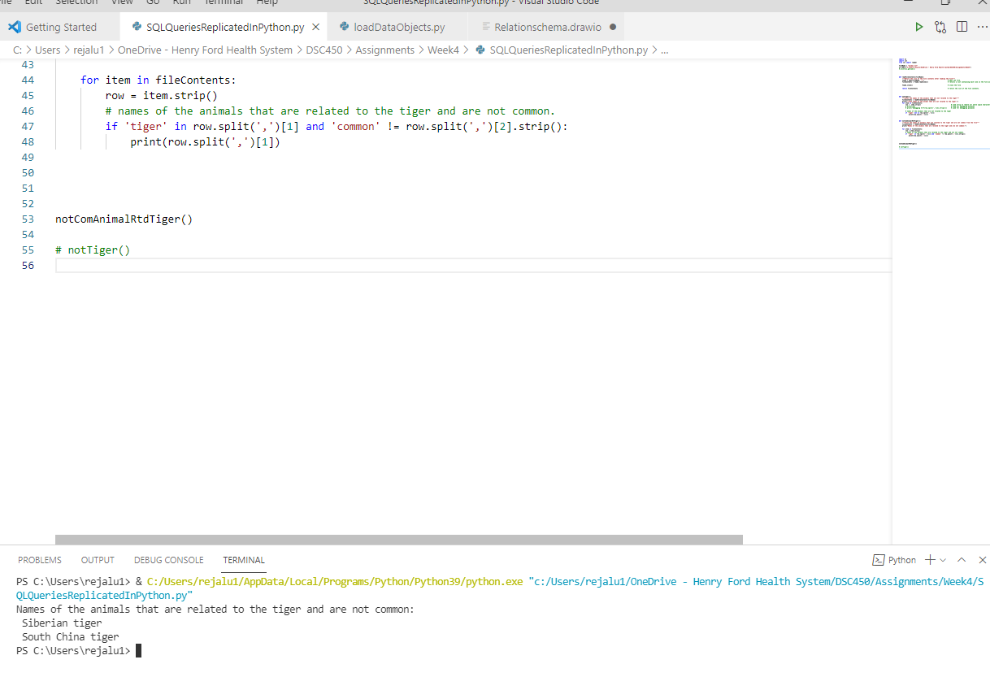

- Find the names of the animals that are not related to the tiger

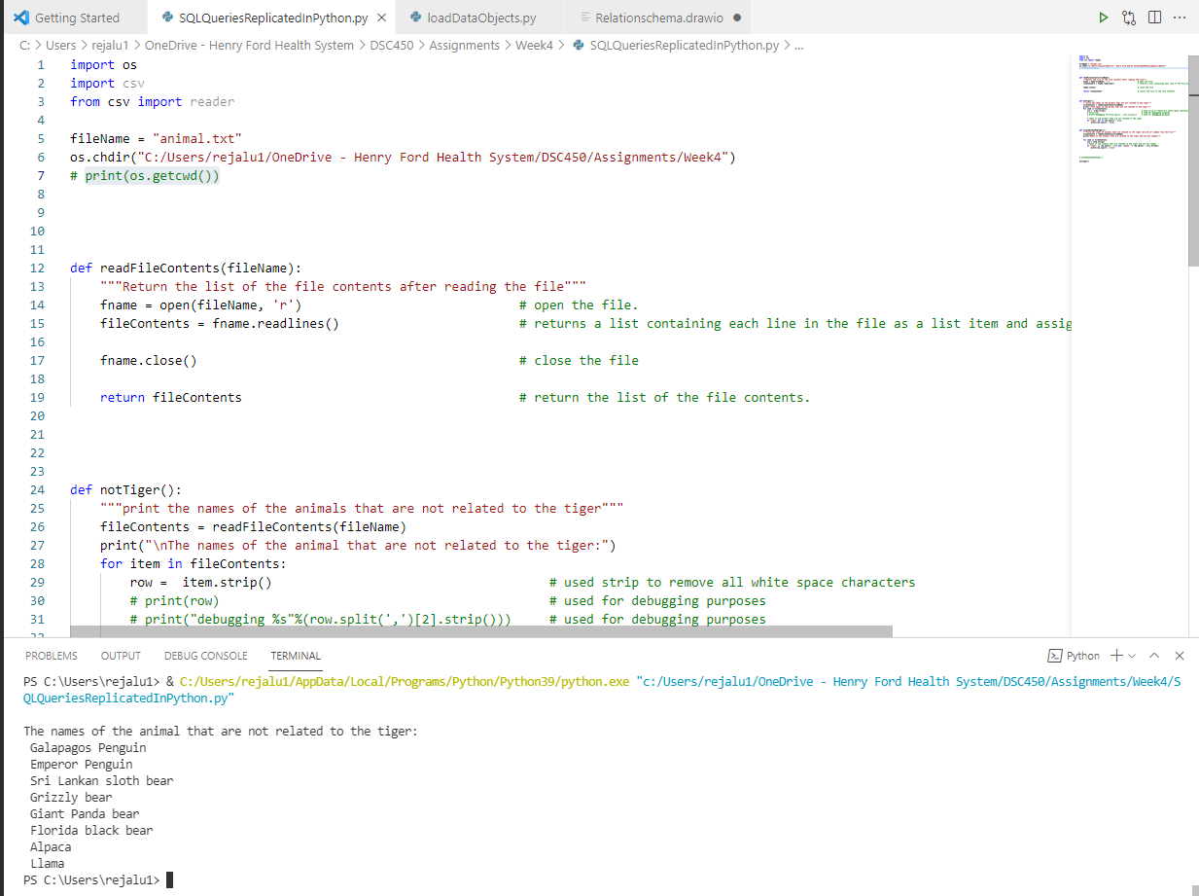

Part 2

- You are given a following schema in 1NF:
(First, Last, Address, Job, Salary, Assistant) and the following set of functional dependencies:

First, Last → Address
Job → Salary, Assistant

Decompose the schema to make sure it is in Third Normal Form (3NF).

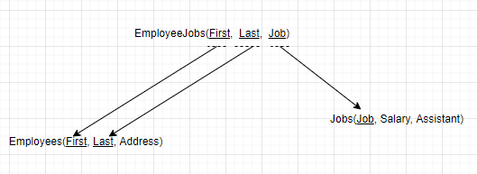

- Write the necessary SQL DDL statements (CREATE TABLE) to define these the tables you created.

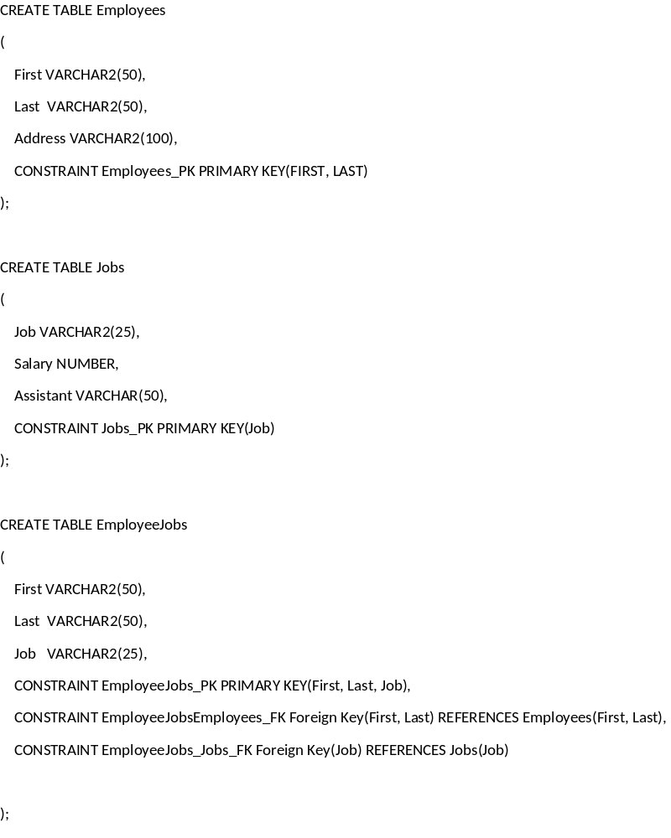

- Write a python script that is going to create your tables and populate them with data automatically from data_module4_part2.txt (file attached). You do not have to use executemany, your python code can load data row-by-row. Make sure that you are inserting a proper NULL into the database. HINT: You can use INSERT OR IGNORE statement (instead of a regular INSERT statement) in SQLite to skip over duplicate primary key inserts without throwing an error.

For example:
cursor.execute("INSERT OR IGNORE INTO Animal VALUES(?,?,?,?)", [11, 'Llama', None, 3.5]);
would automatically ignore the insert if animal with ID 11 already exists in the database and insert a NULL into the third column. If you use ‘NULL’ value instead, animal category would be set to the 4-character string ‘NULL’

Python Code:

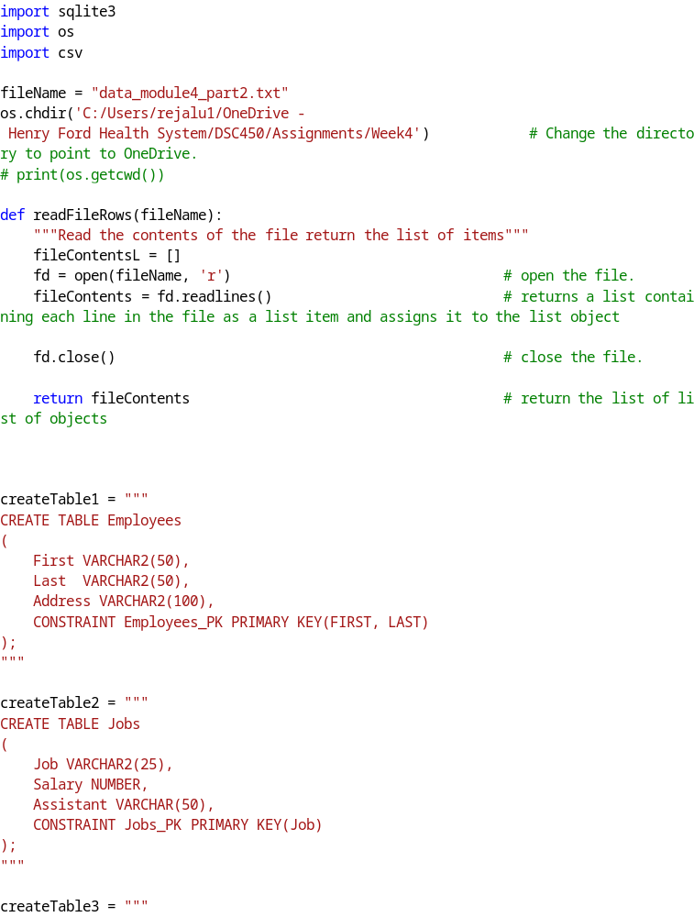
Screenshots of the above Python code running:

