DSC 450: Database Processing for Large-Scale Analytics

Assignment Module 5

Name: Ronaldlee Ejalu

Part 1

  - Write a function to generate a list of x random numbers, where x is the parameter indicating how many numbers to generate. Each generated number should randomly fall in the range between 31 and 100.
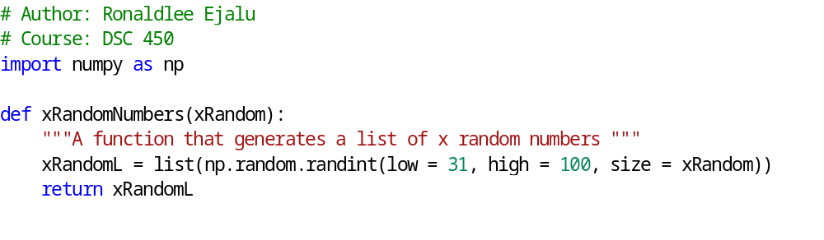
  - Use your function from 1-a to create a list of 60 random numbers with your code and use pandas.Series to determine how many of the numbers are below 37

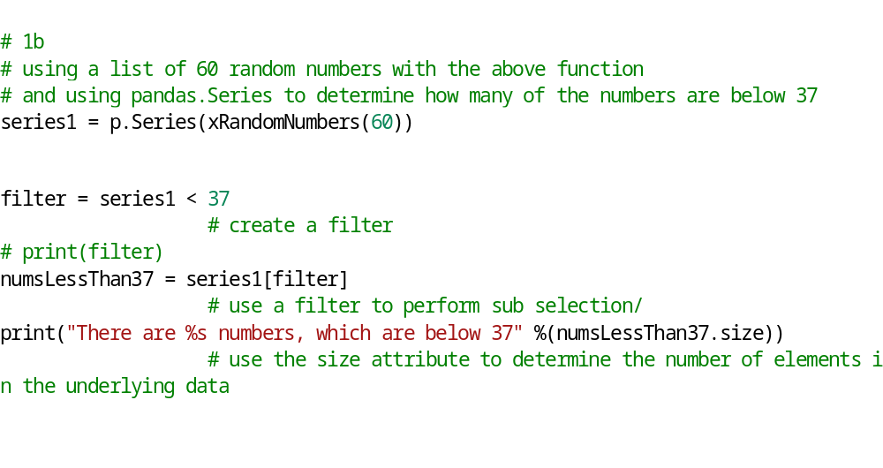

  - Using the same list of 60 random numbers, 1) create a numpy array, modify it to 6x10 (you can do this by calling numpy.reshape(yourArray, (6,10)) and then replace all the numbers that are greater than or equal to 50 (50-100) by 50.
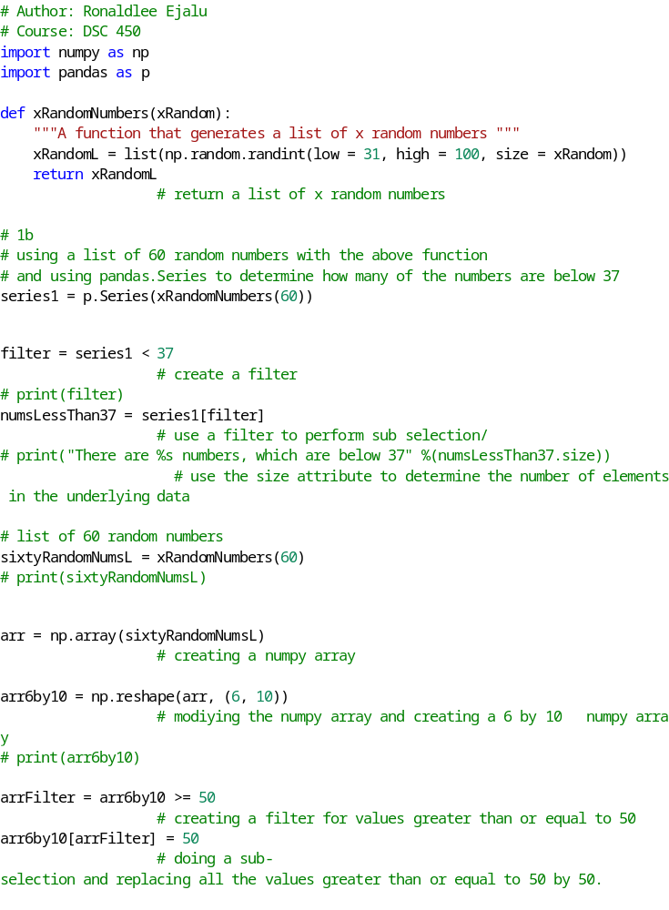

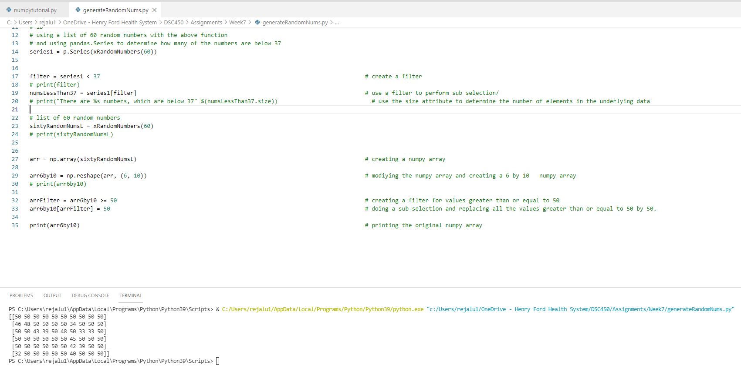

Part 2

In this part we are going to work with a larger collection of tweets (10,000) that are available here.
https://dbgroup.cdm.depaul.edu/DSC450/Module7.txt

The tweets are all on separate lines, but some of the tweets are intentionally damaged and will not parse properly. You will need to store these tweets in a separate “error” file. At the bottom of the page you can find python code that will let you skip over badly formed tweets.

  - Create a new SQL table for the user dictionary. It should contain the following attributes “id”, “name”, “screen_name”, “description” and “friends_count”. Modify your SQL table from Module 5 to include “user_id” columns which will be a foreign key referencing the user table.

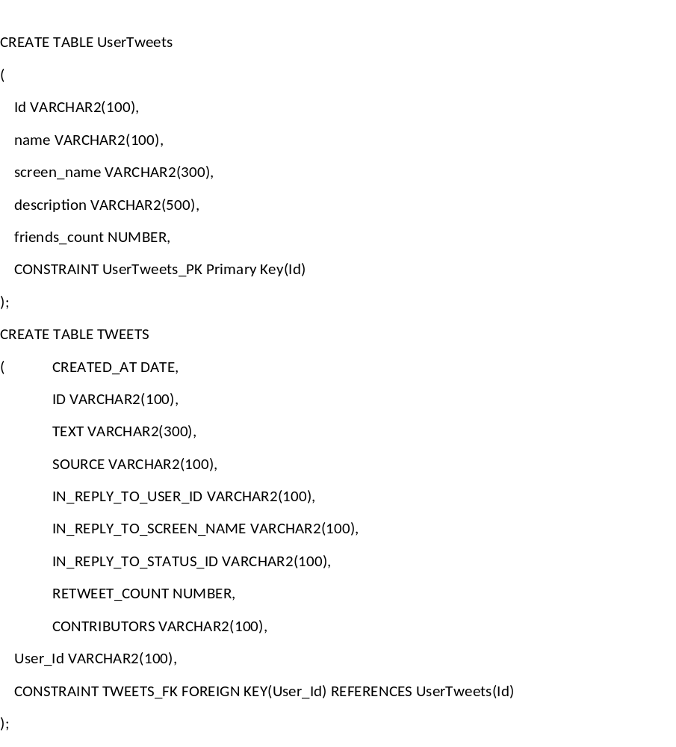

  - Write python code that is going to read and load the Module7.txt file directly from the web and populate both of your tables (Tweet table from Module5 and User table from this assignment). You can use the same code from the previous assignment with an additional step of inserting data into the newly created table.
For tweets that could not parse, write them into a Module7_errors.txt file.

You can gracefully catch JSON errors using the following code:

for tweet in allTweets:
try:
tdict = json.loads(tweet.decode('utf8'))
except ValueError:
# Handle the problematic tweet, which in your case would require writing it to another file
print (tweet)

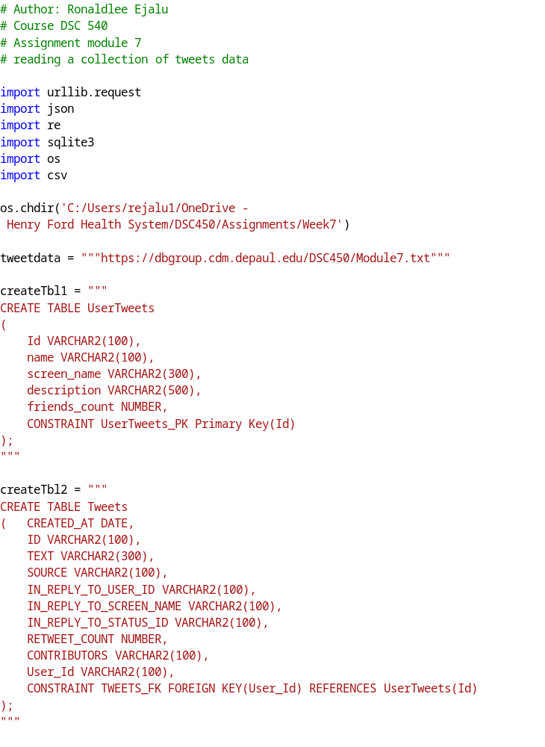
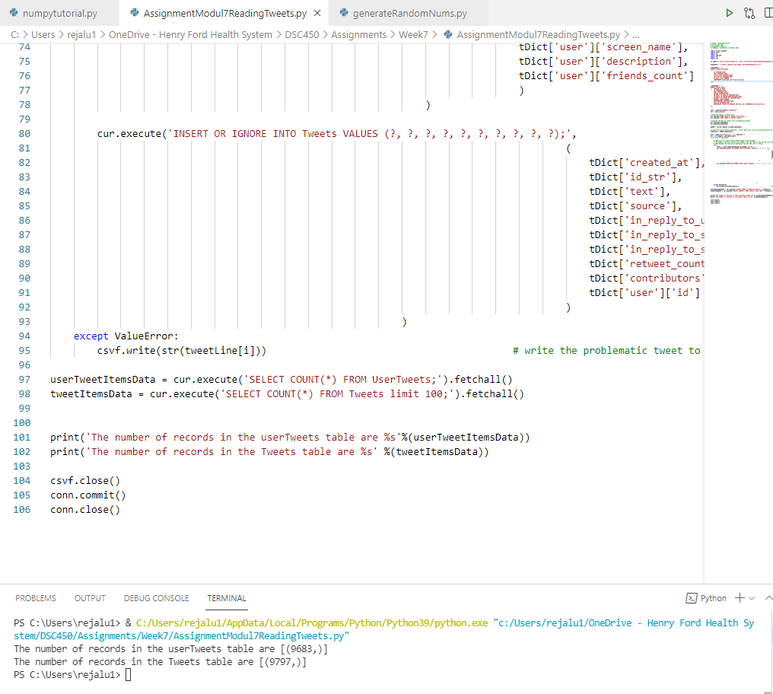

The screen shot of the error file:

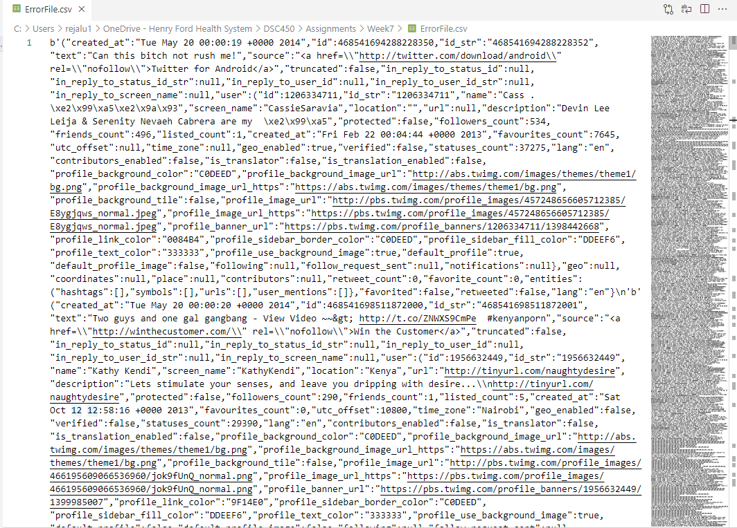

Part 3

- Write a PL/SQL trigger that will cap the course number column in the university.sql database at 598. That is, any time an update or an insert would provide course number 599 or higher, automatically reset the value back to 598. Be sure to verify that your trigger is working with some sample data.

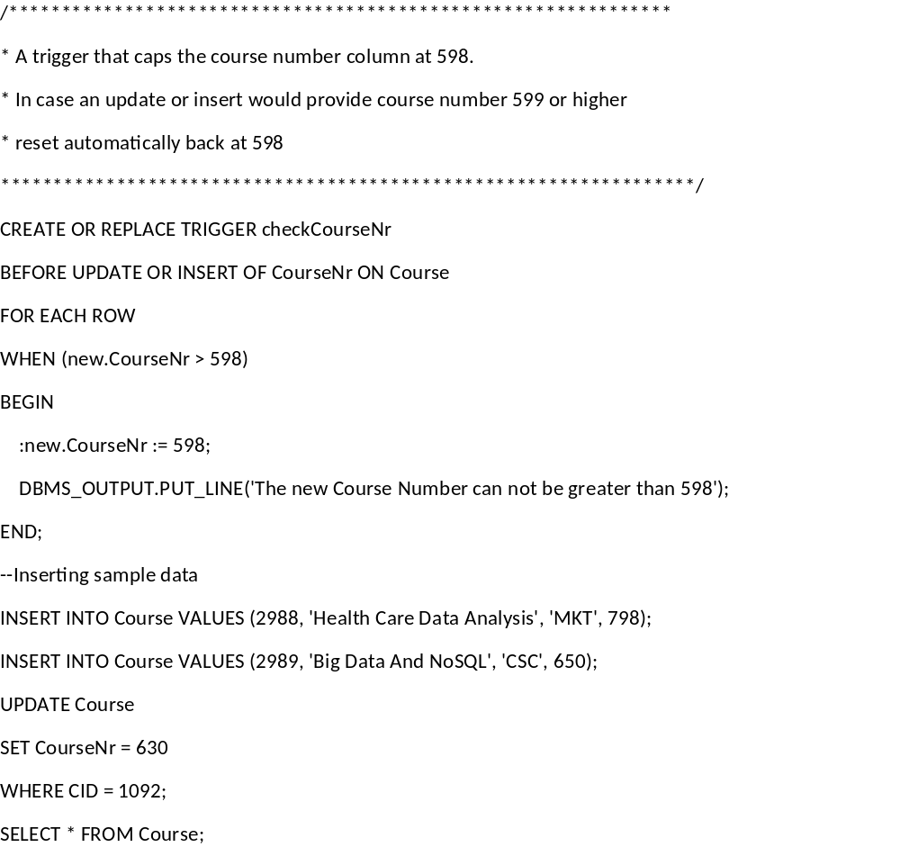
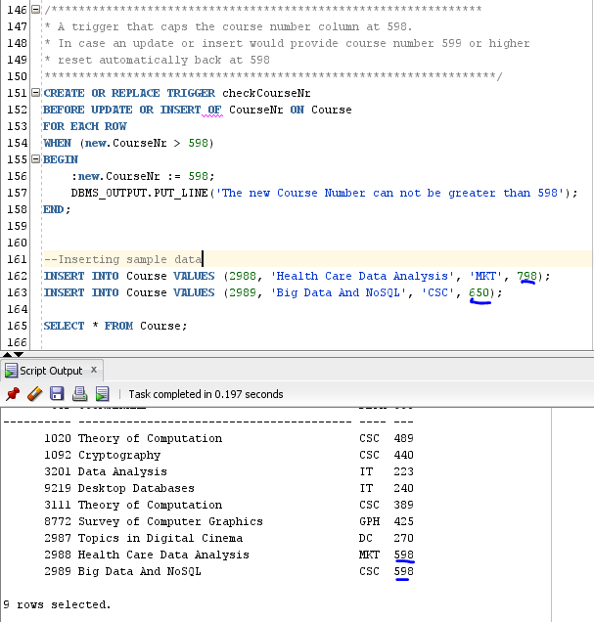

The course number column was automatically reset to 598 during the insertion process by the trigger.

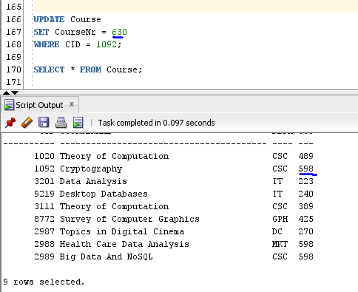

The update process tried to an update the Course number ,440, of the course id 1092 to 630, but it was automatically reset back to 598.

- Write a regular expression to match credit card numbers, assuming a 16-digit credit card that may or may not include spaces after each 4 digits. Create the code to validate that your regular expression works in either python or Oracle.

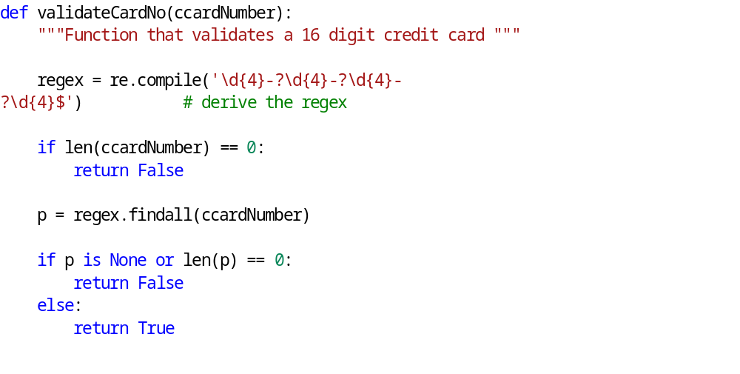
The screen shots of the sample credit card numbers:

