DSC 450: Database Processing for Large-Scale Analytics

Assignment Module 9

Student Name: Ronaldlee Ejalu
Part 1

Using the same tweets from: https://dbgroup.cdm.depaul.edu/DSC450/Module7.txt

Create a third table, now incorporating the Geo table (in addition to tweet and user tables that you already have) and extend your schema accordingly. You do not need to use ALTER TABLE, it is sufficient to just re-create (drop and create) your schema.
You will need to generate an ID for the Geo table primary key (you may use any value or reasonable combination of values as long as it is unique) for that table and link it to the Tweet table (foreign key should be in the Tweet). However, that value should be related to the location (i.e., same value for same location) – do not use a simple incremental key or a random key.
In addition to the primary key column, the geo table should have the “type”, “longitude” and “latitude” columns. NOTE: that there are no longitude/latitude dictionary keys. Instead, the geo dictionary has a 2-value tuple which are the lon/lat coordinates.
Load the tweet data into your new tables.

Python Code:
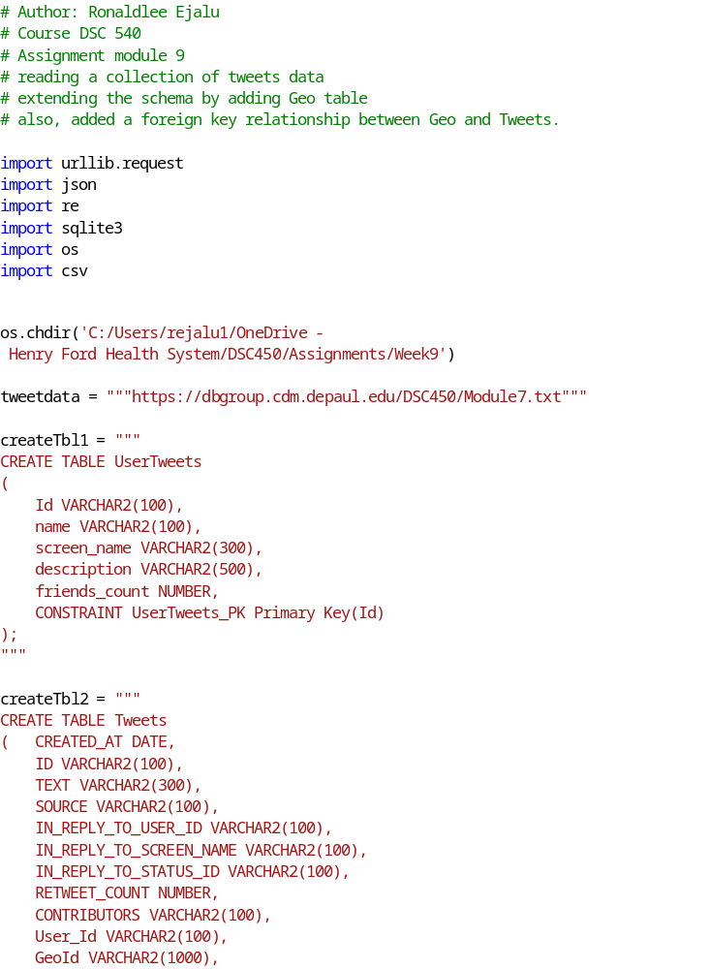

  - Write and execute a SQL query to do the following. Time and report the runtime of your query. Find tweets where tweet id_str contains “888” or “77” anywhere in the column

Python Code is below:

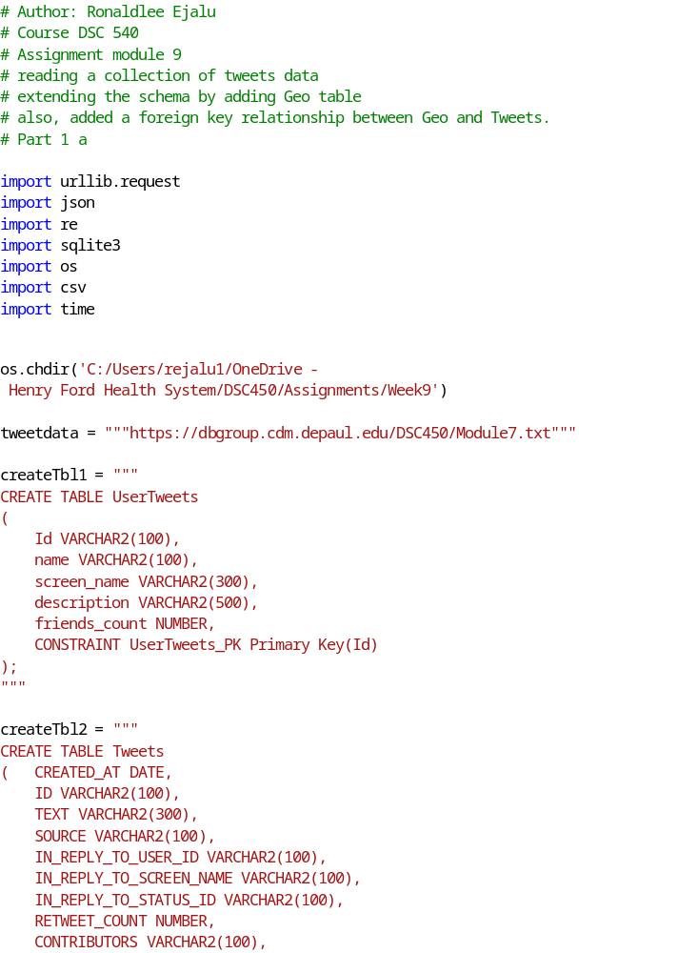

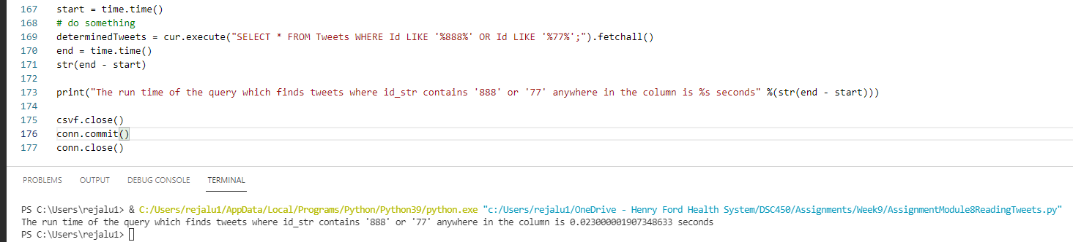

  - Write the equivalent of the previous query in python (without using SQL) by reading it from the file. Time and report the runtime of your query.

The code shown below:

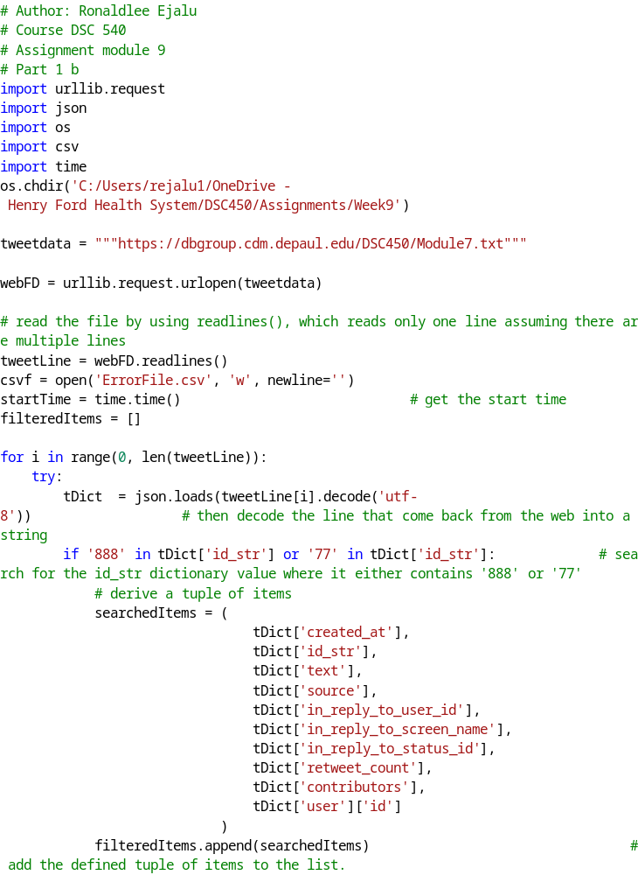
Below is the output screenshot:
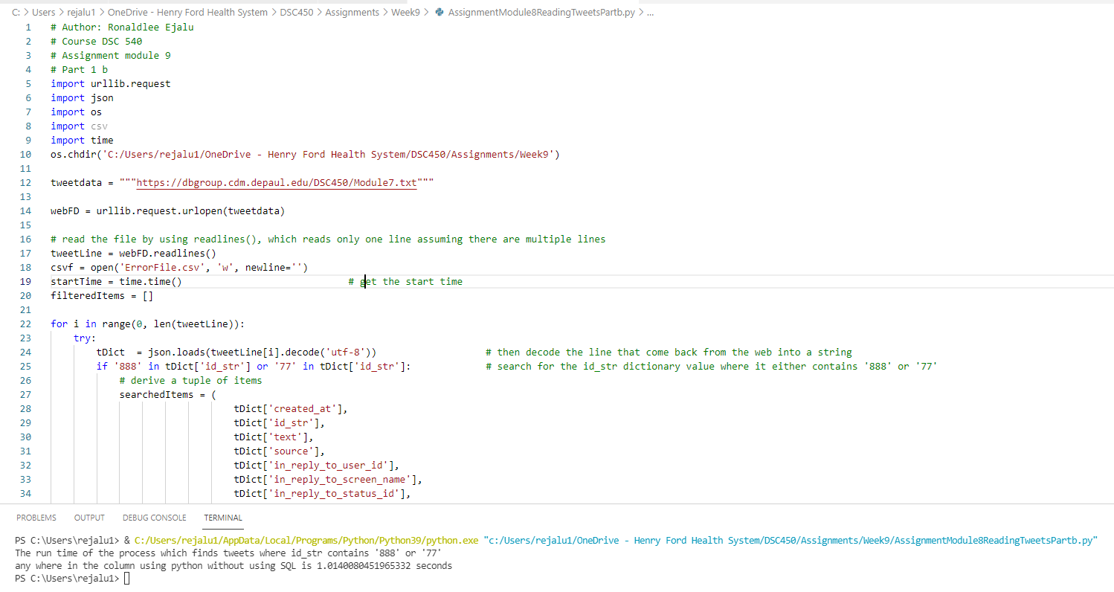

  - Write and execute a SQL query to do the following. Time and report the runtime of your query.

Find how many unique values are there in the “in_reply_to_user_id” column

# Author: Ronaldlee Ejalu
# Course DSC 540
# Assignment module 9
# reading a collection of tweets data
# extending the schema by adding Geo table
# also, added a foreign key relationship between Geo and Tweets.
# Part 1 c

import urllib.request
import json
import re
import sqlite3
import os
import csv
import time

os.chdir('C:/Users/rejalu1/OneDrive - Henry Ford Health System/DSC450/Assignments/Week9')

tweetdata = """https://dbgroup.cdm.depaul.edu/DSC450/Module7.txt"""

createTbl1 = """
CREATE TABLE UserTweets
(
Id VARCHAR2(100),
name VARCHAR2(100),
screen_name VARCHAR2(300),
description VARCHAR2(500),
friends_count NUMBER,
CONSTRAINT UserTweets_PK Primary Key(Id)
);
"""

createTbl2 = """
CREATE TABLE Tweets
( CREATED_AT DATE,
ID VARCHAR2(100),
TEXT VARCHAR2(300),
SOURCE VARCHAR2(100),
IN_REPLY_TO_USER_ID VARCHAR2(100),
IN_REPLY_TO_SCREEN_NAME VARCHAR2(100),
IN_REPLY_TO_STATUS_ID VARCHAR2(100),
RETWEET_COUNT NUMBER,
CONTRIBUTORS VARCHAR2(100),
User_Id VARCHAR2(100),
GeoId VARCHAR2(1000),
CONSTRAINT TWEETS_FK1 FOREIGN KEY(User_Id) REFERENCES UserTweets(Id),
CONSTRAINT TWEETS_FK2 FOREIGN KEY(GeoId) REFERENCES Geo(Id)
);
"""

createTbl3 = """
CREATE TABLE Geo
(
Id VARCHAR2(1000),
Type VARCHAR2(50),
longitude NUMBER,
latitude NUMBER,
CONSTRAINT Geo_PK Primary Key (Id)
);
"""

conn = sqlite3.connect('dsc450.db') # open the connection
cur = conn.cursor() # instantiate a cursor object

# Drop the tables if they exist
cur.execute('DROP TABLE IF EXISTS UserTweets;')
cur.execute('DROP TABLE IF EXISTS Tweets;')
cur.execute('DROP TABLE IF EXISTS Geo;')

# execute the DDL to create the corresponding tables
cur.execute(createTbl1)
cur.execute(createTbl3)
cur.execute(createTbl2)

webFD = urllib.request.urlopen(tweetdata)

# read the file by using readlines(), which reads only one line assuming there are multiple lines
tweetLine = webFD.readlines()

csvf = open('ErrorFile.csv', 'w', newline='')
count = 0
for i in range(0, len(tweetLine)):
try:
if tweetLine[i]: # check if the item is empty before hand
# tweetLine is a byte object which needs to be decoded.
# the loads() function in the json object lets you convert the string into the json object which acts like a dictionary.
# then decode the line that come back from the web into a string.

tDict = json.loads(tweetLine[i].decode('utf-8')) # then decode the line that come back from the web into a string
# print(type(tDict))

cur.execute('INSERT OR IGNORE INTO UserTweets VALUES (?, ?, ?, ?, ?);',
(
tDict['user']['id'],
tDict['user']['name'],
tDict['user']['screen_name'],
tDict['user']['description'],
tDict['user']['friends_count']
)
)

geoV = tDict['geo']
if geoV is not None and (not isinstance(geoV, str) or geoV.strip()): # Check if the key is not None neither is it a string or blanck string
geoValue = tDict['geo']['type'] + str(tDict['geo']['coordinates'][0]) + str(tDict['geo']['coordinates'][1])

cur.execute('INSERT OR IGNORE INTO Geo VALUES (?, ?, ?, ?);',
(
geoValue,
tDict['geo']['type'],
tDict['geo']['coordinates'][0],
tDict['geo']['coordinates'][1])
)

cur.execute('INSERT OR IGNORE INTO Tweets VALUES (?, ?, ?, ?, ?, ?, ?, ?, ?, ?, ?);',
(
tDict['created_at'],
tDict['id_str'],
tDict['text'],
tDict['source'],
tDict['in_reply_to_user_id'],
tDict['in_reply_to_screen_name'],
tDict['in_reply_to_status_id'],
tDict['retweet_count'],
tDict['contributors'],
tDict['user']['id'],
geoValue
)
)

count = count + 1
else: # for the rest of the line items where the dictionary key, 'geo' is None
cur.execute('INSERT OR IGNORE INTO Tweets VALUES (?, ?, ?, ?, ?, ?, ?, ?, ?, ?, ?);',
(
tDict['created_at'],
tDict['id_str'],
tDict['text'],
tDict['source'],
tDict['in_reply_to_user_id'],
tDict['in_reply_to_screen_name'],
tDict['in_reply_to_status_id'],
tDict['retweet_count'],
tDict['contributors'],
tDict['user']['id'],
None
)
)

except ValueError:
csvf.write(str(tweetLine[i])) # write the problematic tweet to a file

userTweetItemsData = cur.execute('SELECT COUNT(*) FROM UserTweets;').fetchall()
tweetItemsData = cur.execute('SELECT COUNT(*) FROM Tweets limit 100;').fetchall()
geoItemsData = cur.execute('SELECT COUNT(*) FROM Geo;').fetchall()
# this is for debugging purposes
# geoTweetsData = cur.execute('SELECT * FROM Tweets WHERE GeoId IS NOT NULL OR GeoId <> "None" Limit 10;').fetchall()

# print('The number of records in the userTweets table are %s'%(userTweetItemsData))
# print('The number of records in the Tweets table are %s' %(tweetItemsData))
# print('The number of records in the Geo table are %s' %(geoItemsData))
# print('The Records in Tweets Object where GeoId is NOT NULL are /n %s' %(geoTweetsData))

# Part 1a
start = time.time()
# do something
determinedTweets = cur.execute("SELECT * FROM Tweets WHERE Id LIKE '%888%' OR Id LIKE '%77%';").fetchall()
end = time.time()
str(end - start)

# print("The run time of the query which finds tweets where id_str contains '888' or '77' anywhere in the column is %s seconds" %(str(end - start)))

# Part 1C
startTime = time.time() # derive the start time
# do something
uniqueInReplyUserIds = cur.execute("SELECT COUNT(DISTINCT IN_REPLY_TO_USER_ID) FROM Tweets;").fetchall()
endTime = time.time() # derive the end time.
print("The runtime of finding unique values in the 'in_reply_to_user_id' column using SQL is %s seconds" %(str(endTime - startTime)))

csvf.close()
conn.commit()
conn.close()

The output screenshot when you run the python script:

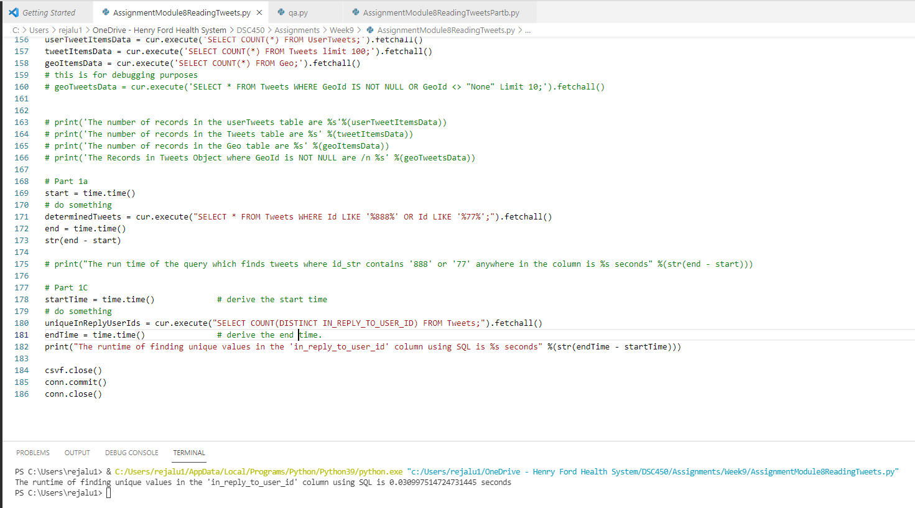

  - Write the equivalent of the previous query in python (without using SQL) by reading it from the file. Time and report the runtime of your query.

The python code is below:
# Author: Ronaldlee Ejalu
# Course DSC 540
# Assignment module 9
# Part 1 d
import urllib.request
import json
import os
import csv
import time
os.chdir('C:/Users/rejalu1/OneDrive - Henry Ford Health System/DSC450/Assignments/Week9')

tweetdata = """https://dbgroup.cdm.depaul.edu/DSC450/Module7.txt"""

webFD = urllib.request.urlopen(tweetdata)

# read the file by using readlines(), which reads only one line assuming there are multiple lines
tweetLine = webFD.readlines()
csvf = open('ErrorFile.csv', 'w', newline='')

startTime = time.time() # get the start time
# do something
uniqueItems = {} # declare a dictionary of unique items
count = 0
for i in range(0, len(tweetLine)):
try:
tDict = json.loads(tweetLine[i].decode('utf-8')) # then decode the line that come back from the web into a string
if tDict['in_reply_to_user_id']: # check if the key value is not None
if tDict['in_reply_to_user_id'] not in uniqueItems: # check if dictionary key value is not in the declared dictionary, uniqueItems.
uniqueItems[tDict['in_reply_to_user_id']] = 1
count += 1
except ValueError:
csvf.write(str(tweetLine[i])) # write the problematic tweet to a file
endTime = time.time() #derive the end time

# dictValues = uniqueItems.values()
# print(type(dictValues)) # This is for debugging purposes
print("The run time of finding unique values in the 'in_reply_to_user_id' column\n in python by reading it from a file without using SQL is %s seconds" %(str(endTime - startTime)))
# print('The number of unique values are %s' %(sum(uniqueItems.values()))) # print the sumed value of the dictionary unique values
# print(count)
csvf.close()

The output screenshot after running the above code is:
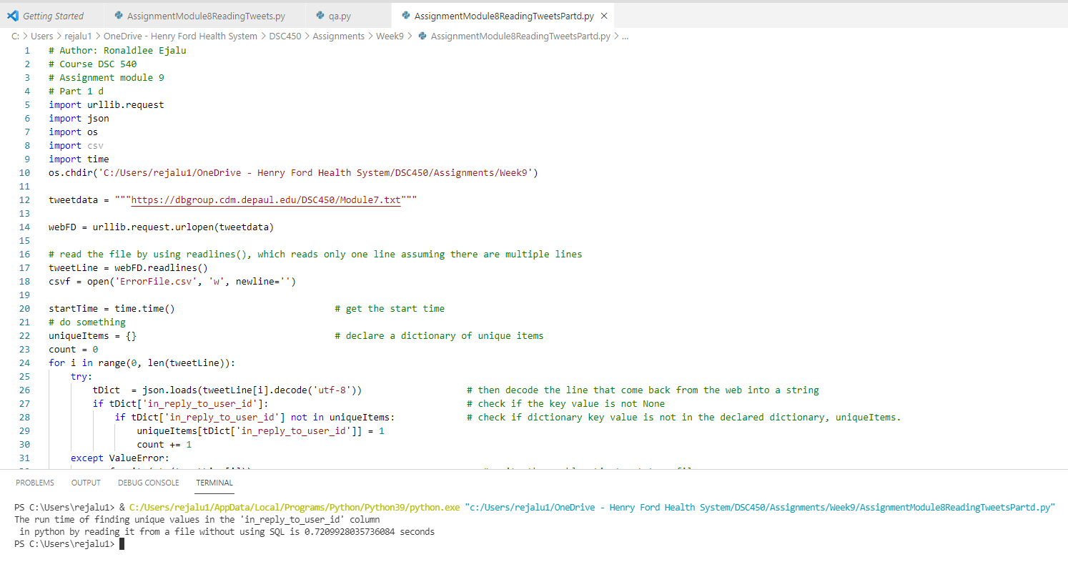

  - Use python to plot the lengths of first 40 tweets (only 40, not all of the tweets) versus the length of the username for the user on a graph. Create a scatterplot. Submit both your python code and the resulting graph file.

The python code is below:

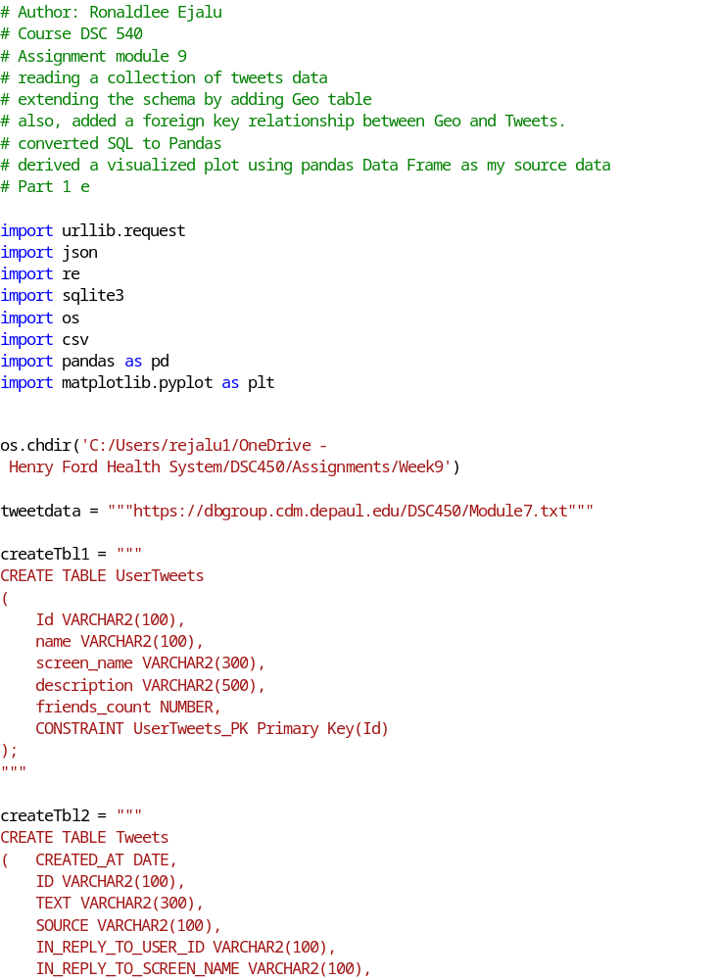
The plot is:

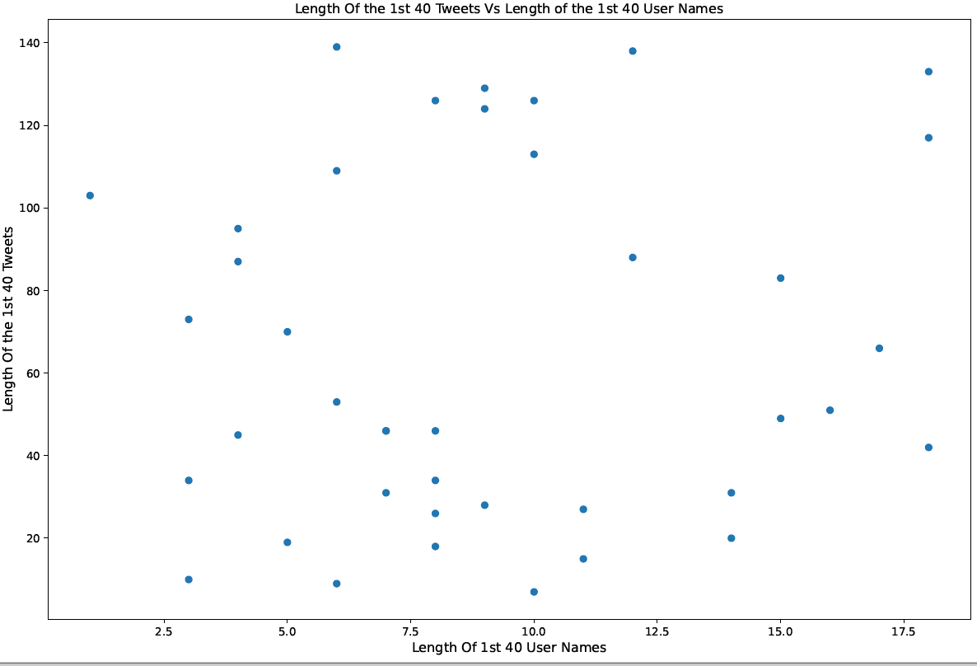

Part 2
- Create an index on userid in Tweet table in SQLite (submit SQL code for this question). These questions are as straightforward as they look, you just need to create an index.
Below is the sample output screenshot of the index creation.

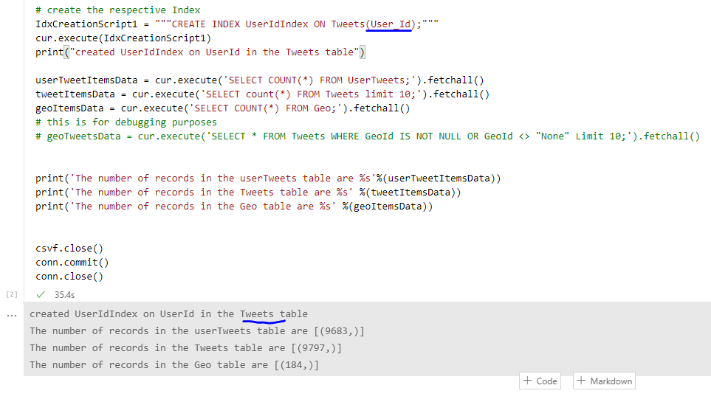
Also, the sql code is below:
CREATE INDEX UserIdIndex ON Tweets(User_Id);

- Create a composite index on (friends_count, screen_name) in User table (submit SQL code for this question)

A sample screenshot after running the python script is below:
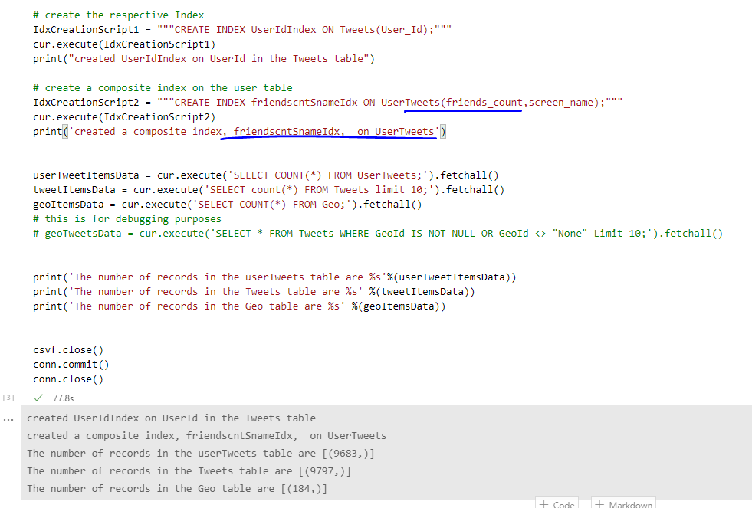
The sql code is:
CREATE INDEX friendscntSnameIdx ON UserTweets(friends_count,screen_name);

- Create a materialized view (using CREATE TABLE AS because SQLite does not have full support for MVs) that answers the query in Part-1-a. Submit your SQL code.

The python code is below:
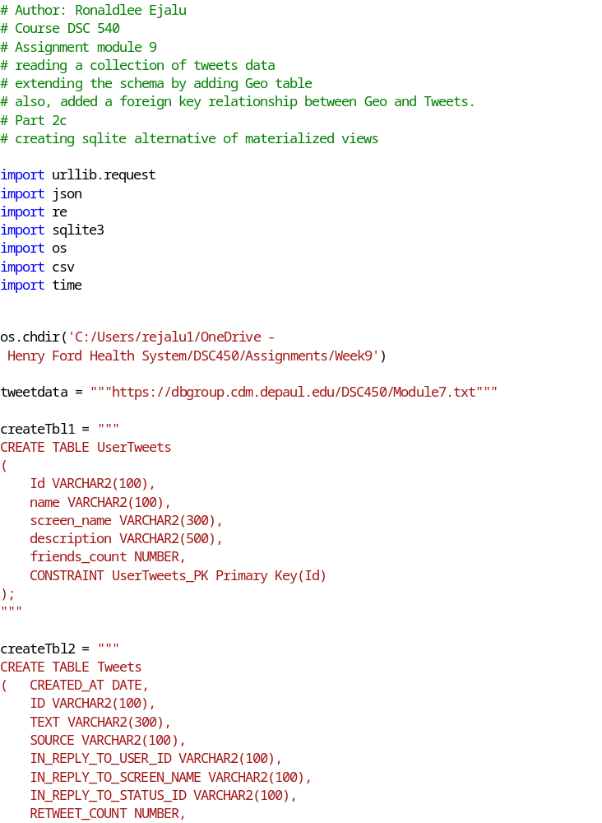The top 20 records from the sqlite materialled view alternative :

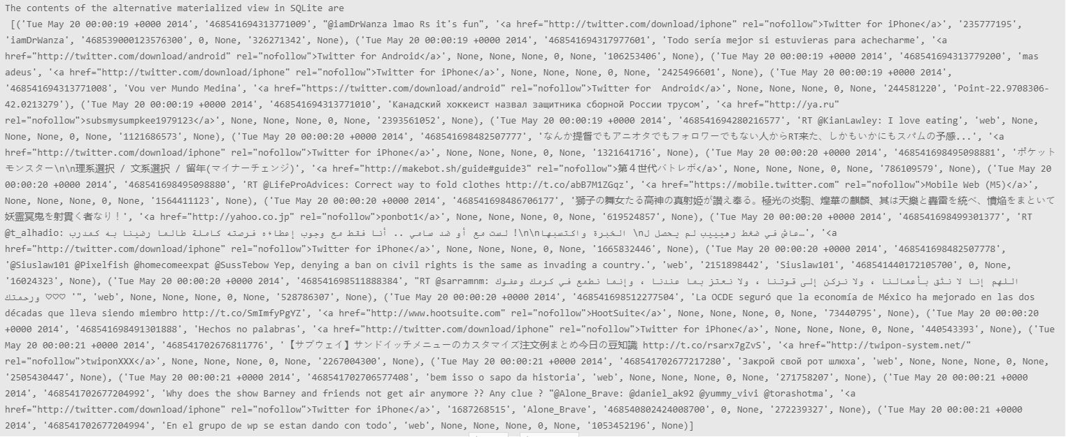

The sql code embedded within the python code above is below:
CREATE TABLE TweetsThatContain888Or77 AS
SELECT * FROM Tweets WHERE Id LIKE '%888%' OR Id LIKE '%77%';

Part 3

- Draw a precedence graph.
Is the schedule serializable? If not, say “no”. If it is, name at least one equivalent serial schedule (e.g., <T1, T2, T3> if the execution is equivalent to individual operations executing in that order)

T1 | T2 | T3
 |  | W(A)
W(A)
 | W(C)
 |  | R(E)
W(B)
 | W(C)

Based on the diagram below, this is schedule serializable.
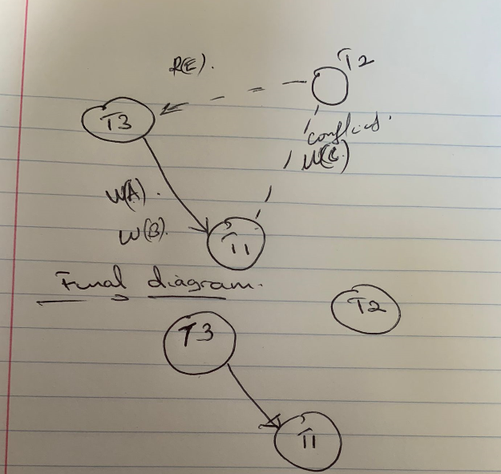

<T3, T1, T2> is one equivalent serial schedule.

- Draw a precedence graph.
Is the schedule serializable? If not, say “no”. If it is, name at least one equivalent serial schedule (e.g., <T1, T2, T3> if the execution is equivalent to individual operations executing in that order)

T1 | T2 | T3
 |  | R(X)
 | R(X)
 |  | W(X)
R(X)
W(X)
 |  | W(X)

Based on the precedence graph below, this is not schedule serializable because it introduces a cycle between Transactions T1 and T3.

