Ronney Aovida

Mentor: Xiaoqiang Wang

Practicum

Analysis of volatility through Technical Stock Trading Strategies

**Background/Introduction:**

Financial markets are an open and regulated system used by companies to obtain large amounts of financial capital to grow their businesses. This is accomplished through the stock and bond markets. Markets also allow these businesses to offset risk with commodities and foreign exchange futures contracts, as well as other derivatives. Since the markets are public, they provide an open and transparent platform to set prices on everything traded. These prices assume that all available knowledge about everything traded is taken into consideration. Sellers can easily unload assets whenever they need to raise cash. The size also reduces the cost of doing business, since companies don't have to go far to find a buyer, or someone willing to sell [1].

In regards to this research being presented, we will be looking into the market of Stock Exchange. The Stock market is used by successful corporations looking to expand by raising large amounts of cash. In order to do this they must first go public, referring to a private companies initial public offering (IPO). However, a company cannot go public without referring to an investment bank for evaluation first. They will evaluate a price for the IPO through analysis of the companies demand, comparables and future growth projections[2]. With an initial price decided, the company is then made public, meaning that the ownership is now in the hands of the companies stock holders, the public. It is then established that a stocks value is now determined by the people, making a stocks rise and fall in result of simple supply and demand. Stock price fluctuations are determined by the decision making of human beings, they determine the price of a stock to be either too high or too low through analysis.

There are many types of analysis used to determine the true value of a stock, the two most popular approaches being fundamental analysis and technical analysis [4]. Fundamental analysis is a method of evaluating a security to measure its intrinsic value, by examining related economic, financial and other qualitative and quantitative factors. Fundamental analysts study anything that can affect the security's value, including macroeconomic factors such as the overall economy and industry conditions, and microeconomic factors such as financial conditions and company management [5]. Technical analysis is a trading tool employed to evaluate [securities](http://www.investopedia.com/terms/s/security.asp) and attempt to forecast their future movement by analyzing statistics gathered from trading activity, such as price movement and volume. There are numerous other approaches to analyzing/forecasting a stocks price such as current events and the use of behavioral psychology with machine learning algorithms, however this research with be more focused on the technical analytics.

Using technical analysis as an investor is not only to forecast chart trends, but rather human made patterns, since it is the behavior of human decision making causing these trends, analyzing these human made patterns is what technical analyst do. Technical analysts believe that the current price fully reflects all information. Because all information is already reflected in the price, it represents the fair value, and should form the basis for analysis. After all, the market price reflects the sum knowledge of all participants, including traders, investors, portfolio managers, buy-side analysts, sell-side analysts, market strategist, technical analysts, fundamental analysts and many others. It would be folly to disagree with the price set by such an impressive array of people with impeccable credentials. Technical analysis utilizes the information captured by the price to interpret what the market is saying with the purpose of forming a view on the future [6]. The goal in technical analytics is to identify trends happening during a set time-frame to find a predictive pattern. These trends occur due to the fact that the human collective dictates the behavior of markets, and as a species human beings act today just as we did thousands of years ago, when we first came together to trade in markets. We chase the prospect of profits. When returns become overabundant, the crowd turns greedy. when price turns against us, the herd becomes anxious, anxiety gives way to fear, fear gives way to panic. Then in come the bargain hunters, and the whole process starts again [7]. However, to find these trends technical analyst need to use more than just observation of charts, they need tools and techniques for finding these patterns, these are referred to as technical indicators.

Technical indicator is a series of data points that are derived by applying a formula to the price data of a security. Price data includes any combination of the open, high, low or close over a period of time. Some indicators may use only the closing prices, while others incorporate volume and open interest onto their formulas. For analysis purposes, technical indicators are usually shown in a graphical form above or below a securities price chart and is then compared to the corresponding price chart of the security [8]. This projects focus will be with the use of these technical indicators to test and verify trading strategies incorporating two or more indicators. However, before a trading strategy can be formulated, a time and place needs to be identified.

What type of trading time frame being conducted is a crucial factor that must be determined before approaching a strategy, the most well-known types of trading are: day trading, swing trading and long term investing [9]. Day traders are known to rarely (if ever) hold any holdings overnight when the market is being traded is closed, hence making these traders more known as technical traders rather than fundamental since their trading period is not long enough for any fundamental analysis to give any real valuable information [10]. Swing trading can be described as the perfect combination of fundamental and technical trading since these traders tend to hold their positions for longer than a day and sometimes weeks, but rarely longer than a month or two [11]. Long term investing is just as the term implies, an investment that is done almost always with fundamental analytics only and goes on for months to years [11].

Once a time-frame is decided, a trading strategy can now be determined that compliments the time frame being traded. A trader has the option to either form their own custom trading strategy or to try a trading strategy that has already been used and tested before. To create a custom trading strategy, technical indicators are used to find a trend within a pre-determined time frame, and within that trend An entry and exit point are located based upon preset rules for buying/selling , that returns profit after taking commission fees into account. The strategy then needs to be back tested on multiple other stocks to see if this same approach can find a similar trend within the same time frame as previously tested stocks [9]. In regards to this research, trading strategies previously used in the past will be back tested on stocks of varying volatility using multiple time frames to verify the efficiency of trade strategies when used in a volatile market vs a non-volatile market.

**Overall project:**

We will be focused around the use of trade strategies. A trading strategy is a fixed plan that is designed to achieve a profitable return by going [long](https://en.wikipedia.org/wiki/Long_(finance)) or [short](https://en.wikipedia.org/wiki/Short_(finance)) in markets. The main reasons that a properly researched trading strategy helps are its verifiability, quantifiability, consistency, and objectivity. The development and application of a trading strategy follows these steps: Formulation, Specification in computer-testable form, Preliminary testing, Optimization and Evaluation of performance. Every trading strategy needs to define assets to trade and entry/exit points based off pre-determined rules. Trading strategies are based on [fundamental](https://en.wikipedia.org/wiki/Fundamental_analysis) or [technical analysis](https://en.wikipedia.org/wiki/Technical_analysis), as previously discussed above [23]. This paper will not be taking fundamental analysis into account, but there is no harm in the use of both fundamental and technical trading together, rather it is more beneficial in the long term.

We will be targeted towards the analysis of these technical stock trading strategies by applying these strategies to past stock data, this process is called back testing. This is the key to a effective trading-system development. It is accomplished by reconstructing, with historical data, trades that would have occurred in the past using rules defined by a given strategy. The result offers statistics that can be used to gauge the effectiveness of the strategy. Using this data, traders can optimize and improve their strategies, find any technical or theoretical flaws, and gain confidence in their strategy before applying it to the real markets. The underlying theory is that any strategy that worked well in the past is likely to work well in the future, and conversely, any strategy that performed poorly in the past is likely to perform poorly in the future [12].

However to back test a trading strategy a method for back testing must first be identified. Most back testing is currently done through licensed software specialized for the task or an add on to a trading platform. These software’s of course come with limitations that do not allow the user to customize the algorithm used to implement a custom trading strategy that does not use any given parameters. To fix this problem many people customize their own back testing algorithms in order to accommodate their own custom made trading strategies. Creating a custom back testing algorithm is not an easy task however, to create a reliable back testing algorithm a few factors need to taken into account such as data overfitting, forward looking bias, survivorship bias, purely focusing on returns, transaction charges, datamining, fundamental change and time frame size, this will be expanded on in the verification/efficiency section [13]. This project will be using custom made algorithm using python. The results from both back tests will be compared and any differences/similarities will be noted in the analysis.

Back testing is of course the last and main part of this research. Before this can occur stock data and trade strategies must be identified. The stocks being tested will be sorted by volatility. Volatility is a statistical measure of the [dispersion](http://www.investopedia.com/terms/d/dispersion.asp) of returns for a given security or [market index](http://www.investopedia.com/terms/m/marketindex.asp), it can either be measured by using the [standard deviation](http://www.investopedia.com/terms/s/standarddeviation.asp) or variance between returns from that same security or market index. Highly volatile stocks tend to rise and fall very rapidly resulting in trades that are very high in risk for the trader [14]. The volatile stocks being used will be leveraged ETF’s. An leveraged exchange-traded fund (ETF) is known as a fund that uses financial derivatives and debt to amplify the returns of an underlying index [27].These stocks are notoriously known for being much harder to predict using technical analysis due to its fast moving nature. An example of this would be the Direxion Daily Financial Bull 3x shares ETF (FAS), this stock is designed to return three times the performance of the Russell 1000 financial services index on a day to day basis. However These ETF’s are known to depreciate over time and hence are known throughout the financial world as a stock that should never be held for longer than a few days. This depreciation occurs due to its volatile nature, for example: suppose an underlying instrument increases by 25% on day 1 and decreases by 20% on day 2. The return of the underlying instrument is (1+0.25)*(1-0.20)-1=0%. Now suppose we construct a leveraged ETF designed to track 3x the daily return of the underlying instrument. The return of the leveraged ETF is now 3 times the original increase and decrease percentiles (1+0.75)*(1-0.60)-1= -30%. The intuition here is that in flat but volatile markets, leveraged ETF’s exhibit price decay due to the effect that volatility has on cumulative returns[26]. It is because of this that these ETF’s are seen as long term bearish, but within short time frames, can be seen as highly bullish. It is these highly bullish trends that occur within small time frames that attracts so many technical day traders to these stocks, where the benefit from a few correct trend predictions has the potential to outweigh the high risk volatility that comes with it. We will be analyzing the differences between these volatile ETF’s and non-volatile stocks. This projects orientation will be towards the analysis of these volatile stocks, in the hopes of finding which level of volatile stocks will return the most optimal returns.

Once the stock data is all ordered, trading strategies will be developed . This research will be targeted towards the goal of verifying the efficiency of these strategies and using strategies with satisfactory returns to analyze the similarities and differences in different groups of stocks (volatility wise). This data will then be analyzed through different time frame windows to find any abnormalities in the results in relation to the real-life results, and documented in the verification/efficiency section of this research. To verify the results even further, they will be benchmarked to other strategies to get comparables that indicate if the method is more optimal than previous methods that could possibly be easier to implement. Under the efficient market hypothesis, no investor should ever be able to beat the market, or the average annual returns that all investors and funds can achieve using their best efforts. This would naturally imply, as many market experts often maintain, that the absolute best investment strategy is simply to place all of one's investment funds into an [index fund](http://www.investopedia.com/terms/i/indexfund.asp), which would increase or decrease according to the overall level of corporate profitability or losses [16]. Hence if that is true, then the primary method used for benchmarking in stock data analytics is would be the buy and hold method of index funds. The strategy results will be compared to the SPDR S&P 500 ETF Trust, otherwise known as SPY. This Trust series 1 ETF (exchange traded fund) reflects 1/10 of the S&P 500 index that it follows, hence providing this method the appropriate credentials as a representation of the market over all. The thesis of this research is the assumption that there are trading strategies out there that are capable of beating the efficient market hypothesis, as well as finding trends among stocks in varying deviations of volatile stocks through different time frames to an accurate extent.

A study very similar in nature is a peer reviewed paper by Alessio Biondo,Elessandro Pluchino, Andrea Rapisarda and Dirk Helbing from the university of Catania, Italy. They study the performance of some of the most used trading strategies in order to predict the dynamics of the financial markets for different international stock exchange indexes. Their main focus will be the back testing of numerous well known trade strategies and comparing their results to that of a random strategy. The strategies implemented in their study are as follows:

* Random strategy-This strategy is the simplest one, since the correspondent trader makes his/her prediction at time http://journals.plos.org/plosone/article/file?type=thumbnail&id=info:doi/10.1371/journal.pone.0068344.e030 completely at random (with uniform distribution).
* Momentum strategy- This strategy is based on the so called ‘momentum’ http://journals.plos.org/plosone/article/file?type=thumbnail&id=info:doi/10.1371/journal.pone.0068344.e031 indicator, i.e. the difference between the value http://journals.plos.org/plosone/article/file?type=thumbnail&id=info:doi/10.1371/journal.pone.0068344.e032 and the value http://journals.plos.org/plosone/article/file?type=thumbnail&id=info:doi/10.1371/journal.pone.0068344.e033, where http://journals.plos.org/plosone/article/file?type=thumbnail&id=info:doi/10.1371/journal.pone.0068344.e034 is a given trading interval (in days). Then, if http://journals.plos.org/plosone/article/file?type=thumbnail&id=info:doi/10.1371/journal.pone.0068344.e035, the trader predicts an increment of the closing index for the next day (i.e. it predicts that http://journals.plos.org/plosone/article/file?type=thumbnail&id=info:doi/10.1371/journal.pone.0068344.e036) and vice-versa
* Relative Strength Index strategy-This strategy is based on a more complex indicator called ‘RSI’. It is considered a measure of the stock’s recent trading strength and its definition is: http://journals.plos.org/plosone/article/file?type=thumbnail&id=info:doi/10.1371/journal.pone.0068344.e038, where http://journals.plos.org/plosone/article/file?type=thumbnail&id=info:doi/10.1371/journal.pone.0068344.e039 is the ratio between the sum of the positive returns and the sum of the negative returns occurred during the last http://journals.plos.org/plosone/article/file?type=thumbnail&id=info:doi/10.1371/journal.pone.0068344.e040 days before http://journals.plos.org/plosone/article/file?type=thumbnail&id=info:doi/10.1371/journal.pone.0068344.e041. Once calculated the RSI index for all the days included in a given time-window of length http://journals.plos.org/plosone/article/file?type=thumbnail&id=info:doi/10.1371/journal.pone.0068344.e042 immediately preceding the time http://journals.plos.org/plosone/article/file?type=thumbnail&id=info:doi/10.1371/journal.pone.0068344.e043, the trader which follows the RSI strategy makes his/her prediction on the basis of a possible reversal of the market trend, revealed by the so called ‘divergence’ between the original time series and the new RSI one
* Moving Average convergence strategy-The ‘MACD’ is a series built by means of the difference between two Exponential Moving Averages (EMA, henceforth) of the market price, referred to two different time windows, one smaller and one larger. In any moment *t*, http://journals.plos.org/plosone/article/file?type=thumbnail&id=info:doi/10.1371/journal.pone.0068344.e051

The goal was simply to predict, day by day and for each strategy, the upward(bullish) or downward (bearish) movement of the index http://journals.plos.org/plosone/article/file?type=thumbnail&id=info:doi/10.1371/journal.pone.0068344.e060 at a given day with respect to the closing value http://journals.plos.org/plosone/article/file?type=thumbnail&id=info:doi/10.1371/journal.pone.0068344.e061 one day before: if the prediction is correct, the trader wins, otherwise he/she loses. They ran these back tests of their strategies through trading windows of equal size. The results of their study revealed a common performance across the board of 50% for all strategies. Meaning, that every strategy was back tested using multiple time frames with the same size series and found that although a marginal amount of profit is made, the win to loss ratio of entry to exit points came to be approx. 50% for even the random strategy approach. The largest difference between the well-known strategies and the random approach is the fluctuations of them, where the well-known strategies would fluctuate between gains and losses heavily as to where the random approach was much less volatile and only produced small losses and small gains. This study in result was able to show that there is no true universal approach to predicting the prices of all stocks. Perhaps a better approach to the prediction in stocks would be to design a strategy that is custom towards the patterns of a certain stock or group of similar stocks, but unfortunately that research is not the focus of this paper[24].

Just as the research done above analyzed the similarities and differences between different technical trade strategies, this current research aims to compare and contrast different trade strategies as well. With this research we will be analyzing the notable differences in the efficiency of trade strategies being implemented on highly volatile stocks compared to low volatility stocks. The goal with this comparison is to find an approach that is more optimal in either stock group that is capable of surpassing the SPY index as a benchmark. Whereas the study done above did the same with their analysis, with their own unique selection of stock, but set their benchmark to instead be focused on beating a randomized strategy rather than the SPY index.

**Indicators/Strategy:**

A technical trading strategy is the use of technical indicator(s) with a detailed plan of when to buy and sell a stock [9]. To understand how this concept works an understanding of how trading strategy and technical indicators work as separate entities is required.

Indicators Indicate. This may sound straight forward, but sometimes traders rely too much on a single indicators signals that they ignore the price action of the stock. This is where having more than one indicator indicating a buy signal comes into play to form a trading strategy. There are currently hundreds of indicators in use today, with new indicators being created every week. Strangely enough, the indicators that usually merit the most attention are those that have been around the longest time and have stood the test of time. When choosing an indicator for a trading strategy it is important to choose them carefully and moderately, attempts of trying a trading strategy with more than five indicators are usually futile. It is best to focus on two or three indicators that complement each other rather than those that move in unison and generate the same signals [8]. When back testing a trading strategy a complete understanding of the types of indicators is largely beneficial.

Leading indicators: These indicators are meant to lead price movements. Most represent a form of price momentum over a fixed look-back period, which is the number of periods used to calculate the indicator. With the main benefit with these indicators being the early signaling for entry and exit. [8]. example’s: Commodity Channel Index(CCI), Momentum, Relative Strength Index(RSI), Stochastic Oscillator and Williams %R

Lagging Indicators: Follow price action and are commonly referred to as trend following indicators. These indicators will rarely lead the price of a security. They work best when markets or securities develop strong trends. They are designed to get traders in and keep them in as long as the trend is intact. Hence not being very useful in sideways markets, if used in such scenario the indicator will most likely lead to many false signals. Examples: exponential moving average, simple moving average, weighted moving average, variable moving average and moving average convergence/divergence (MACD).[8].

Momentum Oscillators: Generally speaking, Momentum measures the rate of change of a security’s price. As the price of a security rises, price momentum increases. The faster it rises, the larger the increase in momentum. Once this rise begins to slow, momentum will also slow. As a security begins to trade flat, momentum starts to actually decline from previous high levels [8]. Example: RSI

Centered Oscillators: These indicators fluctuate above and below a central point or line. These oscillators are good for identifying the strength or weakness, or direction, of momentum behind a security's move. In its purest form, momentum is positive (bullish) when a centered oscillator is trading above its center line and negative (bearish) when the oscillator is trading below its center line. Example: MACD and ROC (Rate Of Change) [8]

Banded Oscillators: These fluctuate above and below two bands that signify extreme price levels. The lower band represents oversold readings and the upper band represents overbought readings. These set bands are based on the oscillator and change little from security to security, allowing the users to easily identify overbought and oversold conditions. Examples: RSI, Stochastic Oscillator and Commodity Channel Index (CCI) [8]

A trade strategy is developed the following way. Now lets call an open position a trade that will be terminated sometime in the future when a condition is met. A long position is one is which profit is made if the financial instrument traded increases in value. A short position is one in which a profit is made if the asset decreases in value. Long positions are considered as bullish (a rising trend in share prices), whereas short positions are considered bearish (a declining trend in share prices). Majority of stock trades are long positions and are simply done through buying a stock through a broker and hoping it rises for profit [17]. Short positions on the other hand are a kind of reverse stock buying, where you sell the stock before you buy it. The way shorting a stock works is like this: traders 'borrow' shares from their broker, sell them in the open market and receive the proceeds from the sale. They wait in hopes that the price of the stock will go down, so they can purchase the stock at a lower price. They can then replace the shares they borrowed from their broker and pocket the difference. Short positions will also have to pay an interest fee for shorting a stock where as long positions do not have this interest fee. In trading strategies, shorting a stock is typically done when the sell signal of a long position is executed [18].

With open, short and long positions established, a set of rules must be established such as how much of the portfolio will be placed on a single trade, an exit strategy and entry point. An exit strategy is a set of conditions determining when a trader should exit the position for either profit or loss. The trader may set a target, which is the minimum profit that will induce the trader to leave the position. Likewise, a trader must have a maximum loss they’re willing to tolerate; if potential losses go beyond this amount, the trader will exit the position in order to prevent any further loss. This is normally done through a stop-loss order, an order that is triggered to prevent further losses. Both the stop-loss order and amount a trader is willing to place on a single order is completely decided by the trader themselves [17]. An entry point however is where the technical indicators come into play, this will decide when a stock should be bought for profit if a trend is found.

With an adequate understanding of strategy and technical indicators, all that is required before proper analysis can be implemented is the organization of gathered data. To do this we will be using the programming language python, and the python library Pandas. A group of stocks are imported into the program from Yahoo Finance database. The data imported provides: the open price (the price of the stock at the beginning of the trading day), high price (the highest price the stock reached during that day), low price (the lowest price the stock reached during that day), close price (the price the stock reached at closing time), volume (the number of trades for that stock during the time) and adjusted close (the closing price of the stock adjusted for corporate actions)[20].

**Determining volatility:**

The stocks volatility is then analyzed. This analysis is done through two approaches, comparing stocks true return values and taking the log of the difference between prices. To attain the stocks true return value we use the following formula where “t” is the current time step and “0” is the initial value: Returnval(t,0)= price(t) / price(0). The price variable will represent the closing price for the stock, hence taking every closing price within the time frame provided and dividing each price by the initial value, hence creating a graph that shows how profitable each stock is [17]. This result is shown in the 1st figure below using AAPL,TSLA and JNUG(using the right y axis) during a 1 year time frame**.** 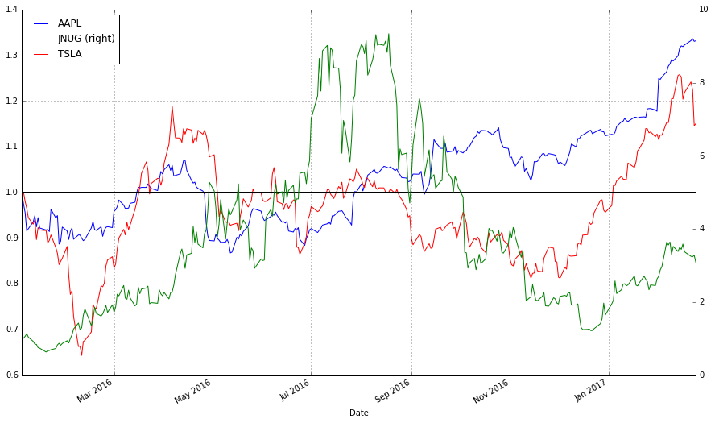

This of course is not an accurate depiction of volatility in a visual way, a better approach is to use logarithms to depict the change in price as a percentage. Using the following formula where “t” is still time and “price” is still the closing price: change(t)= log(price(t)) – log(price(t-1)). With this we can now see exactly how volatile a stock really is by measuring the percentage of change between every days closing price of a stock [17] . a visual representation of this is seen in the 2nd figure below. Using the first chart no analyst would be able to guess which stock is the most volatile as first glance, however using the 2nd chart it is obvious which stock seems to having the largest volatility (JNUG).

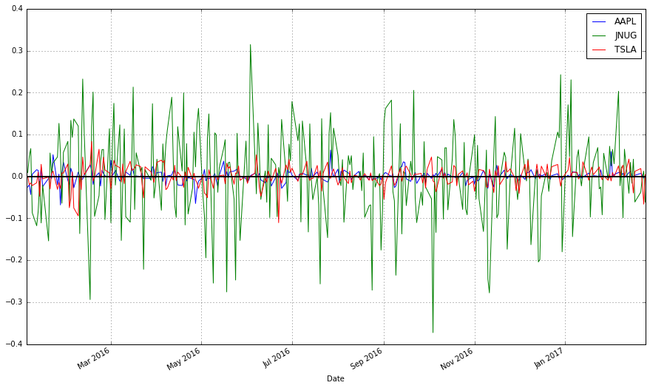

**Candlestick Pattern Charts:**

Once the stocks volatility is analyzed, the stock data is then plotted .When working with stocks however, a candle stick pattern chart are typically more visually appealing and easier to interpret multiple variables such as close, open, high and low prices. We will be using these charts at first in order to read the data more accurately.

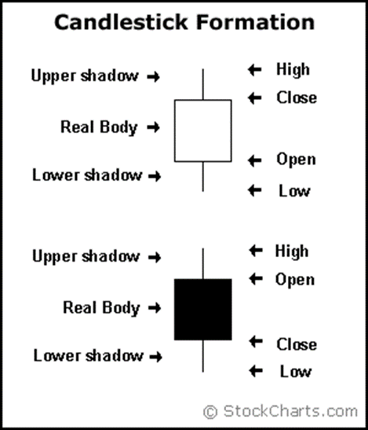 These charts consist of a hollow/filled portion referred to as “the body” and long thin lines above and below the body representing the high/low range referred to as “wicks” or “tail”. The high is marked by the top of the upper wick and the low by the bottom of the wick. If the stock closes higher than its opening price, a hollow candle stick is drawn with the bottom of the body representing the opening price and the top of the body representing the closing price. If the stock closes lower than its opening price, a filled candle stick is drawn with the top of the body representing the opening price and the bottom of the body representing the closing price. The graphs in this paper will be representing a hollow candle stick as a black color instead and a filled candle stick as a red color. The image on the left is a visual representation of this [21].

**Methods/Approach:**

To analyze the difference in trade strategies and to find what is optimal, we must perform analysis from multiple perspectives. We will perform 2 trade strategies on 2 different groups of stocks during multiple time frames and will record any differences and similarities found between them. The 2 groups of stocks will incorporate a volatile and non-volatile group of stocks, as previously mentioned. The 2 strategies will consists of one strategy consisting of primarily lagging indicators and a second strategy that implements the use of a leading indicator with the lagging indicators. These two strategies will be conducted on both stock groups using multiple time frames in the attempt of finding what difference is made when an leading indicator is implemented with lagging indicators, and how the relationship between volatile/non-volatile stocks coincide or differ. Using these findings, it is our hope to find what indicators work best in unison to return profits that are capable of beating the set benchmark.

**First Strategy:**

The first trading strategy we will be back testing will be using lagging indicators. As shown previously in the indicators section, lagging indicators are indicators that find trends and keep you in it, but are also delayed in their predictions. The most commonly used lagging indicators are moving averages (MA).

What is a moving average? It is a trend following indicator. It does not predict price direction, but rather define the current direction with a lag. Moving averages lag because they are based on past prices. Despite this lag, moving averages help smooth price action and filter outside noise. The longer the time frame for a moving average is the more lag it will accrue, whereas it is the opposite effect with shorter time frame averages. Taking this into account, moving averages set to time frames from 5-20 are best suited for short term trades, from 20-60 for medium term trends and of course 100 to 200 for long term[19].

There are 3 types of moving averages:

simple MA- The simple average being better for identifying support/resistance levels since it is in fact a true average [19].

exponential MA- is designed to put more weight on recent data and less weight on past data. A exponential moving average is calculated by multiplying each of the previous days' data by a weight. The weight is based on the number of days in the moving average. The weight on the first day is 1.0 [19].

convergence/divergence (MACD)- The MACD turns two trend-following indicators, [moving averages](http://stockcharts.com/school/doku.php?id=chart_school:technical_indicators:moving_averages), into a momentum oscillator by subtracting the longer moving average from the shorter moving average[29].

For Now We will only be focusing on the simple moving average for this strategy. The back testing in this first implementation will be done manually in order to gain an understanding of the process itself.

How it is calculated: It is formed by computing the average price of a security over a specific number of periods. Most moving averages are based on closing prices. A 5-day simple moving average is the five day sum of closing prices divided by five. Old data is then dropped as new data comes available, causing the average the move along the time scale, hence the name “moving average”. [19]

The moving average crossover strategy (otherwise known as the double crossover method): is a trading strategy developed by John Murphy in his book “Technical Analysis of the Financial Markets” from 1986. It involves one relatively short moving average and one relatively long moving average. An example of a short term time frame approach would be using a 5 day MA and a 35 day MA, where as a 50 day and 200 day MA would be considered medium. Bullish crossovers will occur when the shorter moving average crosses the longer average. Bearish crossovers occur when the shorter moving average crosses below the longer moving average. Hence the strategy for this will have two simple rules:

* Trade the asset when the faster average crosses over the slower average
* Exit the trade when the fast moving average crosses over the slow moving average again

A long term trade will be prompted when the fast moving average crosses from below to above the slower average and the trade will be exited if the fast moving average crosses below the slow average later. A short trade will occur when the fast moving average crosses below the slow average and it will be exited when the fast average crosses the slower one later.

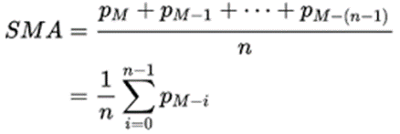With all the data sorted, the back testing can begin. We will be working with a 15 day average and a 40 day average as our short and long time frames respectfully. The data is input into the formula seen in the **figure** below where P= closing price, M= time and n=time frame (in our case it is 15 and 40)**.** We then take the difference between the 15 and 40 day SMA in order to figure out when the two moving averages cross paths, we will refer to this difference as MAD.

To identify when these two SMA’s cross each other we indicate into the algorithm that when the MAD value is positive then it is a bullish signal, but when it is below 0 (or negative in value) then the bearish signal will be called. The figure belowusing apple stock data from 2014 to 2017,shows the results of when the algorithm has found a bullish trend, bearish trend or neutral signal (neutral indicating that the difference was not above or below 0).

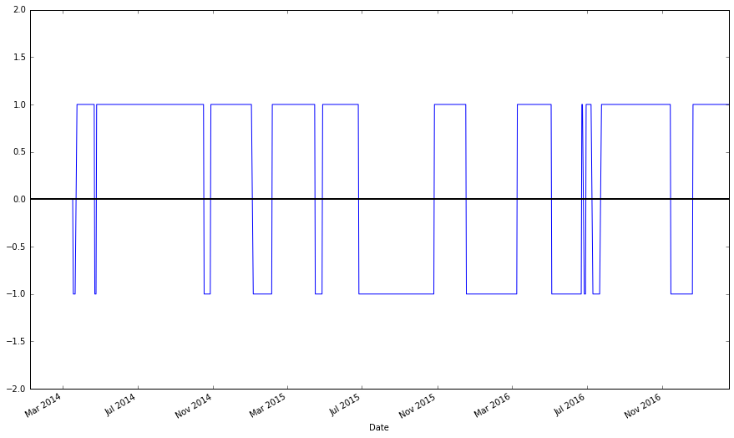

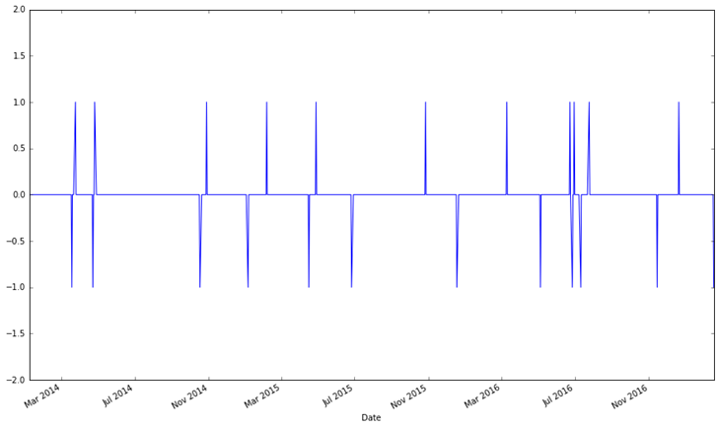In reference to the figure above, we found a total of 482 bullish trends, 256 bearish trends and 49 neutral. However what we are looking for is a buy and sell signal rather than just trends. In order to identify these signals we use the following formula where t=time and x=MAD: signal(t)= sign of( (x(t)- x(t-1) ). This formula takes the difference between the present and previous time step of the MAD value so that a buy signal can be generated once a bullish trend is developing .When signal(t) is a positive integer, a buy signal will be triggered, when negative a sell signal is triggered and when 0 no action will be done, the figure belowprovides a visualization for this, where positive values are buy signals and negative are sell signals.

The figure here indicates that there are 11 buy signals, 12 sell signals and 763 no action signals out of the 482 and 256 trends found previously. Just having buy and sell signals is not enough to determine if a profit is made. To do so we take the difference between the price of every buy signal in relation to the next sell signal. This is done by first identifying what the price was at each buy signal and sell signal and the date at which they were activated. The signals and their respective prices are then merged into one single data group and then sorted by date. The difference is then taken between each buy or sell signal as long as the date they were activated is in the closest proximity to the next opposite signal. This difference is then converted into a percentage of change between the two dates that the difference was taken of. Most may think stopping at this point is fine, since the total profit is easily calculable from here through simple addition and subtraction, but as you can see from the figure below showing the moving averages on apple stock data from 2011-2017,there is still something wrong with our calculations. 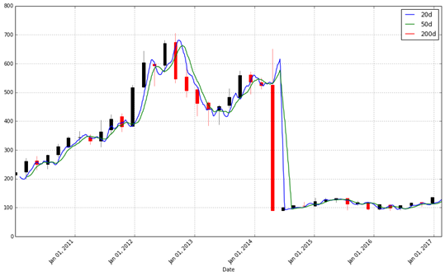

What’s happening is that our data in not taking into account stock splits [17]. When a company declares a stock split, the number of shares of that company increases, but the market cap remains the same. Existing shares split, but the underlying value remains the same. As the number of shares increase, price per share goes down. This is typically don’t to infuse liquidity and to make shares affordable for various investors who could not buy the shares of that company before due to high prices[22]. So to fix this problem we will need to adjust the prices to account for the stock splits and dividends. To attain this we need to adjust our open, high and low prices to be like that of the adjusted close price (since we have the adjusted close already no adjusting will be needed). By using the following Formula where P=the variable being adjusted: adjprice= (P* Adjusted Close ) / Close. The below figure is the result of the adjusted values. 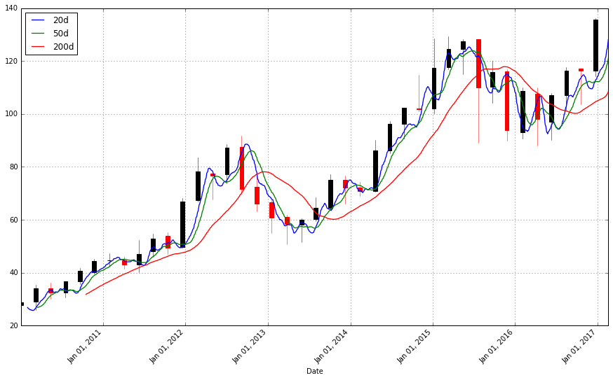

With everything in place, a simulation can now be run. The complete back test algorithm will take in the following parameters: initial investment (any positive integer), percent of portfolio to invest in a single trade (any positive decimal between 0 and 1), The time frame dictated by the length of the date provided by the user, the signals generated previously that dictate when a buy/sell signal occurs and the high/low Moving average sizes.

The output of the back test will consist of: portfolio value, end portfolio value, date of trades, amount of shares, share price, value of the trade during the given time frame, profit per share and the total profit.

The back test is run through a single function. The function will take in multiple stocks, these stocks will be bought as soon as a buy signal is indicated and sold when a sell signal is indicated. By first indexing through each buy and sell signal previously generated, we are able to match each buy signal to its respectful sell signal by date. With a data frame of buy and sell signals set in an orderly fashion, we are then able to extract the closing price of the stock correlated with those provided dates. Using these closing price we determine the amount of a stocks we can purchase by taking (cash*percent_to_invest) / price_of_stock. This value is then used to calculate the trade value of this trade by multiplying the amount of stocks being purchased by the value of the stock. With all this information gathered, a final profit can finally be calculated. To calculate the amount of profit per share we take the difference between the stock price first bought at the buy signal and the price at selling. That value is then used to calculate the total profit for that buy/sell timeframe by multiplying the profit per share by the amount of stocks that can be purchased, these total profits are then added together at the end to provide a total overall profit for the simulation.

To fully analyze the result of the back test, the parameters will need to be tested at different value sets. This is done in the hopes of finding an optimal set of values that produce optimal results, as well as to determine the largest impact a single parameter can have on the results.

The following parameters will be:

* Stock:
  + Non-volatile: TSLA,,AAPL,GOOGL,WFC,GS,BA
  + Volatile ETF: JNUG,DGAZ,JDST,UGAZ,DUST,UNG
* Initial investment: 100,000
* Percent of portfolio to invest: 0.16 (1/(amount of stocks))
* Time frame: Swing trader= 3 months. Long term=1 year.
* high MA- 35,200
* low MA- 5,50

Below are the results of two back tests done for each volatile group. Each group will be run through twice to account for long term trading with a moving average of 50 and 200, and for swing trading with moving averages of 5 and 35. These moving average numbers are based on John Murphys recommended parameters for short term trading and long term trading, as previously in this paper.

Note: Trade strategies will not be analyzing the time frame for day trading since the data collected consists of only closing prices per day. To day trade, intra-day prices are required.

With the assumption that the trading platform does not charge a commission fee ( example: Robinhood or Loyal3), *so we will not be taking into account commission fees in these run*.

Robinhood makes money through margin lending interest and interest on any uninvested customer cash deposits

Volatile swing trade- -14.8% Loss 2016-9-05 to 2016-12-05 low MA- 5 -- high MA- 35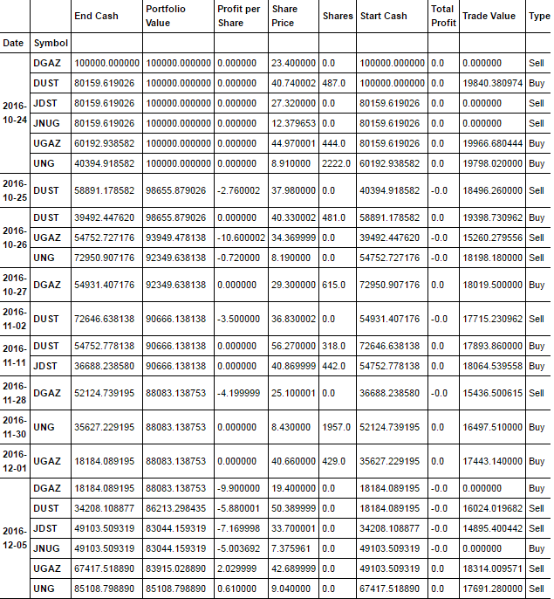

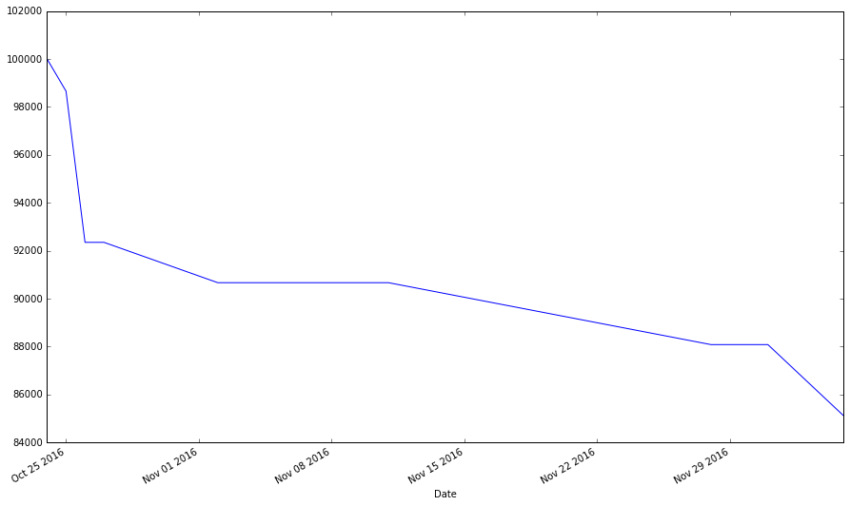

Volatile long term- -12.6% Loss 2015-12-05 to 2016-12-05 low MA- 50-- high MA- 200

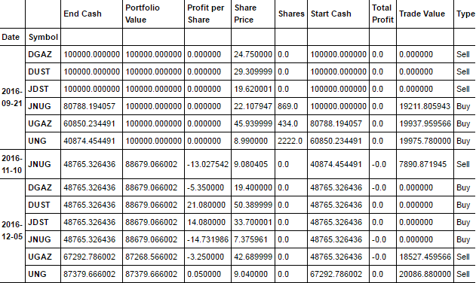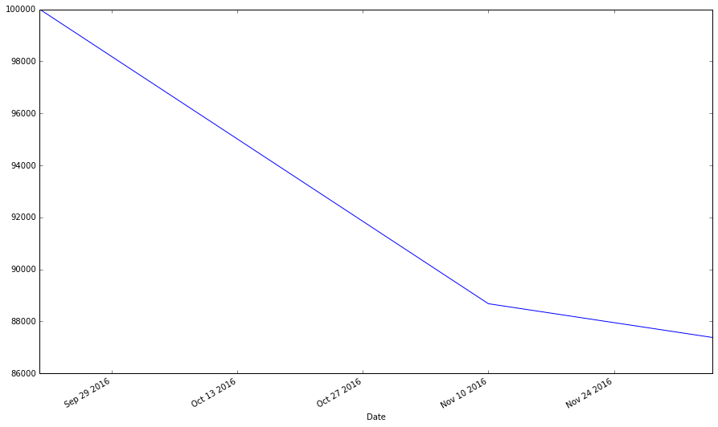

Non-volatile swing- 9.7% Profit 2016-9-05 to 2016-12-05 low MA- 5 -- high MA- 35

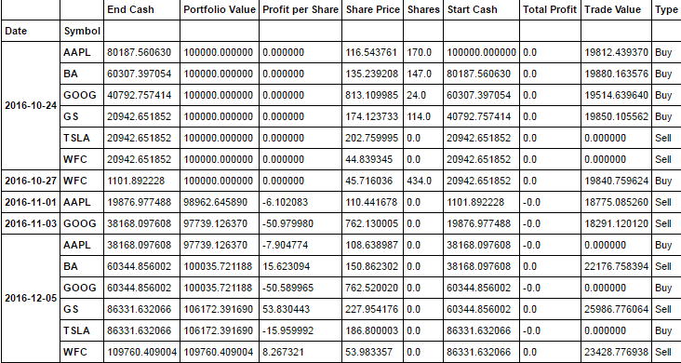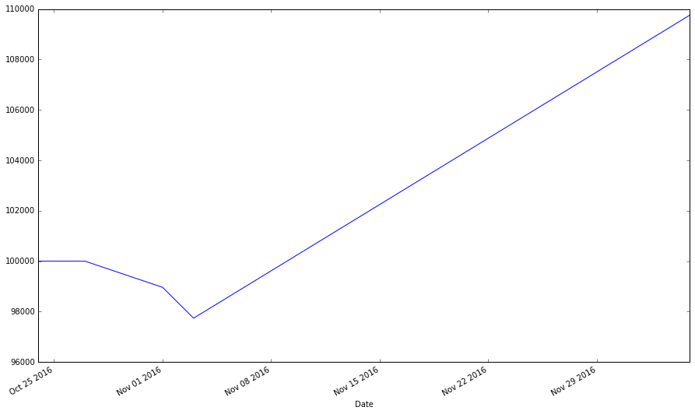

Non-volatile long term- 10.1% Profit 2015-12-05 to 2016-12-05 low MA- 50 -- high MA- 200

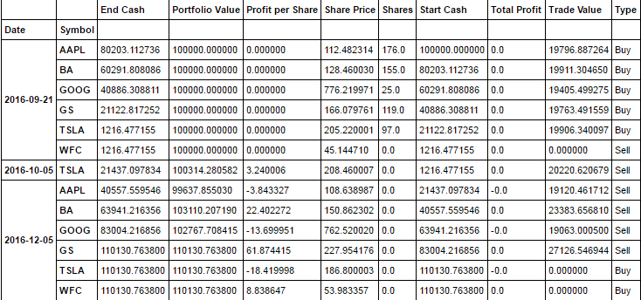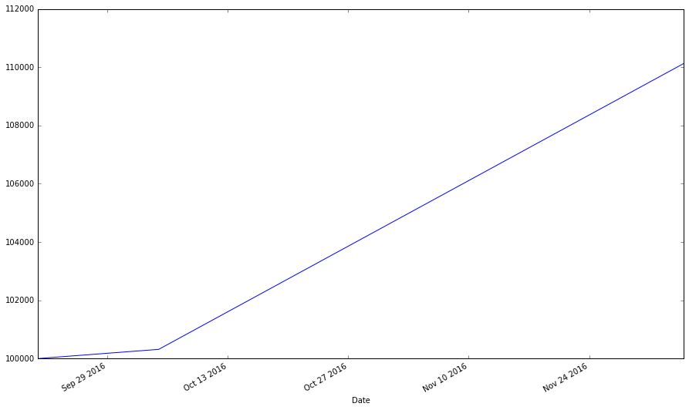

From these results, a vague conclusion could be made that non-volatile groups tend to provide more profit regardless of the time frame and moving average sizes, compared to the volatile group. However, another variable to account for is the time these back tests were run through, results tend to vary substantially depending on when the back test is conducted. To reach a more accurate conclusion, more analysis needs to be conducted. Below is a table showing the results of back testing volatile vs non-volatile stocks with different moving average sizes and varying dates. These dates will range from January 1st of one year to January first of the next year.

|  |  |  |  |  |  |  |
| --- | --- | --- | --- | --- | --- | --- |
| Non-volatile | Fast-5  Slow- 15 | Fast- 10  Slow- 30 | Fast- 15  Slow- 45 | Fast- 20  Slow- 60 | Fast-25  Slow-75 | Fast-30  Slow-90 |
| 2012-2013 | 9.2% | 9.6% | 1.8% | 0.3% | -2.3% | 5.2% |
| 2013-2014 | 48% | 59.7% | 49.6% | 50.2% | 38.5% | 15.5% |
| 2014-2015 | 5.9% | 5.9% | 0.9% | 8.8% | 4.5% | 3.3% |
| 2015-2016 | -4.4% | 2.1% | -4.2% | 8.5% | -9.6% | -9% |
| 2016-2017 | 22.2% | 13.3% | 5.4% | 3.9% | 3.3% | 7.5% |

Legend: Yellow indicates the optimal value where as blue indicates the 2nd most optimal in regard to its respective date.

It appears from this data that John Murphys recommendation of a fast 5 and slow 35 MA nearly coincide with what we have found to be optimal. No matter what year is back tested, the fast 10 and slow 30 MA seem to consistently perform near best among the rest. This data also shows that the date a back test is conducted has a huge influence on a results outcome, what may work one year, may not work as well the next.

Note: JNUG and JDST did not have any data for 2012.

|  |  |  |  |  |  |  |
| --- | --- | --- | --- | --- | --- | --- |
| Volatile | Fast-5  Slow- 15 | Fast- 10  Slow- 30 | Fast- 15  Slow- 45 | Fast- 20  Slow- 60 | Fast-25  Slow-75 | Fast-30  Slow-90 |
| 2013-2014 | 24% | -14.1% | -6.2% | -16% | -15.7% | -16.9% |
| 2014-2015 | 16.5% | -21% | -7.2% | -9.8% | -21.7% | -23% |
| 2015-2016 | -6.1% | 15.7% | -7.9% | -9.7% | -4% | -4% |
| 2016-2017 | -31.3% | -26.6% | -14.8% | -15.5% | -20.2% | -18% |

Legend: Yellow indicates the optimal value where as blue indicates the 2nd most optimal in regard to its respective date.

When it comes to Volatile ETF’s however, there seems to be no real optimal MA size since there is no commonality amongst the optimal values found. It was presumed that since these volatile ETF’s tend to be best traded in small time holdings, that the use of small MA’s would produce the best results. This presumption did not hold out to be true since the average MA values with the most optimal values is a fast 15 slow 45. The volatile stocks in the end seemed to have very little correlation between profits returned and MA values, but optimum MA values do exist around the middle ground of the MA value set.

After analyzing the results overall, we found that non-volatile stocks fair much better than the volatile stocks when using an lagging trade strategy. There seems to be little to no evidence supporting that the non-volatile group had any similar results to the volatile group. While the non-volatile group seemed to remain stable by producing lower results as the MA’s increased, the volatile stocks did not display any signs of stability, but rather chaos. All in all, using lagging indicators on volatile ETF’s seems to be an unfavorable approach, but a favorable one for stocks not so volatile.

**Strategy Two:**

The second trading strategy we will be back testing will be using a leading indicator. As shown previously in the indicators section, leading indicators are designed to lead price movements. Most represent a form of price [momentum](http://stockcharts.com/school/doku.php?id=chart_school:glossary_m) over a fixed look-back period, which is the number of periods used to calculate the indicator.. The most commonly used leading indicators are [Commodity Channel Index](http://stockcharts.com/school/doku.php?id=chart_school:glossary_c) (CCI), [Momentum](http://stockcharts.com/school/doku.php?id=chart_school:glossary_m), [Relative Strength Index](http://stockcharts.com/school/doku.php?id=chart_school:glossary_r) (RSI), [Stochastic Oscillator](http://stockcharts.com/school/doku.php?id=chart_school:glossary_s) and [Williams %R](http://stockcharts.com/school/doku.php?id=chart_school:glossary_w).. However, we will be focusing on the one indicator that is most well respected in the trading community, The RSI.

The major indicator used here will be the Relative Strength Index. It was developed by J. Welles Wilder in 1978 and published in his book “New Concepts in Technical Trading Systems”. The RSI is a momentum oscillator that measures the speed and change of price movements (please refer to page 10 for a more detailed description of what momentum oscillators are) . It will oscillate between zero and 100, and according to Wilder, the RSI is considered overbought when above 70 and oversold when below 30.

**How RSI is calculated:**

It is broken down into two basic components: Relive Strength, Average Gain and Average Loss (Losses will be expressed as positive values).

The very first calculations for average gain and average loss are simple X period averages. Where X is any user given value for how many periods they want their RSI to account. The default value suggested by Wilder in his book is X=14.

100

RSI = 100 - --------

1 + RS

Relative Strength = Average Gain / Average Loss

* First Average Gain= Sum of Gains over the past X periods / X
* First average Loss= Sum of Losses over the past X periods/ X
* Average Gain= [(previous Average Gain) x 13 + current Average Gain] / X
* Average Gain= [[(previous Average Loss) x 13 + current Average Loss] / X

By taking the prior value plus the current value is a smoothing technique similar to that used in exponential moving average calculations, but this also means that the RSI calculations become more accurate as the calculation period extends.

What Wilders formula does is the normalization of the Relative Strength and turns it into an oscillator that fluctuates between 0 and 100. When the RSI is 0 it mean that the average gain equals zero, and this could only occur if the prices have moved lower for all X amount of periods. An RSI of 100 means the average loss equals 0, indicating that for all X periods the prices moved higher.

**Influence of the parameters:**

The look back period for the RSI determines the indicators sensitivity. As previously stated the 14 day period is typically the default. However if it were to be lowered to say 10 periods, the RSI will be much more likely to reach overbought or oversold levels easily, and of course the opposite if provided a 20 period RSI for example.

As previously mentioned, according to Wilder when the RSI is above 70 it is typically considered overbought, whereas when its below 30 it is oversold. These traditional levels can also be adjusted to better fit the security or analytical requirements. By raising the overbought and lowering the oversold thresholds, the number of readings in return will be reduced. However, these readings will tend to return more accurate entry/exit points in comparison to the traditional used levels.

**Implementation:**

This strategy will be implemented in the same way as the previous strategy. Where the moving crossover strategy created a matrix of entry and exit points, the RSI approach will be conducted in the same manner. By first creating a function that takes in a stocks price and a set number of periods for the RSI to look back at, it is then able to run the calculation mentioned above and provide an output of what the RSI values are in relation to the given prices. Below is a visualization of this function using the closing prices of Tesla (in orange) from 8/2014 to 8/2015 and its complimentary RSI values set at the default value of 14 periods (in blue).

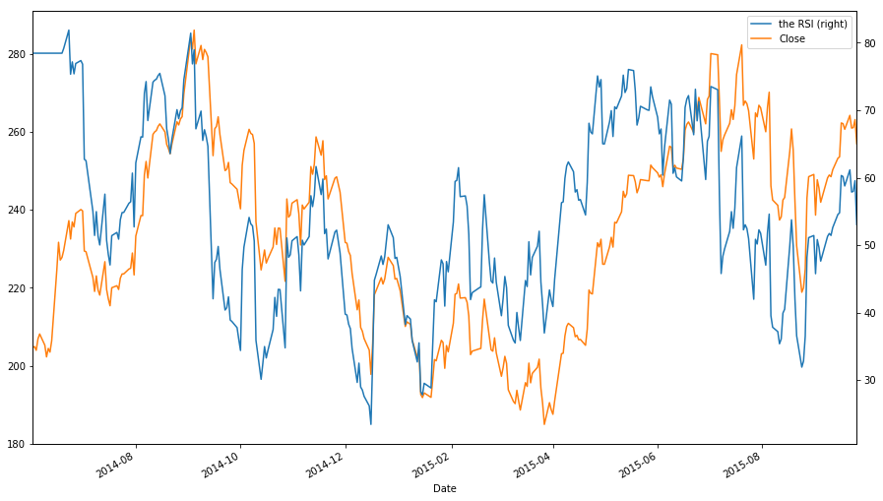

As you can see the RSI is much different from moving averages in how they do not lag behind the closed pricing whatsoever. This is because RSI is not simply a calculation measuring the average of prices but rather the average of the profit vs the average of losses over the provided period. By dividing the profits by the losses we are able to acquire the relative strength (velocity and magnitude) of the data set.

These RSI values are put through the same process as the lagging indicator strategy by finding entry and exit points based off of Boolean logic. The logic is of whether the values provided are higher or lower than the given parameter boundaries. For example, if the boundaries provided are a high RSI of 90 and low of 10, then the FIRST value that touches above 90 will initiate a sell signal since it is overbought, and respectfully the opposite will occur when the FIRST value touches below 10, initiating a sell signal due to being oversold. We take only the first value due to the RSI producing multiple values for consecutive days that surpass the set boundary, if these values were all accounted for then there would be multiple buy signals consecutively. By taking the first value we are able to generate an accurate entry point, however a break out point from these consecutive values will also need to be determined. By taking the average time these consecutive values go for, we are able to determine a break out point at which the algorithm can continue searching for another entry point following the last entry point. After calculating the average from multiple sample sizes, we found the optimal breakout point to be 3-4 days.

**Results:**

In order to determine the efficiency of this strategy, the parameters of look back period, RSI oversold value and RSI overbought value will need to be run through different combinations. The goal being to find out what are the optimal parameters in this strategy, just as we did for the strategy before.

Below will be 2 tables being run using the following parameters of:

* Stock:
  + Non-volatile: TSLA,,AAPL,GOOGL,WFC,GS,BA
  + Volatile ETF: JNUG,DGAZ,JDST,UGAZ,DUST,UNG
* Starting amount: $100,000 Amount invested per trade: 0.16 (1/number of stocks)
* Time frame: 2014-1-10 to 2015-1-10. 2015-1-10 to 2016-1-10. 2016-1-10 to 2017-1-10.

The table below will show the results of running this RSI strategy on non-volatile stocks:

Legend: blue indicates the most optimal values in regard to look back period for 2016-2017, where as yellow and red represent 2015-2016 and 2014-2015 respectfully.

|  |  |  |  |  |  |  |  |
| --- | --- | --- | --- | --- | --- | --- | --- |
| Look Back Period | High- 95  Low-5 | High-90  Low-10 | High-85  Low- 15 | High-80  Low-20 | High-75  Low-25 | High-70  Low-30 | High-65  Low-35 |
| LBP- 2  2016-2017 2015-2016 2014-2015 | 11.9% 18.9% 15.3% | 10.9% 18.1% 11.6% | 12.3% 22.3% 11.7% | 10.8% 21.8% 11% | 11.7% 18.5% 7.9% | 12.2% 18.8% 7.8% | 13% 15.4% 5.2% |
| LBP-4  2016-2017 2015-2016 2014-2015 | 2.7% 0 2% | 9.8% 3.9% 3.5% | 14% 6.4% 7.4% | 11.9% 9% 10.4% | 8.2% 15.6% 10.7% | 5% 16.5% 15.3% | 2.9% 13.8% 10.5% |
| LBP-6  2016-2017 2015-2016 2014-2015 | 0 0 0 | 1.3% 0 0 | 15.5% 0.7% 1.2% | 9.6% 1.9% 8.1% | 9.7% 10% 6% | 9.9% 7.7% 7.4% | 3.2% 15% 15.4% |
| LBP-8  2016-2017 2015-2016 2014-2015 | 0 0 0 | 0 0 0 | 10% 0 3% | 17.2% 1.8% 0.6% | 8.1% 4.7% 6% | 11.2% 9.5% 9.6% | 8.9% 5.9% 6.2% |
| LBP-10  2016-2017 2015-2016 2014-2015 | 0 0 0 | 0 0 0 | 0 0 0 | 12.4% 0 1% | 13% 5% 2.8% | 8.8% 4.2% 8.5% | 9.7% 7.7% 7.2% |
| LBP-12  2016-2017 2015-2016 2014-2015 | 0 0 0 | 0 0 0 | 0 0 0 | 9% 0 0 | 11.6% 0 0.4% | 10.7% 2% 0.9% | 10.1% 9.2% 8.2% |
| LBP-14  2016-2017 2015-2016 2014-2015 | 0 0 0 | 0 0 0 | 0 0 0 | 0 0 0 | 10.5% 0 0.5% | 10.3% 1.9% 3.1% | 11% 3.6% 7.7% |
| LBP-16  2016-2017 2015-2016 2014-2015 | 0 0 0 | 0 0 0 | 0 0 0 | 0 0 0 | 9. 4% 0 0 | 8.6% 0 0.9% | 10.4% 1.4% 1.1% |

After back testing the non-volatile stocks through multiple look back periods and boundary values we found that 78% of the optimal values fell into a look back period of 2, 9% for period 4 and 6, and 4% for period 8 . As for the boundary values in regard to their most profitable look back periods, in 2014-2015 as the boundary values widened the profit returned decreased, leaving the most profitable values at the 95-5 boundary set. in 2015-2016 the most optimal values were found between the 85-15 boundary and 80-20 boundary.2016-2017 there seemed to be little to no correlation between the profits and boundary values. However a correlation between look back period and boundary values can be determined by taking the average of every years returns values and comparing it to that years potential gain (best potential being represented by its optimal value of that year). By doing this we were able to determine that at LBP-2 the best boundary values were 95 and 5, and for the LBP-4/LBP-6 the 75-25 boundaries provided the best results.

Using this data it is determined that for non-volatile stocks, it is most likely best to use a look back period between 2 and 6. As the RSI’s sensitivity rises it the boundaries required to produce optimal results seem to decrease. An observation that explains why this happens can be seen in the dataset by observing where the boundaries decreased and LBP increased, the amount of signals generated decreased so much that important oversold and overbought signals were not noticed, hence providing returns of 0 in many cases.

The table below will show the results of running this RSI strategy on volatile ETF stocks:

|  |  |  |  |  |  |  |  |
| --- | --- | --- | --- | --- | --- | --- | --- |
| Look Back Period | High- 95  Low-5 | High-90  Low-10 | High-85  Low- 15 | High-80  Low-20 | High-75  Low-25 | High-70  Low-30 | High-65  Low-35 |
| LBP- 2  2016-2017 2015-2016 2014-2015 | 0.6% 14% -6.7% | -17.8% 24% 0.1% | -38% 8.3% -2.6% | -42.5% -3.1% -4.3% | -25.4% -0.2% 2.9% | -24.7% 18.2% -3.4% | -7.8% -8.1% -25% |
| LBP-4  2016-2017 2015-2016 2014-2015 | 98.1% 0% 5.8% | -46.7% -16.2% -15.5% | -52.3% 13.2% -37.8% | -21.2% -1.5% -13.4% | 4.2% 6.3% -23.2% | -23.2% 1.3% -17.1% | -28% -9.7% -5% |
| LBP-6  2016-2017 2015-2016 2014-2015 | 0 0 0 | 0 0 0 | -7.4% 0 27.5% | -47.5% -12.4% -12.1% | -46.2% 1.5% -35% | 5.4% -6% -22.6% | -13.1% 6.3% -37.8% |
| LBP-8  2016-2017 2015-2016 2014-2015 | 0 0 0 | 0 0 0 | 0 0 0 | -31.7% 0 13.2% | -43.1% 31.7% -11.2% | -54% -4% -39% | -27.8% -16.2% -22.3% |
| LBP-10  2016-2017 2015-2016 2014-2015 | 0 0 0 | 0 0 0 | 0 0 0 | -7.3% 0 25% | -30% 0% 11.1% | -50% 18.1% -9.7% | -43.1% 5.7% -25.8% |
| LBP-12  2016-2017 2015-2016 2014-2015 | 0 0 0 | 0 0 0 | 0 0 0 | 0 0 0 | 14% 0 17% | -17.6% 11.5% 0.4% | -42.8% 9.5% -28% |
| LBP-14  2016-2017 2015-2016 2014-2015 | 0 0 0 | 0 0 0 | 0 0 0 | 0 0 0 | 0 0 0 | -26.3% 0 13% | -41.1% 10% -11.4% |
| LBP-16  2016-2017 2015-2016 2014-2015 | 0 0 0 | 0 0 0 | 0 0 0 | 0 0 0 | 0 0 0 | -24.7% 0 16.3% | -35.7% 8.8% -6.5% |

Unlike the non-volatile stock, the volatile stocks provided no determinant patterns/correlation between returns, look back period and boundary size. The overall return rates provided were significantly lower in comparison to the volatile stocks run through the same strategy and parameters. After thorough analysis of the dataset, there seems to be no distinguishable optimum that should be used with these stocks. The results of running an RSI strategy on these stocks resulted in what can be best described as random returns with deterioration due to their highly volatile nature.

**Strategy 3:**

The third strategy to be implemented will be using an leading indicator with lagging indicators. This will be conducted as a comparable to the standalone strategies that implement only lagging or leading indicators. The comparison is done in order to determine the positive and negative effects a leading or lagging indicator bring to a trade strategy. This strategy will aim to out perform the previous strategies by using a complimentary indicator capable of performing well in areas an lagging or leading indicator is weak in.

The name of the strategy is called RSI2. It was developed by Larry Conners as a mean-revision trading strategy designed to buy or sell securities after a corrective period [30]. The strategy consists of 2 steps.

First, identify the major trend using a long-term moving average. Connors advocates the 200-day moving average. The long-term trend is up when a security is above its 200-day SMA and down when a security is below its 200-day SMA. Traders should look for buying opportunities when above the 200-day SMA and short-selling opportunities when below the 200-day SMA.[30]

Second, choose an RSI level to identify buying or selling opportunities within the bigger trend. Connors tested RSI levels between 0 and 10 for buying, and between 90 and 100 for selling. Connors found that returns were higher when buying on an RSI dip below 5 than on an RSI dip below 10. In other words, the lower RSI dipped, the higher the returns on subsequent long positions. For short positions, the returns were higher when selling-short on an RSI surge above 95 than on a surge above 90. In other words, the more short-term overbought the security, the greater the subsequent returns on a short position.[30]

**Implementation/Results:**

This strategy will be combining the last 2 strategies using the same approach. The program will be simulating a real life use of this strategy by only purchasing the first buy signal provided rather than any consecutive buy signals that follow it before a sell signal is generated. This means that is a trader is using this strategy in real time, when a buy signal is generated they will purchase that stock at that time, so if multiple buy signals from other indicators are signaling to the trader to buy the same stock again before a sell signal has been triggered, they will be ignored. The same concept will follow for sell signals as well, it will be set a s a first come first serve basis.

The first 2 back tests will be using Larry’s default parameters as a benchmark, for the following back tests following it, that will aim to beat the return generated from it.

The parameters used in these 2 back tests are:

* Stock:
  + Non-volatile: TSLA,,AAPL,GOOGL,WFC,GS,BA
  + Volatile ETF: JNUG,DGAZ,JDST,UGAZ,DUST,UNG
* Starting amount: $100,000 Amount invested per trade: 0.16 (1/number of stocks)
* Time frame: 2016-1-10 to 2017-1-10
* Parameters: 200 slow MA. 5 fast MA. 2 period RSI. High 95 Low 5 RSI boundaries.
* 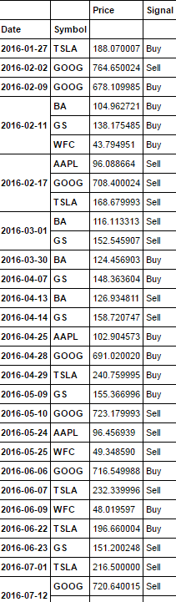 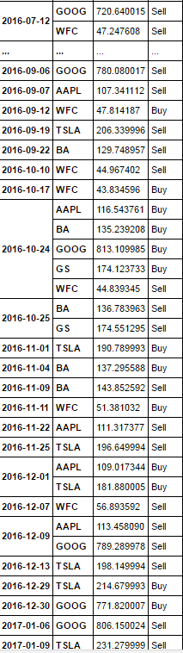 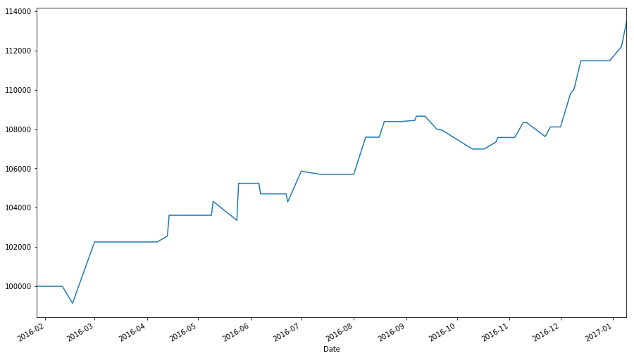

Below are the results of the back test for the non-volatile stocks: 13.5% profit

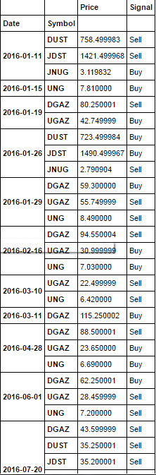 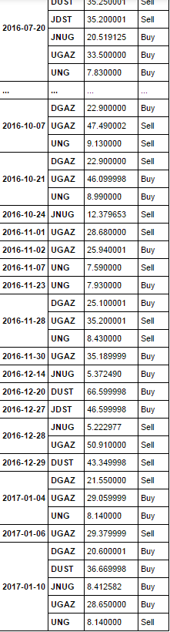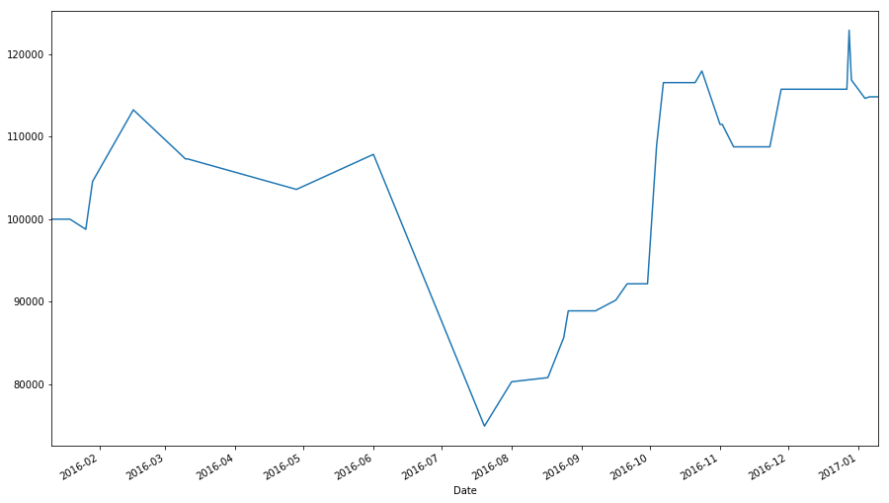

Below is the back test for the volatile stocks: 14.8% profit

Remarkably the back tests above provided positive returns for not only the non-volatile stocks, but for the volatile stocks as well, with returns that actually exceeded those of the non-volatile for the first time compared to previous strategies. But of course, one similarity in relation to previous strategies is the volatiles stocks tendency to have a unstable back test, where as the non-volatile as usual are much more stable. The depiction of their stability can be seen from their graphs above, notice how the non-volatile stocks have a graph that rises in a more uniform manner in comparison to that of the volatile stocks. These back tests are not enough data to base a conclusion upon, and hence more testing will need to be conducted.

Below will be back testing of this strategy on volatile and non-volatile stocks using the same stocks, starting amount and amount invested per trade as the previous back tests above. The time frames will be from 2013-1-10 to 2014-1-10, 2014-1-10 to 2015-1-10, 2015-1-10 to 2016-1-10 and 2016-1-10 to 2017-1-10. These dates are selected in order to keep consistency in relation to previous strategies in order to attain accurate comparisons and differences between them. We will be using the optimal parameters of the previous strategies to find the optimum returns for this strategy. From strategy one, we found that the most optimal parameters for the moving averages to be a fast 10 MA and slow 30 MA. From strategy two, we found that majority of the optimal return values were found around the 2nd to 6th look back periods. The boundary values however will be determined through Larry Conner’s approach, by using tighter boundaries in shorter periods, the return values should be more optimal than the use of wider boundarie. Hence we will be associating the 95-5 boundary with the 2 period RSI, the 75-25 with the 4th period and 75-25 with the 6th period.

|  |  |  |  |
| --- | --- | --- | --- |
| Non-Volatile Stocks | MA 5/15 | MA 10/30 | MA15/45 |
| LBP 2 95-5  2013-2014  2014-2015  2015-2016  2016-2017 | 13.4%  19%  12.7%  19% | 9.2%  20.1%  14.5%  12.7% | 6.9%  17.8%  9.4%  7.1% |
| LBP 4 75-25  2013-2014  2014-2015  2015-2016  2016-2017 | 18.4%  12.8%  7.5%  13.9% | 16.7%  13.3%  10%  9.8% | 13.9%  8.4%  9.4%  7.8% |
| LBP 6 75-25  2013-2014  2014-2015  2015-2016  2016-2017 | 13.5%  10%  7.9%  13.5% | 8.6%  11.3%  7.7%  13.6% | 13.4%  7.2%  3.9%  11% |

Using Yellow to represent the #1 largest return value for that year, Red for #2 largest return for that year and Blue for #3 largest return of that year. We are able to use these return values to pinpoint what the most optimal parameters are. By looking at where these high return values center around, given that Yellow values are a higher weight than blue/red and Red is given a higher weight than Blue. We are able to find that non-volatile stocks are in fact very stable and in return able to depict what optimal parameters can be used to provide optimal results. By finding the center of the given weights, the best parameters seem to be at a LBP of 2 and a MA of 5/15. It is at these parameters that the profit return values are most optimal, and hence will be used as the case set against the set benchmark.

|  |  |  |  |
| --- | --- | --- | --- |
| Volatile Stocks | MA 5/15 | MA 10/30 | MA15/45 |
| LBP 2 95-5  2013-2014  2014-2015  2015-2016  2016-2017 | 4.3%  14.6%  -2.7%  -17% | 1.6%  -5.2%  3%  23.5% | 2.2%  -12.5%  -17.7%  -20.1% |
| LBP 4 75-25  2013-2014  2014-2015  2015-2016  2016-2017 | -1.4%  20.6%  3.9%  27.3% | -2.3%  -24%  19.5%  -10.8% | 5.3%  -22.5%  -21%  -24% |
| LBP 6 75-25  2013-2014  2014-2015  2015-2016  2016-2017 | 30%  -23%  -4.7%  -44.2% | 2.2%  -33.1%  17.3%  -42.4% | 11.7%  -25%  -19.4%  -52.4% |

Using the same color scheme as previously, all high valued returns are highlighted accordingly. Unfortunately the optimistic returns shown in the previous back test with this strategy with volatile stocks was not a good depiction of the true results. As it can be seen from the results above, the return values of the volatile stocks are very similar to the previous strategies. 60% of all the returns turned out to be highly negative whereas 40% of the return values were highly positive, but is of course not surprising since these are volatile stocks being dealt with. There also seems to be no stability once more in these results pointing towards any optimal parameters, unlike the non-volatile stocks that are capable of doing so. Hence, it is concluded that these strategic approaches to volatile stocks are no better than an at random 50-50 pick strategy.

**Verification/Efficiency:**

Working with the double crossover method provided some great results, but there is a lot of room for optimization of the strategy. This strategy uses two lagging indicators that are trend following. This means that using this approach will most likely have very skewed results if it hits a curve that is sideways since lagging indicators are also known as trend following indicators and sideways curves are obviously not trends. The signals created by these moving averages will also be a bit late for any buy and sell signals since it does in fact depend on past data to move [8].

The system as it stands also is not very robust, this is because if for even a fleeting moment when the fast moving average is above the slow moving average triggers a trade, resulting in trades that end immediately (we want to avoid this due to possible commission fees eroding earnings). Additionally, every bullish regime immediately transitions into a bearish regime, this would lead to the end of one trade immediately triggering a new trade that bets in the opposite direction. A better system would require more evidence that the market is moving in a certain direction. [17].

This strategy would be made much more efficient if combined with some other indicators that complimented its trend following tendencies. An example of this would be the use of the MACD indicator, This would be able to identify and quantify the cross overs by showing a line that represents the difference between the two averages. The MACD will turn positive for when a lower average crosses a slower average above it and it will show to be negative if crossed the other way around. Using the percentage price oscillator (PPO) would also work in the same way, however, both of these would work much better with an exponential average rather than simple. One last indicator that would help make this strategy a lot more effective would be the RSI. The reasoning for this being that moving averages are simply trend followers, the flaw however is that they at the same time are lagging so knowing when the trend will end exactly is hard to predict, and in result will lose the trader a lot of potential earnings. The RSI is able to indicate when a stock is at over bought or over sold levels, using this with the moving averages will most likely increase profit by a good margin [19].

Two other ways for improving the results of this method would be: to include the shorting of stocks, that way this system would be able to take advantage of both sides of the coin. And making the trade signals more robust by triggering a trade only when the moving averages differ by a fixed amount using standard deviations.

While running these back test it was presumed that when using a technical trade strategy, very few losses would occur, but to the contrary quite a lot of losses did occur while testing numerous stocks. A naïve approach to fixing this problem is implementing a stop loss in the algorithm. A stop loss is an order placed with a [broker](http://www.investopedia.com/terms/b/broker.asp) to sell a security when it reaches a certain price. A stop-loss order is designed to limit an investor’s loss on a position in a security. A stop loss can be used in two ways, initial or trailing. An initial stop loss will be a function that takes in the time frame and the percentage that the user would like the stop loss to occur at. If the stock price within the given timeframe falls below the initial price of the stock (at the beginning of the time frame) multiplied by (1-stop loss percentage), then a stop loss will be triggered. If a stop loss is triggered, the profit will be calculated by taking the difference of the price of the stock at the entry point date and the price on the date the stop loss occurred. The second type, a trailing stop loss, is an approach in which a stop loss is triggered if the difference in percentage between two consecutive days surpass the set stop limit, instead of using the initial value in the given time frame. These approaches will always sell all holdings once a limit is surpassed. However, there are quite a few problem with using these stop losses. When playing in a volatile market, a stock price can gap down almost instantly, for example: from 1% to -7%. When a price falls too fast, even a automated stop loss is not capable of catching it on time and will end up selling all the stocks at the bottom price of -7% even if the stop loss is set for -5%. A game many market-players (a company or financial institution capable of influencing a certain market) play is “run the stops”, where they sell a large amount of shares in order to drop the value of the stock to the point that most people’s stop losses are then triggered. Once the stock is sold and the stop losses triggered, the stock will reverse direction and rally up in price for a solid amount of gain for the market makers. It is not only market makers that cause this problem, sometimes when a current event occurs, it can effect a stocks price. Sometimes the problem is even as simple as the stock price fluctuating by going down say 5% for example but then up 15% over the next few days, this is potential profit that is loss due to the automated stop loss [25]. It is for that reason that a trailing stop loss will not be used in the back tests, but rather the initial stop loss instead. Below is an example of how a stop loss in this trade strategy helps produce better returns.

**Benchmarking:**

As previously mentioned above, the most optimal way to evaluate the efficiency of a trading strategy is to compare it to the S&P 500 index fund or SPY, an index that follows the S&P 500 at 1/10th the price. Below is a chart of SPY from 2013 to 2017 (the same time frame as the moving cross over back test). This chart shows that the increase in SPY over the 4 years was about 66%.

**Lagging Indicator:**

Below are two charts representing the results of the back test of the two stock groups being run through the first implemented strategy using a slow MA of 30 and fast of 10. Each stock group will be run for the time period of 2013 to 2017 as a comparison to the benchmark that is set.

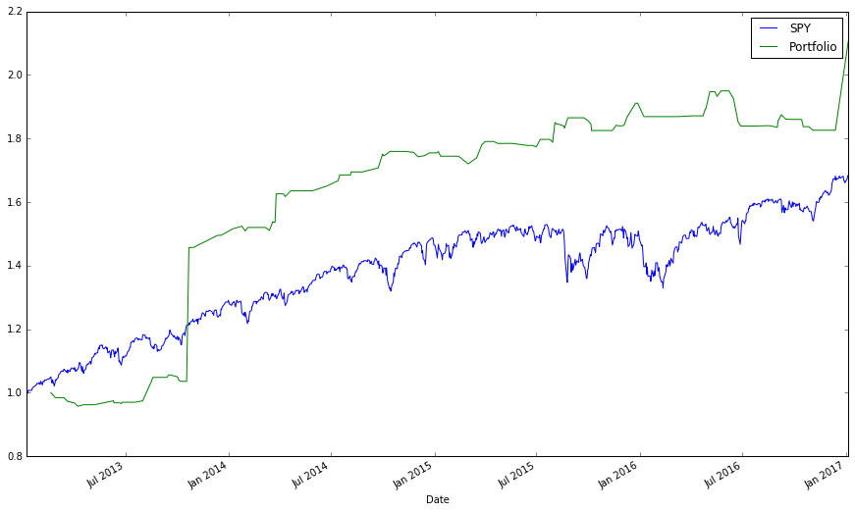

The graph Above shows the results of the NON-volatile stocks and SPY over a 4 year period. The non-volatile stocks over this time accrued a total profit of 110%. Hence beating the set benchmark. Although if the jump in late 2013 seemed to provide a 50% rise in a very short period, this is most likely due to a fundamental component of a company exceeding expectations. These events are not always guaranteed, and so if this jump theoretically did not occur, this back test would then provide a return almost equal to that of the benchmark. (60% without tesla, batch=0.2)

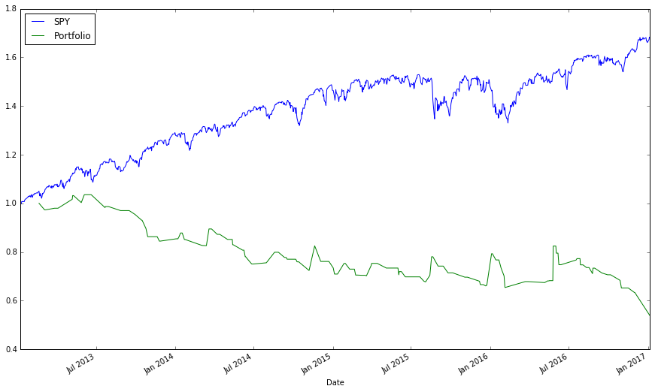

The graph above shows the results of the Volatile stocks and SPY over a four year period. The Volatile stocks over this time accrued a loss of -46%. Hence not even close to surpassing the set benchmark.

As observed. Even though the same strategy was applied with the same parameters and dates, the outcome between the 2 stock groups are immense to say the least.

**Leading Indicator:**

Below are two charts representing the results of the back test of the two stock groups being run through the second implemented strategy using the Relative Strength Index indicator. This run will be using the most optimally found parameters of a LBP-2 and boundaries of 95-5 as a comparison to the benchmark. Each stock group will be run for the time period of 2013 to 2017.

This is the comparison between the non-volatile stocks. The total profit generated in the portfolio is 47%. So unfortunately, although it was close, using the leading indicator approach did not generate more returns than the set benchmark.

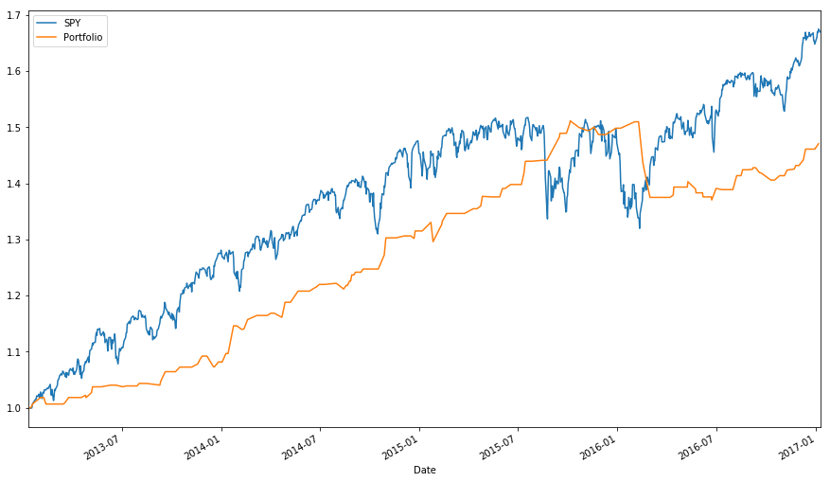

This is the comparison between the non-volatile stocks. The total profit generated in the portfolio is -5%. These results, although very low in comparison to non-volatile stocks returns using the same strategy, were actually much better when compared to the moving average strategy on volatile stocks. In the MA strategy the difference between the volatile and non-volatile stocks return was 156%, where as with the RSI approach the difference between the two is 52%. However, presuming that jump in the MA strategy did not occur (as previously explained) we can assume the results between these two strategies for non-volatile stocks is very similar. But even by taking that into account, the return of volatile stocks with the RSI approach was still significantly better. Hence it may be concluded that the RSI strategy may be more adequate when dealing with volatile stocks.

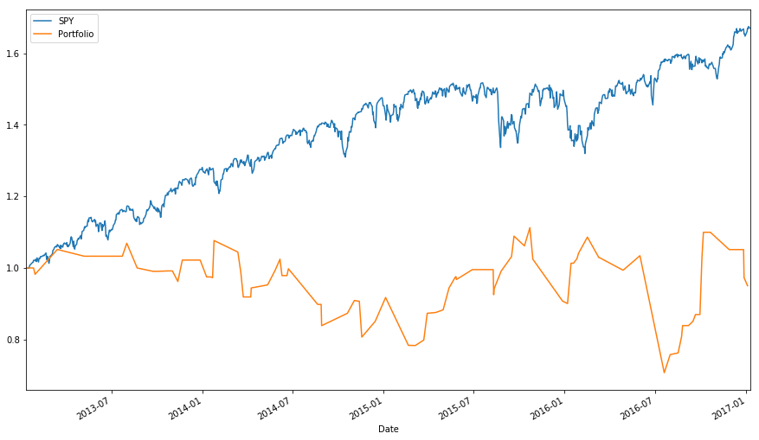

**Strategy 3:**

Below are two charts representing the results of the back test of the two stock groups being run through the third implemented strategy using the Relative Strength Index indicator and moving averages. This run will be using the most optimally found parameters of a LBP-2, boundaries of 95-5, a fast MA 5 and slow MA 15 as a comparison to the benchmark. Each stock group will be run for the time period of 2013 to 2017.

This is the comparison with the non-volatile stocks. The total profit generated in the portfolio is 57%. These results are the most stable results in relation to the benchmark, it follows it well and is closer to being equal with the benchmark than previous strategies. Better results than the RSI alone, but less than the MA alone, although if the MA spike is not considered, we could say that this strategy surpasses the MA approach as well.

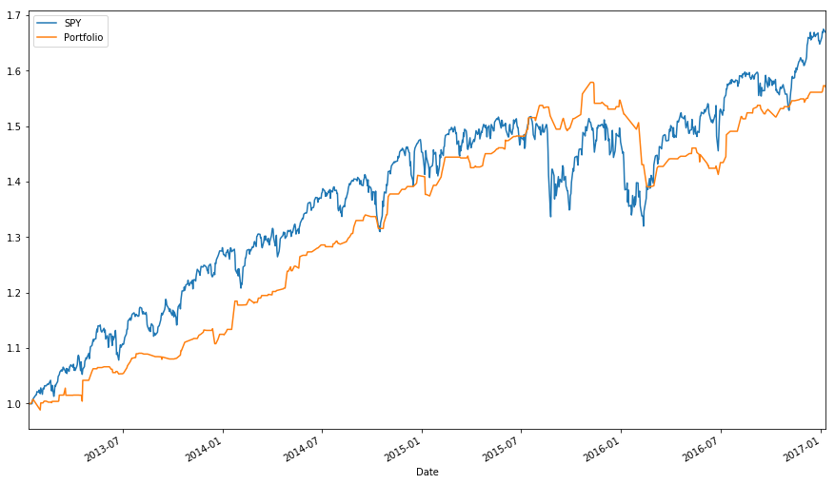

This is the comparison with the volatile stocks. The total profit generated in the portfolio is -5.4%. Even with the use of both indicators in strategy 3, it seems like once again the volatile stocks could not be predicted by technical indicators. These results however are much more impressive in relation to the MA approach, but almost no different than the RSI approach.

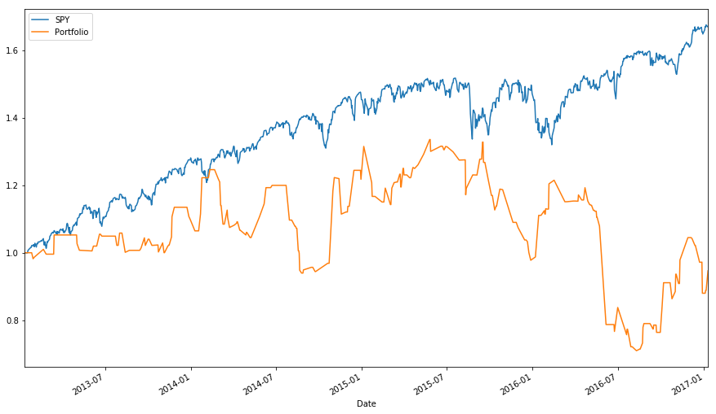

**CONCLUSION:**

After back testing multiple stocks of different volatility levels using three different trade strategies, we found there to be a large amount of differences between each approach.

In relation to the stability of the different strategies with non-volatile, it was evident in the benchmarking that the lagging strategy provided the least stable results with random jumps involved, the leading indicator provided better stability than lagging and the RSI2 strategy proving to have the best stability when compared to the benchmark that is a measure of the market as a whole. In reference to volatile stocks however, each strategy proved to have an equal amount of instability, showing no relation among its multiple profit returns.

In terms of profitability, the most optimal way to measure which strategies provide the highest returns we observe the benchmarking once again. The benchmark results are a result of comparing the overall market returns to the most optimal parameters for each strategy. Using these optimal parameters we found that the strategy with the most optimal returns with non-volatile stocks to be the lagging strategy with returns of 110% compared to the leading strategy with 47% and RSI2 with 57%. Even by taking out the stock causing a large jump in the lagging strategy (TSLA), it was still able to provide returns above the previous approaches with a 60% return. With volatile stocks, we found the returns to unfortunately be nowhere near the same margins as the non-volatile stocks across all strategies. The lagging strategy provided the worst returns with volatile stocks with a -50% profit and the leading strategy along with the RSI2 returning much better returns of -5% for both. It is concluded from these statistics that the use of lagging indicators with volatile stocks is not the best idea, but rather when used with an leading indicator can juristically help provide better returns.

Beating the efficient market hypothesis may be possible through other means, but in terms of this paper alone, beating it was not possible. We were instead able to decipher the differences between each leading/lagging strategies returns, and determine how efficient technical analysis is on volatile stocks. These results in turn were able to provide a few conclusions:

* Lagging indicators are less stable and provide higher returns in comparison to leading indicators using non-volatile stocks.
* Leading indicators are better with volatile stocks compared to lagging.
* Volatile stocks are unstable overall. Non-volatile are stable overall.
* Volatile stocks and technical indicators do not mix well.
* When not using commission fees it is best to use day trade parameters.
* Beating the market is not possible through these approaches.

As a personal conclusion, I have determined that the efficient market hypothesis hold some truth to it. Creating general strategies to find a common pattern among all stocks is not a very efficient approach since every stock is different in its own ways. Although stocks overall do have some patterns found commonly among them, it will not be enough to provide returns large enough for beat the market overall. A better approach I’ve determined is to select a single stock and customize a strategy and its parameters to that stocks specific patterns. By doing this I predict more accurate entry and exit points can be determined since these set rules are not generalized among thousands of other stocks. Of course, none of this is provable at this time, and is nothing more than a personal observation from the results of this paper overall.

**References:**

1. Professor Leigh Tesfatsion. "Introduction to Financial Markets (Econ 308, Tesfatsion)." Introduction to Financial Markets (Econ 308, Tesfatsion). IAstate, n.d. Web. 25 Feb. 2017.
2. Gad, Sham. "How An IPO Is Valued." Investopedia. N.p., 13 Feb. 2016. Web. 25 Feb. 2017.
3. Manisha Thakor. "Public vs. Private: What Does It Mean for a Company to Go Public?" LearnVest. Learnvest, 4 Oct. 2010. Web. 25 Feb. 2017.
4. Staff, Investopedia. "Technical Analysis: Fundamental Vs. Technical Analysis." Investopedia. N.p., 05 June 2006. Web. 25 Feb. 2017.
5. Staff, Investopedia. "Introduction To Fundamental Analysis." Investopedia. N.p., 01 Dec. 2003. Web. 25 Feb. 2017.
6. "Technical Analysis." StockCharts.com. Chartschool, 09 May 2016. Web. 25 Feb. 2017.
7. Fleckenstein, Loren. "The Psychology Of Chart Patterns." TradingMarkets.com. N.p., 29 Dec. 2009. Web. 25 Feb. 2017.
8. "Introduction to Technical Indicators and Oscillators." StockCharts.com. Stockschool, 13 Jan. 2016. Web. 25 Feb. 2017.
9. Mitchell, Cory. "Create Your Own Trading Strategies." Investopedia. N.p., 09 Aug. 2016. Web. 25 Feb. 2017.
10. Milton, Adam. "What Is Day Trading?" The Balance. N.p., n.d. Web. 25 Feb. 2017.
11. Bergen, Jason Van. "Introduction To Swing Trading." Investopedia. N.p., 30 Dec. 2003. Web. 25 Feb. 2017.
12. Kuepper, Justin. "Backtesting: Interpreting The Past." Investopedia. N.p., 28 Sept. 2016. Web. 25 Feb. 2017.
13. "Product Development: Is the Backtest Trustworthy?" Exceed Investments. N.p., 21 Apr. 2016. Web. 25 Feb. 2017.
14. ROGER G. IBBOTSON. "Why Does Market Volatility Matter?" Yale School of Management. N.p., 20 Sept. 2016. Web. 25 Feb. 2017.
15. Uy, Kristine June D., and Chris Rudyard F. Naval. "Volatility Similarities of Stock Prices within the Same Industries." Recoletos Multidisciplinary Research Journal 1.2 (2013). Web. 09 November 2015.
16. Investopedia. "Efficient Market Hypothesis: Is The Stock Market Efficient?" Forbes. Forbes Magazine, 01 May 2012. Web. 25 Feb. 2017.
17. Miller, Curtis. "Curtis Miller's Personal Website." Curtis Miller's Personal Website. N.p., 16 Sept. 2016. Web. 25 Feb. 2017.
18. "Scripting Must Be Enabled to Use This Site." What Is "short Selling"? How Does It Work? IBD, n.d. Web. 25 Feb. 2017.
19. "Moving Averages - Simple and Exponential." StockCharts.com. Stockschool, 10 Feb. 2015. Web. 25 Feb. 2017.
20. Karl. "Do You Know How to Read Stocks?" WiseStockBuyer. Merrill Edge, 17 Jan. 2013. Web. 25 Feb. 2017.
21. "Introduction to Candlesticks." StockCharts.com. Stock School, 09 June 2014. Web. 25 Feb. 2017.
22. "Definition of 'Stock Split'." The Economic Times. N.p., n.d. Web. 25 Feb. 2017.
23. Pardo, R. The Evaluation and Optimization of Trading Strategies. J. Wiley & Sons, 2008, page 18. [ISBN 978-0-470-12801-5](https://en.wikipedia.org/wiki/Special:BookSources/9780470128015)
24. Biondo, Alessio Emanuele, Alessandro Pluchino, Andrea Rapisarda, and Dirk Helbing. "Are Random Trading Strategies More Successful than Technical Ones?" PLOS ONE. Public Library of Science, n.d. Web. 17 Mar. 2017.
25. Sincere, Michael. "Why I Stopped Using Stop Loss Orders." MarketWatch. N.p., 09 May 2013. Web. 18 Mar. 2017.
26. Kevin. "The Definitive Guide to Shorting Leveraged ETFs." Signal Plot. N.p., 30 Jan. 2017. Web. 23 Mar. 2017.
27. Staff, Investopedia. "Leveraged ETF." Investopedia. N.p., 28 Dec. 2015. Web. 23 Mar. 2017.
28. Nicolas. "Variable Moving Average (VMA)." ProRealCode - Sharing ProRealTime Knowledge. N.p., 14 Dec. 2016. Web. 30 Mar. 2017.
29. "MACD (Moving Average Convergence/Divergence Oscillator)." StockCharts.com. N.p., 21 Nov. 2014. Web. 30 Mar. 2017.
30. "RSI2." StockCharts.com. N.p., 21 Nov. 2014. Web. 02 Apr. 2017.