

Happy 26th Birthday

1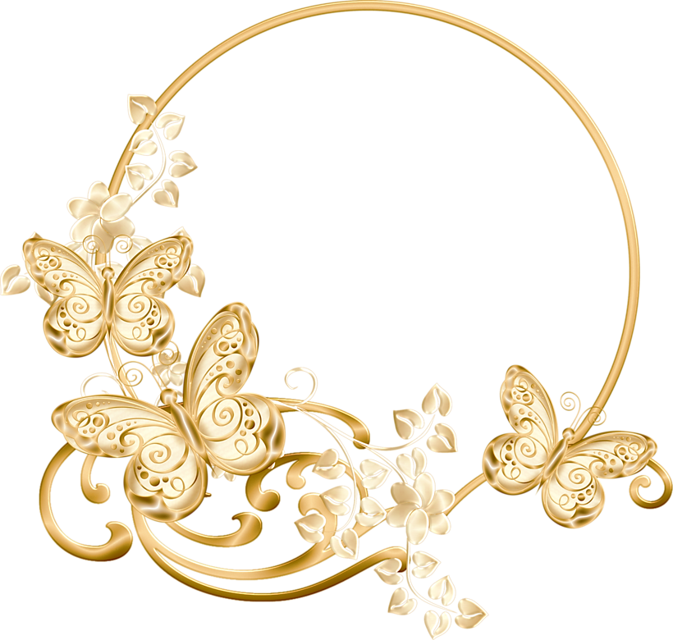

Virly Rose

Love: Mama & Papa

HAPPY B-DAY JOHN PAUL

Happy Birthday,

Mama Delia!

Happy Birthday,

Raine!