Configuration

- Purpose

The configuration menu will be used to define lookup data for all the form views in EPFC Loan module. This menu is subdivided into the following groups:

- Financing – parameters needed for processing of loan and payments.
- Accounting
- Localization
- MC Registration
- Config Logs
- Credit Investigation Questions
- Branch Information
- Vehicle Information
- Documentation
- Others
- Reports

- Financing

Submenu | Accessed By | Fields | Description
Payment Terms | Inquiry  Credit Investigation  Adjustments > Change Term  Loan Application  Loan Release  Purchase Order | No. of Months* | number of months in number
Payment Terms |  | Term | description
Rebates | Inquiry  Loan Application  Loan Release | Active | Indicates whether this record is being used.
Rebates | Inquiry  Loan Application  Loan Release | Branch | Indicates on which branch transactions the rebate amount will take effect.
Rebates | Inquiry  Loan Application  Loan Release | Effectivity Date | Indicates when the rebate amount will take effect.
Rebates | Inquiry  Loan Application  Loan Release | Brand New | Rebate amount for brand new motorcycle units.
Rebates | Inquiry  Loan Application  Loan Release | Repo | Rebate amount for repossessed motorcycle units.
Interest Rate | Inquiry  Loan Application  Loan Release | Active | Indicates whether this record is being used.
Interest Rate | Inquiry  Loan Application  Loan Release | Branch | Indicates on which branch transactions the interest rate will take effect.
Interest Rate | Inquiry  Loan Application  Loan Release | Effectivity Date | Indicates when the interest rate will take effect.
Interest Rate | Inquiry  Loan Application  Loan Release | Brand New | Interest rate for brand new motorcycle units.
Interest Rate | Inquiry  Loan Application  Loan Release | Repo | Interest rate for repossessed motorcycle units.
Processing Fee for Account Adjustments | Adjustments > Pre-Termination  Adjustments > Change Term  Cashiering > Other Collections | Active | Indicates whether this record is being used.
Processing Fee for Account Adjustments |  | Particulars | Indicates the type of adjustment.
Processing Fee for Account Adjustments |  | Branch | Indicates on which branch transactions the processing will take effect.
Processing Fee for Account Adjustments |  | Effectivity Date | Indicates on when the processing will take effect.
Processing Fee for Account Adjustments |  | Range From | Lower limit in terms of month
Processing Fee for Account Adjustments |  | Range To | Upper limit in terms of month
Processing Fee for Account Adjustments |  | Amount | Processing fee
Payment Type | Cashiering > Other Collections | Description | Nature of payment
Payment Type | Cashiering > Other Collections | Account Code | Mapping to the Chart of Accounts  If not specified, user will have to specify the account code upon payment.
Surcharge Rate | Inquiry  Loan Application  Loan Release  Payment Schedule | Active | Indicates whether this record is being used.
Surcharge Rate | Inquiry  Loan Application  Loan Release  Payment Schedule | Branch | Indicates on which branch transactions the surcharge rate will take effect.
Surcharge Rate | Inquiry  Loan Application  Loan Release  Payment Schedule | Effectivity Date | Indicates when the surcharge rate will take effect.
Surcharge Rate | Inquiry  Loan Application  Loan Release  Payment Schedule | Surcharge Rate | Surcharge rate for late payments.
Grace Period | Payment Schedule  First Notice  Second Notice | Active | Indicates whether this record is being used.
Grace Period | Payment Schedule  First Notice  Second Notice | Effectivity Date | Indicates when the surcharge rate will take effect.
Grace Period | Payment Schedule  First Notice  Second Notice | Grace Period | Number of days extension after the due date.
Due Date Forwarding | Payment Schedule  First Notice  Second Notice | Loan Release that fall from 26th to 31st of the month, forward to 1st day of succeeding month? | As described by the field label.
Default Payment Timing | First Notice  Second Notice | Active | Indicates whether this record is being used.
Default Payment Timing | First Notice  Second Notice | Number of days to generate 2nd notice after receipt | As described by the field label.
Default Payment Timing | First Notice  Second Notice | Number of days to generate 2nd notice if 1st notice is not updated | As described by the field label.
Maturity Surcharge Rate | Cashiering > Financing Collection  Cashiering > Inter-Branch Financing Collection | Active | Indicates whether this record is being used.
Maturity Surcharge Rate |  | Branch | Indicates on which branch transactions the maturity surcharge rate will take effect.
Maturity Surcharge Rate |  | Effectivity Date | Indicates when the maturity surcharge rate will take effect.
Maturity Surcharge Rate |  | Maturity Surcharge Rate | Maturity surcharge rate for late payments.
*required

- Accounting

Submenu | Accessed By | Fields | Description
Journals | Loan Release  MC Registration > Liquidation  Cashiering  Adjustments  MC Unit Repossession  Job Order > Expenses  Ownership Transfer  Accounting > Treasury  Accounting > Payables | Journal Name* | Name of the journal
Journals |  | Code | This will be used as suffix for journal entries record numbers.
Journals |  | Type | Transaction Type
Journals |  | Debit | List of debit accounts based on transaction type, model, field, condition, condition value.  Syntax of condition:  <operand1>, <operator>, <operand2>  Type of value:  Fix – takes the value of the field  Computed – for enhancement  Percentage
Journals |  | Credit | List of debit accounts based on transaction type, model, field, condition, condition value [fix, computed, percentage].  Syntax of condition:  <operand1>, <operator>, <operand2>  Type of value:  Fix – takes the value of the field  Computed – for enhancement  Percentage
Journals |  | Display Mode | Gives the view used when browsing entries in this journal
Denomination | Cashiering > Reconciliation of Daily Cash Balances | Active | Indicates whether this record is being used.
Denomination | Cashiering > Reconciliation of Daily Cash Balances | Denomination | Amount.
*required

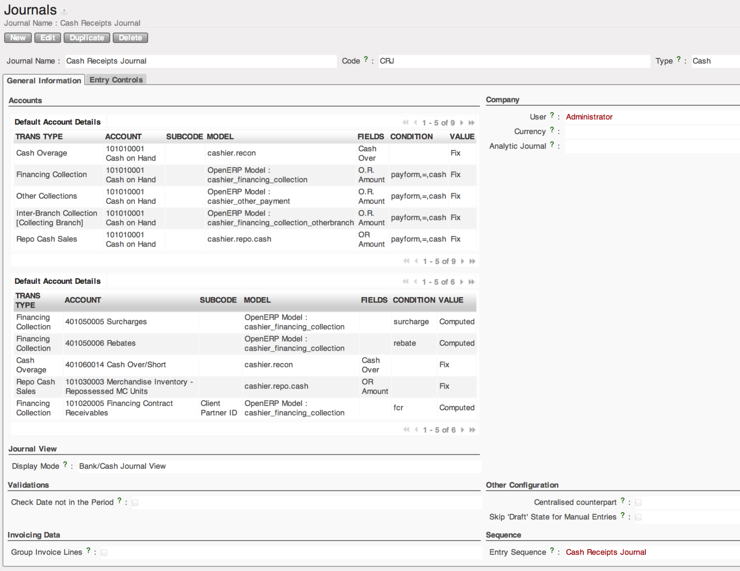
Figure 1. Form view of Configuration > Accounting > Journals

- Localization

Submenu | Accessed By | Fields | Description
Collectors | Inquiry  Loan Application  Credit Investigation  Loan Release  Cashiering > Financing Collection  Cashiering > Inter-Branch Financing Collection | Collector | Name of collector
Collectors |  | Branch | Name of branch
Collectors |  | Assigned Barangays | List of barangays assigned to the collector.
Barangay | Client Information  Inquiry  Loan Application  Configuration > Localization > Collectors | Barangay Code | System-generated code.
Barangay |  | Old Barangay Code | Barangay code in the old system
Barangay |  | City / Municipality * | City or town in which the barangay belongs to.
Barangay |  | Barangay Name* | Name of barangay
City / Municipality | Client Information  Inquiry  Loan Application  Configuration > Localization > Barangay | City Code | System-generated code.
City / Municipality |  | Old Municipal Code | Municipal code in the old system
City / Municipality |  | Province * | Province in which the barangay belongs to.
City / Municipality |  | City Name* | Name of city
Province | Client Information  Inquiry  Loan Application  Configuration > Localization > City / Municipality | Province Code | System-generated code.
Province |  | Old Province Code | Province code in the old system
Province |  | Province Name* | Name of province
Credit Investigation Questions | Credit Investigation | Category | Selection of:  Character  Capacity  Capital  Collateral  Condition
Credit Investigation Questions | Credit Investigation | Question | Questionnaire
Credit Investigation Questions | Credit Investigation | Rating 1 | Value for 1 rating
Credit Investigation Questions | Credit Investigation | Rating 2 | Value for 2 rating
Credit Investigation Questions | Credit Investigation | Rating 3 | Value for 3 rating
Credit Investigation Questions | Credit Investigation | Rating 4 | Value for 4 rating
Credit Investigation Questions | Credit Investigation | Rating 5 | Value for 5 rating
Credit Investigation Questions | Credit Investigation | Active | Indicates whether this record is being used.
Branch Location | All | Branch Code | System-generated code.
Branch Location | All | Old Branch Code | Branch code in the old system
Branch Location | All | Branch Name | Name of branch
Branch Location | All | Partner ID | Company definition in res.partner
Branch Location | All | Branch Address | Location of branch
Branch Location | All | Branch Tel. No. | Contact details of branch
Branch Location | All | Manager | Manager of branch

- MC Registration
- Config Logs
- Credit Investigation Questions
- Branch Information
- Vehicle Information
- Documentation
- Others

