MC Unit Redemption

- Purpose

When the customer fails to settle his account after the Second Notice, the CI/Collector or the Cashier will encode the Notice for Deposit and send a copy to the customer. When the customer agrees to deposit the unit for safekeeping while he/she secures the necessary funds to settle his/her overdue account, the CI/Collector will now encode the Unit Deposit Receipt.

- Views
  - List View
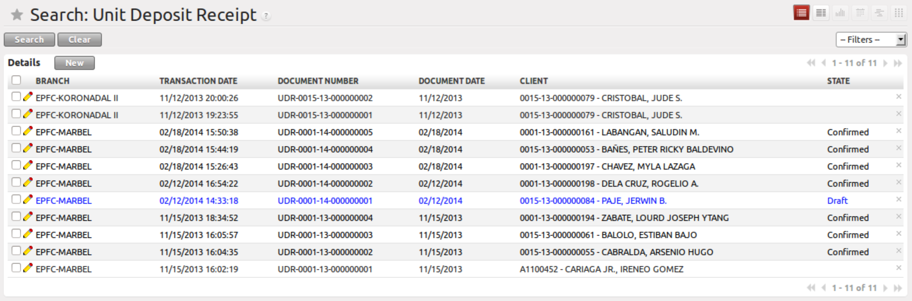
Figure 1. List view of Unit Deposit Receipt

  - Form View
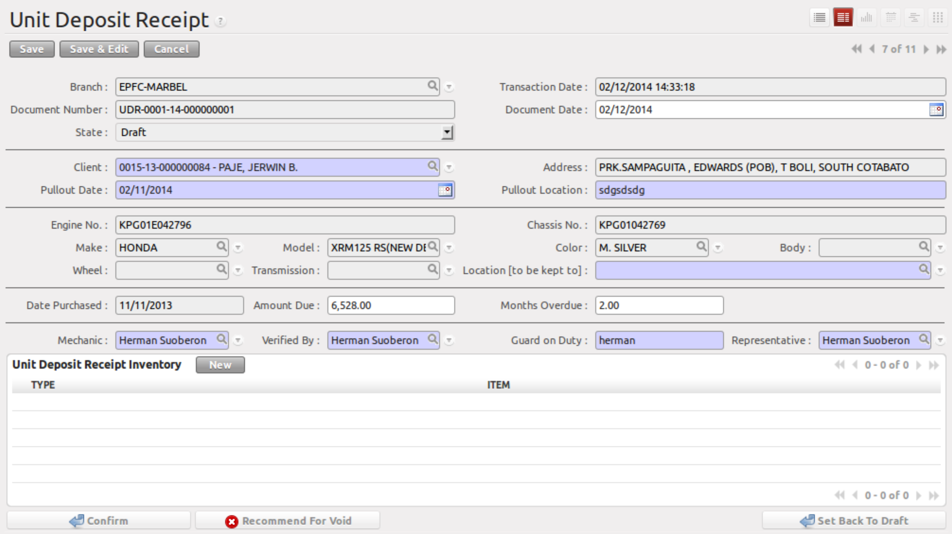
Figure 2. Form view of Unit Deposit Receipt

- Menu and Access Rights
  - Menu – Loan > MC Deposit > Unit Deposit Receipt
  - Access Rights
Role | Read | Write | Create | Delete
Receptionist | Yes | Yes | Yes | No
CI/Collector | Yes | Yes | Yes | No
Branch Manager | Yes | Yes | Yes | No

- Required Fields
All required fields can be easily distinguished from the form view. These are the fields highlighted in Figure 2.

- Client – name of the client, use the lookup function to set this
- Pull-Out Date – date when the unit was taken from / deposited by the client
- Pull-Out Location – location where the unit was taken from the client
- Destination Location – branch location where the unit was deposited
- Mechanic – name of the mechanic responsible for checking the state of the unit
- Verified By – name of the branch manager who confirmed the UDR
- Guard on Duty – name of the guard who witnessed receipt of the unit
- Representative – name of the CI/Collector who was responsible for pulling-out / depositing the unit

- Workflow
Below is the list of states and visibility of the various buttons based on the record state:

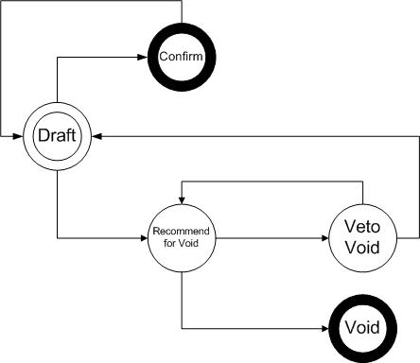
Figure 3. Workflow of Unit Deposit Receipt

State | Description | Visible Buttons
Draft | Initial state of the UDR record | Confirm  Recommend for Void
Confirm | Confirms the UDR record | Set Back to Draft*
Draft/Confirm - Recommend | UDR was recommended for void by the accounting assistant | Veto Void Recommendation  Void
Void | Cancels UDR | N/A
Veto Void Recommendation | Cancels Recommendation for Void | Recommend for Void  Confirm  Set Back to Draft
* for finalization

- User Action
Below is the list of user action available for specific users and its corresponding procedures:

Button | Action | Triggred By
Confirm | - Creates product information found in Warehouse > MC Units > Deposited Units  - Creates a draft record in Asset Transfer Slip | Receptionist  CI/Collector  Branch Manager
Recommend for Void | No Action | Accounting Assistant
Void | - Deletes product information found in Warehouse > MC Units > Deposited Units  - Voids the draft record in Asset Transfer Slip | Branch Manager
Veto Void Recommendation | No Action | Accounting Assistant
Set Back to Draft* | Only allow this action when Asset Transfer Slip is still in ‘Draft’ state | Accounting Assistant  Accounting Assistant 2  Branch Manager
*for finalization

- Field Visibility
Below is the list of fields and their accessibility based on the record state:

Field | Description | Editable States
Document Date | Date when the UDR record was created | Draft
Pull-Out Date | Date when the unit was pulled-out from the customer | Draft
Pull-Out Location | Location of the unit when it was pulled-out | Draft
Amount Due | Total amount due | Draft
Months Overdue | Length of time that the account is on default | Draft
Mechanic ID | Name of mechanic responsible for checking the unit when it was pulled-out | Draft
Verified By | Name of the branch manager who confirmed the UDR | Draft
Guard on Duty | Name of the guard who witnessed receipt of the unit | Draft
Representative | Name of the CI/Collector who was responsible for pulling-out / depositing the unit | Draft

- Reports and Print Outs
