Getting Setup

The purpose document is to get the tools needed and setup for the **RESTful API Demo Project**.

We are assuming you have no knowledge of where to get or how to setup the basic tooling. Everything is free from Microsoft with the Dev Essentials Subscription which is tailored for NEWBIES.

For details and to sign up go to this link: <https://visualstudio.microsoft.com/dev-essentials/> to sign up.

Once signed up you use this link to access your benefits: <https://my.visualstudio.com/>

Here is a list of some of the benefits you receive for FREE!

* Visual Studio Community
* Visual Studio Community for Mac
* Visual Studio Code
* CODE Magazine*
* Pluralsight*
* Azure Free Account – includes 1 year of free services and $200 credit for the 1st month
* Azure DevOps
* Visual Studio App Center
* Microsoft 365 Developer Program
* Power Apps Community Plan
* SQL Server Developer Edition
* Power BI
* Office Online

Once you are signed up you need to down load and install the SQL Server 2022 developer Edition, Visual Studio 2022 Community Edition and SQL Server Management Studio.

Click on the download menu. First we are going to download everything we need.

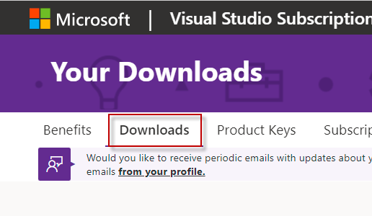

Then click on the SQL Server 2022 link.

**(IMPORTANT NOTE: I’M REUSING SCREENSHOTS. Were it say 2017 pretend it says 2022)**

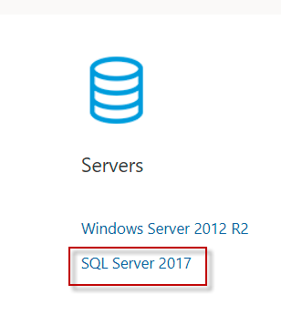

You can then download SQL Server 2022 Developer Edition

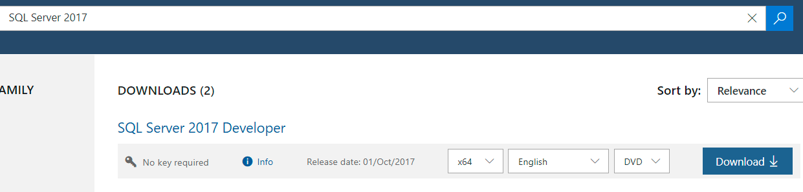

**OR**

My preference would be to change the search bar to SQL Server 2022 Developer Edition and down load that.

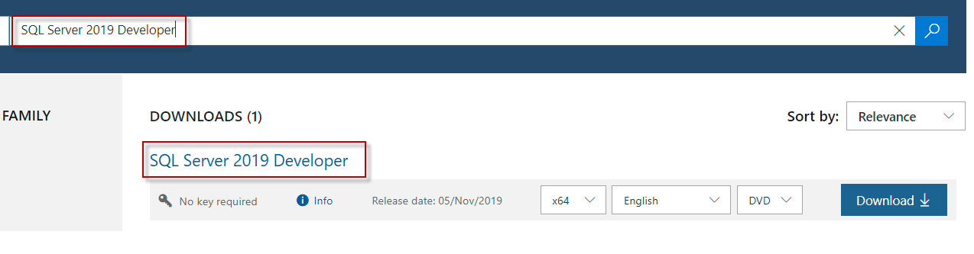

Next go back to the downloads main page and select Visual Studio 2022.

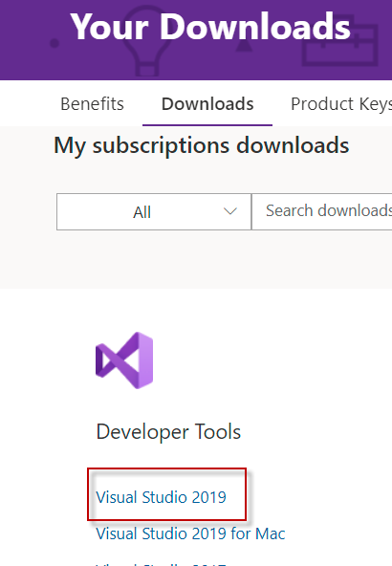

Change the search bar to find the community version of Visual Studio 2022 and download that.

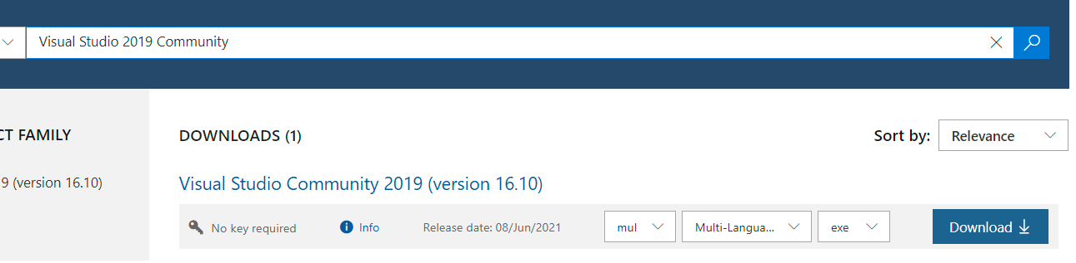

Next go to this link: [Download SQL Server Management Studio (SSMS) - SQL Server Management Studio (SSMS) | Microsoft Docs](https://docs.microsoft.com/en-us/sql/ssms/download-sql-server-management-studio-ssms?view=sql-server-ver15)

This is where we will download the SQL Server Management Studio for FREE of course.

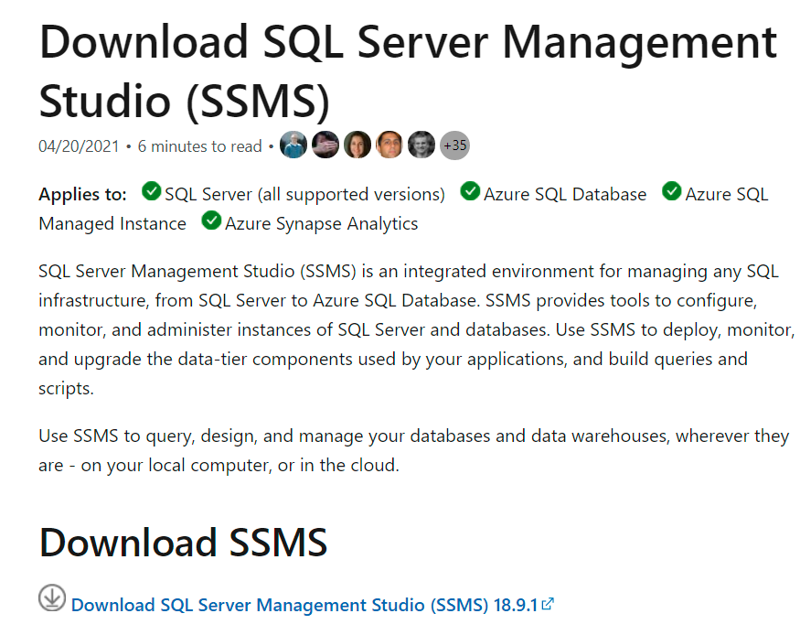

Now that you have downloaded all the tools it is time to install them.

Let’s first install SQL Server Developer Edition. I’m going to assume you know how to mount the ISO file for the SQL Server 2022 and start the installer.

Once the menu comes up select installation.

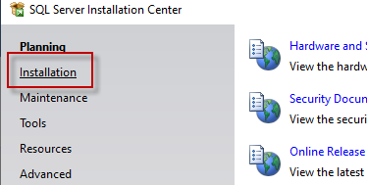

Then select “New SQL Server stand-alone installation”

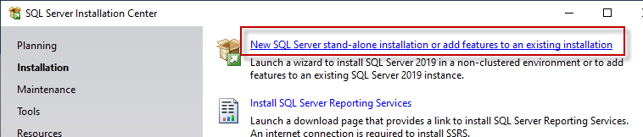

Accept all the defaults for installing the database engine. You won’t need Analysis Services or Reporting Services. Make sure you check at least the four the items in the red boxes below (they are not in the screenshot)

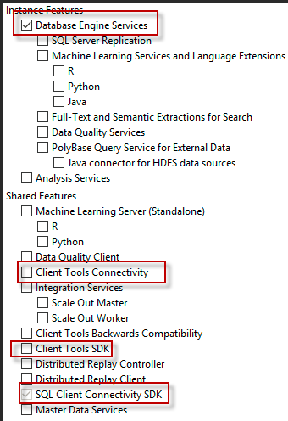

The only tings you should changes is to for the user setup. You should select ”MIXED MODE” and setup a basic “SA” (Server Adminsistrator) and a password on this screen.

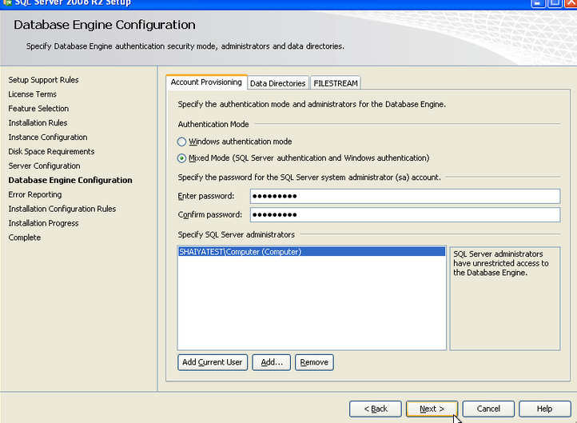

Click through all the prompts installing with the default setup. Then after some time you will be done.

Next, we will install the Visual Studio 2022 Community Edition. Run the installer that you downloaded.

You will be presented with a screen listing of types of development you want to configure for. In the following two screenshots you can see what I have checked for this laptop used in the presentation. At minimum you should select the groups in the red boxes. Or chose mine. IF you are daring you could select everything. For you python people you will see that I have that loaded on my system.

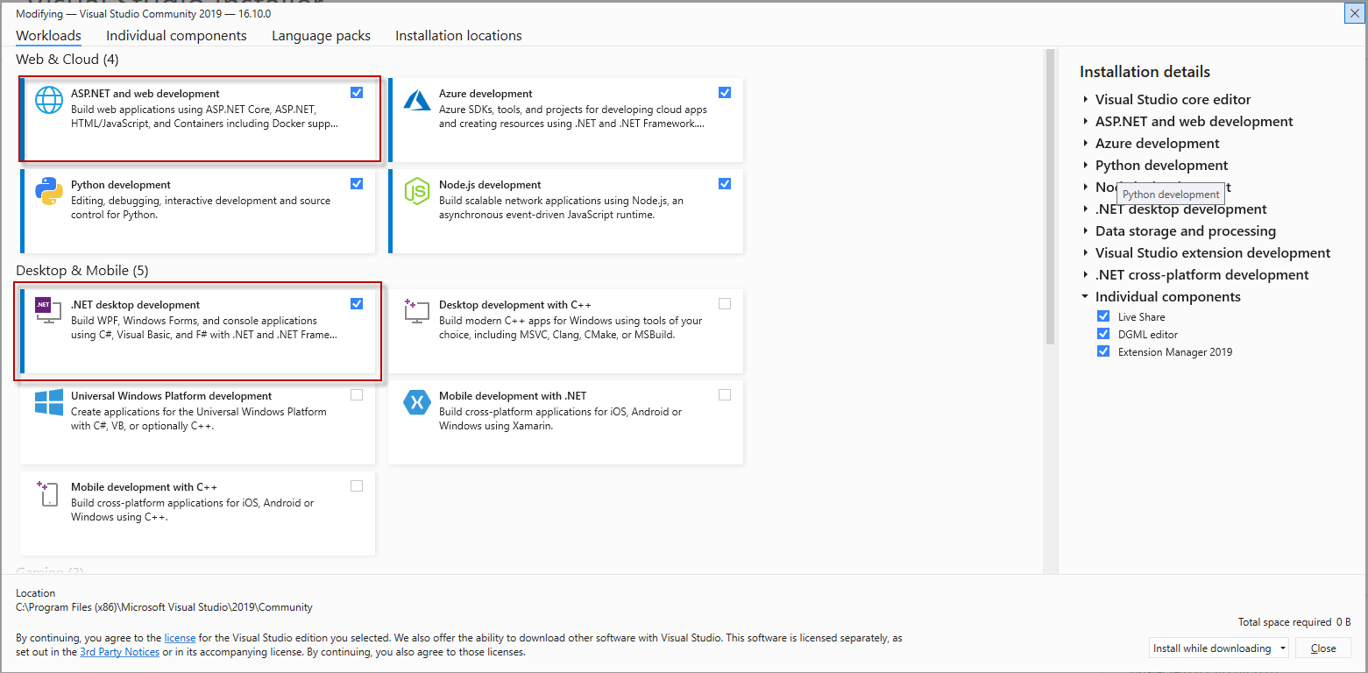

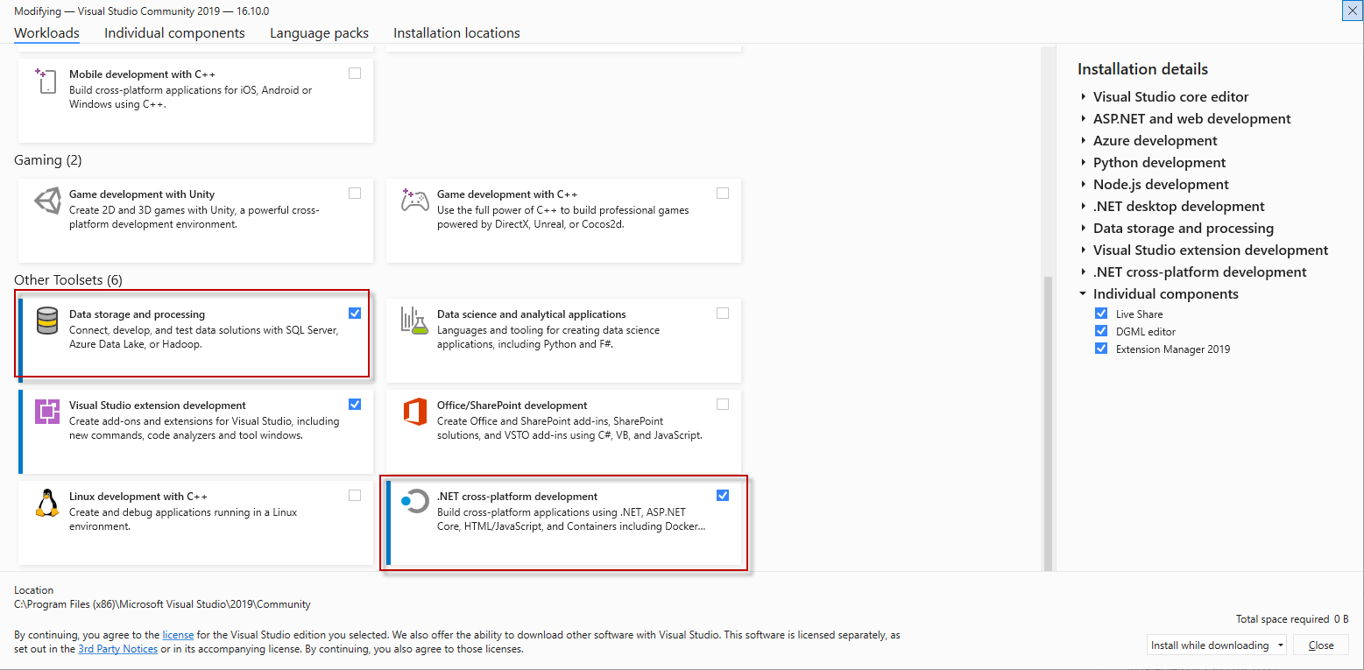

After selecting what you need click the install while downloading button.

Now that Visual Studio is installed let finish the last installation.

Let’s run the SSMS Installer you downloaded.



Nothing to change here except the installation path. So let’s accept the defaults and click install.

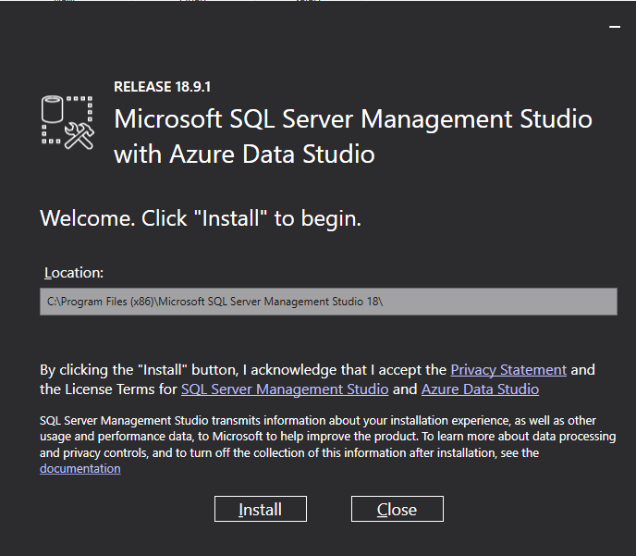

That is it we are done installing software.