Build the DVDStore Database

First thing we need to do is open SQL Server Management Studio (SSMS).

When this happens the “**Connect to Server**” dialog box should open.

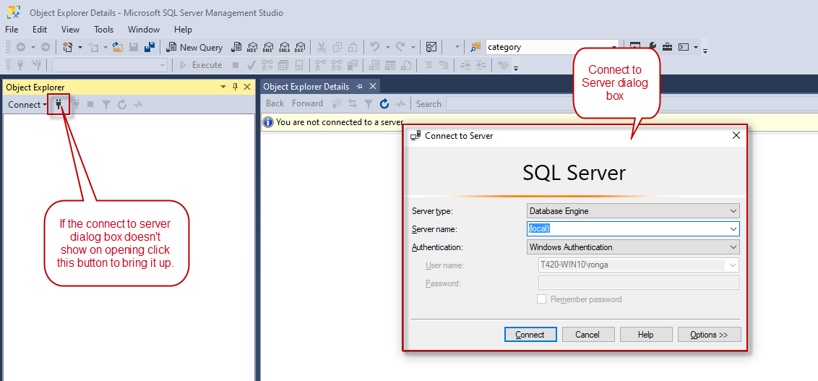

In the Server name enter “**(local)**” as shown in the screenshot. Set the authentication to “**Windows Authentication”**.

Once connected your Object explorer will look something like this. When you expand the Databases node of the tree view you won’t have any database. (In my case my database was already existing and has a couple databases in it)

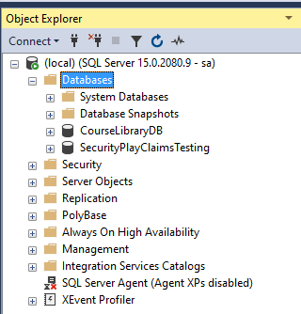

Let’s resolve that for you and open the “**CreateDVDStoreDBWithData.sql**” script in the **DVDStoreApplication** repository that we are assuming you pulled down from GitHub if you are reading this document. 😊

We do this in SSMS by going to the File menu selecting Open and then File to bring up this dialog which we use to navigate to the SQL Script.

As you can see selected here in the screenshot. Then click the Open button.

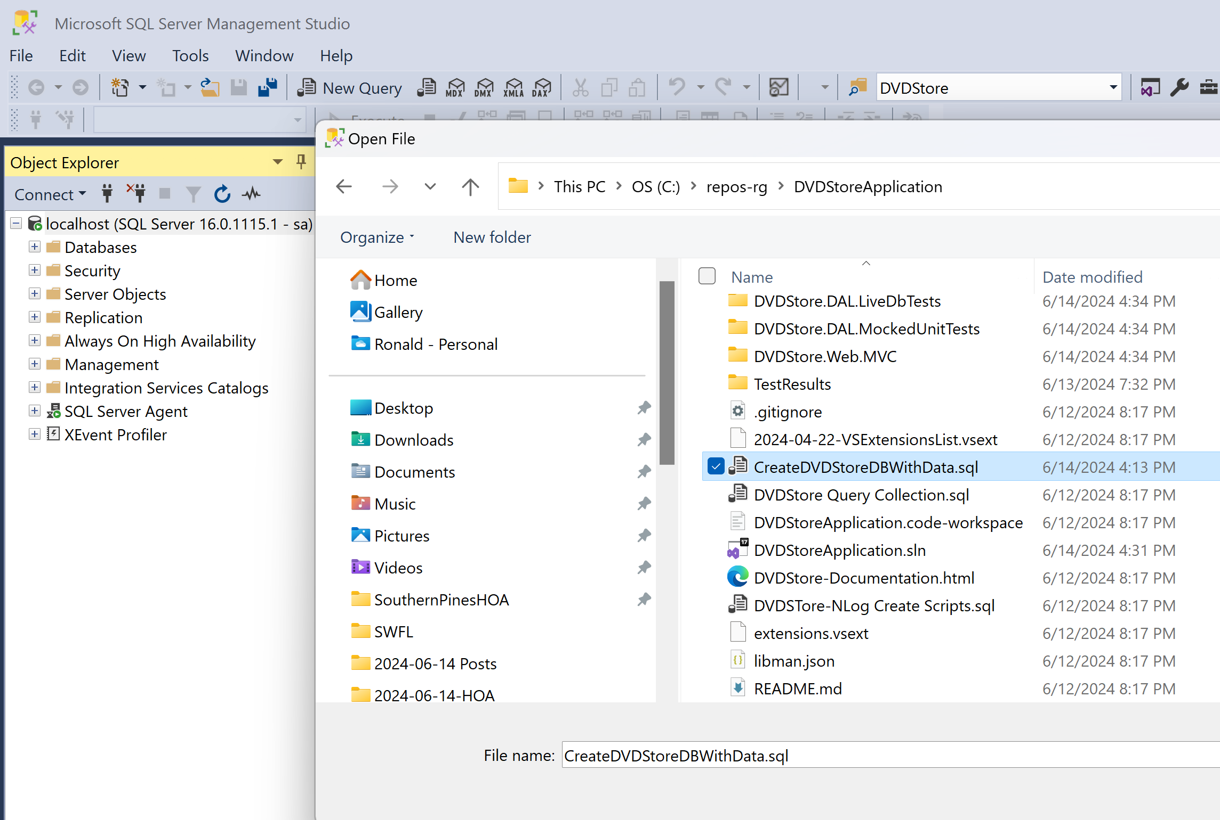

Now look at the script that is loaded in SSMS. Notice in the screenshot there are RED BOXES indicating you must create the folder where you want the database files created on YOUR machine.

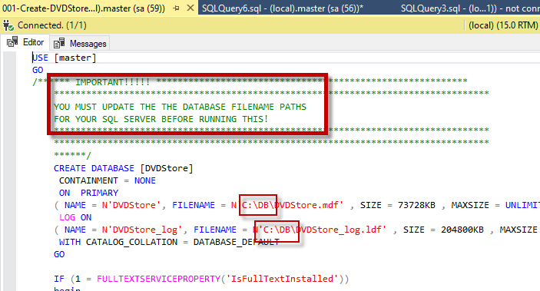

Once you have edited it in this script you can then press F5 or click the Execute button in the toolbar above. This script will create the **DVDStore** database and load it with data. You can find it the Object Explorer.

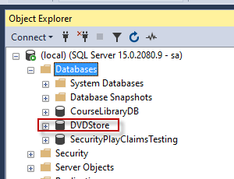

We are now ready to look at the RESTful API Demo code.