Build the DVDStore Database

First thing we need to do is open SQL Server Management Studio (SSMS).

When this happens the “**Connect to Server**” dialog box should open.

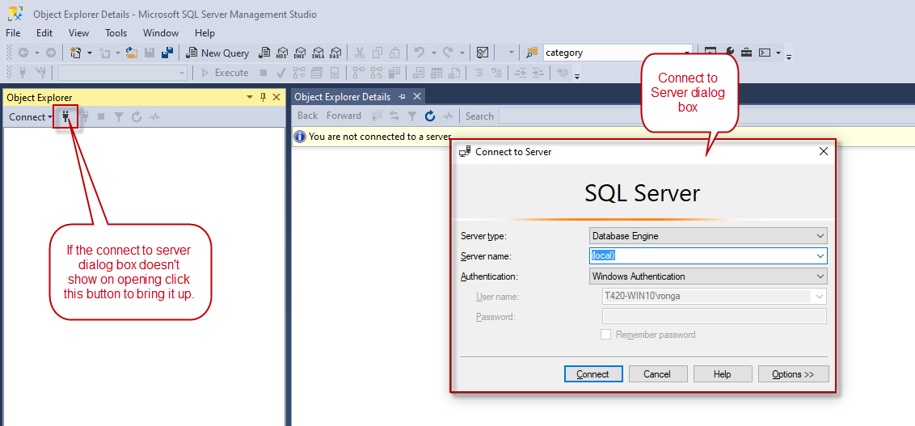

In the Server name enter “**(local)**” as shown in the screenshot. Set the authentication to “**Windows Authentication”**.