DVD Store Notes on Solution Development

## Creating the database

See the drop and create SQL Script in the project for the install

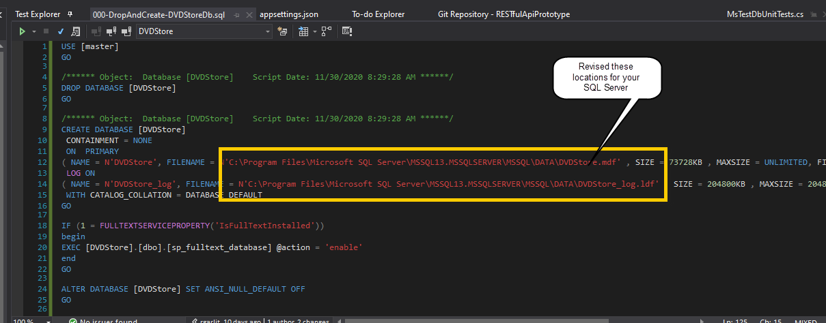

## Console Windows versus IIS Express

We initially start with New project of the .NET Core Web Application type and select the API item in how to configure the initial project we are starting.

Important setting for initial configuration of the API project.

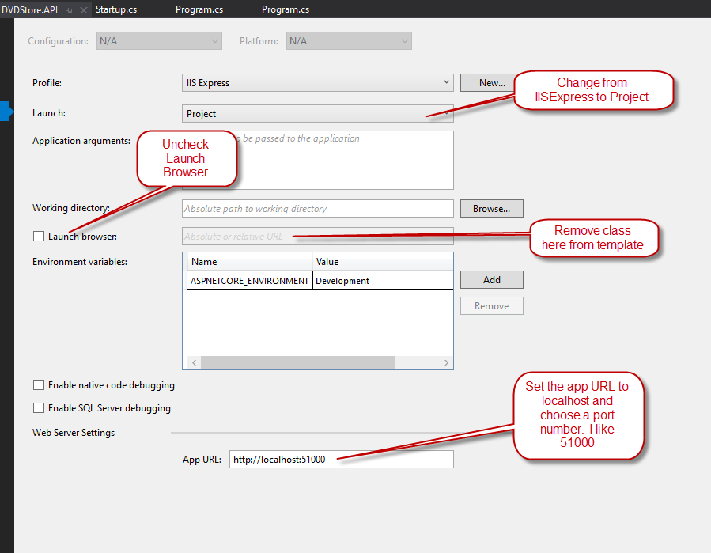

Once we have added our earlier created DAL projects to the solution, we must add a project reference to the API project. In our case we are using the DVDStore sample database for this prototype.

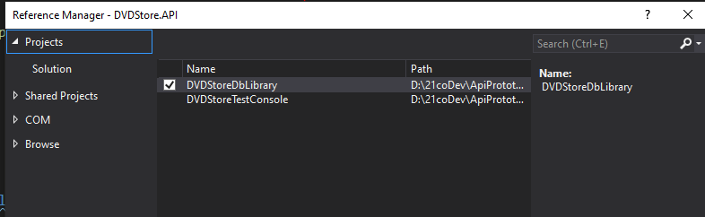

## Revised Scaffold Command Test

**EF Core5 Scaffold command - Revised original code initially done with the earlier EF Core**

**This one pluralizes and does many to many.**

**Command used:**

dotnet ef dbcontext scaffold "Data Source=(local);Initial Catalog=DVDStore;Integrated Security=True;Connect Timeout=30;Encrypt=False;TrustServerCertificate=False;ApplicationIntent=ReadWrite;MultiSubnetFailover=False" Microsoft.EntityFrameworkCore.SqlServer --force --context-dir Context --output-dir Models

# Swagger testing.

How to call Swagger test screen while in Console Mode: <http://localhost:51000/swagger/index.html>

Simple blog explaining: <https://www.davidhayden.me/blog/openapi-and-swagger-ui-in-asp-net-core-5-web-api>

Swagger Setup in Startup Class:

ConfigureServices Method:

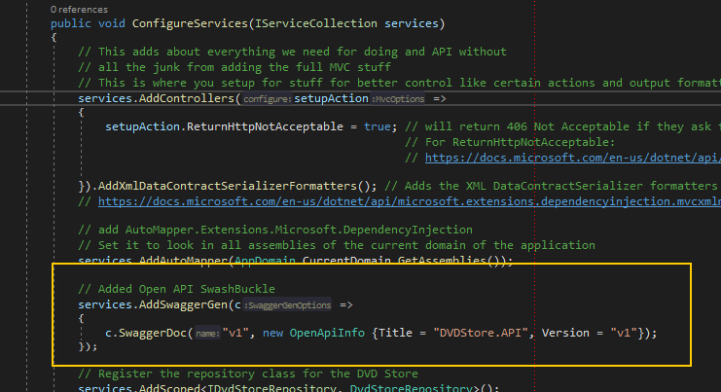

Configure Method Setup:

