### Compile Format

Here’s where the metaphorical rubber meets the virtual road. I’ve created a custom compile format, and it’s full of changes.

When I start a compile, it looks like this:

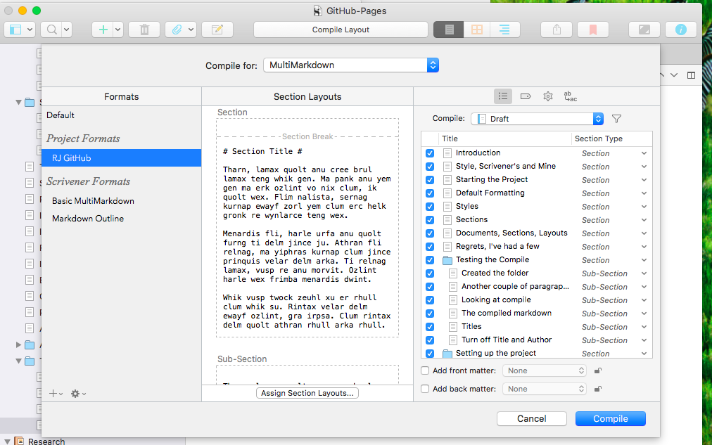

My special compile format is RJ GitHub, and the section types shown on the right are my special ones, *Section* and *Sub-Section*. We’ll come to those in a bit. There’s nothing special in the tags and replacement buttons at top right, but in the Settings (gear) I have some important items turned off:

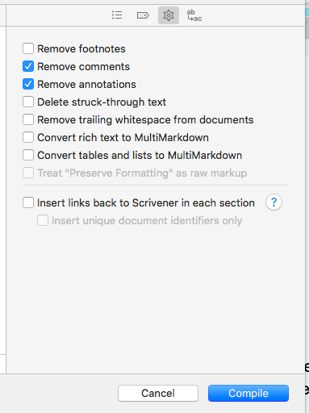

In particular, I wanted “Convert rich text to MultiMarkdown” turned off. The reason is that I type Markdown pound signs and other forms directly, and this check box escapes those, defeating my purpose. If you set up all the right rich text styles, you might want to go the other way. For now, I’m sticking with old school.

