Just for grins, this is yet another sub-document, called Looking at compile. Here’s what the compile window looks like now:

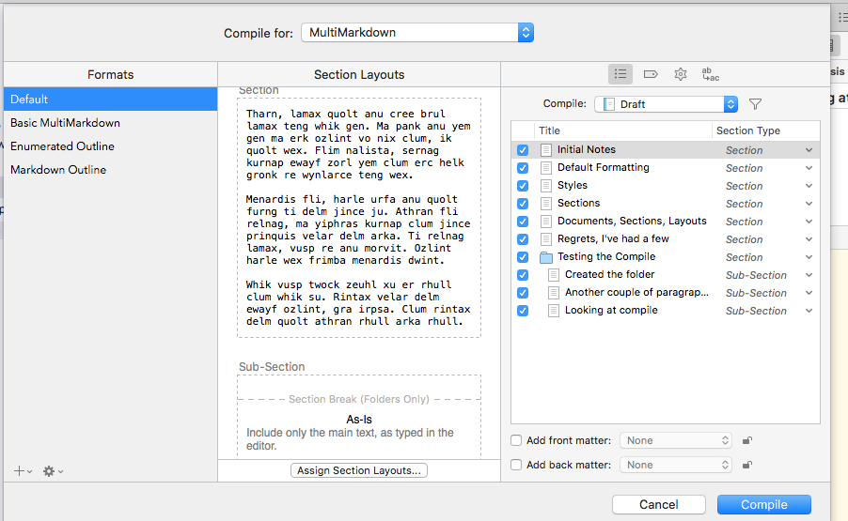

Notice that the sub documents in the folder are called Sub-Section, just as we intended. That happened automatically, because of that structure setup we did. You can see that the Section Types are all shown in italic. That means they were automatically defined from structure. We could set them explicitly if we wanted to. But we don’t. I *would* like to see what the compiled text looks like right now, so I’ll let the compile go through.

