That url, with /v20180615.md/v20180615.html, is what I had to use because of how Scrivener does a compile of an MMD, it needs to export all your pictures, and all your text, into the same folder. And the compile window has only one name field in it, so they create a folder with the name you give, and a markdown .md file of the same name, and then when GitHub compiles the site, you get that name with .html instead of .md. Thus the odd name.

Now what I’d *like* would be to have a folder name like `v20180615`, and the file name index.md, so that the URL could be something like `ronjeffries.github.io/v20180615/` and the implicit lookup for index.html would do the rest. So I looked in the manual and asked on the excellent Scrivener forum. Soon I got the answer, which was so odd and incredible that it took me four tries to understand and believe it. Hold on.

If the folder you compile into happens to have a name ending in `_mmd` or `-mmd`, then the name you put in the compile window, like `index.md` will be applied to the output file only. No subdirectory will be created, and all the files will just dump into your `_mmd` folder. This bizarre fact is actually documented, on page 530 of the Scrivener manual.

But wait, there’s more.

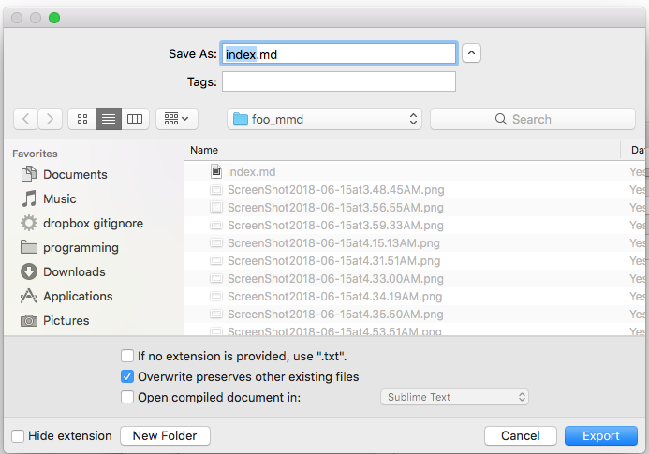

Normally when MMD is compiled, I guess, they clear the folder and then fill it. Apparently that checkbox in the dialog above ensures that any other files in the folder are left alone: only the ones Scrivener creates are overwritten. The description of this seems to say that the _mmd trick also avoids the overwriting, and that setting the checkbox may write to the parent folder. It’s very confusing. I expect to destroy the GitHub pages at least once because of this.

However, what this suggests to me is that I can get a shorter URL for these early draft copies using the _mmd trick. I’ll try that right now, hoping to create this version right here. And before I do that, I’ll put a version marker at the very top of the book. Then I’ll compile it and push a copy.

That works and it’s preserved at [https://ronjeffries.github.io/scriv-git-pages/v20180616_mmd/](https://ronjeffries.github.io/scriv-git-pages/v20180616_mmd/)

