To get the titles to come out, we need to do a bit of layout assignment. I think maybe we don’t need to create new layouts yet, we might just be able to tick some options. Let’s try, inside compile:

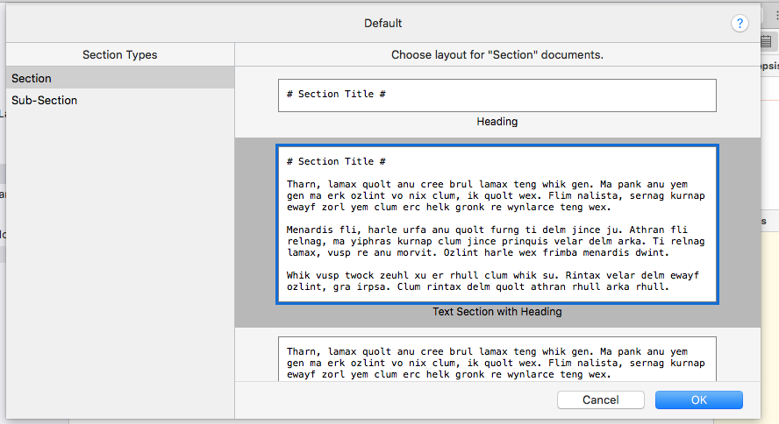

There’s already a layout defined, Text Section with Heading, that nearly does the job. I notice it’s using H1 (one # sign), but maybe that’s OK. Now the compiled Markdown looks like this:

```
Title: GitHub-Pages
Author: Ronald Jeffries

# Initial Notes #

We’re here to create a little “book”, showing how to create the GitHub pages you will be reading when this is all done. This chapter starts at the beginning, though it may not wind up being the first page of the “book”.

I’ve just started with a blank Scrivener project, which I named “GitHub-Pages” and saved in Dropbox/Apps/Scrivener, where my shared Scrivener projects live.

Right now, what I see on the screen looks like this:

![][ScreenShot2018-06-15at3.48.45AM]

I’ve got View > Text Editing > Show invisibles turned on right now. That’s making the paragraph markers and dots for spaces show up. I don’t usually have that on but wanted to talk about the defaults set so far.

I’m going to compile from Scrivener to MultiMarkdown, which is its compile form intended to produce, well, MultiMarkdown, which will be roughly what GitHub expects to make our pages. And although Scrivener lets you format your typing any way you like, and although we may play with that capability later on, I’m used to typing in a sans-serif font (presently Arial) with explicit returns between paragraphs. I’ve got Scrivener’s default formatting set up that way.

# Default Formatting #

You set your initial font and paragraph info in Scrivener > Preferences, (command-comma). My info looks like this:
```

And so on. I notice it has included Title and Author at the top. There’s a way to turn that off, and I’d like to do that while I’m thinking about it.

