Mumble mumble how do we turn that off. I knew that yesterday or the day before …

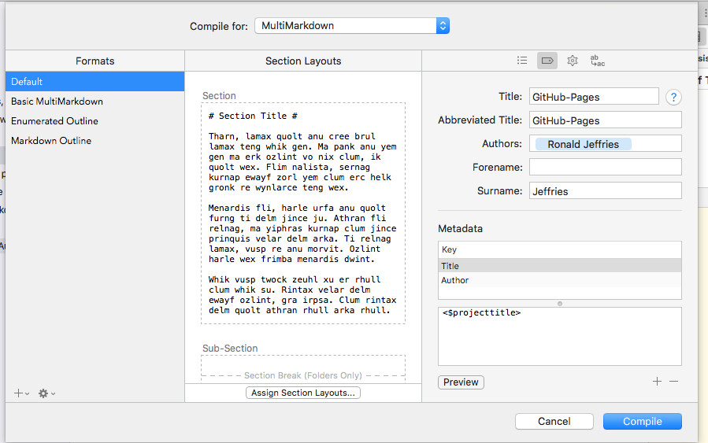

Ah, yes. In the tags subtab of compile, it lists the metadata. Way down in the lower right, you can delete and add the stuff it includes. It’s basically putting YAML at the top of your compiled document. That’s actually something you might want on another day. Today is not that day. I’ll delete those items now:

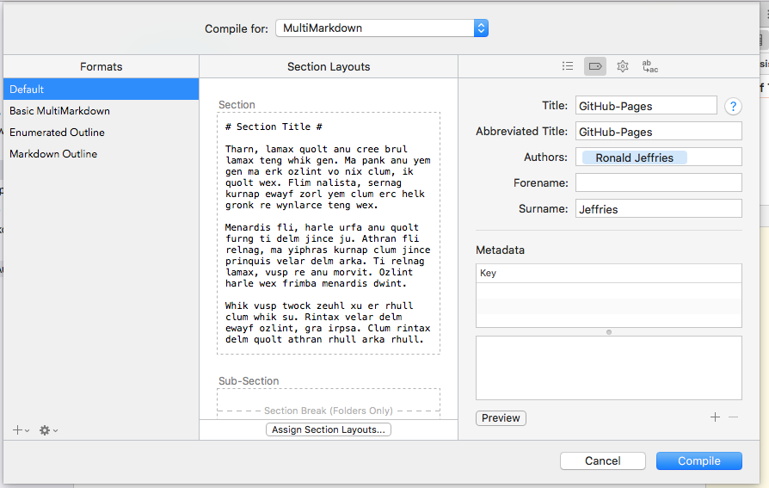

And sure enough, they’re gone from the top of the file.

We could actually turn this into a GitHub Pages page right now. Maybe I’ll do that next. Right now, it’s time for a break.

