If this is going to be about creating GitHub Pages in Scrivener, we’re going to need a GitHub project. Let’s set that up. We’ll call it scriv-git-pages, and make it public in case anyone ever reads this.

That’s done, and I’ve cloned the project to a folder in my Dropbox. Now we need to set up Pages. I think you do that in GitHub settings:

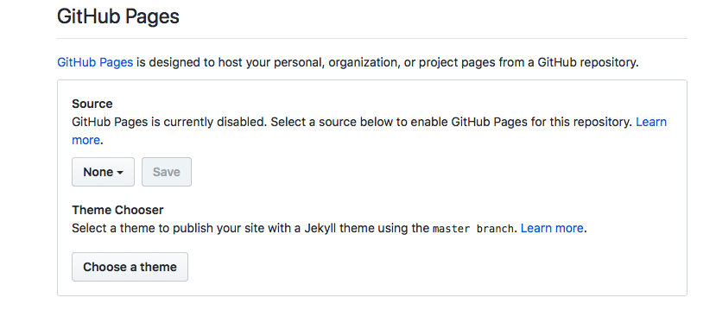

We need to decide whether to put this whole project in GitHub Pages or just the docs folder. I guess we’ll do the whole thing, since the whole project probably should be public. It’s set up and working. The site address is [https://ronjeffries.github.io/scriv-git-pages/](https://ronjeffries.github.io/scriv-git-pages/). It looks like this:

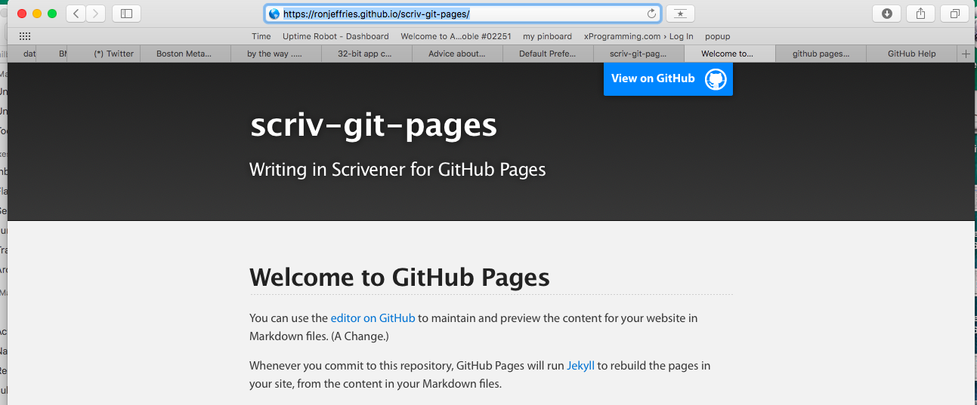

A little research tells me that GitHub Pages will put the README.md as the home page of the site, *unless* you have an *index.md* file, in which case it’ll be used.

