This is being written in a second sub-document, called “Another couple of paragraphs”. The Scrivener binder looks like this:

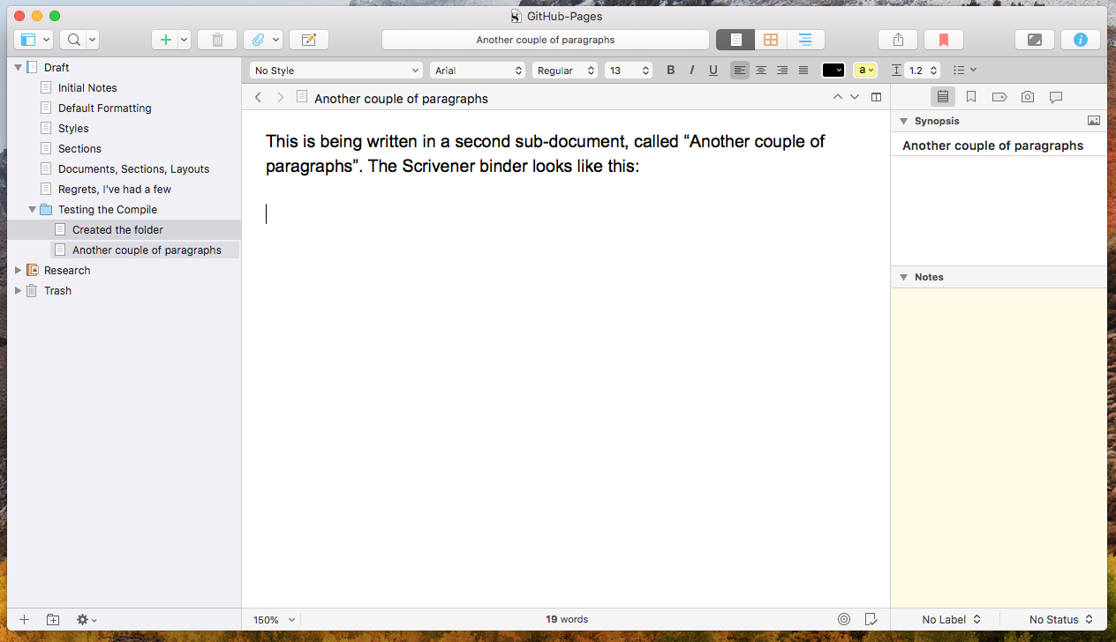

This should be enough to let us see whether our sections are working right. Let’s look at the compile:

