### Some random information about settings lest I forget

View > Text Editing > Show Titles in Scrivenings

Related Options in Scrivener Preferences (command comma)

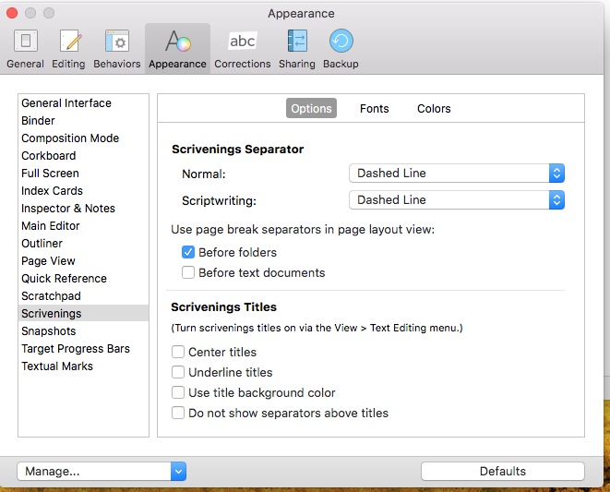

Note especially “Do not show separators above titles”. Uncheck to get separators plus titles. I prefer that.

