Double-clicking my format, we can start looking at the details:

### Section Layouts

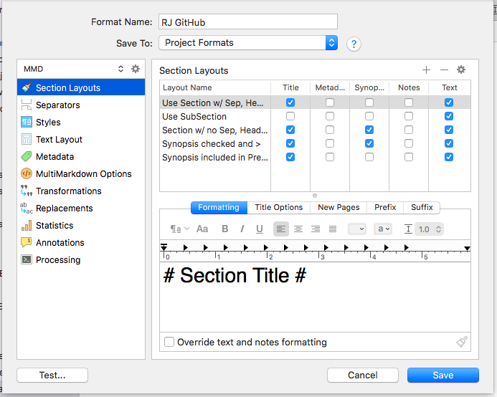
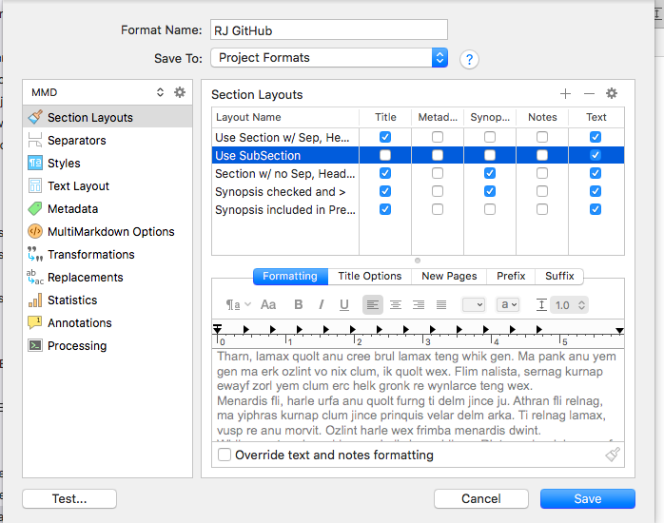

In section layouts there’s really nothing special on the initial page, and none of the other tabs have anything changed in them.

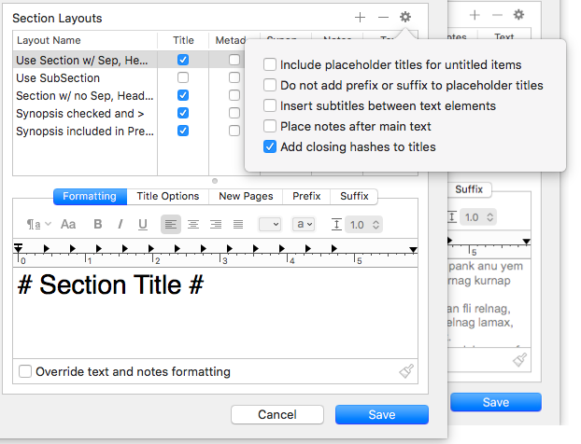

I have it adding closing hashes to titles, which is, I believe, the default.

### Separators

I’ve overridden the default separators on Folders and Text Files in my layouts. The ones I actually use are called “Use” this and that:

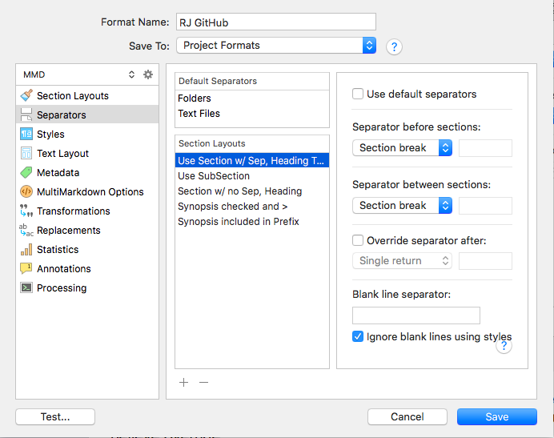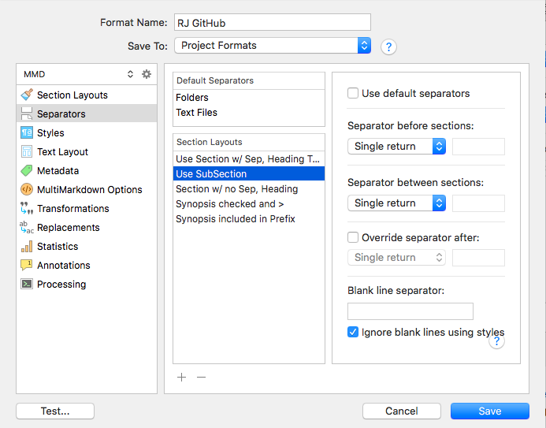

It turns out that these settings are important. Section break, in the top one, inserts the default page separator, four dashes, that my splitter script searches for. It would be possible to put in a more unique separator, as AmberV’s example, referenced elsewhere, does.

The three other sections are experimental and I won’t trouble you with them.

### Text Layout

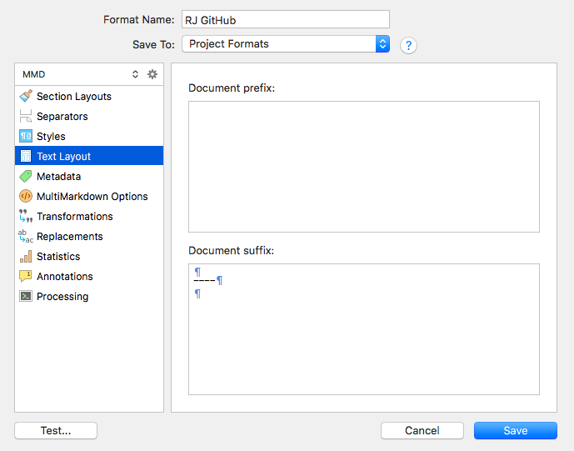

This one puts a separator at the end of the document, namely ahead of the magic references links that my splitter script looks for. If I didn’t include this, it would be difficult for splitter to find and break off the references, which we insert into every page we split out.

### Processing

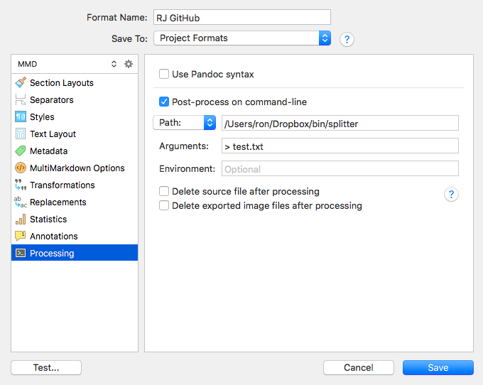

Here’s where we put the link to our Ruby splitter script, which divides up Scrivener’s big output file into the smaller files we want for GitHub pages. The path has to be a legitimate path to the file. The operating system $PATH or equivalent variables are not interrogated.

The arguments will automatically include the name of the output file, and the script will be running in the Scrivener output folder. The `> test.txt` is there so that I can see what happened during the run of splitter. Generally I don’t look.

