### Layout Assignments

We assign a section layout to each section type in Scrivener. There’s a button at the bottom of the middle section of the compile panel that says “Assign Section Layouts” and, well, that’s what it does. It opens another panel looking like this:

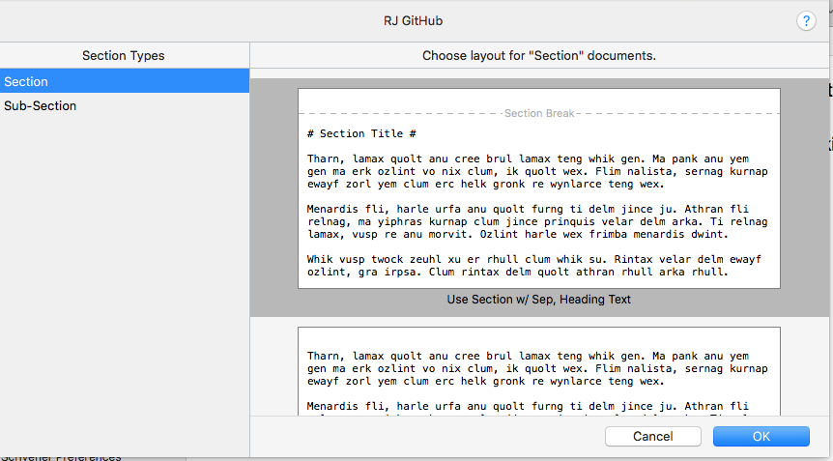

I have “Section” assigned to “Use Section w/ Sep, Heading Text, and “Sub-Section” is assigned to “Use SubSection”. (I often name things that are intended to be “used” with the word “Use” in their name, as a reminder.)

I believe that if I were to assign “As-Is” to “Sub-Section” it would probably also work, but “Use SubSection” is what I’m using and I’m sticking to it.

