### System Preferences

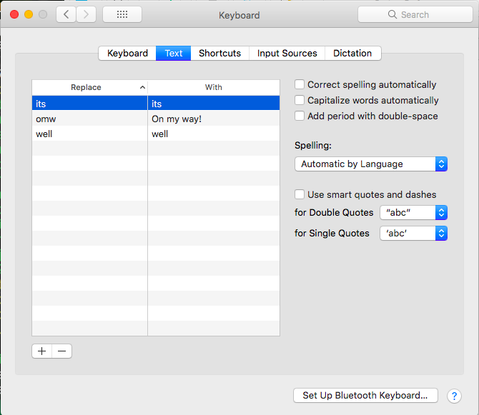

As you see here, I have most everything turned off. Most of that is just personal preference, though smart quotes may have caused me a little trouble in the transition from Scrivener to markdown to GitHub.

I’ve also adjusted my preference for date formatting, because I’m using Scrivener’s placeholders for date and time up at the top of this booklet.

I think that’s all that I’ve touched.

