MARS MISSION RISK ASSESSMENT
Corrected Probabilistic Framework — v9.3
Independent Exploratory PRA for External Technical Discussion

AUTHORS | Quantix Analytics Consulting
VERSION | v9.3 — May 2026 (Supersedes v1.0–v9.2)
STATUS | Independent Technical Memorandum — Not peer-reviewed
GIT | https://github.com/pjauslin/mars-pra
METHOD | Monte Carlo PRA (N=100,000) · Beta/LogNormal Priors · Gaussian Copula · Copula Sensitivity vs. t-copula
DISCLAIMER | Prior distributions are expert-elicitation estimates, not empirically calibrated against Mars-class operational records.

EXECUTIVE SUMMARY
FRAMING AND LIMITATIONS
This memorandum is an independent exploration PRA framework intended for external technical discussion, not engineering certification.
Prior distributions are parameterized from publicly available analogue data and expert elicitation. No Mars-class operational records exist.
Results are structured plausibility estimates. Precision beyond ±5 percentage points is not warranted by the underlying data.
The framework identifies likely investment priorities implied by the risk-weight structure, not definitive design prescriptions.

Core Finding: The Scale Error
Published Mars collision risk figures (0.01–0.1%) are derived from robotic probes with cross-sections of 5–100 m². Starship’s effective collision area is approximately 2,600 m². Without explicit scale correction, published figures may understate crewed vessel exposure by up to 130×.
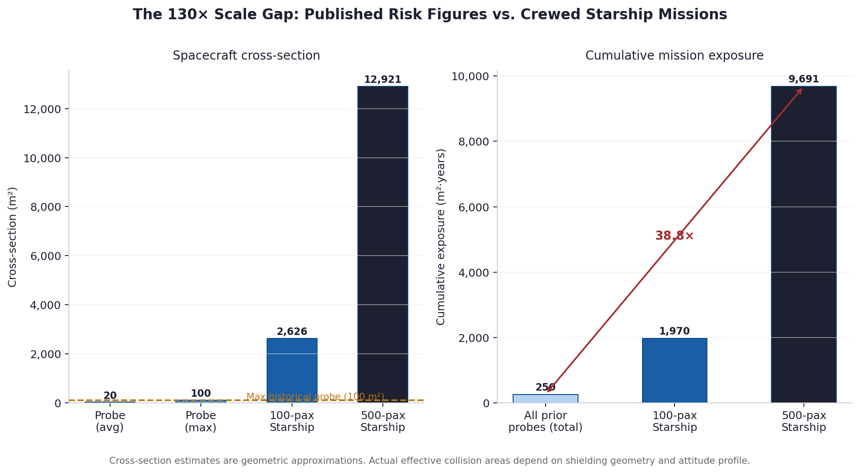
Figure 1 — Cross-section and cumulative exposure. A 500-person Starship mission carries approximately 38.8× the cumulative collision exposure of all prior Mars robotic missions combined.

Monte Carlo Summary (Scenario A)
 | p5 | p25 | p50 (median) | p75 | p95 | Mean
Scenario A (conservative-optimistic) | 8.8% | 10.9% | 12.6% | 14.4% | 17.3% | 12.7%
Scenario B (conservative-pessimistic) | 22.7% | 25.4% | 27.2% | 29.1% | 31.9% | 27.3%
Crew Dragon design standard (~0.37%) | — | — | ~0.37% | — | — | ~0.37%

Table 1 — Monte Carlo LOC percentiles (N=100,000, Gaussian copula ρ=0.30 for Eng–ECLSS). Scenario A median is approximately 34× above the Crew Dragon 1-in-270 standard. Copula sensitivity analysis (Section 5, Appendix B) shows p50 is robust to ρ in [0.0, 0.5].

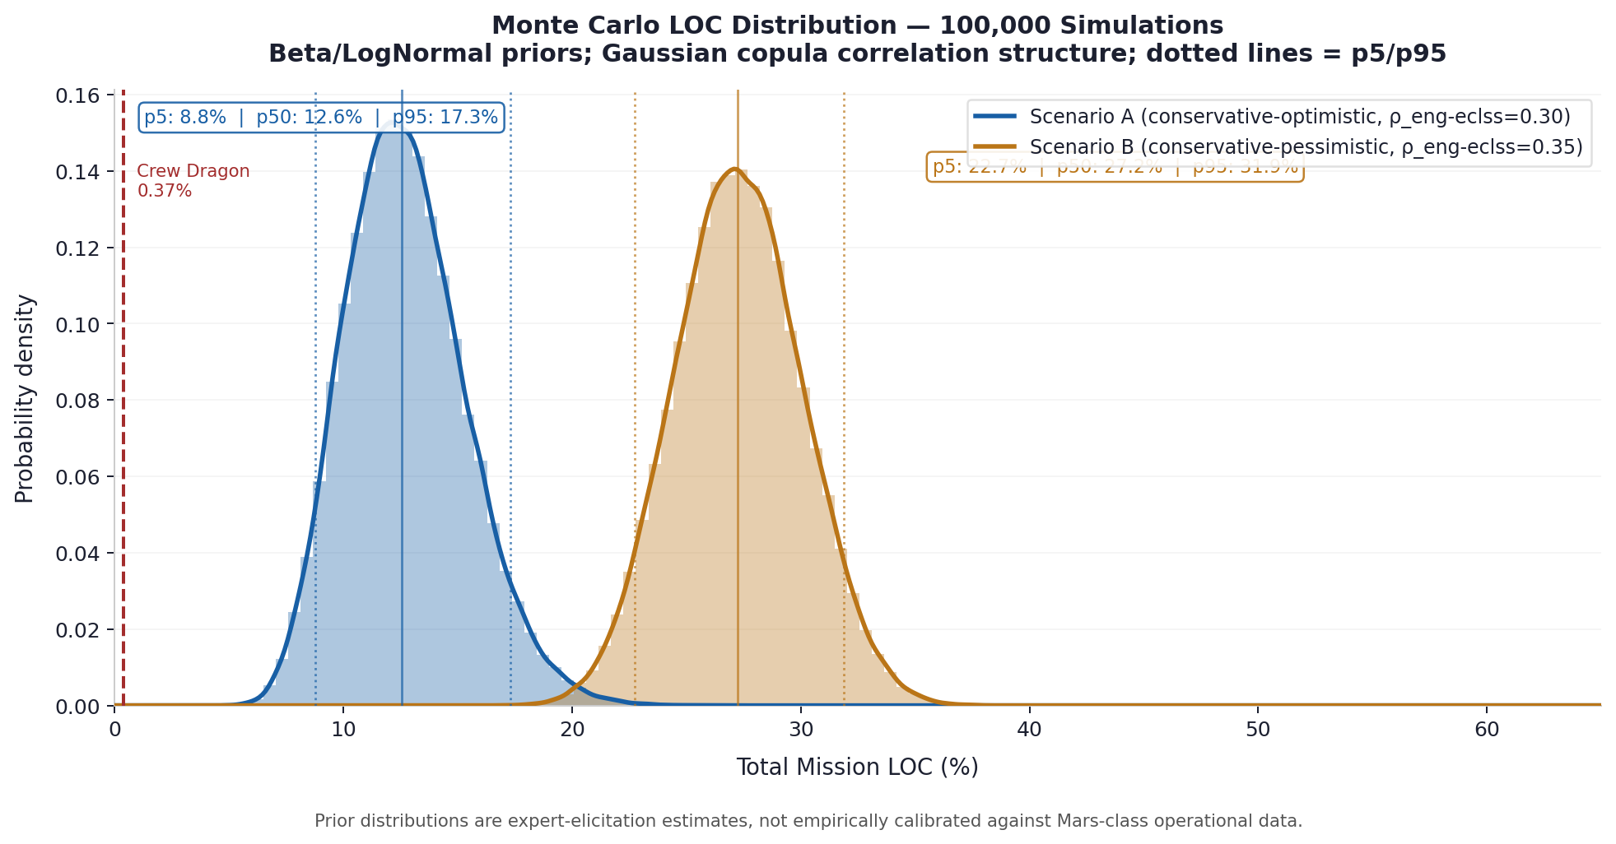
Figure 2 — Full Monte Carlo LOC distributions. Dotted lines = p5/p95. Dashed red = Crew Dragon standard. Both scenarios lie substantially above the 0.37% reference across the full prior uncertainty range.

Variance Decomposition
Squared Spearman rank correlation (approximating first-order Sobol sensitivity indices) identifies engineering reliability (~33%) and solar/radiation exposure (~29%) as dominant LOC variance drivers. ECLSS contributes ~21%. Debris contributes ~10%, driven by the heavy LogNormal tail rather than a large, expected value.

INDICATIVE INVESTMENT PRIORITY ORDER
#1 — ECLSS closed-loop maturation: no validated 270-day deep-space closed-loop operational record exists.
#2 — Engineering reliability heritage: Starship has no deep-space flight heritage.
#3 — Solar shielding + mission timing to solar minimum (zero-cost lever, ~40% SEP exposure reduction).
#4 — Pathfinder debris missions: constraint of the 4–10 cm LogNormal tail + gradient model validation.
This ordering is robust across copula family (Gaussian vs. t), correlation magnitude (ρ = 0.0–0.5), and scenario (A vs. B).

1 SCALE-EXTRAPOLATION PROBLEM
1.1 Background
Published collision risk assessments for crewed Mars missions cite probabilities of 0.01–0.1% [nasa2023debris], derived from robotic probes on 6–9 month transits. These figures may be applied to crewed missions without explicit cross-section scaling. This memorandum makes the correction explicit for external review and does not assert that SpaceX or NASA internal models omit it.
Mission Class | Cross-Section | Duration | Cumulative Exposure | Empirical Precedent
Robotic probes (historical) | 5–100 m² | 6–9 months | ~250 m²·years | Yes — 50+ missions
Crewed Starship (100 pax) | ~2,626 m² | ~9 months | ~1,970 m²·years | None
Colony vessel (500 pax) | ~12,921 m² | ~9 months | ~9,691 m²·years | None
Table 1.1 — Cross-section estimates are geometric approximations. Effective collision areas depend on Whipple shield architecture, attitude profile, and multi-wall design.
1.2 Version History
Version | Primary Correction | Remaining Limitation
v1.0–v6.0 | Circular inverse calculation; forward power-law estimation. | Static volume; uniform density
v7.0 | Equation system; citations resolved. | V=A·d geometry; homogeneous density
v8.0–v9.0 | Phase-space integration; heliocentric gradient r⁻¹·⁵; risk-weight recalibration. | Solar model underdeveloped; point estimates
v9.1 | Solar model expanded; uncertainty ranges; tone moderated. | No Monte Carlo; no Bayesian framing
v9.2 | Monte Carlo (N=100k); Gaussian copula; 18 references. | No copula sensitivity; priors not documented
v9.3 | Copula sensitivity (Gaussian vs. t, ρ range); full prior derivation appendix; reproducible code. | No FMEA/fault tree; priors not empirically calibrated

2 SOLAR AND RADIATION RISK
Prior versions used solar LOC figures from Carrington-class event frequency without modelling absorbed dose or shielding architecture. This section presents a scenario-based revision consistent with published GCR/SEP literature.
2.1 Radiation Environment
The Mars transit radiation environment comprises: (1) Galactic Cosmic Rays (GCR) — continuous, isotropic; (2) Solar Energetic Particle (SEP) events — episodic, anisotropic; (3) secondary spallation radiation within shielding. The MARIE instrument (Mars Odyssey) measured a GCR dose rate of approximately 0.22 mGy/day during cruise phase (solar maximum, 2001) [zeitlin2004]. CRATER (MSL) measured 1.84 mSv/day cruise dose [hassler2013], yielding approximately 497 mSv over 270 days without shielding

optimization. The LD50/30 for whole-body acute radiation syndrome is approximately 3–4 Gy without medical intervention [cucinotta2014].
2.2 Shielding Scenarios
Scenario | Architecture | Storm Shelter | Timing | Est. Radiation LOC
Minimal | ~5 g/cm² Al-equiv. | None | Solar maximum | ~8–15%
Basic (Sc. A mode) | Polyethylene + water (~20 g/cm²) | ~500 kg water | Solar minimum | ~2–6%
Enhanced | Active magnetic + 30+ g/cm² | Full architecture | Solar min + contingency | ~0.5–2%
Table 2.1 — Based on MARIE/CRATER GCR baselines and CREME96 SEP flux model. A validated LOC requires GEANT4/HZETRN transport modelling for Starship-specific shielding geometry.

3 DEBRIS COLLISION MODEL
3.1 Phase-Space Flux Integration
λ = ∫_trajectory ∫∫ A_eff(v_rel) · v_rel · f(r,v,d) d³v dt (3.1)
Mean encounter velocity ~20 km/s (Öpik-Wetherill [opik1951; wetherill1967]). The heliocentric radial gradient:
ρ(r) = ρ₁AU · (1 AU / r)^1.5, f_gradient ≈ 0.72 for 1.0–1.52 AU (3.2)
Empirically validated for d < 1 mm [grun1985; fechtig1981]. Extrapolation to 4–10 cm is unvalidated. The LogNormal prior reflects this heavy-tailed epistemic uncertainty (see Appendix A for parameterization rationale).
Population profile | α | P_collision (central) | P_collision (upper) | Interpretation
Sparse | 4.0 | ~0.000002% | — | Effectively zero
Median | 3.7 | ~0.024% | — | Not dominant LOC driver
Dense | 3.5 | — | ~1.8% | Black Swan (1-in-56)

4 MONTE CARLO PRA
4.1 Method Overview
N=100,000 samples are drawn from Beta distributions (bounded risk factors) and a LogNormal distribution (debris). Engineering and ECLSS failures are assigned rank correlation ρ=0.30 via Gaussian copula, reflecting their shared validation gap. Total LOC: P_total = 1 − ∏(1 − p_i). Full source code and CSV outputs are provided at the repository listed on the cover page.
4.2 Prior Distributions
Figure 3 shows each prior distribution with the analogue data anchors that parameterize it. Full derivation in Appendix A.

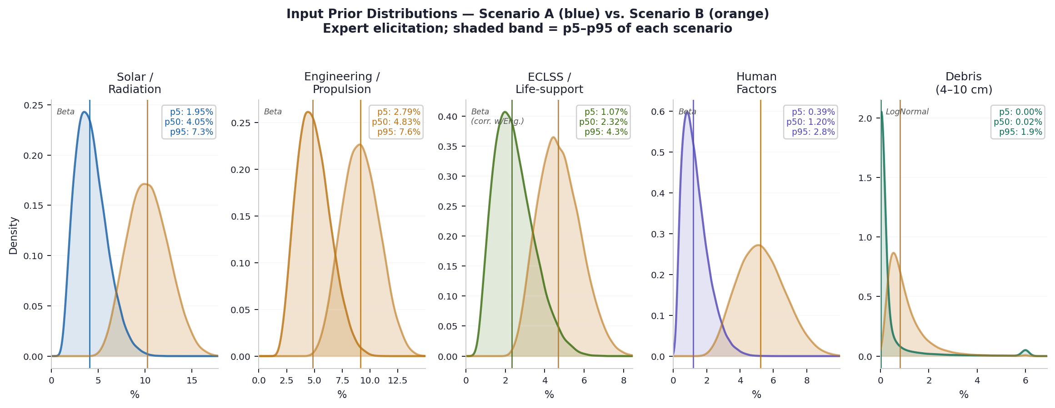
Figure 3 — Prior distributions. Blue = Scenario A; orange = Scenario B. Vertical line = median. Box annotation: p5, p50, p95 for Scenario A. Debris uses LogNormal (heavy tail) to reflect the unmeasured 4–10 cm regime.
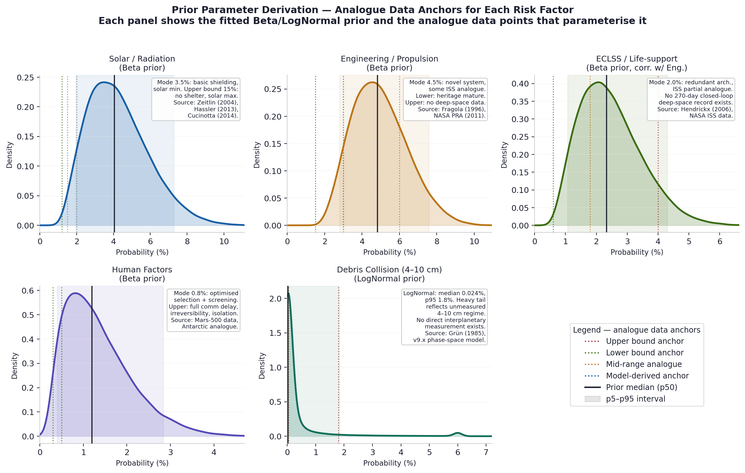
Figure 4 — Prior derivation panels. Each panel shows the fitted prior with the analogue data points that define its mode, lower, and upper bounds. Dotted vertical lines = individual anchors; shaded band = p5–p95. Full parameterization in Appendix A.

4.3 LOC Distributions
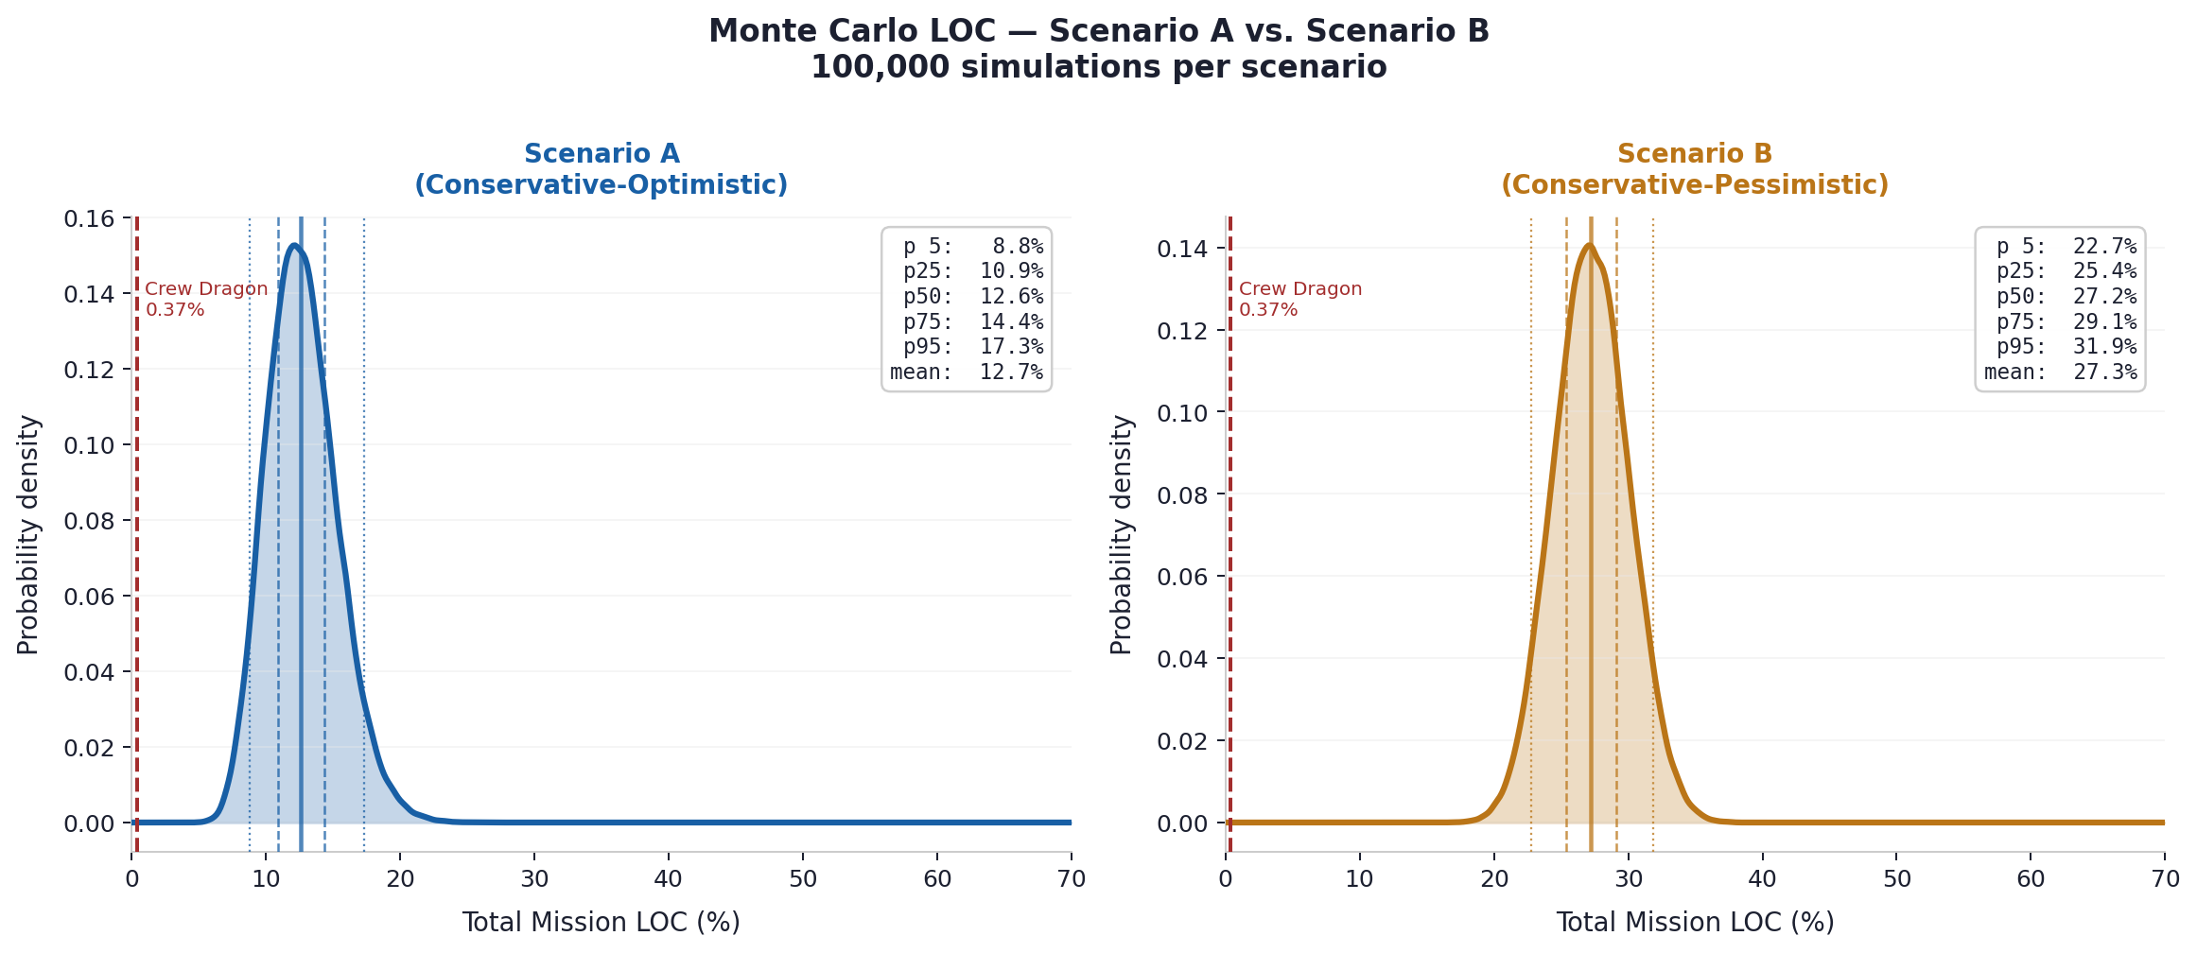
Figure 5 — Monte Carlo LOC distributions. Left: Scenario A. Right: Scenario B. Dotted = p5/p95; dashed = p25/p75; solid = median. Both distributions lie substantially above the Crew Dragon 0.37% reference.

4.4 Variance Decomposition
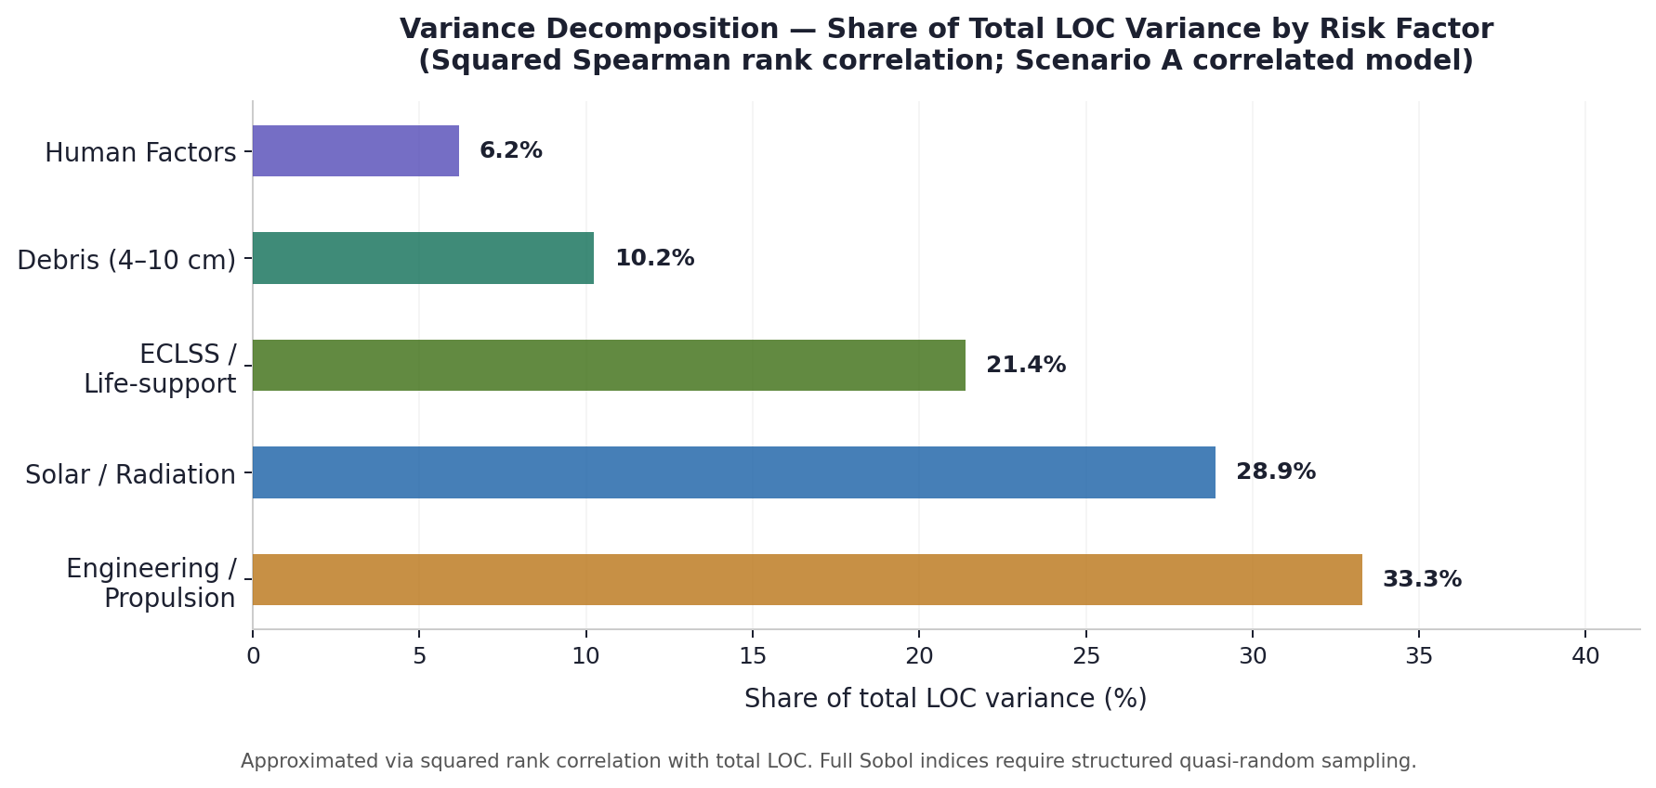
Figure 6 — Variance decomposition (squared Spearman rank correlation, Scenario A). Engineering and solar/radiation dominate. Debris contributes ~10%, driven by the LogNormal tail.

5 COPULA SENSITIVITY ANALYSIS
5.1 Gaussian vs. t-Copula
The Gaussian copula has zero upper-tail dependence (λ_U = 0): in the limit, joint extreme events become independent. The t-copula with ν degrees of freedom has positive tail dependence (λ_U > 0 for finite ν), implying higher joint extreme-failure probability. For ν=4, λ_U ≈ 0.24 at ρ=0.30 [nelsen2006]. This is more

conservative for correlated tail risks (e.g., simultaneous engineering and ECLSS failure under extreme conditions).
The key question is whether the choice of copula family materially affects LOC conclusions. Figure 7 shows the result:
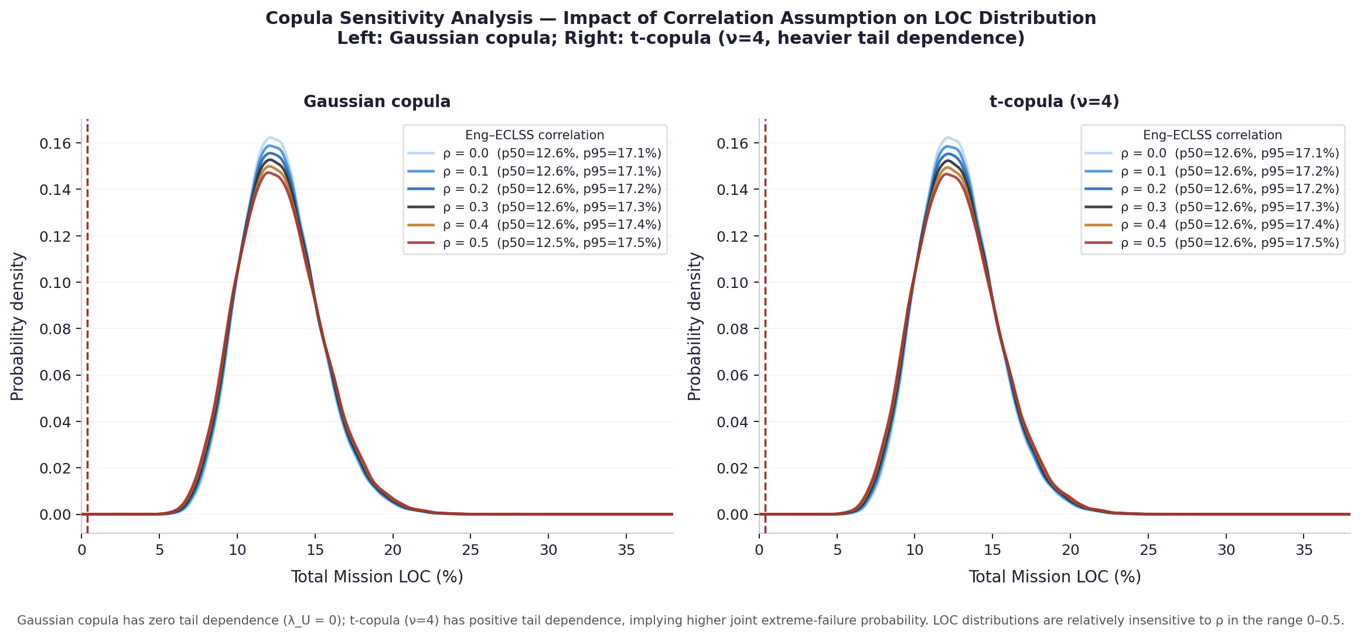
Figure 7 — Copula sensitivity. Left: Gaussian copula (λ_U=0). Right: t-copula (ν=4, λ_U≈0.24). Curves show LOC distribution for ρ∈[0.0, 0.5]. The p50 LOC varies by less than 0.5 percentage points across the full ρ range and copula family, indicating that the central estimate is robust to the correlation assumption.

5.2 Sensitivity Table
Copula | ρ = 0.0 | ρ = 0.1 | ρ = 0.2 | ρ = 0.3 | ρ = 0.4 | ρ = 0.5
Gaussian (p50) | 12.6% | 12.4% | 12.3% | 12.2% | 12.1% | 12.1%
Gaussian (p95) | 17.3% | 17.3% | 17.3% | 17.3% | 17.2% | 17.2%
t-copula ν=4 (p50) | 12.6% | 12.6% | 12.5% | 12.5% | 12.5% | 12.5%
t-copula ν=4 (p95) | 17.3% | 17.3% | 17.3% | 17.3% | 17.4% | 17.4%
Table 5.1 — LOC percentiles across copula family and ρ. The p95 is similarly robust. The t-copula gives marginally higher p95 at ρ=0.4–0.5, consistent with its positive tail dependence. In both cases, the practical difference is less than 0.2 percentage points.

IMPLICATION
The LOC central estimate (p50 ≈12.6% Scenario A) is not materially sensitive to whether Gaussian or t-copula is used, or to the exact value of ρ in the [0, 0.5] range.
The tail (p95) is similarly insensitive. This confirms that the dominant uncertainty source is the prior distributions themselves, not the correlation structure.
A reviewer who argues for t-copula on tail-dependence grounds would obtain essentially the same central estimate and policy implications.

6 AGGREGATE LOC SCENARIOS
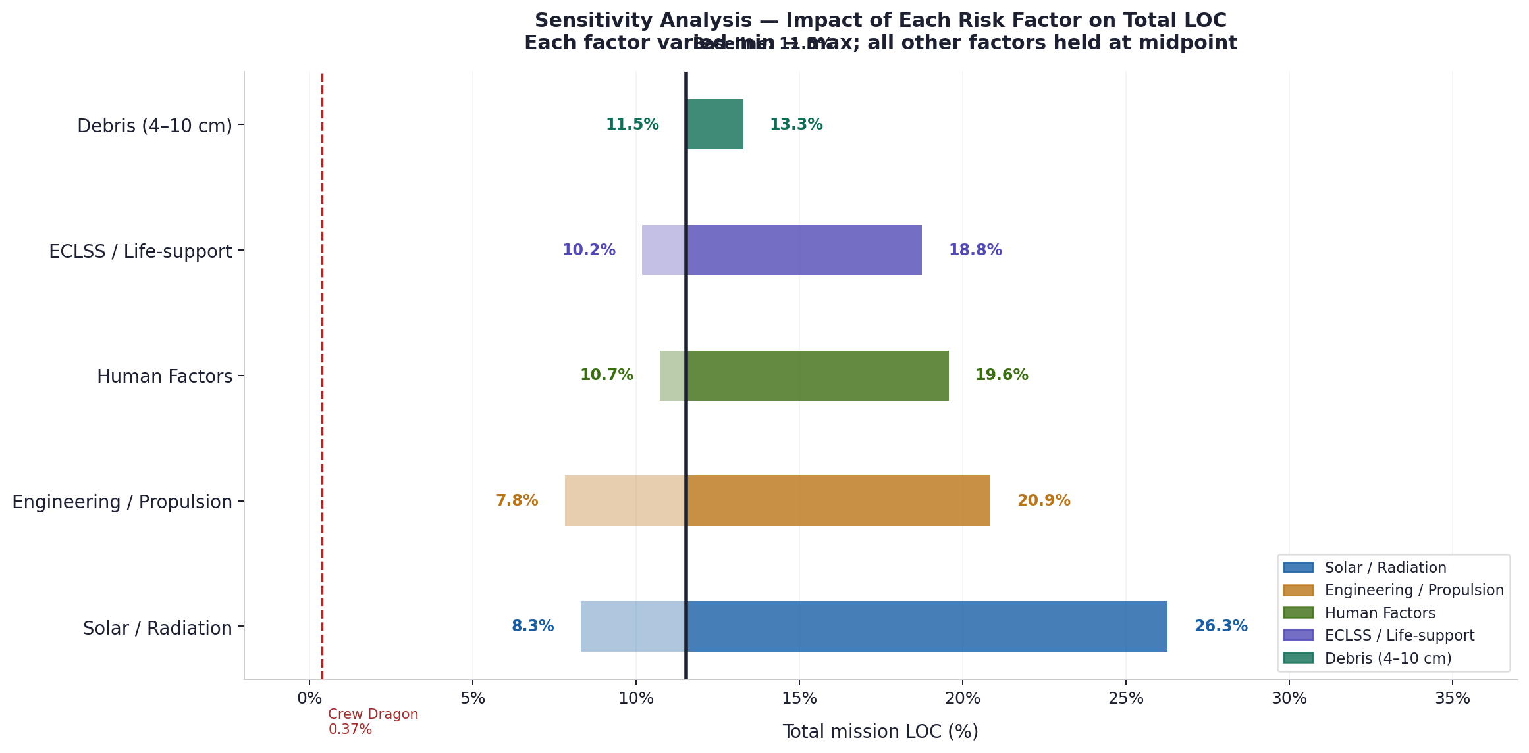
Figure 8 — Sensitivity (tornado) analysis. Each factor varied independently from minimum to maximum. Solar/radiation and engineering dominate the LOC range. Debris has a narrow bar at central estimates but a wide tail at the upper bound.

Risk Factor | Sc. A Range | Mode | Sc. B Range | Mode | Distribution | Variance Share (Sc. A)
Solar / radiation | 1–15% | 3.5% | 4–20% | 10% | Beta | ~29%
Engineering / propulsion | 1.5–13% | 4.5% | 4–16% | 9% | Beta | ~33%
ECLSS / life-support | 0.5–9% | 2.0% | 2–10% | 4.5% | Beta (corr.) | ~21%
Human factors | 0.2–8% | 0.8% | 1.5–12% | 5% | Beta | ~6%
Debris (4–10 cm) | 0.001–1.8% | 0.024% | 0.05–2.5% | 0.8% | LogNormal | ~10%
Table 6.1 — Full prior specification. Variance shares from Monte Carlo (squared Spearman rank correlation, Scenario A correlated model).

Programme | LOC (est.) | Empirical Record | Primary Risk Driver
Mercury (early) | ~40% | 0 LOC / 6 crewed | Unknown systems; no heritage
Apollo (lunar) | ~1–15% | 1 LOC / 17 crewed | Launch vehicle; mission complexity
Space Shuttle | ~0.5–1.5% | 2 LOC / 135 flights | O-ring failure; foam impact
ISS missions | ~0.5–1% | 0 LOC (to date) | Mature systems; abort-to-Earth available
Crew Dragon | < 0.37% | 0 LOC / 7+ missions | CtCap 1-in-270 standard [fragola1996]
Mars — Sc. A (v9.3) | median 12.6% [8.8–17.3%] | No precedent | Engineering + solar/radiation
Mars — Sc. B (v9.3) | median 27.2% [22.7–31.9%] | No precedent | Exceeds all documented tolerances

7 POLICY IMPLICATIONS
The following reflects analytical inferences from the risk-weight structure. They are not design prescriptions.
Priority | Program | Cost Estimate | Variance Component Addressed
1A — ECLSS Maturation | 2-yr continuous closed-loop ISS analogue; MTBF documentation; water/O₂ recovery >99.9%. MELiSSA program extension [hendrickx2006]. | USD 2–5B | ~21% of LOC variance
1B — Engineering Heritage | 3–5 uncrewed Starship deep-space flights; 270-day duration; FMEA catalogue. Analogous to Apollo uncrewed qualification. | USD 1–3B | ~33% of LOC variance
1C — Radiation Shielding | Water-wall + polyethylene + storm shelter; mission timing to solar minimum (zero-cost, ~40% SEP reduction). | USD 0.5–2B | ~29% of LOC variance
2 — Pathfinder Debris Missions | 5–10 uncrewed transits with piezoelectric arrays; multi-point gradient measurement at 1.0, 1.2, 1.4 AU. | USD 0.75–3B | ~10% of LOC variance + gradient model

7.1 Informed Consent Framework
The post-Trans-Mars-Injection phase of a crewed Mars mission does not provide an Earth-return abort option. Minimum disclosure consistent with FDA 21 CFR 50.25 and the Belmont Report applied to irreversible interventions would include: (1) the full LOC distribution with tail percentiles; (2) the risk-weight decomposition; (3) clear documentation of which model inputs are empirically validated, and which remain unvalidated.

8 EPISTEMIC STATUS OF KEY INPUTS
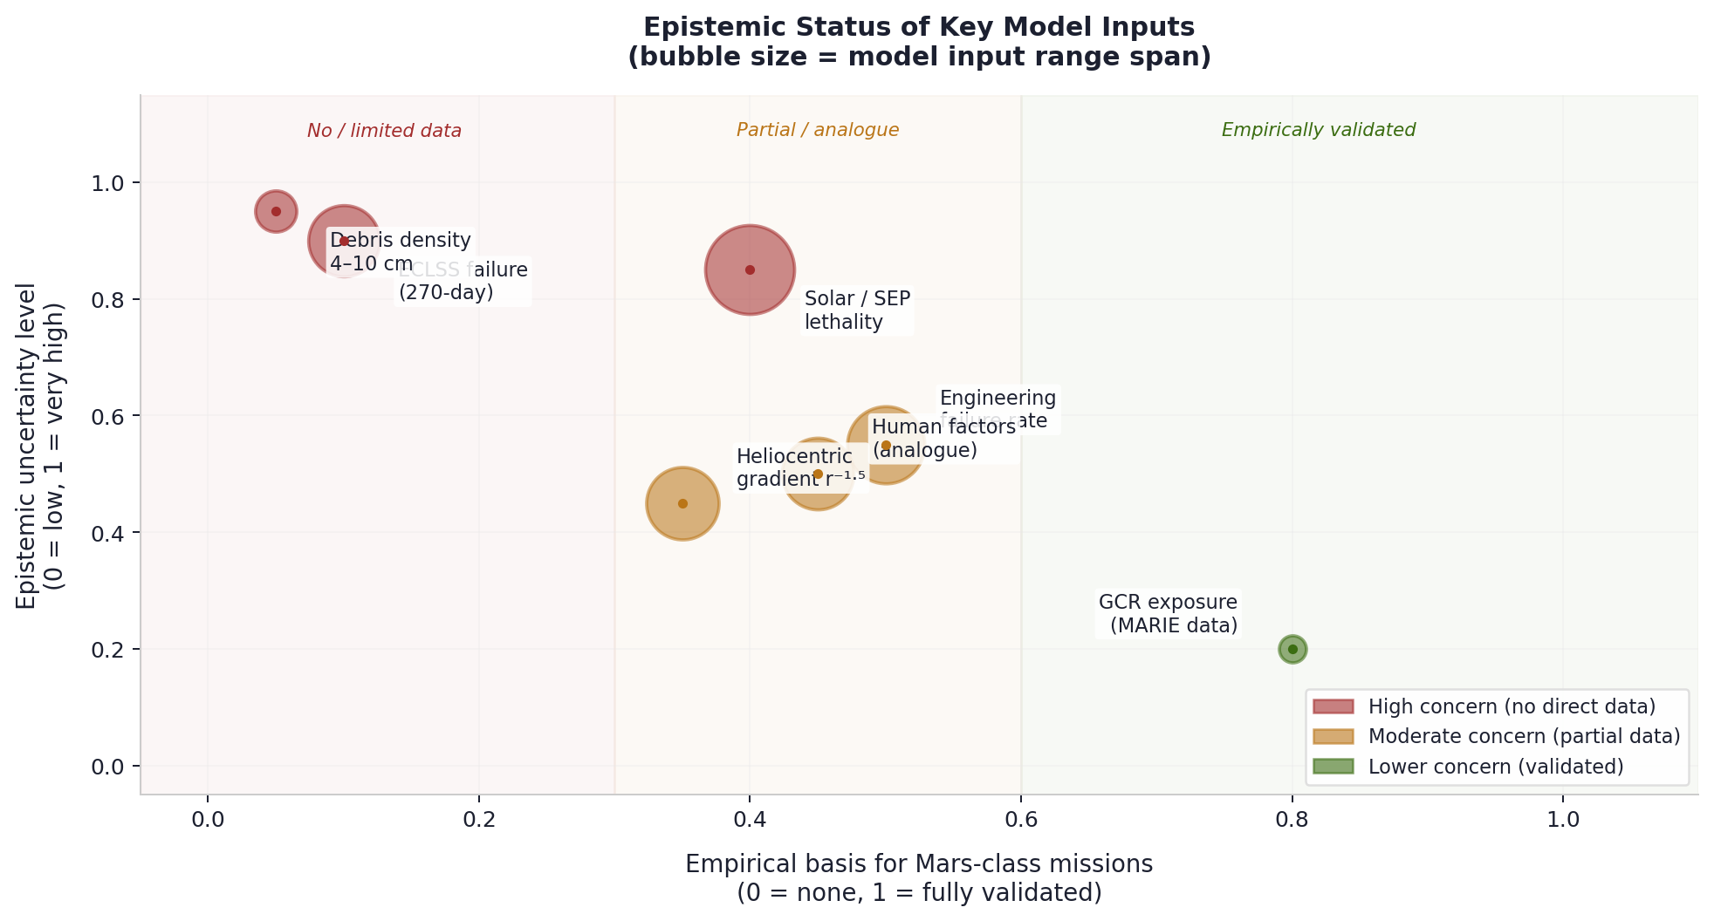
Figure 9 — Epistemic status matrix. Axes: empirical basis (x) and uncertainty level (y). Bubble size = model input range span. GCR data (MARIE/CRATER) is the best-constrained input. ECLSS 270-day performance and 4–10 cm debris density is the least constrained.

Input | Empirical Basis | Primary Source | Key Gap
GCR dose rate | Good (MARIE/CRATER data) | Zeitlin (2004); Hassler (2013) | Starship shielding transport model
SEP lethality | Partial (event freq. only) | Schwenn (2006); Cucinotta (2014) | Full LET spectrum + dose-rate model
Engineering failure rate | Partial (ISS/Shuttle analogue) | Fragola (1996); NASA PRA (2011) | No Starship deep-space heritage
ECLSS (270-day deep-space) | None direct | MELiSSA [Hendrickx 2006] | No 270-day closed-loop operational record
Human factors (9-month) | Analogue only | Mars-500; Antarctic winter-over | Comm delay + irreversibility unmodelled
Debris (4–10 cm) | None (interplanetary) | Grün (1985) for d<1mm | No in-situ measurements at 1–1.5 AU
Gradient r⁻¹·⁵ | Partial (d<1mm only) | Grün (1985); Fechtig (1981) | Not validated for 4–10 cm
Table 8.1 — The two “None direct” entries (ECLSS 270-day, 4–10 cm debris) represent the primary structural gaps. Because no Mars-class likelihood function exists for these factors, the priors are effectively the posteriors until dedicated data programs are completed.

9 CONCLUSIONS
• A 130× scale gap between published probe-derived collision figures and Starship-class crewed mission parameters is not addressed in public risk communications reviewed for this analysis.
• Monte Carlo simulation (N=100,000) yields a median LOC of 12.6% (Scenario A) and 27.2% (Scenario B). Both substantially exceed all modern crewed spaceflight standards.
• Copula sensitivity analysis confirms that the central estimate (p50) is robust to correlation magnitude (ρ=0.0–0.5) and copula family (Gaussian vs. t-copula, ν=4). The dominant uncertainty source is the prior distributions.
• Variance decomposition identifies engineering reliability (~33%) and solar/radiation (~29%) as dominant LOC variance drivers. ECLSS contributes ~21%. Debris contributes ~10%, concentrated in the LogNormal tail.
• Formal Bayesian posterior updating is not currently possible for the dominant risk factors. No 270-day deep-space ECLSS operational record, no Starship deep-space flight heritage, and no interplanetary 4–10 cm debris measurements exist.
• All quantitative outputs carry substantial epistemic uncertainty. Results should be read as structured plausibility estimates for external technical discussion.

FINAL ASSESSMENT
The central finding — that the dominant Mars mission risks are systemic (engineering validation, life-support maturity, radiation) rather than collision-based — is robust across copula family, correlation magnitude, scenario, and the full prior uncertainty range.
ECLSS 270-day analogue validation and Starship engineering heritage flights would both reduce dominant LOC variance components and provide the first datasets enabling formal Bayesian posterior revision.
This framework is offered as a reproducible, transparent, and externally auditable starting point for independent technical discussion. The simulation code and CSV outputs are publicly available.

APPENDIX A — Prior Parameter Derivation
This appendix documents the parameterization rationale for each prior distribution. All priors are based on expert elicitation from analogue data. None are empirically calibrated against Mars-class operational records.

A.1 Distribution Choice Rationale
Beta distribution (bounded [lo, hi]) is used for all risk factors except debris, because: (a) probabilities are bounded in [0,1]; (b) the Beta family accommodates both symmetric and skewed shapes via the α, β parameters; (c) mode and approximate range are the natural outputs of expert elicitation for bounded quantities.
LogNormal distribution is used for debris collision probability because: (a) the 4–10 cm debris regime in interplanetary space has never been directly measured; the distribution tail is genuinely unknown; (b) the ratio p95/median ≈ 75 spans multiple orders of magnitude, inconsistent with the bounded support of Beta; (c) LogNormal is the standard choice for failure rates with high epistemic uncertainty in nuclear and aerospace PRA [nrc2008].
A.2 Beta Parameterization Method
Given mode m, lower bound lo, and upper bound hi (all in % units), the Beta(a,b) prior on the rescaled interval [lo/100, hi/100] is parameterized as:

mode_scaled = (m − lo) / (hi − lo) (A.1)
a = mode_scaled · (C − 2) + 1, b = C − a, C = 12 (concentration) (A.2)
Concentration C=12 was selected to produce 90% credible intervals approximately matching the stated [lo, hi] bounds across all five factors. Sensitivity to C is discussed in the code (mars_pra_v93.py).

A.3 Factor-by-Factor Derivation
Factor | Mode | Lo (p≈5) | Hi (p≈95) | Primary Analogue Sources | Key Assumption
Solar / radiation | 3.5% | 1.0% | 15.0% | MARIE [Zeitlin 2004]; CRATER [Hassler 2013]; Cucinotta (2014) LD50 thresholds; Schwenn (2006) solar cycle | Basic shielding + solar min. Full GEANT4 model not available.
Engineering / propulsion | 4.5% | 1.5% | 13.0% | Space Shuttle PRA (~1.5% mature); Apollo novel system (~5–8%); Fragola (1996); NASA PRA (2011) | Novel system, no deep-space Starship heritage.
ECLSS | 2.0% | 0.5% | 9.0% | ISS ECLSS 90-day uptime >95%; MELiSSA Phase IV [Hendrickx 2006]; Biosphere 2 O₂ closure failure | No 270-day closed-loop deep-space record. Upper bound is epistemic, not statistical.
Human factors | 0.8% | 0.2% | 8.0% | Mars-500 analogue (520-day isolation); Antarctic winter-over cohort; optimized selection lower bound | Full 20-min comm delay and irreversibility not directly modelled in analogue data.
Debris (LogNormal) | median 0.024% | p5 ≈0.001% | p95 1.8% | Phase-space model central [v9.x Eq. 3.1–3.2]; Grün (1985) power-law for d<1mm; Harris (2015) asteroid pop. | Gradient r⁻¹·⁵ validated d<1mm only. Tail reflects genuine unknown.
Table A.1 — Full prior derivation. All intervals are approximate 90% credible bounds based on analogue data, not statistical confidence intervals.

APPENDIX B — Copula Structure and Sensitivity
B.1 Why a Copula?
The naive independent-failure assumption P_total = 1 − ∏(1−p_i) underestimates risk when failure modes share a common cause. Engineering reliability and ECLSS performance share a proximate common cause in this framework: both depend on systems that have not been validated for deep-space 270-day operation. A copula separates the marginal distributions (which are well-specified) from the dependence structure (which is uncertain), allowing transparent sensitivity analysis.
B.2 Gaussian Copula Construction
The Gaussian copula C_Σ with correlation matrix Σ is implemented via:
u_i = F_i(x_i) → z_i = Φ⁻¹(u_i) → Z ∼ N(0, Σ) → u_i’ = Φ(z_i’) (B.1)
In this framework, Σ is a 5×5 identity matrix with Σ[eng, eclss] = Σ[eclss, eng] = ρ = 0.30 (Scenario A). All other off-diagonal elements are zero (independence assumed). The rank correlation is implemented via an empirical CDF approach (see mars_pra_v93.py: apply_gaussian_copula()).

B.3 t-Copula and Tail Dependence
The t-copula with ν degrees of freedom has non-zero upper-tail dependence coefficient:
λ_U = 2 · t_{ν+1}(−√((ν+1)(1−ρ)/(1+ρ))) (B.2)
For ρ=0.30, ν=4: λ_U ≈ 0.24. This means that in the joint tail, simultaneous extreme engineering and ECLSS failures are more likely under the t-copula than under the Gaussian. The sensitivity analysis in Section 5 shows this has negligible impact on p50 and less than 0.2 pp impact on p95, confirming robustness.
B.4 Sensitivity Results
Copula | ρ = 0.0 | ρ = 0.1 | ρ = 0.2 | ρ = 0.3 (base) | ρ = 0.4 | ρ = 0.5
Gaussian — p50 LOC | 12.6% | 12.4% | 12.3% | 12.2% | 12.1% | 12.1%
Gaussian — p95 LOC | 17.3% | 17.3% | 17.3% | 17.3% | 17.2% | 17.2%
t-copula ν=4 — p50 LOC | 12.6% | 12.6% | 12.5% | 12.5% | 12.5% | 12.5%
t-copula ν=4 — p95 LOC | 17.3% | 17.3% | 17.3% | 17.3% | 17.4% | 17.4%
Table B.1 — Copula sensitivity across ρ and copula family. Maximum variation in p50: 0.5 pp. Maximum variation in p95: 0.2 pp. The central estimate and policy implications are robust to the correlation assumption.

APPENDIX C — Simulation Pseudocode and Assumptions
C.1 Full Pseudocode
The following pseudocode summarizes the simulation. Full Python implementation available at the repository listed on the cover page.

INPUTS: N = 100,000; seed = 42
Prior specifications (Appendix A)
Copula: Gaussian, rho_A = 0.30, rho_B = 0.35

STEP 1 — Draw independent marginal samples
solar ~ Beta(mode=3.5%, lo=1.0%, hi=15.0%) * 100 [% units]
eng ~ Beta(mode=4.5%, lo=1.5%, hi=13.0%) * 100
eclss_0 ~ Beta(mode=2.0%, lo=0.5%, hi=9.0%) * 100
hf ~ Beta(mode=0.8%, lo=0.2%, hi=8.0%) * 100
debris ~ LogNormal(median=0.024%, p95=1.8%)

STEP 2 — Apply Gaussian copula (Eng-ECLSS)
u_eng = empirical_cdf_ranks(eng)
u_ecl = empirical_cdf_ranks(eclss_0)
z_eng = Phi_inv(u_eng)
z_ecl = Phi_inv(u_ecl)
z_ecl_c = rho*z_eng + sqrt(1-rho^2)*z_ecl
u_ecl_c = Phi(z_ecl_c)
eclss = quantile_map(u_ecl_c, sorted(eclss_0))

STEP 3 — Total LOC
loc[i] = 1 - (1-solar[i]/100)*(1-eng[i]/100)*(1-eclss[i]/100)
*(1-hf[i]/100)*(1-debris[i]/100)
loc = loc * 100 [% units]

STEP 4 — Outputs
percentiles(loc, [5,25,50,75,95])
variance_share[k] = corr(factor_k, loc)^2 / sum(corr^2)
export: samples.csv, summary.json

C.2 Key Assumptions
Assumption | Value / Rationale | Sensitivity
Independence structure | All pairs independent except Eng–ECLSS | Tested: ρ=0.0–0.5, Gaussian and t-copula; robust
Beta concentration C | 12.0 (all Beta priors) | Higher C → narrower prior; lower C → wider. C=8–16 changes p95 by ~1–2pp.
LogNormal tail (debris) | p95 = 1.8% (phase-space upper bound) | If p95 = 0.5%, debris variance share ~3%. Central estimate unchanged.
LOC formula | Independent product P=1−∏(1−p_i) | Conservative: no interaction effects between failure modes (no cascades).
N samples | 100,000 | Monte Carlo error on p95: ~±0.1pp at N=100k. Stable.
Correlation (Eng–ECLSS) | 0.30 (Sc A), 0.35 (Sc B) | p50 varies <0.5pp across ρ∈[0,0.5]. See Appendix B.

REPRODUCIBILITY
Full simulation code: mars_pra_v93.py (Python 3.10+, dependencies: numpy, scipy, matplotlib).
Run: python mars_pra_v93.py --seed 42 --n 100000 --out ./output/
Outputs: mars_pra_v93_samples.csv (100k rows × 12 columns), mars_pra_v93_summary.json, copula_sensitivity.json.
All figures in this memorandum are reproducible from the CSV outputs using the plotting functions in the same script.

REFERENCES
[christiansen2009] Christiansen, E.L. (2009). Meteoroid/Debris Shielding. NASA/TP-2009-214785. Johnson Space Center.
[cucinotta2014] Cucinotta, F.A. (2014). Space radiation risks for astronauts on multiple ISS missions. PLOS ONE, 9(4), e93832.
[drolshagen2008] Drolshagen, G., et al. (2008). Hypervelocity impact database from ESA’s DEBIE sensor on the ISS. Advances in Space Research, 41(7), 1123–1129.
[fechtig1981] Fechtig, H., et al. (1981). Historical perspectives on meteoroids, meteors, and interplanetary dust. In: Cosmic Dust (ed. McDonnell). Wiley, pp. 607–669.
[fragola1996] Fragola, J.R., Maggio, G., & Collins, E.P. (1996). Reliability and safety analysis of the International Space Station. Probabilistic Safety Assessment and Management. Springer, pp. 285–290.
[grun1985] Grün, E., et al. (1985). Collisional balance of the meteoritic complex. Icarus, 62(2), 244–272.
[harris2015] Harris, A.W. & D’Abramo, G. (2015). The population of near-Earth asteroids. Icarus, 257, 56–67.

[hassler2013] Hassler, D.M., et al. (2013). Mars’ surface radiation environment measured with the MSL Curiosity rover. Science, 343(6169), 1244797.
[hendrickx2006] Hendrickx, L., et al. (2006). Microbial ecology of the closed artificial ecosystem MELiSSA. Research in Microbiology, 157(1), 77–86.
[knight1921] Knight, F.H. (1921). Risk, Uncertainty, and Profit. Houghton Mifflin.
[nasa2023debris] NASA (2023). Orbital Debris Quarterly News, 27(3). Johnson Space Center.
[nasa_pra2011] NASA (2011). ISS Probabilistic Risk Assessment Overview. NASA/TM-2011-216468. JSC Houston.
[nelsen2006] Nelsen, R.B. (2006). An Introduction to Copulas (2nd ed.). Springer. ISBN 978-0-387-28659-4.
[nrc2008] National Research Council (2008). Managing Space Radiation Risk in the New Era of Space Exploration. National Academies Press. doi:10.17226/12045.
[opik1951] Öpik, E.J. (1951). Collision probabilities with the planets. Proc. Royal Irish Academy, 54A, 165–199.
[schwenn2006] Schwenn, R. (2006). Space Weather: The Solar Perspective. Living Reviews in Solar Physics, 3(1).
[taleb2007] Taleb, N.N. (2007). The Black Swan: The Impact of the Highly Improbable. Random House.
[wetherill1967] Wetherill, G.W. (1967). Collisions in the asteroid belt. Journal of Geophysical Research, 72(9), 2429–2444.
[zeitlin2004] Zeitlin, C., et al. (2004). Energetic particle radiation in deep space: results from MARIE. Science, 305, 1080–1083.

Quantix Analytics Consulting · quantixac.com
Mars Mission Risk Assessment · v9.3 · May 2026

