LUNAR CORROSION  Scaffold Program  CONTROL LLC | Date:  2019 | Department  Safety Department
LUNAR CORROSION  Scaffold Program  CONTROL LLC |  | Approved by:  Management

TABLE OF CONTENTS
Page

- Purpose …………………………………………………………………… 1
- Scope ……………………………………………………………………… 1
- References ………………………………………………………………… 1
- Responsibilities …………………………………………………………… 2
- Scaffolding Program …………………………………………………….. 2
- Design …………………………………………………………. 2
- Scaffold Platform Construction …………………………….. 2
- Criteria for Supporting Scaffolding ………………………… 3
- Criteria for Suspension Scaffolds …………………………… 4
- Accessing Scaffolds ………………………………………….. 5
- Scaffolding Use ………………………………………………. 6
- Fall Protection ……………………………………………….. 6
- Falling Object Protection ……………………………………. 7
VI. Definitions ………………………………………………………………… 8
VII. Attachments ……………………………………………………………. 13

PURPOSE

It is the policy of Lunar Corrosion Control LLC, that each employee follows the guidelines set forth in this written program. The purpose of this written program is to protect all Lunar Corrosion Control LLC employees who may work on or around a scaffold.

SCOPE

The Safety Services Department is the program manager and is responsible for its implementation. Certain employees “competent persons” will be authorized to inspect, investigate, or assess workplace conditions before work begins or after all work has been completed. These authorized employees determine if all walking/working surfaces on which our employees work have the strength and structural integrity to support the employees. Our employees will not be allowed to work on these surfaces until they have the requisite strength and structural integrity.

REFERENCES

1. CFR 29 1915 Subpart N
2. CFR 29 1926 Subpart L
3. Lunar Corrosion Control LLC Fall Protection Program

RESPONSIBILITES

- The Safety Services Department will ensure a Scaffold Program is in place, reviewed and updated appropriately. The Safety Department will assist the offices with compliance, training program and hazard specific information.
- The Site Safety Representative at each facility has the overall responsibility to ensure compliance and proper training in the handling of scaffolds.
- The Facility Manager shall ensure all employees have received training and instructions on proper procedures when dealing with scaffolds. They are also responsible for performing site audits to ensure the effectiveness of the employee’s awareness and proper handling of scaffolding. They are responsible for correcting any inefficiency in the procedures being performed.
- All Employees shall observe training and instructions received regarding the proper procedures for working on scaffolds.

IV. SCAFFOLDING PROGRAM

A. DESIGN
A Lunar competent person will ensure each scaffold and scaffold component shall be capable of supporting, without failure, its own weight and at least 4 times the maximum intended load applied or transmitted to it.

Scaffolds shall be designed by a qualified person and shall be constructed and loaded in accordance with that design. Lunar employees will not be required to design or build scaffolds.

B. SCAFFOLD PLATFORM CONSTRUCTION

Lunar’s competent person will ensure the following:

- Each platform on all working levels of scaffolds shall be fully planked or decked between the front uprights and the guardrail;

- Each scaffold platform and walkway shall be at least 18 inches (46 cm) wide;

- Each ladder jack scaffold, top plate bracket scaffold, roof bracket scaffold, and pump jack scaffold shall be at least 12 inches (30 cm) wide;

- Where scaffolds must be used in areas that the employer can demonstrate are so narrow that platforms and walkways cannot be at least 18 inches (46 cm) wide, such platforms and walkways shall be as wide as feasible, and employees on those platforms and walkways shall be protected from fall hazards by the use of guardrails and/or personal fall arrest systems;

- Each end of a platform 10 feet or less in length shall not extend over its support more than 12 inches (30 cm) unless the platform is designed and installed so that the cantilevered portion of the platform is able to support employees and/or materials without tipping, or has guardrails which block employee access to the cantilevered end;

- On scaffolds where scaffold planks are abutted to create a long platform, each abutted end shall rest on a separate support surface;

- On scaffolds where platforms are overlapped to create a long platform, the overlap shall occur only over supports, and shall not be less than 12 inches (30 cm) unless the platforms are nailed together or otherwise restrained to prevent movement;

- Wood platforms shall not be covered with opaque finishes, except that platform edges may be covered or marked for identification. Platforms may be coated periodically with wood preservatives, fire-retardant finishes, and slip-resistant finishes; however, the coating may not obscure the top or bottom wood surfaces.

- Catenary scaffolds will meet the following requirements”

- No more than one platform shall be placed between consecutive vertical pickups, and no more than two platforms hall be used on a catenary scaffold.
- Platforms supported by wire ropes shall have hook-shaped stops on each end of the platforms to prevent them from slipping off the wire ropes. These hooks shall be so placed that they will prevent the platform from falling if one of the horizontal wire ropes break.
- Wire ropes shall not be tightened to the extent that the application of scaffold load will overstress them.
- Wire ropes shall be continuous and without splices between anchors.

C. CRITERIA FOR SUPPORTTED SCAFFOLDS

Lunar’s competent person will ensure the following:

- Supported scaffolds with a height to base width (including outrigger supports, if used) ratio of more than four to one (4:1) shall be restrained from tipping by guying, tying, bracing, or equivalent means;

- Guys, ties, and braces shall be installed at locations where horizontal members support both inner and outer legs;

- Ties, guys, braces, or outriggers shall be used to prevent the tipping of supported scaffolds in all circumstances where an eccentric load, such as a cantilevered work platform, is applied or is transmitted to the scaffold;

- Supported scaffold poles, legs, posts, frames, and uprights shall bear on base plates and mud sills or other adequate firm foundation;

- Footings shall be level, sound, rigid, and capable of supporting the loaded scaffold without settling or displacement;

- Unstable objects shall not be used to support scaffolds or platform units or used as working platforms;

- Supported scaffold poles, legs, posts, frames, and uprights shall be plumb and braced to prevent swaying and displacement.

D. CRITERIA FOR SUSPENSION SCAFFOLDS

- All suspension scaffold support devices, such as outrigger beams, cornice hooks, parapet clamps, and similar devices, shall rest on surfaces capable of supporting at least 4 times the load imposed on them by the scaffold operating at the rated load of the hoist (or at least 1.5 times the load imposed on them by the scaffold at the stall capacity of the hoist, whichever is greater);

- Counterweights shall be made of non-flowable material. Sand, gravel and similar materials that can be easily dislocated shall not be used as counterweights. Only those items specifically designed as counterweights shall be used to counterweight scaffold systems. Construction materials such as, but not limited to, masonry units and rolls of roofing felt, shall not be used as counterweights;

- Tiebacks shall be secured to a structurally sound anchorage on the building or structure. Sound anchorages include structural members, but do not include standpipes, vents, other piping systems, or electrical conduit.

- Provided with stop bolts or shackles at both ends;
- Securely fastened together with the flanges turned out when channel iron beams are used in place of I-beams;
- Installed with all bearing supports perpendicular to the beam center line;
- Set and maintained with the web in a vertical position; and
- When an outrigger beam is used, the shackle or clevis with which the rope is attached to the outrigger beam shall be placed directly over the center line of the stirrup.
- The use of repaired wire rope as suspension rope is prohibited.
- Ropes shall be inspected for defects by a competent person prior to each work shift and after every occurrence which could affect a rope's integrity. Ropes shall be replaced if any of the following conditions exist:

- Any physical damage which impairs the function and strength of the rope.
- Kinks that might impair the tracking or wrapping of rope around the drum(s) or sheave(s).
- Six randomly distributed broken wires in one rope lay or three broken wires in one strand in one rope lay.
- Abrasion, corrosion, scrubbing, flattening or peening causing loss of more than one-third of the original diameter of the outside wires.
- Heat damage caused by a torch or any damage caused by contact with electrical wires.
- Evidence that the secondary brake has been activated during an overspeed condition and has engaged the suspension rope.

- Devices that sole function is to provide emergency escape and rescue shall not be used as working platforms. This provision does not preclude the use of systems which are designed to function both as suspension scaffolds and emergency systems.

E. ACCESSING SCAFFOLDING

All Lunar employees will follow the below guidelines for accessing a scaffold:

- When scaffold platforms are more than 2 feet (0.6 m) above or below a point of access, portable ladders, hook-on ladders, attachable ladders, stair towers (scaffold stairways/towers), stairway-type ladders (such as ladder stands), ramps, walkways, integral prefabricated scaffold access, or direct access from another scaffold, structure, personnel hoist, or similar surface shall be used. Crossbraces shall not be used as a means of access.

- Portable, hook-on, and attachable ladders:

- Portable, hook-on, and attachable ladders shall be positioned so as not to tip the scaffold;
- Hook-on and attachable ladders shall be positioned so that their bottom rung is not more than 24 inches (61 cm) above the scaffold supporting level;
- When hook-on and attachable ladders are used on a supported scaffold more than 35 feet (10.7 m) high, they shall have rest platforms at 35-foot (10.7 m) maximum vertical intervals.
- Hook-on and attachable ladders shall be specifically designed for use with the type of scaffold used;
- Hook-on and attachable ladders shall have a minimum rung length of 11 1/2 inches (29 cm); and
- Hook-on and attachable ladders shall have uniformly spaced rungs with a maximum spacing between rungs of 16 3/4 inches.

- Stairway-type ladders shall:

- Be positioned such that the bottom step is not more than 24 inches (61 cm) above the scaffold supporting level;
- Be provided with rest platforms at 12 foot (3.7 m) maximum vertical intervals;
- Have a minimum step width of 16 inches (41 cm), except that mobile scaffold stairway-type ladders shall have a minimum step width of 11 1/2 inches (30 cm); and
- Have slip-resistant treads on all steps and landings.

- A stair-rail consisting of a top-rail and a mid-rail shall be provided on each side of each scaffold stairway.

- The top-rail of each stair-rail system shall also be capable of serving as a handrail, unless a separate handrail is provided.

- Stair-rail systems and handrails shall be surfaced to prevent injury to employees from punctures or lacerations, and to prevent snagging of clothing.

- A landing platform at least 18 inches (45.7 cm) wide by at least 18 inches (45.7 cm) long shall be provided at each level.

- Treads and landings shall have slip-resistant surfaces.

- Guardrails shall be provided on the open sides and ends of each landing.

F. SCAFFOLDING USE

All Lunar employees will follow the below guidelines for scaffolding use:

- Scaffolds and scaffold components shall not be loaded in excess of their maximum intended loads or rated capacities, whichever is less. Prior to working on the scaffold the employee must know the rated capacities

- The use of shore or lean-to scaffolds is prohibited.

- Scaffolds and scaffold components shall be inspected for visible defects by a competent person before each work shift, and after any occurrence which could affect a scaffold's structural integrity.

- Scaffolds shall not be moved horizontally while Lunar employees are on them.

- Lunar employees shall be prohibited from working on scaffolds covered with snow, ice, or other slippery material except as necessary for removal of such materials.

- Work on or from scaffolds is prohibited during storms or high winds.

- Debris shall not be allowed to accumulate on platforms.

- Ladders shall not be used on scaffolds to increase the working level height of employees, except on large area scaffolds where employers have satisfied the following criteria:
- When the ladder is placed against a structure which is not a part of the scaffold, the scaffold shall be secured against the sideways thrust exerted by the ladder;
- The platform units shall be secured to the scaffold to prevent their movement;
- The ladder legs shall be on the same platform or other means shall be provided to stabilize the ladder against unequal platform deflection, and
- The ladder legs shall be secured to prevent them from slipping or being pushed off the platform.

G. FALL PROTECTION

- Each Lunar employee on a scaffold more than 10 feet (3.1 m) above a lower level shall be protected from falling to that lower level. Either by guardrail system or harness/lanyard system or any other approved method listed in reference 3.

- Each employee on a self-contained adjustable scaffold shall be protected by a guardrail system (with minimum 200 pound toprail capacity) when the platform is supported by the frame structure, and by both a personal fall arrest system and a guardrail system (with minimum 200 pound toprail capacity) when the platform is supported by ropes.

- In addition to meeting the requirements of 1926.502(d), personal fall arrest systems used on scaffolds shall be attached by lanyard to a vertical lifeline, horizontal lifeline, or scaffold structural member. Vertical lifelines shall not be used when overhead components, such as overhead protection or additional platform levels, are part of a single-point or two-point adjustable suspension scaffold.

- When vertical lifelines are used, they shall be fastened to a fixed safe point of anchorage, shall be independent of the scaffold, and shall be protected from sharp edges and abrasion. Safe points of anchorage include structural members of buildings, but do not include standpipes, vents, other piping systems, electrical conduit, outrigger beams, or counterweights.

- Guardrail systems will be installed to meet the requirements of the OSHA standard.

H. FALLING OBJECT PROTECTION

- In the event employees are exposed to falling objects Lunar employees will wear hardhats. Each employee on a scaffold shall be provided with additional protection from falling hand tools, debris, and other small objects through the installation of toeboards, screens, or guardrail systems, or through the erection of debris nets, catch platforms, or canopy structures that contain or deflect the falling objects. When the falling objects are too large, heavy or massive to be contained or deflected by any of the above-listed measures, Lunar shall place such potential falling objects away from the edge of the surface from which they could fall and shall secure those materials as necessary to prevent their falling.

- Where there is a danger of tools, materials, or equipment falling from a scaffold and striking employees below, the following provisions apply:
- The area below the scaffold to which objects can fall shall be barricaded, and employees shall not be permitted to enter the hazard area; or
- A toeboard shall be erected along the edge of platforms more than 10 feet (3.1 m) above lower levels for a distance sufficient to protect employees below, except on float (ship) scaffolds where an edging of 3/4 x 1 1/2 inch (2 x 4 cm) wood or equivalent may be used in lieu of toeboards;
- Where tools, materials, or equipment are piled to a height higher than the top edge of the toeboard, paneling or screening extending from the toeboard or platform to the top of the guardrail shall be erected for a distance sufficient to protect employees below; or
- A guardrail system shall be installed with openings small enough to prevent passage of potential falling objects; or
- A canopy structure, debris net, or catch platform strong enough to withstand the impact forces of the potential falling objects shall be erected over the employees below.

- Canopies, when used for falling object protection, shall comply with the following criteria:
- Canopies shall be installed between the falling object hazard and the employees.
- When canopies are used on suspension scaffolds for falling object protection, the scaffold shall be equipped with additional independent support lines equal in number to the number of points supported, and equivalent in strength to the strength of the suspension ropes.
- Independent support lines and suspension ropes shall not be attached to the same points of anchorage.

DEFINITIONS

Adjustable suspension scaffold means a suspension scaffold equipped with a hoist(s) that can be operated by an employee(s) on the scaffold.

Bearer (putlog) means a horizontal transverse scaffold member (which may be supported by ledgers or runners) upon which the scaffold platform rests and which joins scaffold uprights, posts, poles, and similar members.

Boatswains' chair means a single-point adjustable suspension scaffold consisting of a seat or sling designed to support one employee in a sitting position.

Body belt (safety belt) means a strap with means both for securing it about the waist and for attaching it to a lanyard, lifeline, or deceleration device. May only be used as a positioning device, not as a means of fall protection.

Body harness means a design of straps which may be secured about the employee in a manner to distribute the fall arrest forces over at least the thighs, pelvis, waist, chest and shoulders, with means for attaching it to other components of a personal fall arrest system.

Brace means a rigid connection that holds one scaffold member in a fixed position with respect to another member, or to a building or structure.

Bricklayers' square scaffold means a supported scaffold composed of framed squares which support a platform.

Carpenters' bracket scaffold means a supported scaffold consisting of a platform supported by brackets attached to building or structural walls.

Catenary scaffold means a suspension scaffold consisting of a platform supported by two essentially horizontal and parallel ropes attached to structural members of a building or other structure. Additional support may be provided by vertical pickups.

Chimney hoist means a multi-point adjustable suspension scaffold used to provide access to work inside chimneys

Cleat means a structural block used at the end of a platform to prevent the platform from slipping off its supports. Cleats are also used to provide footing on sloped surfaces such as crawling boards.

Competent person means one who is capable of identifying existing and predictable hazards in the surroundings or working conditions which are unsanitary, hazardous, or dangerous to employees, and who has authorization to take prompt corrective measures to eliminate them.

Continuous run scaffold (Run scaffold) means a two-point or multi-point adjustable suspension scaffold constructed using a series of interconnected braced scaffold members or supporting structures erected to form a continuous scaffold.

Coupler means a device for locking together the tubes of a tube and coupler scaffold.

Crawling board (chicken ladder) means a supported scaffold consisting of a plank with cleats spaced and secured to provide footing, for use on sloped surfaces such as roofs.

Deceleration device means any mechanism, such as a rope grab, rip-stitch lanyard, specially-woven lanyard, tearing or deforming lanyard, or automatic self-retracting lifeline lanyard, which dissipates a substantial amount of energy during a fall arrest or limits the energy imposed on an employee during fall arrest.

Double pole (independent pole) scaffold means a supported scaffold consisting of a platform(s) resting on cross beams (bearers) supported by ledgers and a double row of uprights independent of support (except ties, guys, braces) from any structure.

Equivalent means alternative designs, materials or methods to protect against a hazard which the employer can demonstrate will provide an equal or greater degree of safety for employees than the methods, materials or designs specified in the standard.

Exposed power lines means electrical power lines which are accessible to employees and which are not shielded from contact. Such lines do not include extension cords or power tool cords.

Eye or Eye splice means a loop with or without a thimble at the end of a wire rope.

Fabricated decking and planking means manufactured platforms made of wood (including laminated wood, and solid sawn wood planks), metal or other materials.

Fabricated frame scaffold (tubular welded frame scaffold) means a scaffold consisting of a platform(s) supported on fabricated end frames with integral posts, horizontal bearers, and intermediate members.

Failure means load refusal, breakage, or separation of component parts. Load refusal is the point where the ultimate strength is exceeded.

Float (ship) scaffold means a suspension scaffold consisting of a braced platform resting on two parallel bearers and hung from overhead supports by ropes of fixed length.

Form scaffold means a supported scaffold consisting of a platform supported by brackets attached to formwork.

Guardrail system means a vertical barrier, consisting of, but not limited to, top-rails, mi-rails, and posts, erected to prevent employees from falling off a scaffold platform or walkway to lower levels.

Hoist means a manual or power-operated mechanical device to raise or lower a suspended scaffold.

Horse scaffold means a supported scaffold consisting of a platform supported by construction horses (saw horses). Horse scaffolds constructed of metal are sometimes known as trestle scaffolds.

Interior hung scaffold means a suspension scaffold consisting of a platform suspended from the ceiling or roof structure by fixed length supports.

Ladder jack scaffold means a supported scaffold consisting of a platform resting on brackets attached to ladders.

Ladder stand means a mobile, fixed-size, self-supporting ladder consisting of a wide flat tread ladder in the form of stairs.

Landing means a platform at the end of a flight of stairs.

Large area scaffold means a pole scaffold, tube and coupler scaffold, systems scaffold, or fabricated frame scaffold erected over substantially the entire work area. For example: a scaffold erected over the entire floor area of a room.

Lean-to scaffold means a supported scaffold which is kept erect by tilting it toward and resting it against a building or structure.

Lifeline means a component consisting of a flexible line that connects to an anchorage at one end to hang vertically (vertical lifeline), or that connects to anchorages at both ends to stretch horizontally (horizontal lifeline), and which serves as a means for connecting other components of a personal fall arrest system to the anchorage.

Lower levels means areas below the level where the employee is located and to which an employee can fall. Such areas include, but are not limited to, ground levels, floors, roofs, ramps, runways, excavations, pits, tanks, materials, water, and equipment.

Masons' multi-point adjustable suspension scaffold means a continuous run suspension scaffold designed and used for masonry operations.

Maximum intended load means the total load of all persons, equipment, tools, materials, transmitted loads, and other loads reasonably anticipated to be applied to a scaffold or scaffold component at any one time.

Mobile scaffold means a powered or unpowered, portable, caster or wheel-mounted supported scaffold.

Multi-level suspended scaffold means a two-point or multi-point adjustable suspension scaffold with a series of platforms at various levels resting on common stirrups.

Multi-point adjustable suspension scaffold means a suspension scaffold consisting of a platform(s) which is suspended by more than two ropes from overhead supports and equipped with means to raise and lower the platform to desired work levels. Such scaffolds include chimney hoists.

Needle beam scaffold means a platform suspended from needle beams.

Open sides and ends means the edges of a platform that are more than 14 inches (36 cm) away horizontally from a sturdy, continuous, vertical surface (such as a building wall) or a sturdy, continuous horizontal surface (such as a floor), or a point of access. Exception: For plastering and lathing operations the horizontal threshold distance is 18 inches (46 cm).

Outrigger means the structural member of a supported scaffold used to increase the base width of a scaffold in order to provide support for and increased stability of the scaffold.

Outrigger beam (Thrustout) means the structural member of a suspension scaffold or outrigger scaffold which provides support for the scaffold by extending the scaffold point of attachment to a point out and away from the structure or building.

Outrigger scaffold means a supported scaffold consisting of a platform resting on outrigger beams (thrustouts) projecting beyond the wall or face of the building or structure, the inboard ends of which are secured inside the building or structure.

Personal fall arrest system means a system used to arrest an employee's fall. It consists of an anchorage, connectors, a body belt or body harness and may include a lanyard, deceleration device, lifeline, or combinations of these.

Platform means a work surface elevated above lower levels. Platforms can be constructed using individual wood planks, fabricated planks, fabricated decks, and fabricated platforms
.
Power operated hoist means a hoist which is powered by other than human energy.

Pump jack scaffold means a supported scaffold consisting of a platform supported by vertical poles and movable support brackets.

Qualified means one who, by possession of a recognized degree, certificate, or professional standing, or who by extensive knowledge, training, and experience, has successfully demonstrated his/her ability to solve or resolve problems related to the subject matter, the work, or the project.

Rated load means the manufacturer's specified maximum load to be lifted by a hoist or to be applied to a scaffold or scaffold component.

Repair bracket scaffold means a supported scaffold consisting of a platform supported by brackets which are secured in place around the circumference or perimeter of a chimney, stack, tank or other supporting structure by one or more wire ropes placed around the supporting structure.

Roof bracket scaffold means a rooftop supported scaffold consisting of a platform resting on angular-shaped supports.

Runner (ledger or ribbon) means the lengthwise horizontal spacing or bracing member which may support the bearers.

Scaffold means any temporary elevated platform (supported or suspended) and its supporting structure (including points of anchorage), used for supporting employees or materials or both.

Self-contained adjustable scaffold means a combination supported and suspension scaffold consisting of an adjustable platform(s) mounted on an independent supporting frame(s) not a part of the object being worked on, and which is equipped with a means to permit the raising and lowering of the platform(s). Such systems include rolling roof rigs, rolling outrigger systems, and some masons' adjustable supported scaffolds.

Shore scaffold means a supported scaffold which is placed against a building or structure and held in place with props.

Single-point adjustable suspension scaffold means a suspension scaffold consisting of a platform suspended by one rope from an overhead support and equipped with means to permit the movement of the platform to desired work levels.

Single-pole scaffold means a supported scaffold consisting of a platform(s) resting on bearers, the outside ends of which are supported on runners secured to a single row of posts or uprights, and the inner ends of which are supported on or in a structure or building wall.

Stair tower (Scaffold stairway/tower) means a tower comprised of scaffold components and which contains internal stairway units and rest platforms. These towers are used to provide access to scaffold platforms and other elevated points such as floors and roofs.

Stall load means the load at which the prime-mover of a power-operated hoist stalls or the power to the prime-mover is automatically disconnected.

Step, platform, and trestle ladder scaffold means a platform resting directly on the rungs of step ladders or trestle ladders.

Stilts means a pair of poles or similar supports with raised footrests, used to permit walking above the ground or working surface.

Supported scaffold means one or more platforms supported by outrigger beams, brackets, poles, legs, uprights, posts, frames, or similar rigid support.

Suspension scaffold means one or more platforms suspended by ropes or other non-rigid means from an overhead structure(s).

System scaffold means a scaffold consisting of posts with fixed connection points that accept runners, bearers, and diagonals that can be interconnected at predetermined levels.

Tank builders' scaffold means a supported scaffold consisting of a platform resting on brackets that are either directly attached to a cylindrical tank or attached to devices that are attached to such a tank.

Top plate bracket scaffold means a scaffold supported by brackets that hook over or are attached to the top of a wall. This type of scaffold is similar to carpenters' bracket scaffolds and form scaffolds and is used in residential construction for setting trusses.

Tube and coupler scaffold means a supported or suspended scaffold consisting of a platform(s) supported by tubing, erected with coupling devices connecting uprights, braces, bearers, and runners.

Two-point suspension scaffold (swing stage) means a suspension scaffold consisting of a platform supported by hangers (stirrups) suspended by two ropes from overhead supports and equipped with means to permit the raising and lowering of the platform to desired work levels.

Unstable objects means items whose strength, configuration, or lack of stability may allow them to become dislocated and shift and therefore may not properly support the loads imposed on them. Unstable objects do not constitute a safe base support for scaffolds, platforms, or employees. Examples include, but are not limited to, barrels, boxes, loose brick, and concrete blocks.

Vertical pickup means a rope used to support the horizontal rope in catenary scaffolds.

Walkway means a portion of a scaffold platform used only for access and not as a work level.

Window jack scaffold means a platform resting on a bracket or jack which projects through a window opening.

VII. ATTACHMENTS

Examples of different types of scaffolds:

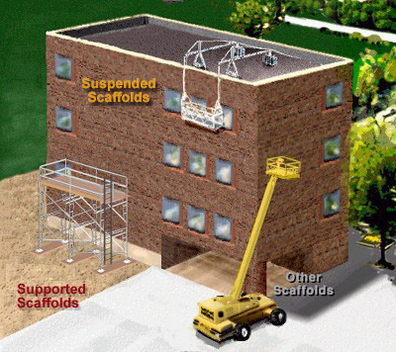

Catenary Scaffold Two Point Swing Stage
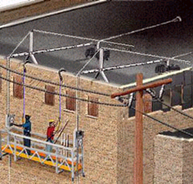
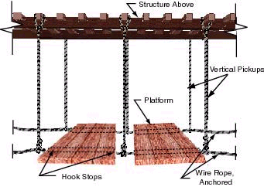

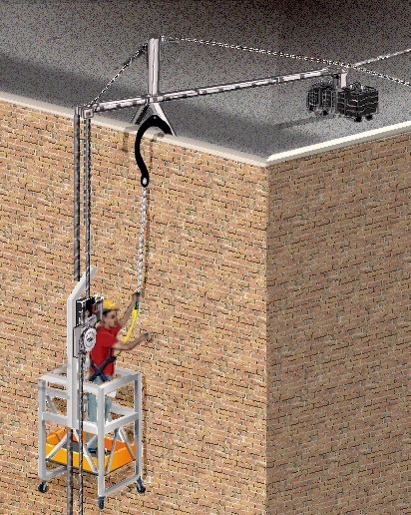
Single Point Adjustable

Multi Point Adjustable
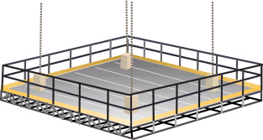

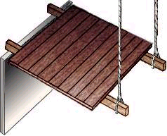
Interior Hung Needle Beam
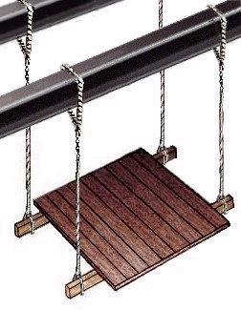

Multi Level

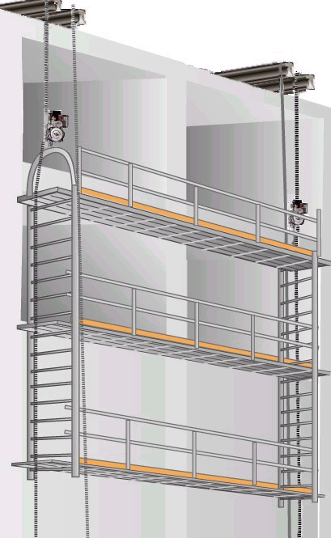

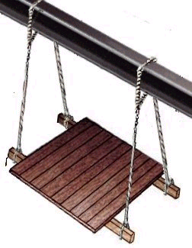
Float (Ship) Frame Scaffold
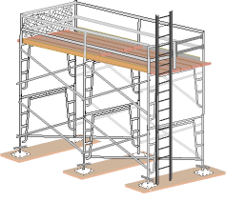

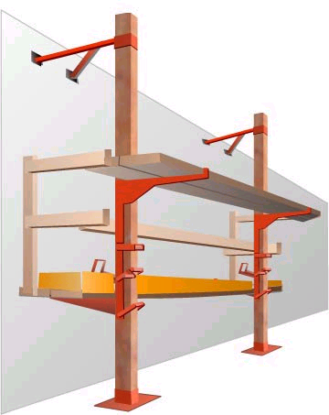
Moble Scaffold Pump Jack
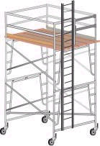

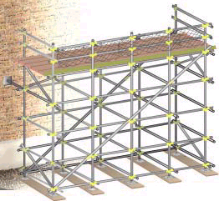
Ladder Jack Tube and Coupler
