Studio Project 4

Galaga Remake

Brandon Goh Nian Zhou ( 121309D )

Sim Yuan He ( 122816M )

Kho Liang Hao ( 121320S )

Ron Ng Jian Ying ( 120160Y )

Galaga Remake Pitch Document

Proposal:

We are remaking Galaga for the Windows platform. Galaga is a game by Namco that was first released in 1981 and was an instant hit in Arcades. The game is similar to space invaders however the aliens fly in from outside of the screen before moving into their respective positions just like in Space Invaders.

The remake will include things such as better particle effects, local 2 player multiplayer and better AI. The art style would remain largely faithful to the game but with slightly updated graphics such as using higher resolution sprite characters and fully painted art. The sound will also be upgraded and we will be adding different BGMs for the game as well as more realistic sound effect such as when an alien dies.

Audience:

The game is targeted at teenagers who have never played Galaga before as it was before their time. The game will be a modernized Galaga with better graphics, better controls and includes character progression such as weapon unlocks.

Task List:

Brandon:

* Xbox 360 Controller
* Save Game
* Saves encryption
* Particle System

Yuan He:

* UI
* Sound

Liang Hao:

* Ship
* Upgrades
* Weapons

Ron:

* Collision
* AI
* Object and Collision Manager class

Draft Gantt Chart:

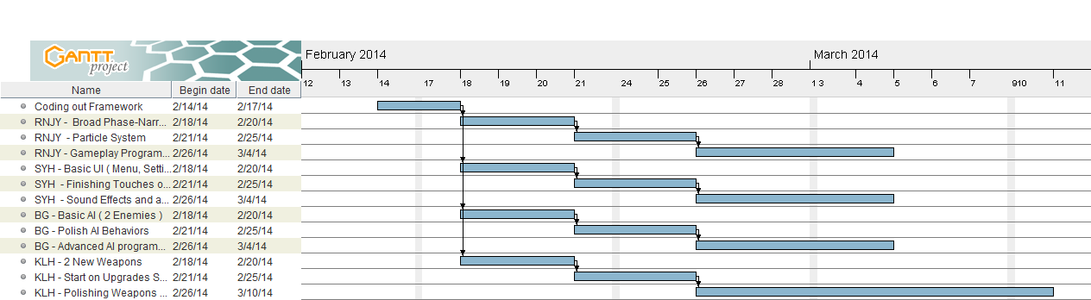

Version Control:

The Version Control Software we will be using is Git with GitHub. This means that any commitments will be directly uploaded to GitHub hence we can access everyone’s files the moment they committed a code while Git is the interface that is being used to push commitments.