CN LAB – 8 : STUDY OF DHCP

Q7.1) Configure two VMs that will be used to test connectivity from end to end and R1 will serve as a DHCP server to distribute IP addresses. The diagram below details the current setup:
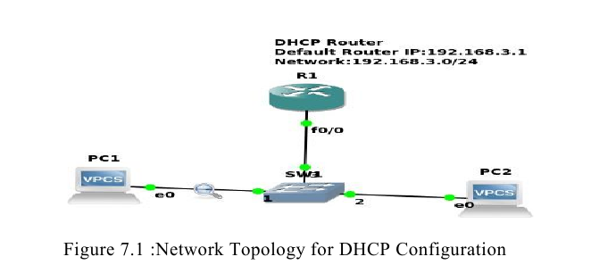

1. In order to configure our router as a DHCP server the following commands were used.
R1(config)#IP dhcp pool NAME
R1(dhcp-config)#Network 192.168.3.0 255.255.255.0
R1(dhcp-config)#Default-router 192.168.3.1
The commands above create a DHCP pool, adds the network that we want to assign IP addresses from, and specifies the default gateway for this subnet.
Note: There are many other parameters that go into configuring a DHCP server, but this will suffice for our test environment. That should be it for the DHCP configuration.
2.The next thing that you want to do is configure the fastethernet 0/0 interface which will connect to our switch.
R1(config)#Interface fastEthernet 0/0
R1(config-if)#No shutdown

R1(config-if)#ip address 192.168.3.1 255.255.255.0
The commands above will turn the interface on and assign an IP address.
3. Turn on the VPCS. In PC1 and PC2 type dhcp
That is,
PC1>dhcp
PC2>dhcp
4. Let’s analyse some of the traffic patterns using Wireshark.
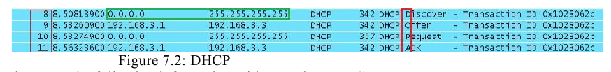
We see a discover message followed by an offer, request, and an acknowledgement. This is
the process that clients go through in order to obtain an IP address via DHCP. The mnemonic for the steps above is DORA and it should help in memorizing the order of the steps.

Solution :
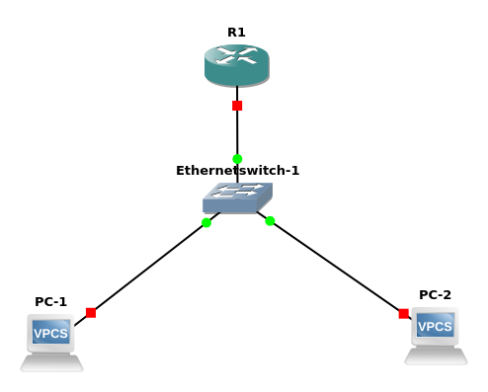

Router Configeration :

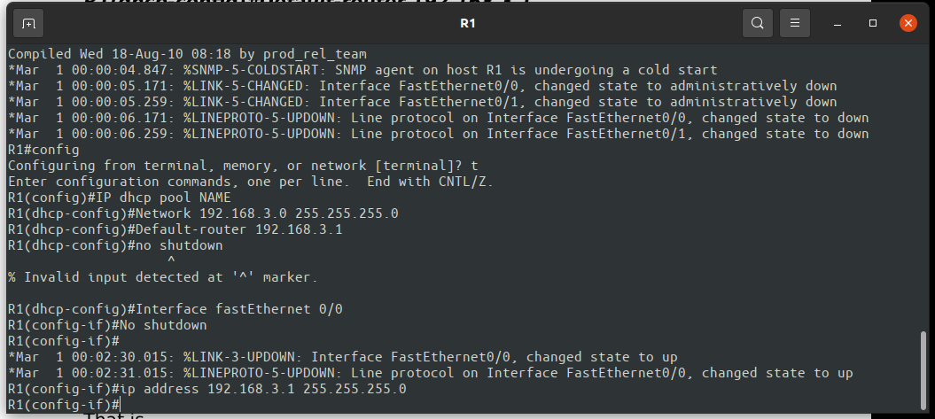

PC’s Configeration :

