OS Lab #8
Question 1

/*
Producer-Consumer Code where producer can produce
at most 10 more items that consumer has consumed
*/

#include<stdio.h>
#include<unistd.h>
#include<pthread.h>
#include<semaphore.h>

int buff[5],f,r;
sem_t mutex,full,empty;

void* producer(void* args)
{
for(int i=0;i<10;i++)
{
sem_wait(&empty);
sem_wait(&mutex);
printf("Produced item is : %d\n",i);
buff[(r++)%10] = i;
sleep(1);
sem_post(&mutex);
sem_post(&full);
}
}

void* consumer(void* args)
{
int item;
for(int i=0;i<5;i++)
{
sem_wait(&full);
sem_wait(&mutex);
item = buff[(f++)%10];
printf("Consumed item is %d\n",item);
sleep(1);
sem_post(&mutex);
sem_post(&full);
}
}

int main()
{
pthread_t t1,t2;
sem_init(&mutex,0,1);
sem_init(&full,0,1);
sem_init(&empty,0,10);

pthread_create(&t1,0,producer,0);
pthread_create(&t2,0,consumer,0);

pthread_join(t1,0);
pthread_join(t2,0);
}

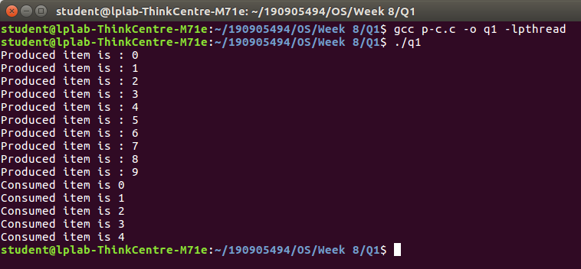

Question 2

/*
Implementing the Reader - Writer
Problem using semaphores
*/

#include<stdio.h>
#include<unistd.h>
#include<pthread.h>
#include<semaphore.h>

sem_t wrt;
pthread_mutex_t mutex;
int count = 1, numreader = 0;

void* writer(void* wno)
{
sem_wait(&wrt);
count *= 2;
printf("Writer %d modified count to %d\n",*((int*)wno),count);
sem_post(&wrt);
}

void* reader(void* rno)
{
pthread_mutex_lock(&mutex);
numreader++;

if(numreader == 1)
sem_wait(&wrt);

pthread_mutex_unlock(&mutex);

printf("Reader %d read count as %d\n",*((int*)rno),count);
pthread_mutex_lock(&mutex);
numreader--;

if(numreader == 0)
sem_post(&wrt);

pthread_mutex_unlock(&mutex);
}

int main()
{
pthread_t read[10],write[5];
pthread_mutex_init(&mutex,0);
sem_init(&wrt,0,1);

int a[10] = {1,2,3,4,5,6,7,8,9,10};

for(int i = 0;i<10;i++)
pthread_create(&read[i],0,reader,&a[i]);

for(int i = 0;i<5;i++)
pthread_create(&write[i],0,writer,&a[i]);

for(int i = 0;i<10;i++)
pthread_join(read[i],0);

for(int i = 0;i<5;i++)
pthread_join(write[i],0);

pthread_mutex_destroy(&mutex);
sem_destroy(&wrt);

}

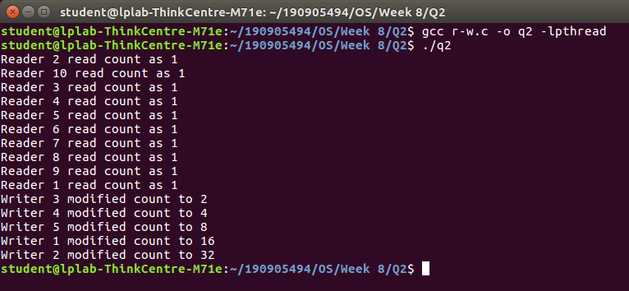

Question 3

/*
Creating Deadlock while accessing shared Resorce,
by the improper use of semaphores
*/

#include<stdio.h>
#include<unistd.h>
#include<pthread.h>
#include<semaphore.h>

sem_t s1,s2;

void* func1(void* p)
{
sem_wait(&s1);
sem_wait(&s2);
printf("Thread 1 (Deadlock Created, Thread 2 not executed)\n");
sem_post(&s1);
}

void* func2(void* p)
{
sem_wait(&s2);
sem_wait(&s1);
printf("Thread 2 (Deadlock Created, Thread 1 not executed)\n");
sem_post(&s2);
}

int main()
{
pthread_t t1,t2;
sem_init(&s1,0,1);
sem_init(&s2,0,1);
pthread_create(&t1,0,func1,0);
pthread_create(&t2,0,func2,0);

pthread_join(t1,0);
pthread_join(t2,0);

sem_destroy(&s1);
sem_destroy(&s2);
}

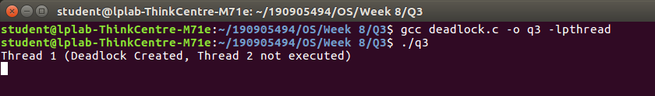

Question 4

/*
Using semaphores to demonstrate the
working of the sleeping barber problem
*/

#include<stdio.h>
#include<stdlib.h>
#include<unistd.h>
#include<pthread.h>
#include<semaphore.h>

sem_t customer, barber;
pthread_mutex_t seat;
int free0 = 10;

void* br(void* args)
{
while(1)
{
sem_wait(&customer);
pthread_mutex_lock(&seat);

if(free0 < 10)
free0++;

sleep(1);
printf("Cutting completed : Free seats : %d\n",free0);
sem_post(&barber);
pthread_mutex_unlock(&seat);
}
}

void* cr(void* args)
{
while(1)
{
pthread_mutex_lock(&seat);

if(free0 > 0)
{
free0--;
printf("Customer waiting : Free seats : %d\n",free0);
sem_post(&customer);
pthread_mutex_unlock(&seat);
sem_wait(&barber);
}
else
pthread_mutex_unlock(&seat);
}
}

int main()
{
pthread_t t1,t2;
sem_init(&barber,0,1);
sem_init(&customer,0,1);

pthread_mutex_init(&seat,0);
pthread_create(&t1,0,br,0);
pthread_create(&t2,0,cr,0);

pthread_join(t1,0);
pthread_join(t2,0);

sem_destroy(&barber);
sem_destroy(&customer);
pthread_mutex_destroy(&seat);
}

